**Lab 6**

**MSDS 6370**

**Submitted by Hari Narayan Sanadhya**

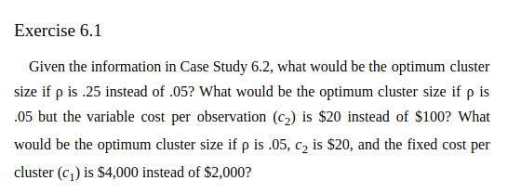

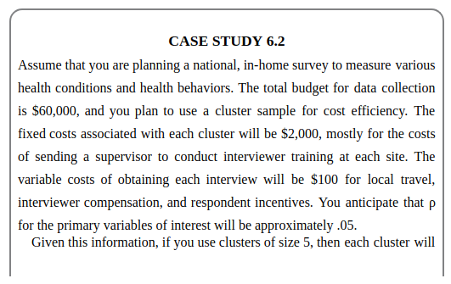

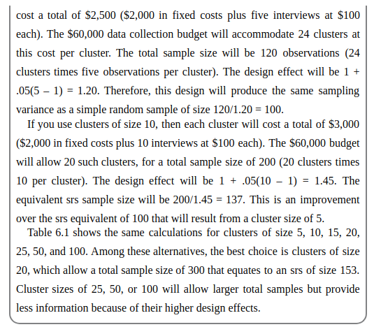

**Solution**:

|  |  |  |  |
| --- | --- | --- | --- |
| Exercise 6.1 |  |  |  |
| c1 | 2000 | 2000 | 4000 |
| c2 | 100 | 20 | 20 |
| Intra Cluster Correlation Coefficient | 0.25 | 0.05 | 0.05 |
| Total Budget | 60000 | 60000 | 60000 |
| Optimal Cluster size | 8 | 44 | 62 |
| Cost per Cluster | 2800 | 2880 | 5240 |
| No of Clusters | 21 | 20 | 11 |
| Total Sample Size | 168 | 880 | 682 |
| Design Effect | 2.75 | 3.15 | 4.05 |
| Equivalent SRS Sample Size | 61 | 279 | 168 |

Optimal Cluster Size in the three cases are 8, 44 and 62 respectively.

