RFM SEGMENTATION
Customer Insight Analysis
Eight analytical questions • Findings • Recommendations • Supporting evidence
Prepared from transaction-level analysis and RFM segmentation

Contents
1. Identifying Potential Churn and Designing Retention Strategies
2. Marketing Strategies for Each RFM Segment
3. Using Product Preferences to Inform Product Development
4. Leveraging Geographic Data for Targeted Marketing Campaigns
5. Planning Seasonal Marketing Campaigns Using RFM Segmentation
6. Identifying Cross-Selling Opportunities and Creating Bundled Offers
7. Using Indirect Feedback to Refine RFM Segmentation and Improve Customer Satisfaction
8. Analysing Revenue Variation by Weekday and RFM Segment
Each question includes its objective, supporting analysis, recommendations, expected business benefits, limitations and conclusion, with a relevant notebook screenshot placed alongside the discussion.

1. Identifying Potential Churn and Designing Retention Strategies
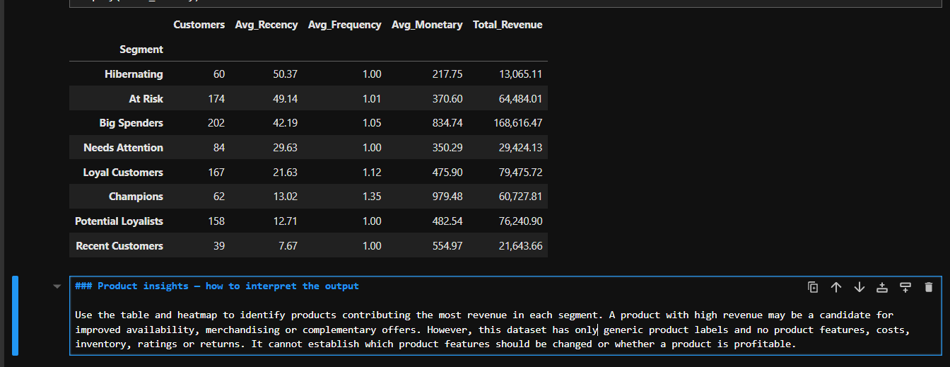
RFM segment profile supporting the retention priorities

Objective
The objective is to identify customer segments that may be at risk of disengagement using Recency, Frequency and Monetary (RFM) analysis and recommend targeted interventions to encourage repeat purchases and preserve customer revenue.

Analysis and Key Findings
The RFM analysis identifies the At Risk and Hibernating segments as potential candidates for retention campaigns.
At Risk: This segment contains 174 customers, with an average recency of 49.14 days, average purchase frequency of 1.01 orders, and average monetary value of 370.60. Its total revenue is 64,484.01. These customers represent a potential re-engagement opportunity because they have not purchased recently relative to the observed dataset.
Hibernating: This segment contains 60 customers, with an average recency of 50.37 days, average purchase frequency of 1.00 order, and average monetary value of 217.75. Its total revenue is 13,065.11. This segment has the highest average recency and lowest average monetary value among the eight segments, suggesting that a low-cost reactivation strategy may be appropriate.
Both segments have an average purchase frequency close to one order per customer. Therefore, some customers may be first-time purchasers rather than previously loyal customers who have disengaged.

Recommended Interventions

1. Targeted re-engagement for At Risk customers
Develop personalised campaigns using previous purchase information and relevant product recommendations. Test time-limited incentives where appropriate, comparing campaign performance with a control group to determine whether the offers generate additional purchases.

2. Cost-effective win-back campaigns for Hibernating customers
Use low-cost email or messaging campaigns to remind customers about relevant products. Avoid immediately offering large discounts to every customer. Instead, test different incentives and assess whether the resulting revenue justifies the campaign expense.

3. Prioritise customers based on value and engagement
Within these segments, investigate customers with higher historical spending who have not purchased recently. Where customer-level trends support it, consider personalised service, loyalty benefits or early access to products. This can help focus retention spending on customers with greater potential value.

4. Measure campaign effectiveness
Evaluate retention initiatives using reactivation rate, repeat-purchase rate, incremental revenue and campaign cost. Where feasible, use controlled experiments to distinguish the effect of a campaign from purchases that would have occurred without it.

Expected Business Benefits
These interventions could help the business identify customers who respond to re-engagement efforts, encourage repeat purchases and allocate marketing budgets more efficiently. Their actual impact must be established through campaign testing rather than assumed in advance.

Limitations
The dataset covers a relatively short transaction period and does not contain an explicit churn outcome. Consequently, the At Risk and Hibernating classifications indicate potential inactivity relative to the observed period, not confirmed churn. The low purchase frequency across these segments also means that some customers may simply have made a single purchase. Further transaction history and campaign-response data would improve the reliability of churn-risk assessment.

Conclusion
The At Risk segment is a reasonable priority for retention testing because it contains 174 customers and generates 64,484.01 in observed revenue. The Hibernating segment may be better suited to low-cost win-back campaigns because it contains 60 customers, has an average monetary value of 217.75 and generates 13,065.11 in revenue. A targeted, measurable approach would allow the business to evaluate which interventions encourage repeat purchasing while controlling marketing costs.

2. Marketing Strategies for Each RFM Segment
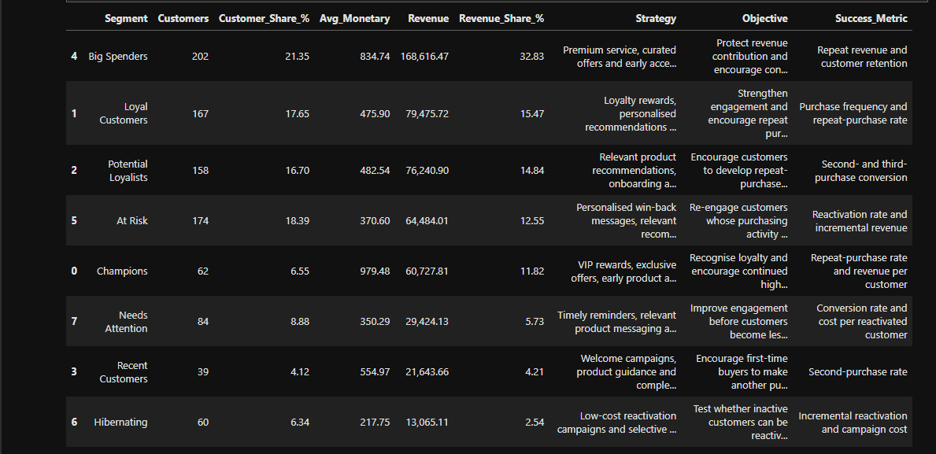
Segment-level revenue contribution and suggested marketing approaches

Objective
The objective is to develop targeted marketing strategies for each RFM segment based on customer behaviour, spending patterns and revenue contribution. A differentiated approach can help strengthen customer relationships, encourage repeat purchases and allocate marketing resources more effectively.

Analysis and Key Findings
The segment analysis reveals differences in customer value and revenue contribution:
Big Spenders: This segment contains 202 customers, representing 21.35% of the customer base, and contributes 32.83% of total revenue (168,616.47). Its average monetary value is 834.74, making customer retention and personalised premium offers important strategies to investigate.
Champions: Although this segment contains only 62 customers (6.55% of the customer base), its average monetary value is the highest at 979.48. It contributes 11.82% of total revenue (60,727.81), making loyalty recognition and personalised engagement suitable approaches to test.
Loyal Customers and Potential Loyalists: These segments contain 167 and 158 customers, respectively. They contribute 15.47% and 14.84% of total revenue. Loyalty rewards and relevant product recommendations could encourage continued engagement and repeat purchasing.
At Risk: This segment contains 174 customers and contributes 12.55% of total revenue (64,484.01). Targeted re-engagement campaigns may help encourage customers to return.
Needs Attention and Hibernating: These segments contribute 5.73% and 2.54% of total revenue, respectively. Low-cost, targeted campaigns can be tested before allocating substantial marketing budgets.
Recent Customers: This segment contains 39 customers and contributes 4.21% of total revenue. Welcome communications and relevant product recommendations could help encourage a second purchase.

Recommended Marketing Strategies

1. Champions — Exclusive experiences and loyalty recognition
Offer VIP benefits, early access to selected products, exclusive promotions and personalised service. The objective is to recognise valuable customer relationships and encourage continued engagement. Measure success through repeat-purchase rates and revenue per customer.

2. Loyal Customers — Rewards and relationship building
Introduce loyalty rewards, personalised recommendations and referral initiatives. These activities aim to strengthen customer relationships and encourage repeat purchasing. Monitor changes in purchase frequency and repeat-purchase rates.

3. Potential Loyalists — Encourage repeat-purchase habits
Use relevant product recommendations, onboarding communications and modest loyalty incentives. The objective is to encourage customers to purchase again and gradually develop stronger purchasing habits. Measure second- and third-purchase conversion.

4. Recent Customers — Improve the first-to-second purchase conversion
Provide welcome communications, useful product information and recommendations for complementary products where appropriate. Measure the proportion of customers who make a second purchase within a defined period.

5. Big Spenders — Protect revenue contribution
Test premium service, curated offers and early access to selected products. Since this segment contributes the largest share of total revenue, the business should investigate ways to maintain engagement without relying on unnecessary discounts. Track repeat revenue, retention and revenue per customer.

6. At Risk — Targeted re-engagement
Send personalised win-back messages and relevant product recommendations. Test time-limited incentives against a control group to determine whether they generate additional purchases. Monitor reactivation rates and incremental revenue.

7. Hibernating — Cost-conscious reactivation
Use low-cost reactivation campaigns and selective discounts. Avoid investing heavily in customers who do not respond; instead, evaluate whether the additional revenue justifies the campaign expense.

8. Needs Attention — Timely and relevant communication
Test targeted reminders, relevant product messaging and controlled promotions. The goal is to improve engagement before purchasing activity declines further. Monitor conversion rates and the cost of reactivating customers.

Measuring Marketing Effectiveness
The effectiveness of each strategy should be evaluated using segment-appropriate measures, including repeat-purchase rate, purchase frequency, second-purchase conversion, reactivation rate, incremental revenue and campaign cost.
Where feasible, controlled experiments should compare customers who receive a campaign with a suitable control group. This helps distinguish genuine campaign impact from purchases that would have occurred anyway.
Marketing costs and profit margins are not available in the current dataset. Consequently, the analysis cannot establish which strategy will produce the highest profit or return on investment.

Conclusion
The findings support a differentiated marketing approach rather than a single campaign for all customers. Big Spenders warrant attention because they contribute 32.83% of total revenue, while Champions have the highest average monetary value per customer. Loyalty-building initiatives may suit established customer relationships, whereas recent and potentially disengaged customers may benefit from onboarding or re-engagement campaigns. These recommendations should be tested and evaluated against measurable outcomes before being adopted at scale.

3. Using Product Preferences to Inform Product Development
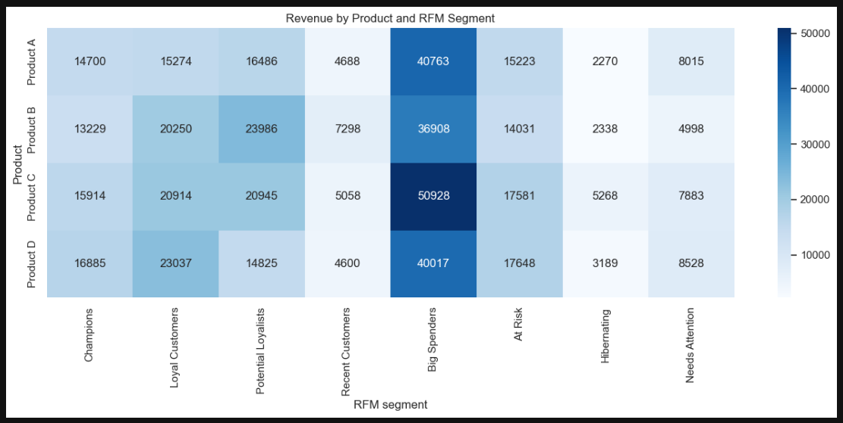
Revenue by product and RFM segment

Objective
The objective is to analyse product purchasing patterns across RFM segments to identify high-performing products, inform product-development priorities and investigate potential gaps in the existing product line.

Analysis and Key Findings
The product-by-segment summary table and the Revenue by Product and RFM Segment heatmap in Section 13 — Product Analysis by RFM Segment provide the supporting evidence for this analysis. The table compares distinct order counts, total revenue and average transaction values across four products and eight RFM segments.
The key findings are:
Champions: Product D generates the highest revenue at 16,885.10 across 22 orders, with an average transaction value of 767.50.
Loyal Customers: Product D leads with revenue of 23,036.82 across 50 orders, with an average transaction value of 460.74.
Potential Loyalists: Product B generates the highest revenue at 23,985.99 across 43 orders, with an average transaction value of 557.81.
Recent Customers: Product B leads with revenue of 7,297.74 across 15 orders, with an average transaction value of 486.52.
Big Spenders: Product C generates the highest revenue at 50,928.16 across 64 orders, with an average transaction value of 795.75.
At Risk: Product D generates the highest revenue at 17,648.04 across 47 orders, with an average transaction value of 375.49.
Hibernating: Product C leads with revenue of 5,268.44 across 21 orders, with an average transaction value of 250.88.
Needs Attention: Product D generates the highest revenue at 8,528.34 across 27 orders, with an average transaction value of 315.86.
These results demonstrate that the highest-revenue product varies across customer segments. Product D leads in four segments, Product C leads among Big Spenders and Hibernating customers, and Product B leads among Potential Loyalists and Recent Customers.
However, revenue and transaction values alone do not establish product quality, customer satisfaction or profitability. These results should guide further investigation rather than be treated as definitive evidence of customer preferences.

Recommended Actions

1. Investigate high-performing products
Evaluate Product D across Champions, Loyal Customers, At Risk and Needs Attention segments, and Product C among Big Spenders. Examine sales trends, availability, repeat purchases, product costs and return rates before deciding whether to expand availability or increase promotional visibility.

2. Tailor product recommendations by segment
Test relevant Product D recommendations for suitable customer segments and Product C recommendations for Big Spenders. Product B could also be tested in campaigns targeting Potential Loyalists and Recent Customers. Measure conversion rates, repeat purchases and incremental revenue to determine whether these recommendations improve outcomes.

3. Collect customer feedback to guide feature improvements
The dataset contains generic product labels without detailed product attributes or feature-level feedback. Collect customer reviews, surveys, ratings and support records to understand which features customers value and what issues they encounter. Use these findings to identify specific product improvements.

4. Investigate potential product-line gaps
Compare customer needs and product requests with the existing range. If additional research identifies unmet needs, consider introducing complementary products, developing new variants or improving existing features. Validate these ideas with customer research before investing in full-scale development.

5. Evaluate products using more than revenue
A product with lower revenue in a segment may have fewer orders or limited exposure rather than poor quality. Review order counts, average transaction values, unique customers, product costs and customer feedback before deciding whether to redesign or discontinue a product.

Expected Business Benefits
Combining transaction analysis with customer feedback can help the business prioritise product research, improve the relevance of product recommendations and identify potential opportunities for new or improved offerings. Small-scale experiments can help determine whether proposed changes improve customer response before broader implementation.

Limitations
The dataset contains four generic product labels and transaction information, but it does not include detailed product attributes, feature-level feedback, customer ratings, return records or product costs. Consequently, the analysis cannot identify specific features to improve, establish product profitability or confirm gaps in the product line. The findings identify product-segment combinations for further investigation rather than proving specific customer preferences.

Conclusion
The product-by-segment analysis in Section 13 shows that Product D leads in revenue among Champions, Loyal Customers, At Risk and Needs Attention customers, Product C leads among Big Spenders and Hibernating customers, and Product B leads among Potential Loyalists and Recent Customers. These findings can guide targeted product recommendations and further product research. However, effective product-development decisions require additional evidence from customer feedback, detailed product attributes, return records and profitability analysis.

4. Leveraging Geographic Data for Targeted Marketing Campaigns
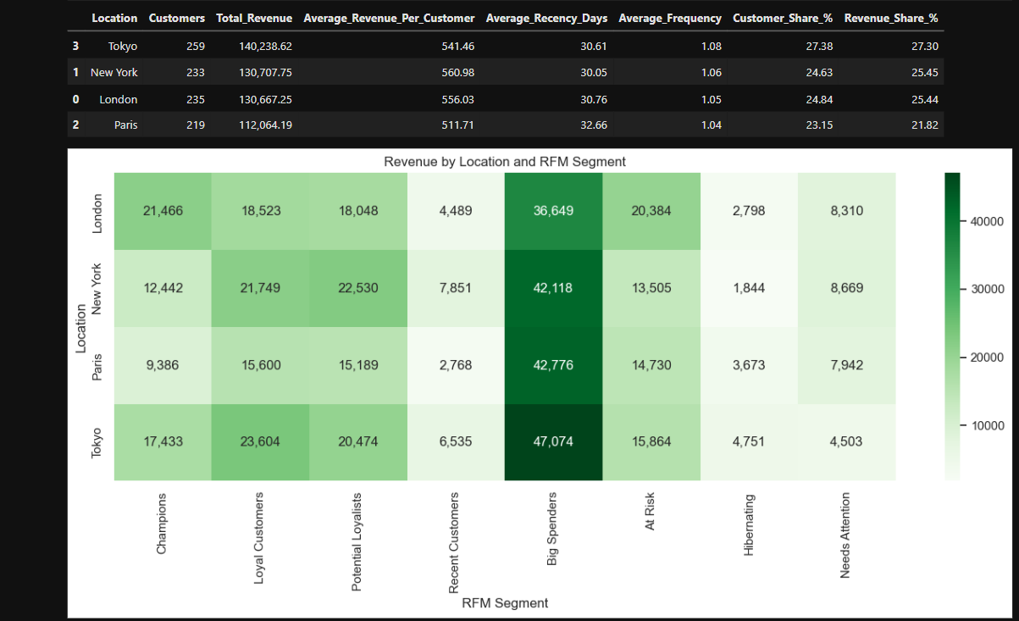
Revenue by location and RFM segment

Objective
The objective is to use geographic information alongside RFM customer segments to identify regional differences in customer value and purchasing activity, then develop targeted marketing campaigns that retain high-value customers and investigate opportunities to improve engagement.

Analysis and Key Findings
The geographic analysis assigns each customer a representative location based on the location with the highest number of distinct orders, using revenue to break ties. The resulting summary compares customer counts, total revenue, average revenue per customer, average recency and average frequency. The Revenue by Location and RFM Segment heatmap further illustrates how each RFM segment contributes to revenue across the four locations.
The key findings are:
Tokyo: Has 259 customers and generates 140,238.62 in revenue, representing 27.30% of total revenue. It has the largest customer base and the highest total revenue.
New York: Has 233 customers and generates 130,707.75 in revenue, contributing 25.45% of total revenue. It records the highest average revenue per customer at 560.98.
London: Has 235 customers and generates 130,667.25 in revenue, contributing 25.44% of total revenue. Its average revenue per customer is 556.03.
Paris: Has 219 customers and generates 112,064.19 in revenue, contributing 21.82% of total revenue. It has the lowest average revenue per customer at 511.71.
The heatmap shows that Big Spenders generate the highest revenue among all RFM segments in each location. Tokyo records 47,074 in Big Spenders revenue, followed by Paris at 42,776, New York at 42,118 and London at 36,649.
These findings indicate that regional marketing should consider both the size and value of the customer base and the composition of RFM segments. Lower regional revenue does not necessarily mean weaker engagement; differences may reflect customer numbers, spending patterns or other factors.

Recommended Actions

1. Retain high-value customers in every location
Because Big Spenders generate the highest segment revenue in all four locations, prioritise retention campaigns for these customers. Test loyalty rewards, personalised recommendations, exclusive product access and complementary offers. Monitor repeat purchases and incremental revenue to determine whether the campaigns improve customer value.

2. Test personalised campaigns in New York
New York has the highest average revenue per customer. Test relevant premium recommendations, cross-selling and loyalty incentives to determine whether existing customer value can be maintained or increased. Avoid broad discounts where personalised offers or service benefits may be more appropriate.

3. Investigate opportunities in Paris
Paris has the lowest total revenue and average revenue per customer among the four locations. Examine its RFM segment distribution, customer purchasing patterns and product-level results to identify potential opportunities. Test relevant recommendations or carefully controlled engagement campaigns rather than assuming that the region has low engagement.

4. Tailor campaigns to regional RFM composition
Use the location-by-segment heatmap to identify which customer groups contribute the most revenue in each region. Develop retention strategies for valuable active customers, repeat-purchase campaigns for promising customers and targeted reactivation campaigns for At Risk or Hibernating customers.

5. Measure campaign effectiveness
Use controlled campaign tests where feasible. Compare campaign recipients with an appropriate control group and monitor conversion rates, repeat-purchase rates, reactivation rates, incremental revenue and campaign costs. This will help distinguish genuine improvements from purchases that would have occurred without the campaign.

Expected Business Benefits
Geographic segmentation combined with RFM analysis can help allocate marketing resources more effectively, strengthen customer retention and identify opportunities to improve regional performance. Tailoring campaigns to regional customer characteristics may also reduce unnecessary discounting and improve the relevance of marketing communications.

Limitations
The analysis is descriptive and covers four locations within the observed transaction period. It does not establish why regional performance differs or prove that any proposed campaign will be effective. In addition, each customer is assigned one representative location based on their most frequently ordered location, with revenue used to break ties. Customers who genuinely purchase in multiple locations may therefore be represented imperfectly. Campaign experiments and additional contextual data would be needed to validate the recommendations.

Conclusion
Tokyo generates the highest total revenue, while New York has the highest average revenue per customer. Big Spenders are the leading revenue-generating segment in every location, making retention a useful priority across all four regions. Paris offers an opportunity for further investigation, but its lower revenue should not automatically be interpreted as low engagement. Combining geographic data with RFM segmentation and measuring campaign outcomes can support more targeted and evidence-based marketing decisions.

5. Planning Seasonal Marketing Campaigns Using RFM Segmentation
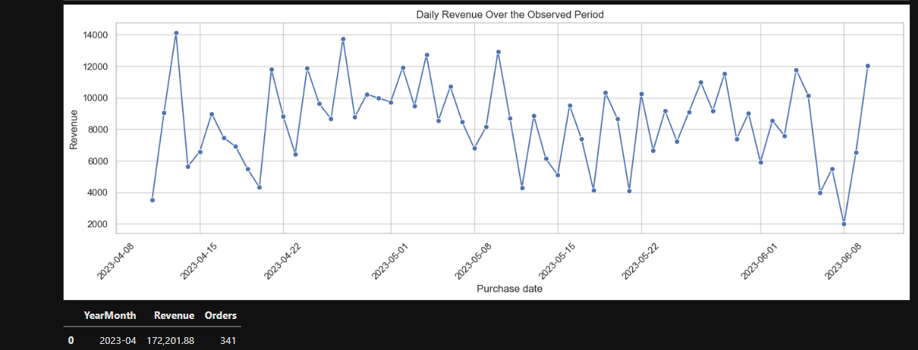
Daily revenue over the observed transaction period

Objective
The objective is to use RFM segmentation and observed purchasing patterns to develop targeted seasonal marketing campaigns. By tailoring campaign strategies to customer behaviour, spending patterns and engagement levels, the business can encourage repeat purchases, improve customer retention and allocate marketing resources more effectively.

Analysis and Key Findings
The RFM analysis identifies eight customer segments with different purchasing behaviours and revenue contributions. These differences provide a basis for developing segment-specific seasonal marketing strategies.
Champions: These customers have the highest average monetary value per customer. Seasonal campaigns can focus on exclusive offers, early access to selected products and loyalty recognition to maintain engagement.
Loyal Customers: These customers have established purchasing relationships with the business. Seasonal loyalty rewards, product recommendations and relevant bundles may encourage continued purchases.
Potential Loyalists: These customers offer an opportunity to build stronger purchasing habits. Seasonal recommendations and modest incentives could encourage repeat purchases.
Recent Customers: Welcome campaigns featuring relevant seasonal products and complementary recommendations may encourage a second purchase.
Big Spenders: This segment contributes the largest share of total revenue at 32.83%. Seasonal campaigns targeting these customers should focus on premium products, personalised recommendations and exclusive benefits to help protect revenue contribution.
At Risk: These customers have relatively high recency values, indicating that they have not purchased recently within the observed period. Targeted seasonal reminders and relevant offers may encourage them to return.
Hibernating: These customers have the highest average recency and lowest average monetary value among the eight segments. Low-cost seasonal reactivation campaigns may be more appropriate than expensive promotions.
Needs Attention: Targeted seasonal messages and carefully tested incentives may help improve engagement and encourage additional purchases.
The transaction data can also be used to examine daily revenue and order patterns during the observed period. These patterns may help identify periods of relatively higher or lower purchasing activity and inform the timing of future campaigns.
However, the dataset covers April to June 2023 and does not include multiple years of transaction history. Therefore, it cannot establish reliable annual seasonality or confirm how customers behave during festivals, holidays or other recurring seasonal events.

Recommended Actions

1. Develop segment-specific seasonal campaigns
Design campaigns around the needs of each RFM segment. Champions and Big Spenders can receive early access, premium product recommendations and exclusive benefits, while Potential Loyalists and Recent Customers can receive relevant recommendations designed to encourage repeat purchases.

2. Prioritise customer retention during seasonal periods
Use seasonal occasions to reconnect with At Risk and Hibernating customers. Send personalised reminders featuring products relevant to their previous purchases. Test limited-time incentives where appropriate, rather than providing discounts to every customer.

3. Use purchasing patterns to inform campaign timing
Analyse daily revenue and order volumes to identify patterns within the available transaction period. Use these findings as an initial guide for scheduling campaigns, then validate the timing with future campaign results and longer-term transaction data.

4. Personalise seasonal product recommendations
Use the product-by-segment analysis to identify products generating higher revenue within each customer segment. Test these products in seasonal recommendations and bundles where appropriate. Measure conversion rates and incremental revenue to determine whether the recommendations improve purchasing outcomes.

5. Measure campaign effectiveness
Evaluate campaigns using conversion rates, repeat-purchase rates, reactivation rates, incremental revenue and campaign costs. Where feasible, compare customers receiving a campaign with a suitable control group to determine whether the campaign generates additional purchases.

Expected Business Benefits
A targeted seasonal marketing approach could help the business strengthen customer relationships, encourage repeat purchases and protect revenue from valuable customer segments. Personalised campaigns may also reduce unnecessary discounting by matching offers to customer behaviour rather than treating all customers identically.
Using transaction patterns to inform campaign timing and measuring campaign outcomes can help the business identify which strategies are most effective. However, the actual benefits must be established through campaign testing rather than assumed in advance.

Limitations
The dataset covers a relatively short period from April to June 2023 and does not contain multiple years of transaction history, explicit seasonal indicators, campaign exposure, discount information or marketing response data. Consequently, the analysis cannot establish recurring seasonal trends or determine which seasonal campaigns will generate the highest returns.
The recommendations are based on observed RFM segments and purchasing patterns. Further transaction history and controlled campaign experiments would be required to validate seasonal effects and assess campaign effectiveness.

Conclusion
RFM segmentation provides a useful basis for planning targeted seasonal marketing campaigns. Champions and Big Spenders may benefit from exclusive benefits and personalised recommendations, while Recent Customers and Potential Loyalists may respond to campaigns encouraging repeat purchases. At Risk and Hibernating customers can be targeted through cost-effective reactivation initiatives.
Although the current dataset provides a starting point for campaign planning, longer-term transaction data and measurable campaign outcomes are necessary to identify reliable seasonal trends and determine which strategies deliver the greatest business value.

6. Identifying Cross-Selling Opportunities and Creating Bundled Offers
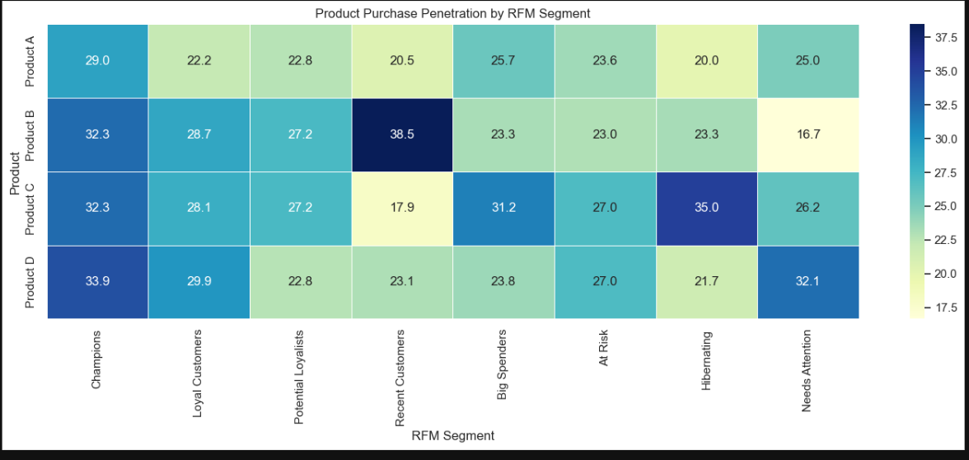
Product purchase penetration by RFM segment

Objective
The objective is to identify potential cross-selling opportunities using customer purchase history, product preferences and RFM segmentation. The aim is to recommend relevant products to different customer groups and develop targeted bundled offers that could increase average order value, encourage repeat purchases and improve customer engagement.

Analysis and Key Findings
The product purchase analysis was used to examine customer penetration across four products within each RFM segment. Customer penetration represents the percentage of customers in a segment who purchased a particular product during the observed period.
The analysis identified the following opportunities:
Champions: Product D has the highest customer penetration at 33.87%, followed by Products C and B at 32.26% each. Product D could be used as a starting point for testing complementary recommendations among these high-value customers.
Loyal Customers: Product D leads with a penetration rate of 29.94%, followed by Product B at 28.74%. Recommendations featuring products not previously purchased could be tested to encourage additional purchases.
Potential Loyalists: Product B and Product C each have a penetration rate of 27.22%. These products could serve as starting points for recommendation campaigns designed to encourage repeat purchases and strengthen customer loyalty.
Recent Customers: Product B has the highest penetration at 38.46%, followed by Product D at 23.08%. Product recommendations could be tested as part of a follow-up campaign to encourage a second purchase.
Big Spenders: Product C has the highest penetration at 31.19% and generates the highest revenue within this segment, amounting to 50,928.16 across 64 orders. It could be used as a starting point for testing premium product recommendations and bundled offers.
At Risk: Products C and D have equal penetration rates of 27.01%. These products could be considered for personalised reactivation campaigns that encourage customers to return.
Hibernating: Product C leads with a penetration rate of 35.00%. It could be included in low-cost recommendation experiments intended to reactivate inactive customers.
Needs Attention: Product D has the highest penetration at 32.14%, followed by Product C at 26.19%. Recommendations featuring products not previously purchased could be tested to improve engagement.
The customer-level product analysis identified products that individual customers had not purchased during the observed period. A baseline recommendation approach was then developed by ranking products according to their penetration and revenue within each customer's RFM segment, excluding products already purchased by that customer.
The recommendation analysis generated 1,891 potential customer-product recommendations across 946 customers. Big Spenders accounted for 404 recommendations, followed by At Risk customers with 348, Loyal Customers with 333, and Potential Loyalists with 316.
These results provide a starting point for targeted recommendation experiments. However, the number of recommendations represents eligible customer-product combinations rather than predicted purchases or confirmed sales opportunities.

Recommended Actions

1. Use product popularity to guide recommendations
Use the product penetration analysis to identify products with relatively high customer adoption within each RFM segment. These products can serve as starting points for recommendation experiments, with results measured through subsequent purchases and conversion rates.

2. Develop segment-specific recommendation strategies
Champions and Big Spenders: Test personalised recommendations and premium product combinations while prioritising customer experience and profitability.
Loyal Customers: Test recommendations for products not previously purchased and introduce relevant bundle offers to encourage additional purchases.
Potential Loyalists and Recent Customers: Use accessible product recommendations and carefully selected bundles to encourage repeat purchases.
At Risk and Hibernating: Test relevant recommendations as part of cost-effective reactivation campaigns. Use incentives selectively rather than offering blanket discounts.
Needs Attention: Experiment with different product recommendations and modest incentives to determine which approaches improve engagement.

3. Use customer purchase history to prioritise recommendations
Combine customer-level product history with RFM segment information to identify products that customers have not purchased. Rank candidate recommendations using product popularity within the relevant segment, then test whether these recommendations lead to additional purchases.

4. Investigate product relationships using detailed transaction data
Obtain transaction-line data containing multiple products per order. This would allow the business to calculate product-pair frequencies and association rules, helping identify products that customers actually purchase together. These relationships could then inform evidence-based bundles.

5. Measure the effectiveness of recommendations and bundles
Evaluate recommendation campaigns using conversion rates, average order value, repeat-purchase rates, incremental revenue and campaign costs. Where possible, compare customers receiving recommendations with a control group to determine whether the campaign generates additional purchases.

6. Consider profitability when designing bundled offers
Before introducing discounts or premium bundles, examine product costs, profit margins and fulfilment expenses. Revenue alone is insufficient to determine whether a bundle is commercially beneficial.

Expected Business Benefits
A segment-based recommendation strategy could help the business identify additional purchasing opportunities, improve the relevance of product recommendations and encourage repeat purchases. Targeted campaigns may also help the business engage high-value customers, encourage newer customers to purchase again and reactivate customers who have become less active.
The analysis of 1,891 potential customer-product recommendations provides a starting point for testing these strategies across different RFM segments. However, the actual business impact must be established by measuring customer responses, incremental sales and profitability.

Limitations
The dataset contains one product label per order, and the analysis confirmed that no order contained more than one distinct product. Consequently, the available data cannot establish which products customers frequently purchase together or support direct market basket analysis and association-rule calculations.
The product recommendation approach ranks products using their popularity and revenue within each RFM segment, excluding products previously purchased by the individual customer. It does not establish product complementarity or predict the probability of a purchase.
The dataset also contains generic product labels and does not include detailed product attributes, customer preferences or product costs. Therefore, the proposed recommendations and bundles should be treated as hypotheses for further testing rather than confirmed cross-selling relationships.

Conclusion
The analysis identifies potential cross-selling opportunities by combining product penetration, revenue contribution, customer purchase history and RFM segmentation. Product D provides a starting point for recommendation experiments among Champions, Loyal Customers and Needs Attention, while Product C could be explored among Big Spenders and Hibernating customers. Product B may be worth testing among Potential Loyalists and Recent Customers.
The baseline recommendation approach generated 1,891 potential customer-product recommendations across 946 customers. By validating these recommendations through controlled experiments and obtaining detailed transaction-line data, the business can move towards evidence-based product bundles and assess their impact on customer engagement, incremental revenue and profitability.

7. Using Indirect Feedback to Refine RFM Segmentation and Improve Customer Satisfaction
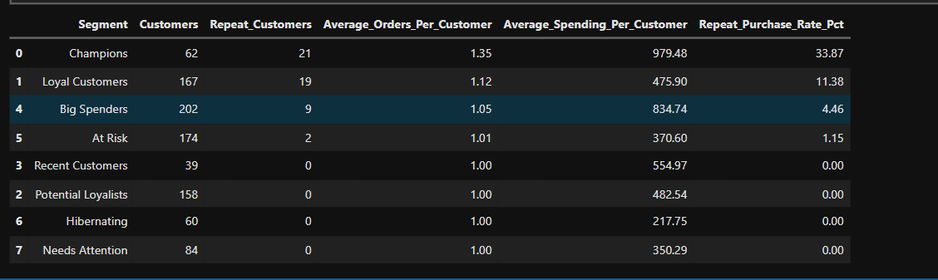
Repeat-purchase behaviour by RFM segment

Objective
The objective is to use indirect customer feedback, such as repeat purchases and product returns, to understand customer behaviour and refine RFM segmentation. These behavioural indicators can help identify changes in customer engagement, improve customer retention strategies and support more personalised marketing decisions when direct feedback, such as ratings, reviews and surveys, is unavailable.

Analysis and Key Findings
The current dataset contains customer identifiers, purchase dates, transaction amounts, product information, order identifiers and locations. Although it does not contain direct customer feedback, purchase history provides indirect insights into customer engagement and purchasing behaviour.
The RFM analysis provides three useful measures:
Recency: Measures how recently a customer made a purchase. Customers with higher recency values have not purchased for longer and may require further investigation to determine whether their engagement has declined.
Frequency: Measures the number of distinct orders placed by a customer. Customers with repeated purchases demonstrate continued purchasing activity during the observed period.
Monetary Value: Measures the total amount spent by each customer. Combined with recency and frequency, it helps distinguish high-spending customers from those contributing less revenue.
To investigate repeat purchasing, the analysis calculated the proportion of customers with more than one distinct order in each RFM segment.
The findings were as follows:
Champions: 21 of 62 customers placed multiple orders, giving the segment a repeat-purchase rate of 33.87%. This was the highest rate among the eight segments.
Loyal Customers: 19 of 167 customers placed multiple orders, resulting in a repeat-purchase rate of 11.38%.
Big Spenders: 9 of 202 customers placed multiple orders, giving the segment a repeat-purchase rate of 4.46%. Despite this low rate, the segment had the highest average spending per customer at 834.74.
At Risk: 2 of 174 customers placed multiple orders, representing a repeat-purchase rate of 1.15%.
Recent Customers, Potential Loyalists, Hibernating and Needs Attention: None of the customers in these segments placed multiple orders during the observed period.
These findings indicate that high spending does not necessarily correspond to frequent purchasing. Champions showed the strongest repeat-purchase behaviour, while Big Spenders contributed relatively high spending despite limited repeat purchases.
However, the absence of repeat purchases in several segments does not establish dissatisfaction or future churn. The dataset covers a relatively short period, and customers may not have had sufficient time or need to make another purchase.

Recommended Actions

1. Use repeat-purchase behaviour to refine customer engagement strategies
Analyse customer frequency alongside recency to identify customers who continue purchasing regularly and those whose purchasing activity may have declined. Champions could be prioritised for loyalty initiatives, while previously active customers who have not purchased recently could receive personalised reminders and relevant product recommendations.

2. Investigate high-spending customers with limited repeat purchases
Big Spenders have an average spending value of 834.74 per customer, but only 4.46% placed multiple orders during the observed period. Test personalised follow-up recommendations and relevant product offers to determine whether these customers can be encouraged to make additional purchases.

3. Monitor changes in customer purchasing behaviour
Compare customer purchase frequency and recency over longer periods to identify meaningful changes in purchasing patterns. Customers who previously purchased regularly but have stopped purchasing may warrant further investigation and targeted retention campaigns.

4. Incorporate product returns into future segmentation
Collect return records containing customer IDs, order IDs, product identifiers, return dates, return reasons and refund amounts. Calculate return rates by customer, product and RFM segment to identify patterns that may indicate product-quality issues, unmet expectations or fulfilment problems.
Customers with unusually high return rates should be investigated rather than automatically classified as dissatisfied. Return behaviour should be interpreted alongside purchase history, return reasons and other customer feedback.

5. Refine RFM segmentation using additional behavioural indicators
Once additional data becomes available, combine RFM metrics with repeat-purchase rates, return frequency and return reasons. For example, a high-value customer who purchases regularly but frequently returns products may require a different retention strategy from a high-value customer with consistent purchases and few returns.

6. Collect direct customer feedback
Supplement behavioural analysis with customer surveys, product reviews, ratings and post-purchase feedback. These sources can help validate whether observed purchasing patterns reflect customer satisfaction and identify specific issues requiring improvement.

7. Measure the effectiveness of interventions
Evaluate retention campaigns and customer-experience improvements using repeat-purchase rates, customer retention, changes in RFM scores, return rates and customer feedback. Where feasible, compare outcomes between customers receiving an intervention and a suitable control group to assess its effectiveness.

Expected Business Benefits
Using indirect behavioural indicators alongside RFM segmentation could help the business identify changes in customer engagement, prioritise retention efforts and investigate potential product or fulfilment problems. The repeat-purchase analysis highlights Champions as the segment with the highest repeat-purchase rate, while the relatively low rate among Big Spenders presents an opportunity to test strategies encouraging additional purchases.
Incorporating return information and direct customer feedback in future analyses could further improve customer understanding, support more personalised interventions and help the business distinguish purchasing activity from potential customer-experience concerns.
These benefits must be validated through further analysis and measurable outcomes rather than assumed from purchasing patterns alone.

Limitations
The current dataset contains purchase history but does not include product returns, refund information, return reasons, customer ratings, reviews, complaints or survey responses. Consequently, return rates cannot be calculated, and customer satisfaction cannot be measured directly.
The dataset covers a relatively short observation period. Customers may not have had sufficient time or need to make repeat purchases, so a zero repeat-purchase rate does not necessarily indicate dissatisfaction or disengagement.
Furthermore, repeat purchases are indirect behavioural indicators rather than definitive evidence of satisfaction. Customers may repurchase because of convenience, necessity or limited alternatives.

Conclusion
Repeat purchases and changes in recency provide useful indirect indicators of customer engagement and can help refine retention strategies within RFM segments. The analysis found that Champions had the highest repeat-purchase rate at 33.87%, while Big Spenders had an average spending value of 834.74 per customer despite a repeat-purchase rate of only 4.46%.
These findings can guide further investigation and targeted retention experiments. However, return records and direct customer feedback are needed to assess customer satisfaction more comprehensively. Combining these additional indicators with RFM segmentation would enable the business to develop more informed customer-retention strategies and investigate potential product or service issues.

8. Analysing Revenue Variation by Weekday and RFM Segment
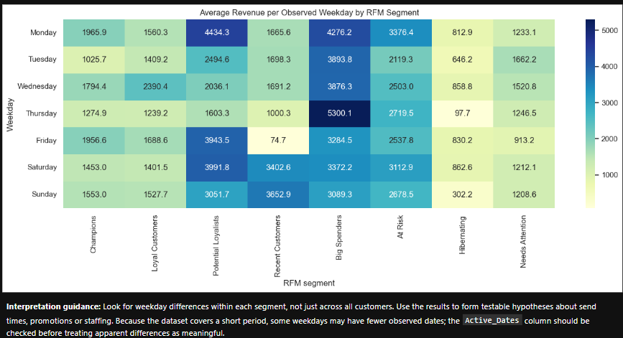
Average revenue per observed weekday by RFM segment

Objective
The objective is to analyse weekday revenue patterns across RFM segments to identify differences in customer purchasing behaviour. These insights can help the business plan targeted marketing campaigns, optimise promotional timing and improve customer engagement.

Analysis and Key Findings
The analysis compared total revenue, order counts, observed purchasing dates and average revenue per observed day for each weekday and RFM segment. Average revenue per observed day was included to account for differences in the number of observed dates.
The findings reveal the following patterns:
Champions: Monday records the highest average daily revenue at 1,965.90, closely followed by Friday at 1,956.62.
Loyal Customers: Wednesday records the highest average daily revenue at 2,390.37.
Potential Loyalists: Monday has the highest average daily revenue at 4,434.29.
Recent Customers: Saturday and Sunday show relatively high average daily revenue. However, these figures are based on very few observed dates and should be interpreted cautiously.
Big Spenders: Thursday records the highest average daily revenue at 5,300.10.
At Risk: Monday has the highest average daily revenue at 3,376.39.
Hibernating: Wednesday records the highest average daily revenue at 858.81, while Thursday has the lowest at 97.74.
Needs Attention: Tuesday records the highest average daily revenue at 1,662.23.
These differences suggest that revenue patterns vary across customer segments and weekdays. However, the observed patterns do not establish that customers have consistent weekday preferences or that campaign timing directly causes higher revenue.

Recommended Actions

1. Test segment-specific campaign timing
Use the observed weekday patterns to develop marketing experiments. For example, campaigns targeting Big Spenders could test Thursday delivery, while campaigns for Potential Loyalists could test Monday delivery. Compare the results with other campaign timings before establishing a long-term schedule.

2. Tailor campaigns to customer behaviour
Develop segment-specific messages and product recommendations based on RFM characteristics. Test different combinations of campaign timing, messaging and offers to determine which approaches generate stronger engagement and additional purchases.

3. Validate patterns using longer-term data
Collect transaction data across a longer period to determine whether the observed weekday patterns persist. Account for differences in the number of observed dates and avoid relying on isolated high-revenue days.

4. Measure campaign effectiveness
Evaluate campaigns using conversion rates, order counts, average order value and incremental revenue. Where feasible, use control groups to determine whether changes in campaign timing produce measurable improvements.

Expected Business Benefits
Analysing weekday revenue by RFM segment can help the business develop more targeted marketing schedules and allocate campaign resources more effectively. Testing different campaign timings may improve customer engagement and identify opportunities to increase revenue.
However, these benefits depend on validating the observed patterns through further analysis and controlled experiments.

Limitations
The dataset covers a relatively short period, and the number of observed dates varies across weekdays and customer segments. Some findings, particularly those for Recent Customers, are based on very few observations and may not represent stable purchasing patterns.
The analysis is descriptive and cannot establish that weekday preferences cause revenue differences. Additional transaction history and controlled campaign experiments are needed to confirm whether segment-specific campaign timing improves business outcomes.

Conclusion
The weekday analysis identifies differences in average daily revenue across RFM segments. Monday performs strongly for Potential Loyalists and At Risk customers, Wednesday leads for Loyal Customers and Hibernating customers, and Thursday records the highest average daily revenue for Big Spenders.
These patterns provide a starting point for testing segment-specific marketing schedules. Longer-term transaction data and controlled experiments are necessary to validate the findings and determine whether adjusting campaign timing can improve customer engagement and revenue.

