**ABSTRACT**

The College Management System is a web application which allows us to access the total information about the college, staff, students and facilities. College Management System will work on college area network which utilizes computer, also which reduces manpower. There can be separate login id and the password for the staff and the higher authorities of the college. Under this system it will include all the departments which comes a particular college. In this application we can get the latest information about the students and staff. This application will maintain the students course details, syllabus and also time tables for the students. The application will be maintained by the administrator. This system will also help the college administrator to get all the information regarding any faculty members on particular day and time. Admin panel will also able to edit the login display panel of teachers, staff members, students etc. Admin can add person, delete person, can give special permission. Admin can schedule classes, their lectures time. Teachers can get information of any students under their particular class. System should be capable to keep track of all the detailed descriptions of the client and the whole details of services offered by the client. This application maintains the complete information about the students and their results. Latest data on marks and students are updated by the administrator which is only available for the admin and the staff

|  |  |  |
| --- | --- | --- |
|  | **TABLE OF CONTENTS** |  |
| **CHAPTER NO.** | **TITLE** | **PAGE NO** |
|  | **ABSTRACT** | **vi** |
|  | **LIST OF FIGURES** | **viii** |
| **1.** | **INTRODUCTION** | **01** |
|  | 1.1 PROBLEM STATEMENT | 01 |
|  | 1.2 OVERVIEW OF PROJECT | 01 |
| **2.** | **AIM AND SCOPE OF THE PROJECT** | **03** |
|  | 2.1 AIM OF THE PROJECT | 03 |
|  | 2.2 SCOPE OF THE PROJECT | 03 |
|  | 2.3 OBJECTIVE | 05 |
| **3.** | **WORK AND METHODOLOGY** | **06** |
|  | 3.1 FRONT-END | 06 |
|  | 3.2 BACKEND | 09 |
|  | 3.3 ENVIRONMENT | 11 |
|  | 3.4 WORK | 13 |
| **4.** | **RESULTS AND DISCUSSION** | **14** |
|  | 4.1 RESULT | 14 |
| **5.** | **SUMMARY AND CONCLUSION** | **15** |
|  | 5.1 SUMMARY | 15 |
|  | 5.2 FUTURE IMPLEMENTATION | 16 |
|  | **REFERENCES** | 17 |
|  | **APPENDIX** | 18 |
|  | SOURCE CODE | 19 |
|  | SCREENSHOTS | 35 |

|  |  |  |
| --- | --- | --- |
|  | **LIST OF FIGURES** |  |
| **FIGURE NO:** | **FIGURE NAME** | **PAGE NO** |
| 3.1.1 | Html5 | 6 |
| 3.1.2 | CSS | 7 |
| 3.1.3 | JavaScript | 8 |
| 3.2.1 | PHP | 9 |
| 3.2.2 | MYSQL | 10 |
| 3.3.1 | WAMPSERVER | 11 |
| 3.3.2 | VISUAL STUDIO 2017 | 12 |
| 4.1.1 | ARCHITECTURE | 14 |
| 6.1.1 | LOGIN PAGE | 35 |
| 6.2.1 | ADMIN PAGE | 36 |
| 6.3.1 | STAFF PAGE | 36 |
| 6.4.1 | DATABASE | 37 |
|  |  |  |
|  |  |  |
|  |  |  |
|  |  |  |

**CHAPTER 1**

**INTRODUCTION**

* 1. **PROBLEM STATEMENT**

This project is based on carrying out various tasks which goes under college management. It will control all activities for a particular college. To handle all the tasks, system has been divided into different modules and presented on a single window, so that its user can handle it in eco-friendly manner. In which the college staff members, students can access the information and will be familiar with college campus. It will provide interactive environment for the staff, students by getting knowledge of student attendance, remarks, exams performances, grades, timetables, notices etc.

* 1. **OVERVIEW OF THE PROJECT**

College Management System is being developed to fulfil all the needs and requirements at college level. It is integrated with the daily operations including activities. It is a web-based system that facilitates the running of events or activities. The user will login in the system with login id and password. Users are individuals who interact with the system. All user interaction is performed through the user's web browser. User should submit details these details are stored in database and if they match then user is provided with username and password using this information user can login. It contains two level of user’s administrator level and staff level where each level has different functionality. It will have all the basic modules and also it makes have all the basic modules and also it makes working fully computerized which is very fast and efficient. It is a software application which maintains records of the students, Users. It is a complete online project, for a firm to run it successfully. It is compulsory to take feedback from clients. The front-end will be HTML pages. PHP will be used for validation and processing of user input and database it will act as a middle layer. Third layer of database will be interacted with these layers, which would be MYSQL database. The web server would be Apache WampServer.

* + 1. **Module wise description**
* Login

Login module is used to check whether the user is an authorized person to use the system or not. For this the user should give the correct user name and password. The different types of users are

1. Admin:

He will be able to add the students, staff and all the student related information and their activities

1. Staff:

This user will be able to add the exams marks, assignments and will be able to change the details also for them.

* The users also have an option to change their settings of the account like password, profile etc.

**CHAPTER 2**

**AIM AND SCOPE OF THE PROJECT**

**2.1 AIM OF THE PROJECT**

Main aim in developing College Management System is to provide an easy way not only to automate all functionalities of a college, but also to provide full functional reports to top management of college with the finest of details about any aspect of college. **It**is to provide a system which can manage all the records of students and [college](https://mcabcaprojects.com/238-asp-net-college-management-system-project-code/). Providing information to all the levels of management within an organization / institution This system will automate all the working of college. This **automated system** will be able to store records without paper and will be able to consume less time. Now admin can spend more time on monitoring the college instead of managing paper work. This application will maintain the students course details, syllabus and also time tables for the students. The application will be maintained by the administrator. This system will also help the college administrator to get all the information regarding any faculty members on particular day and time.

**2.2** **SCOPE OF THE PROJECT**

The requirement of the user is to

* Access / Search information.
* Login to the system through the first page of the application.
* Change the password after logging into the system.
* View / change his / her details.
* Can get help through the ‘HELP’ option to view different features of the system.
* Students can give feedback on college / staff / any other student.
* An admin login should be present who can read as well as remove any uploads.
* It is more efficient and convenient for the colleges.
* It reduces the manpower needed to perform the entire administration task by reducing the paper works needed.
* If all the work is done by the computer there will be no chance of errors. Moreover, storing and retrieving of the information is easy, so work can be done speedily and in time.
* College information: Through this service one can access the complete information about the college campus such as courses available, admission procedure, placements, college events, achievements etc.
* Student’s performance in exams: This facility provides the performance of the student in each exam which is conducted by university or college such as midterm performance. Marks obtained by students in exams will be updated by faculties that can be access by students and parents.
* Exam Notification: This facility notifies students and parents about examination schedule.
* Events: It will give information about different events that will be conducted by college time to time. Information about these events will be updated by administrator.
* Online assignments: This service provides the facility to faculty to upload assignments and to students to submit these assignments online.
* Information about staff: It will help in maintaining complete information about college faculty members such as their department, cadre, date of joining, salary, etc. Administrator will register new faculties and remove their account when they leave the college

**2.3 OBJECTIVE**

This is a web-oriented application allows us to access the whole information about the college, staffs, students, facilities etc. This application provides a virtual tour of Campus. Here we will get the latest information about the students and staffs. This generic application designed for assisting the students of an institute regarding information on the courses, subjects, classes, assignments, grades and timetable. It also provides support that a faculty can also check about his daily schedule, can upload assignments, and notices to the students. Here administrator will manage the accounts of the student and faculties, makes the timetable, and upload the latest information about the campus. It will remove data redundancy and will be fast in operation

2.3.1 **PURPOSE:**

* Its purpose is to centralize the whole system. We are attempting to improve our existing system that basically runs on pen and papers or in a system which is not centralized.
* The main goal of the system is to automate the process carried out in the organization with improved performance and realize the vision of paperless works.

2.3.2 **Need for the proposed system:**

* Automation for management system will use the centralized database of the whole system of the department

2.3.3 **FEAUTURES AND BENIFITS**

* + - User friendly
    - Report are easily generated
    - Very less paper works
    - Computer operator control

**CHAPTER 3**

**WORK AND METHODOLOGY**

**3.1 FRONT-END:**

**3.1.1 HTML:**

**HTML5** is a [mark-up language](https://en.wikipedia.org/wiki/Markup_language) used for structuring and presenting content on the [World Wide Web](https://en.wikipedia.org/wiki/World_Wide_Web). It is the fifth and latest major version of [HTML](https://en.wikipedia.org/wiki/HTML) that is a [World Wide Web Consortium (W3C)](https://en.wikipedia.org/wiki/World_Wide_Web_Consortium) recommendation. Its goals were to improve the language with support for the latest [multimedia](https://en.wikipedia.org/wiki/Multimedia) and other new features; to keep the language both easily readable by humans and consistently understood by computers and to remain [backward-compatible](https://en.wikipedia.org/wiki/Backward-compatible) with older software. It includes detailed processing models to encourage more interoperable implementations; it extends, improves and rationalizes the mark-up available for documents and introduces mark-up and APIs for complex applications. For the same reasons, HTML5 is also a candidate for cross-platform mobile applications, because it includes features designed with low-powered devices in mind. Many new [syntactic](https://en.wikipedia.org/wiki/Syntax_(programming_languages)) features are included. To natively include and handle multimedia and [graphical](https://en.wikipedia.org/wiki/2D_computer_graphics) content [elements](https://en.wikipedia.org/wiki/HTML_element) were added, and support for [scalable vector graphics](https://en.wikipedia.org/wiki/Scalable_vector_graphics) (SVG) content and [MathML](https://en.wikipedia.org/wiki/MathML) for mathematical formulas was also added. To enrich the [semantic](https://en.wikipedia.org/wiki/Semantic_Web) content of documents, new page structure elements are added The APIs and [Document Object Model](https://en.wikipedia.org/wiki/Document_Object_Model) (DOM) are now fundamental parts of the HTML5 specification, and HTML5 also better defines the processing for any invalid documents

. 

FIG.NO:3.1.1

**3.1.2 CSS:**

**Cascading Style Sheets** (**CSS**) is a [stylesheet](https://developer.mozilla.org/en-US/docs/DOM/stylesheet) language used to describe the presentation of a document written in [HTML](https://developer.mozilla.org/en-US/docs/Web/HTML) .CSS describes how elements should be rendered on screen, on paper, in speech, or on other media.CSS is one of the core languages of the **open Web** and is standardized across Web browsers according to the [W3C specification](http://w3.org/Style/CSS/#specs). Previously development of various parts of CSS specification was done synchronously, which allowed versioning of the latest recommendation. You might have heard about CSS1, CSS2.1, CSS3. However, CSS4 has never become an official version. CSS describes how HTML elements are to be displayed on screen, paper, or in other media. CSS saves a lot of work. It can control the layout of multiple web pages all at once. External stylesheets are stored in CSS files. This is used to make the structure of the page more attractive and to get response.CSS allows the separation of presentation from structure. CSS can define colour, font, text alignment, size, borders, spacing, layout and many other typographic characteristics, and can do so independently for on-screen and printed views. There are few more CSS editor’s software that are very popular like Edit Plus, Atom, Text Wrangler, Brackets, and Notepad++. CSS code editors for Linux systems include Edit, Quanta, Scintilla, and CSS. Open source CSS code editors are also available to practice CSS editing



FIG.NO:3.1.2

**3.1.3 JavaScript**

JavaScript is a text-based programming language used both on the client-side and server-side that allows you to make web pages interactive. Where HTML and CSS are languages that give structure and style to web pages, JavaScript gives web pages interactive elements that engage a user.  Implement complex features on web pages. Every time a web page does more than just sit there and display static information for you to look at displaying timely content updates, interactive maps, animated 2D/3D graphics, scrolling video jukeboxes. JavaScript while those used for backend include Java, Ruby, Python.HTML provides the actual content whereas the JavaScript provides an interface for the end users to interact by generating dynamic content to the users. HTML is mainly used for providing static web content whereas JavaScript provides a dynamic environment to handle the dynamic events on the web pages.

**Features:**

* Object-Cantered Script Language.
* Client edge Technology.
* Validation of User’s Input.
* Else and If Statement.
* Interpreter Cantered.



FIG.NO:3.1.3

**3.2 Back-end:**

**3.2.1 php**

Stands for “Hypertext Pre-processor.” (It is a recursive acronym, if you can understand what that means.) PHP is an HTML-embedded Web scripting language. This means PHP code can be inserted into the HTML of a Web page. When a PHP page is accessed, the PHP code is read or “parsed” by the server the page resides on. It is used to manage dynamic content, databases, session tracking, even build entire e-commerce sites. It is integrated with a number of popular databases, including MySQL, PostgreSQL, Oracle, Sybase, Informix, and Microsoft SQL Server.

**ADVANTAGES:**

* + - Easy and Simple to Learn. PHP is considered one of the easiest scripting languages.
    - Extremely Flexible. PHP is highly flexible whether it is during an ongoing project or after completing the project.
    - Easy Integration and Compatibility.
    - Efficient Performance.
    - Cost-Efficient.
    - Gives Web Developer More Control.



FIG.NO:3.2.1

**3.2.2 MySQL**

**MySQL** is a relational database management system based on SQL– Structured Query Language. The application is used for a wide range of purposes, including data warehousing, e-commerce, and logging applications. The most common use for MySQL however, is for the purpose of a web database. MySQL is a relational database management system based on SQL – **S**tructured **Q**uery **L**anguage. The application is used for a wide range of purposes, including data warehousing, e-commerce, and logging applications. The most common use for MySQL however, is for the purpose of a web database. It can be used to store anything from a single record of information to an entire inventory of available products for an online store. In association with a scripting language such as PHP or Perl (both offered on our hosting accounts) it is possible to create websites which will interact in real-time with a MySQL database to rapidly display categorised and searchable information to a website user.

**ADVANTAGES**

* + - * Easy to use. MySQL is easy to use.
      * It is secure. MySQL consists of a solid data security layer that protects sensitive data from intruders.
      * Client/ Server Architecture.
      * Free to download.
      * It is scalable.
      * Speed.
      * High Flexibility.



FIG.NO:3.2.2

**3.3 ENVIRONMENT**

**3.3.1 WAMPSERVER**

WampServer refers to a solution stack for the Microsoft Windows operating system, created by Romain Bourdon and consisting of the Apache web server, OpenSSL for SSL support, MySQL database and PHP programming language. WAMP is a variation of LAMP for Windows systems and is often installed as a software bundle (Apache, MySQL, and PHP). It is often used for web development and internal testing, but may also be used to serve live websites. Nothing like a XAMPP stack, WampServer is only available just for Windows working framework. It comprises of the essential virtual products for running a web server, for example, Apache, PHP, MySQL, and PhpMyAdmin. WampServer can be utilized on Windows PCs to run sites and apps coded in PHP programming language.

#### **Advantages of WAMP**

* It is easy to Use. (Changing Configuration)
* WAMP makes easy to code PHP and Creating Databases (in MySQL) in Windows platform.
* WAMP is Available for both 64 bit and 32-bit system.

#### **Disadvantages of WAMP**

* It is not easy to install as compared to XAMPP.



FIG.NO:3.3.1

**3.3.2 VSCODE**

**Visual Studio Code** is a lightweight but powerful source code editor which runs on your desktop and is available for Windows, macOS and Linux.  Is a streamlined code editor with support for development operations like debugging, task running, and version control? It aims to provide just the tools a developer needs for a quick code-build-debug cycle and leaves more complex workflows to fuller featured IDEs, such as Visual Studio IDE. VSC for short is one of the most popular source code editors used by the programmers. It’s fast, it’s lightweight and it’s powerful too! Microsoft designed VSC as a cross-platform code editor for writing web and cloud applications

**ADVANTAGES:**

* The Visual Studio IDE tool with which we write code is very fast and has a user-friendly display
* Full Stack Web Development
* Legacy app compatibility
* Working with a team on larger projects
* Code completion/checking
* Debugging



FIG.NO:3.3.2

**3.4 WORK**

I have created an application on college management system using html5.Html5 is used to create a structure of the application by adding all the requirements which are needed. By using this I have added nav bar, images, linking other pages to redirect them to a new page, login forms etc. I have added up a few CSS and JavaScript to give my application an attractive look and to make it a responsive layout. To fit all the screen size to display correct I have added up some bootstrap which makes my page to adjust to the corresponding screen size. When it comes to backend all the information which is given will be stored in the database for that I have created a database using MySQL which is integrated with the webpage by using php. PHP is used for both frontend and backend which will be acting like a connector between the page and the database. For using the database, I have created a database named “school” and created tables by taking reference of all the modules present in the application so whenever we give some information in the page it will be automatically stored in the database in the corresponding table by the module name. Whatever the action done to the data in the page will be also reflected in the database. I have done all the coding part in the vscode ide which is well known to everyone and easy to use it comes with a lot of extensions which makes our work easier. finally, after completing all the required I have used wamp server to host the application to run on the server. By using localhost in the chrome, it will be opening the application which I have hosted

**CHAPTER 4**

**RESULTS AND DISCUSSION**

**4.1 RESULTS**

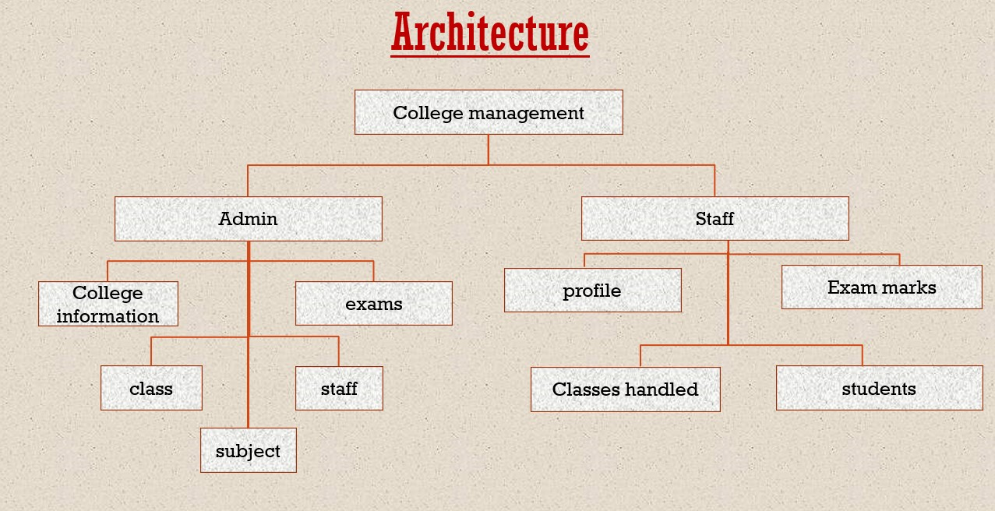

**FIG.NO:4.1.1**

A **college management system** enables colleges and higher education to manage enrolment, admissions, students, faculty, attendance, scheduling, assignments, grades of the institution. The College ERP allows you to manage the entire academic and administrative processes hassle free. to manage the task related to the college students/employees and to reduce time to searching of appropriate candidates in college view. Helps to keep track of all the data

**CHAPTER 5**

**SUMMARY AND CONCLUSION**

**5.1 CONCLUSION**

The project entitled as **College Management System** is the system that deals with the issues related to a particular institution.

* This project is successfully implemented with all the features mentioned in system requirements specification.
* The application provides appropriate information to users according to the chosen service.
* The project is designed keeping in view the day to day problems faced by a college.
* Deployment of our application will certainly help the college to reduce unnecessary wastage of time in personally going to each department for some information.
* The application provides appropriate information to users according to the chosen service.
* The project is designed keeping in view the day to day problems faced by a college.
* Deployment of our application will certainly help the college to reduce unnecessary wastage of time in personally going to each department for some information
* Awareness and right information about any college is essential for both the development of student as well as faculty.

Awareness and right information about any college is essential for both the development of student as well as faculty. So, this serves the right purpose in achieving the desired requirements of both the communities.

**5.2 FUTURE ENHANCEMENT**

* Scheduling of the staff. i.e., time table setting of the staff
* Further, the faculty can upload the videos of their lectures on to this site and students who had missed those classes can view those videos.
* Online examination module would be introduced to conduct online examination.
* Further, the faculty can upload the videos of their lectures on this site and students who had missed those classes can view those videos.
* Attendance facility will also be included by using face recognition

**REFERENCES**

**BOOKS:**

1. Web Development with Java Server Pages BY Duane K. Fields and Mark A. Kolb.
2. Lalit Mohan Joshi MTech schola BTKIT Dwarahat, Almora, Uttarakhand “A Research Paper on College Management System” International Journal of Computer Applications (0975 – 8887) Volume 122 – No.11, July 2015

**WEBSITES**

* <https://ieeexplore.ieee.org/document/7384005>
* <https://ieeexplore.ieee.org/document/5236230>
* <https://www.ijcsmc.com/docs/papers/April2016/V5I4201657>
* <https://www.engpaper.com/college-management-system.htm>

**APPENDIX**

**SOURCE CODE**

**Html file**

**<?php**

**include "database.php";**

**session_start ();**

**?>**

**<!DOCTYPE html>**

**<html>**

**<head>**

**<title>Collage Base Management System - Hari Viswanadh</title>**

**<link rel="stylesheet" type="text/css" href="css/style.css">**

**</head>**

**<body class="back">**

**<?php include"navbar.php";?>**

**<img src="img/baground.jpg" width="800">**

**<div class="login">**

**<h1 class="heading">Admin Login</h1>**

**<div class="log">**

**<?php**

**if(isset($_POST["login"]))**

**{**

**$sql="select * from admin where ANAME='{$_POST["aname"]}' and APASS='{$_POST["apass"]}'";**

**$res=$db->query($sql);**

**if($res->num_rows>0)**

**{**

**$ro=$res->fetch_assoc();**

**$_SESSION["AID"]=$ro["AID"];**

**$_SESSION["ANAME"]=$ro["ANAME"];**

**echo "<script>window.open('admin_home.php','_self');</script>";**

**}**

**else**

**{**

**echo "<div class='error'>Invalid Username or Password</div>";**

**}**

**}**

**if(isset($_GET["mes"]))**

**{**

**echo "<div class='error'>{$_GET["mes"]}</div>";**

**}**

**?>**

**<form method="post" action="<?php echo $_SERVER["PHP_SELF"];?>">**

**<label>User Name</label><br>**

**<input type="text" name="aname" required class="input"><br><br>**

**<label>Password </label><br>**

**<input type="password" name="apass" required class="input"><br>**

**<button type="submit" class="btn" name="login">Login Here</button>**

**</form>**

**</div>**

**</div>**

**<div class="footer">**

**<footer><p>Copyright &copy; Hari Viswanadh </p></footer>**

**</div>**

**<script src="js/jquery.js"></script>**

**<script>**

**$(document).ready(function(){**

**$(".error").fadeTo(1000, 100).slideUp(1000, function(){**

**$(".error").slideUp(1000);**

**});**

**$(".success").fadeTo(1000, 100).slideUp(1000, function(){**

**$(".success").slideUp(1000);**

**});**

**});**

**</script>**

**</body>**

**</html>**

**CSS FILE**

**\*{**

**padding:0px;**

**margin:0px;**

**}**

**html{**

**background:#dddddd;**

**}**

**.back{**

**background:white;**

**height:800px;**

**width:800px;**

**margin:0 auto;**

**margin-top:5px;**

**margin-bottom:5px;**

**font-family:Century;**

**}**

**a{**

**text-decoration:none;**

**}**

**.navbar{**

**background:#663b95;**

**height:60px;**

**width:100%;**

**}**

**.list{**

**list-style:none;**

**text-align:right;**

**}**

**.list li{**

**display:inline;**

**}**

**.list li a{**

**text-decoration:none;**

**color:white;**

**line-height:50px;**

**padding:20px;**

**}**

**h1,h2,h3,h4,h5,h6,label{**

**font-family:roboto;**

**color:#663b95;**

**}**

**.heading{**

**text-align:center;**

**margin-top:40px;**

**}**

**.btn{**

**border-radius:5px;**

**padding:10px;**

**background:#663b95;**

**color:white;**

**margin-top:40px;**

**}**

**.btn:hover{**

**border-radius:5px;**

**padding:10px;**

**background:#8959bd;**

**color:white;**

**margin-top:40px;**

**}**

**.btnr{**

**border-radius:5px;**

**padding:5px;**

**background:#ff0000;**

**color:white;**

**}**

**.btnr:hover{**

**border-radius:5px;**

**padding:5px;**

**background:#ff5e5e;**

**color:white;**

**}**

**.btnb{**

**border-radius:5px;**

**padding:5px;**

**background:#43a7bc;**

**color:white;**

**}**

**.btnb:hover{**

**border-radius:5px;**

**padding:5px;**

**background:#68b9ca;**

**color:white;**

**}**

**.log{**

**height:auto;**

**width:50%;**

**margin:0 auto;**

**margin-top:20px;**

**padding:30px;**

**margin-bottom:40px;**

**-webkit-box-shadow: 0 8px 17px 0 rgba(0, 0, 0, 0.2), 0 6px 20px 0 rgba(0, 0, 0, 0.19);**

**-moz-box-shadow: 0 8px 17px 0 rgba(0, 0, 0, 0.2), 0 6px 20px 0 rgba(0, 0, 0, 0.19);**

**box-shadow: 0 8px 17px 0 rgba(0, 0, 0, 0.2), 0 6px 20px 0 rgba(0, 0, 0, 0.19);**

**}**

**.cont{**

**height:auto;**

**width:50%;**

**margin:0 auto;**

**margin-top:20px;**

**padding:30px;**

**margin-bottom:40px;**

**text-align:center;**

**line-height:40px;**

**-webkit-box-shadow: 0 8px 17px 0 rgba(0, 0, 0, 0.2), 0 6px 20px 0 rgba(0, 0, 0, 0.19);**

**-moz-box-shadow: 0 8px 17px 0 rgba(0, 0, 0, 0.2), 0 6px 20px 0 rgba(0, 0, 0, 0.19);**

**box-shadow: 0 8px 17px 0 rgba(0, 0, 0, 0.2), 0 6px 20px 0 rgba(0, 0, 0, 0.19);**

**}**

**.sha{**

**-webkit-box-shadow: 0 8px 17px 0 rgba(0, 0, 0, 0.2), 0 6px 20px 0 rgba(0, 0, 0, 0.19);**

**-moz-box-shadow: 0 8px 17px 0 rgba(0, 0, 0, 0.2), 0 6px 20px 0 rgba(0, 0, 0, 0.19);**

**box-shadow: 0 8px 17px 0 rgba(0, 0, 0, 0.2), 0 6px 20px 0 rgba(0, 0, 0, 0.19);**

**}**

**.input{**

**height:30px;**

**width:90%;**

**padding:2px;**

**margin-top:10px;**

**}**

**.input2{**

**width:80%;**

**height:40px;**

**margin-top:20px;**

**}**

**label{**

**font-weight:bold;**

**}**

**footer{**

**text-align:center;**

**color:white;**

**line-height:50px;**

**}**

**.success{**

**background:green;**

**color:white;**

**line-height:30px;**

**border-radius:5px;**

**height:30px;**

**text-align:center;**

**margin-bottom:10px;**

**}**

**.error{**

**background:#ff1515;**

**color:white;**

**line-height:30px;**

**border-radius:5px;**

**height:30px;**

**text-align:center;**

**margin-bottom:10px;**

**}**

**.content1{**

**margin-top:30px;**

**}**

**.s{**

**list-style:none;**

**}**

**.li{**

**position: relative;**

**display: block;**

**padding: 10px 15px;**

**margin-bottom: -1px;**

**background-color: #ffffff;**

**border: 1px solid #ecf0f1;**

**}**

**.imgs{**

**height:200px;**

**width:200px;**

**float:left;**

**margin:20px;**

**}**

**.text{**

**text-align:center;**

**}**

**.footer{**

**background:#663b95;**

**height:60px;**

**width:100%;**

**float:left;**

**}**

**#section{**

**height:auto;**

**width:1400px;**

**margin-left:90px;**

**font-family:cambria;**

**}**

**.sidebar{**

**width:400px;**

**height:auto;**

**margin-top:30px;**

**margin-right:30px;**

**float:left;**

**background:white;**

**}**

**.content{**

**margin-top:30px;**

**height:auto;**

**width:950px;**

**float:left;**

**}**

**.content1{**

**margin-top:30px;**

**height:auto;**

**width:450px;**

**float:left;**

**}**

**.para{**

**text-align:justify;**

**padding:15px;**

**line-height:34px;**

**}**

**.tbox{**

**float:left;**

**}**

**.tbox table{**

**border-collapse:collapse;**

**}**

**tr,td,th{**

**padding:20px;**

**}**

**.table{**

**border-collapse:collapse;**

**}**

**.input3{**

**width:90%;**

**height:40px;**

**margin-top:20px;**

**}**

**.input4{**

**width:90%;**

**height:40px;**

**margin-top:20px;**

**}**

**.input5{**

**width:25%;**

**height:40px;**

**margin-top:20px;**

**margin-right:20px;**

**}**

**.lbox{**

**width:45%;**

**margin-right:20px;**

**float:left;**

**}**

**.rbox{**

**width:45%;**

**float:left;**

**}**

**table{**

**border-collapse:collapse;**

**}**

**.lbox1{**

**width:50%;**

**margin-right:20px;**

**float:left;**

**}**

**.rbox1{**

**width:45%;**

**float:left;**

**}**

**.rbox1 table{**

**width:100%;**

**}**

**textarea{**

**resize:none;width:90%;margin-top:20px;**

**}**

**.Output table**

**{**

**width:100%;**

**}**

**.ibox{**

**width:65%;**

**float:left;**

**}**

**.tsbox{**

**width:35%;**

**float:left;**

**}**

**Other source code ref:**

[**https://github.com/viswahari/college-management-system**](https://github.com/viswahari/college-management-system)

**SCREENSHOTS**

**6.1 LOGIN PAGE**



FIG.NO:6.1.1

**6.2 ADMIN PAGE**

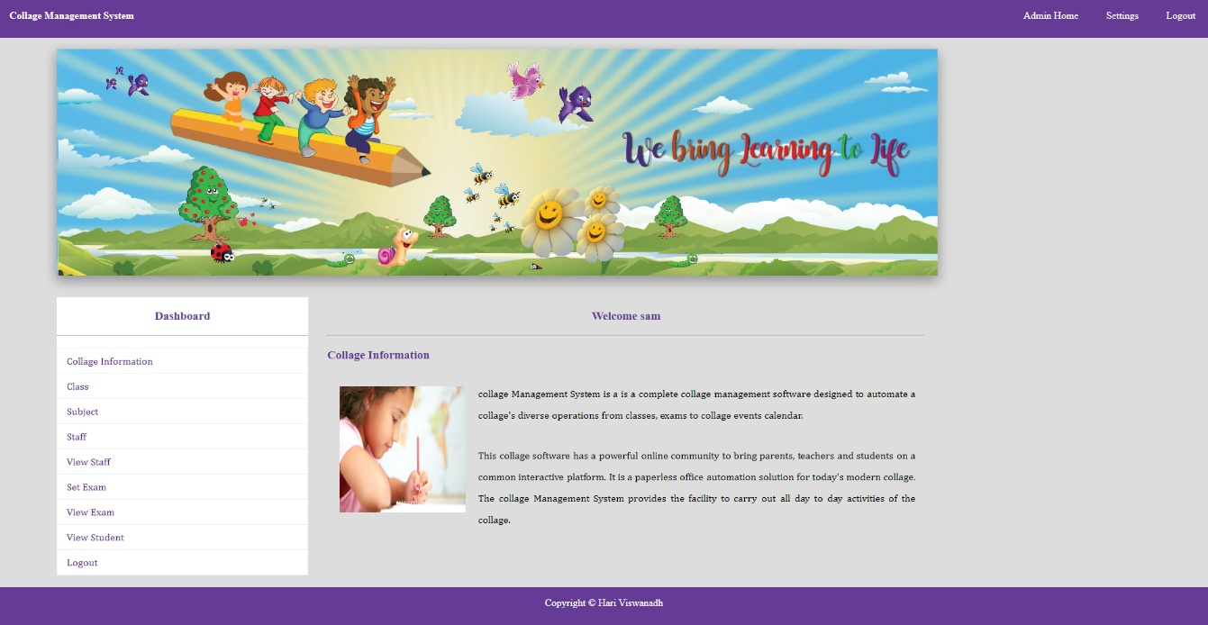

FIG.NO:6.2.1

**6.3 STAFF PAGE**

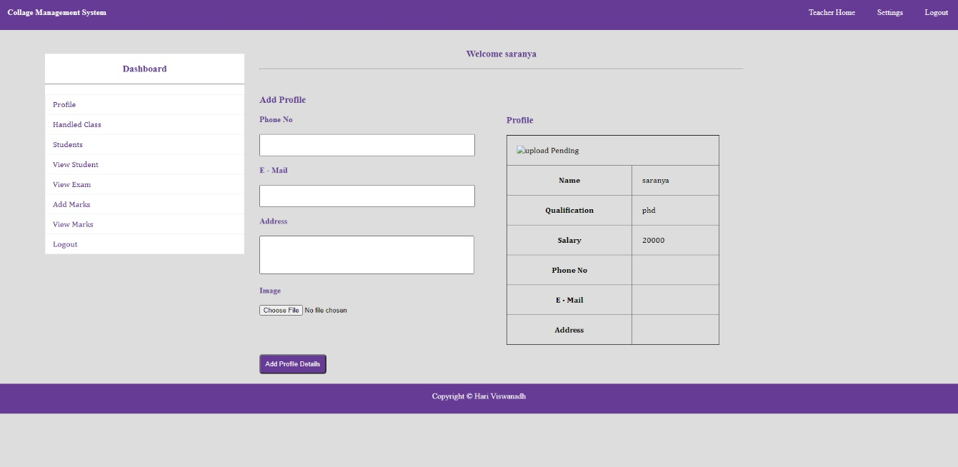

FIG.NO:6.3.1

**6.4 DATABASE**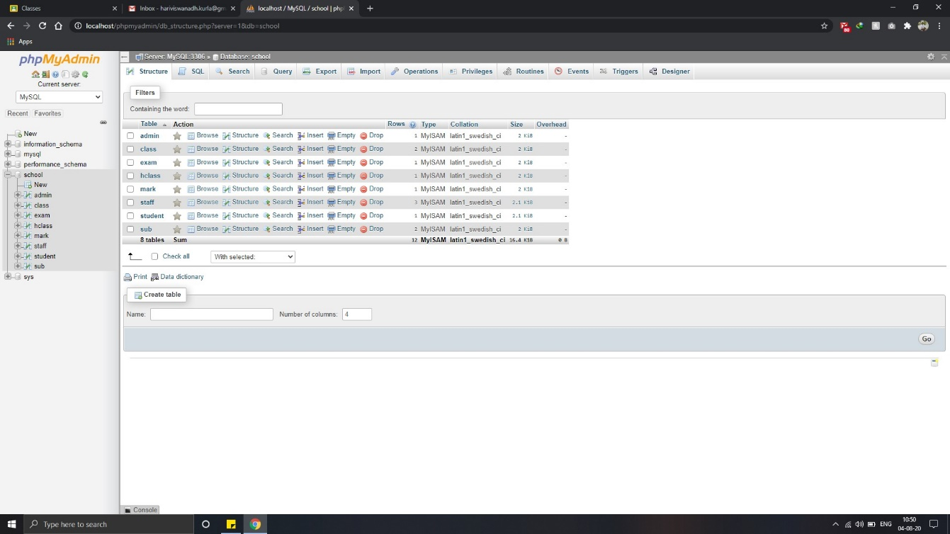

FIG.NO:6.4.1