**Linearization of Flesch readability score with revenue.**

* Where revenue > 0
* Word count of missions > 6

**Linearization of Flesch readability score with revenue.**

* Where revenue > 0
* Word count of missions > 6
* Cluster by states

**Scatterplot and Regression of Flesch Reading Score and Revenue**

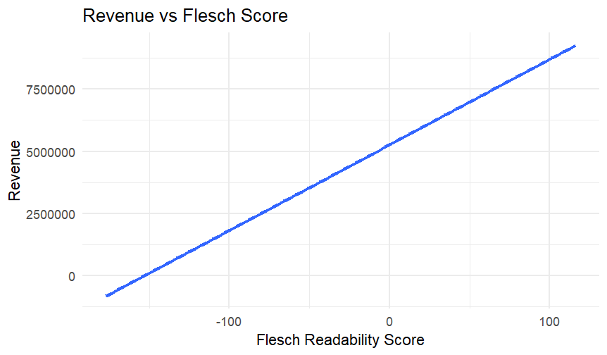

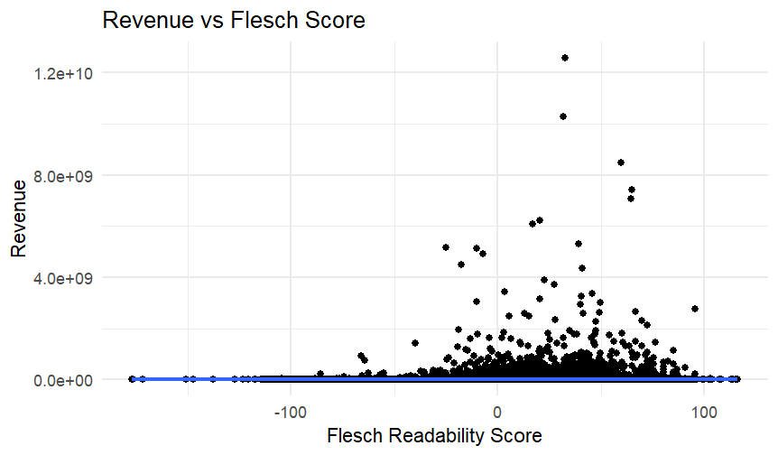

**Linearization of mean sentence length with revenue.**

* Where revenue > 0
* Word count of missions > 6

**Linearization of mean sentence length with revenue**

* Where revenue > 0
* Word count of missions > 6
* Cluster by states

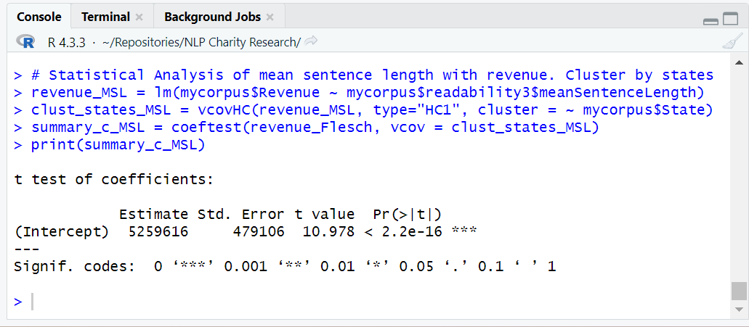

**Scatterplot and Regression of Mean Sentence Length and Revenue**

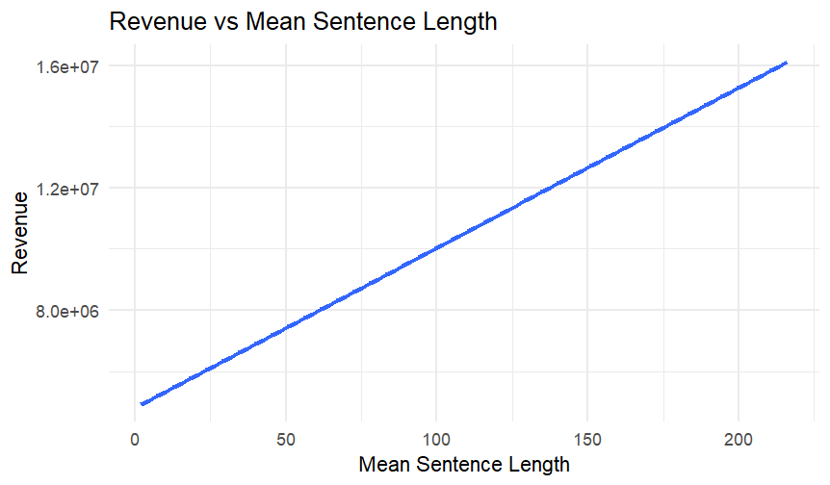

**Linearization of Type-Token Ratio with revenue.**

* Where revenue > 0
* Word count of missions > 6
* Missions are tokenized and preprocessed

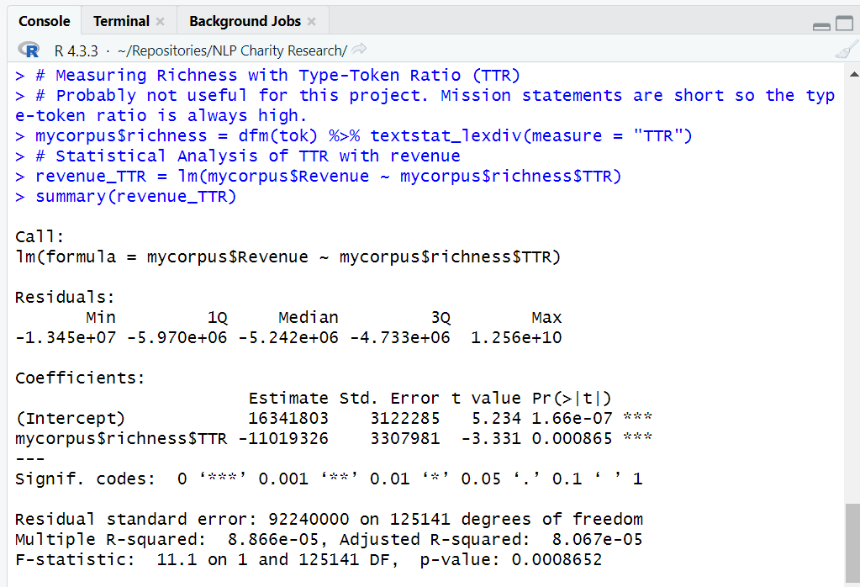

**Linearization of Type-Token Ratio with revenue.**

* Where revenue > 0
* Word count of missions > 6
* Missions are tokenized and preprocessed
* Cluster by state

**Linearization of Hapax Richness with revenue**

* Where revenue > 0
* Word count of missions > 6
* Missions are tokenized and preprocessed

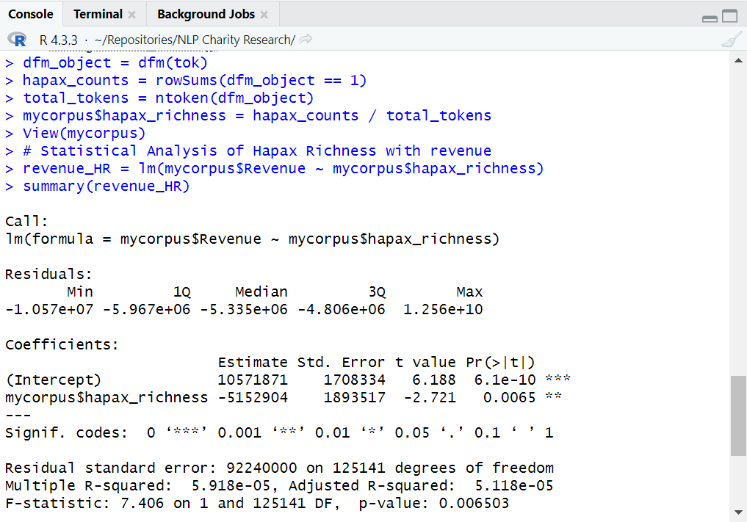

**Linearization of Hapax Richness with revenue**

* Where revenue > 0
* Word count of missions > 6
* Missions are tokenized and preprocessed
* Cluster by state

