November 18 Meeting with Dr. Price
- Check out UCSD CS professor Yi-an Ma for web scraping without web scraping + Paul Brothers in Bruno Business Library to ask about using UA libraries for scraping
  - CC Dr. Price when emailing both
- For ACLED + interest in conflict tracking, use Gallup World Poll combined with ACLED to create model to predict conflict
- Look at uncertainty stuff that Nick Bloom has developed
- Focus on this project through Thanksgiving to next semester instead of GDPR or charity research because this project has competing researchers and we want to publish first
Results from Emails with Paul Brothers
- UA Libraries does not have the kind of API that we are thinking of right now. We could still manually search for articles about each climate disaster using the UA Libraries Faktiva database
- The Chronically America API was recommended to me, but that was not very helpful
Work on November 29
- We can also use this NewsAPI, which claims to include over 150,000 news articles over the last 5 years. I will try not to use this for now because if it only goes through the past 5 years, then it misses news articles from the 2010s and previously. So for now, I am using the Google Search API.
- 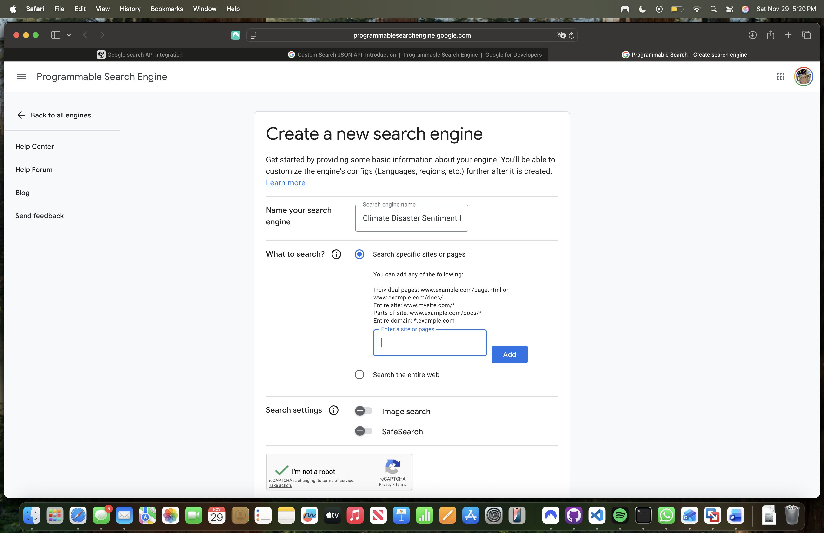When creating a new search engine, I can choose to either search the entire web or search specific sites or pages. For now, I am choosing to search specific sites or pages because I believe that will make it easier just to test the program and to categorize my sources. I can expand the search later if needed. I did not enable Image search or SafeSearch for my search engine.
- I can access my Google project (API, credentials, settings, etc) here and programmable search engine here
- I keep on getting this error, so I will debug on another day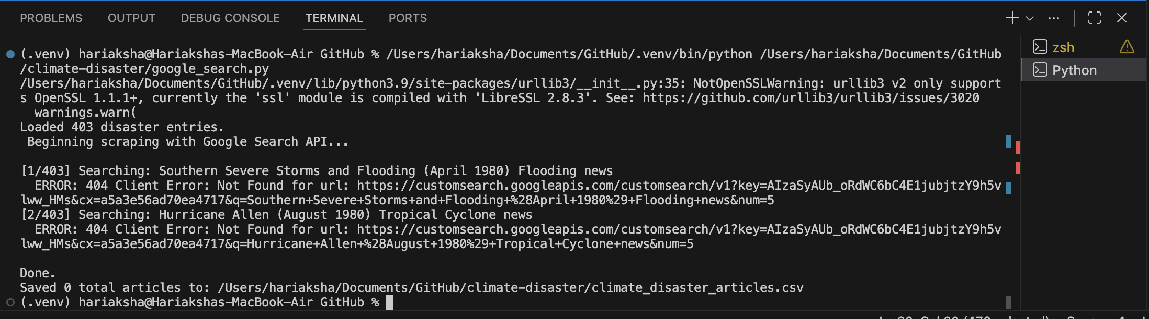
- Work for next session:
  - Sign up for billing here in API console so that I can do up to 10,000 queries per day. 100 queries per day are free, and additional queries are $5 per 1000.
  - Debug the google search program. Check if my Stack Overflow post has an answer.
  - Email Dr. Price to set up a meeting this week if progress is made in next meeting.
Work on December 4
- The scraping script using Google Search works, but I need to start using it everyday to get the data that I want.
Meeting with Dr. Price on December 5
- See pricing and try to use $100 or less for a few rows for each climate disaster. Send pricing information to Dr. Price in email
- Use only disasters after year 2000 because that is the domain of the paper that is being written
- Write scraping script to get text from articles after I have all the links
Work on December 7
- Removed disasters from dataset that came before year 2000. Now we have 313 instead of 413 events
- Created a new Cloud Billing account so that I can do more than 100 search queries per day. Connected the billing account with the “ClimateDisasterResearch” Google Cloud Project. Comes with free $300 credits that expire on March 8, 2026
- I ran the google_search.py file to get 3 links to articles per climate disaster beginning from year 2000; however, the results were overwhelmingly from NOAA or another .gov source such as weather.gov. Specifically, 858 of the 939 results were from .gov sites.
  - Since these are not the news articles that we want to research, I changed the Programmable Search Engine settings to remove weather.gov, noaa.gov, and fema.gov from the list of sites to search. I went ahead and restricted results to the United States too
  - The file created from this iteration of google_search.py was renamed ‘trial-1.csv’ and moved to the ‘search-trials’ folder
- I reran the google_search.py file and sent the file to Dr. Price
Work on February 22
- I added more links for each newspaper from the Access World News database. I now have the first 1000 links. I would continue to add more, but I ran out of file uploads for the week on Perplexity AI, which I was using to find the links
- Use this sheet and this chat to continue finding the links later
Meeting on April 1
- Dr. Price wants me to get the links for all state and national newspapers and then build and run the Programmable Search Engine API on each climate disaster. Then, when we have a bunch of the news articles saved, run it with a good prompt into an LLM to develop some kind of index to quantify how each climate disaster is communicated
- Send him updates by Monday EOD if possible and then set up next meeting
Work on April 4
- Tried traditional search engine web scraping algorithm to find all the links, but that was not successful. Instead, I used a new script that uses the Perplexity API to find each newspaper that exists wherever possible
  - Here is the chat that I used to figure out how to build that script: here
  - The links are found (as much as possible)
- Once that finishes, I will use whatever links I have to build the Programmable Search Engines (probably one for each state/territory + one for the national newspapers) and then run the national search engine and relevant state search engine on each climate disaster to find a ton of articles
Work on April 5
- I created 18 PSEs for about 900 newspaper website domains. I then created a script to find at most 10 articles per climate disaster and then output it to a spreadsheet.
  - Here is the chat that I used to build the script to do the Google searches: here
- After I have the URLs for so many articles, I can scrape the article texts and then run it in an LLM to develop some kind of climate disaster communication index

