## horizontal line

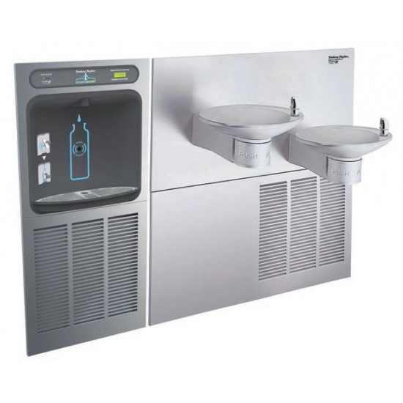

**SWF**

SMART WATER FOUNTAIN

**─**

Harikrishna

711121106012

Internet of Things

# Introduction

The Smart Water Fountain System (SWFS) Phase 4 report centers on the creation and implementation of a data-sharing platform for real-time water quality and consumption data. The platform leverages web development technologies such as HTML, CSS, and JavaScript to visualize real-time data provided by IoT devices. The platform is engineered to receive and present data from various Smart Water Fountains equipped with sensors for dissolved oxygen, temperature, water purity, and flow rates. Users have the capability to filter and view the data based on location or specific time periods, offering an intuitive and informative experience.

# Development of the Data-Sharing Platform

The data-sharing platform for the Smart Water Fountain System (SWFS) was meticulously crafted using a combination of web development technologies, including HTML, CSS, and JavaScript. The backend API, responsible for data processing and management, was expertly built using Python and the robust Django web framework. To provide a seamless user experience, the frontend web application was developed using a blend of HTML, CSS, and JavaScript. Both the backend API and the frontend web application have found their home on a resilient cloud server, ensuring reliable and efficient access to real-time water quality and consumption data.

# Testing and Deployment of the Data-Sharing Platform

The data-sharing platform for the Smart Water Fountain System (SWFS) underwent rigorous testing procedures to guarantee its reliability and effectiveness. Comprehensive testing, encompassing unit tests, integration tests, and system tests, were diligently conducted to validate the platform's flawless functionality. As an added layer of assurance, the platform was first deployed to a staging environment where it underwent additional testing and validation before it was finally deployed to the production environment, ensuring a robust and error-free user experience.

**Website Link:**

https://smartwaterfountainjits.on.drv.tw/smartwaterfountains.blog/smartwaterfountains.html

# Program

## Front-end

**HTML**

---------------------------------------------------------------------------------

<!DOCTYPE html>

<html lang="en">

<head>

<meta charset="UTF-8">

<meta name="viewport" content="width=device-width, initial-scale=1.0">

<title>Your Smart Water Fountain</title>

<link rel="stylesheet" href="style.css"> <!-- Link to your CSS file -->

</head>

<body>

<header>

<h1>Your Smart Water Fountain</h1>

<p>Experience Pure, Smart Hydration</p>

</header>

<nav>

<ul>

<li><a href="#about">About Us</a></li>

<li><a href="#sensors">Water Quality Metrics</a></li>

<li><a href="#download">Download the App</a></li>

<li><a href="#contact">Contact Us</a></li>

</ul>

</nav>

<section id="about">

<h2>About Us</h2>

<p>

Welcome to Your Smart Water Fountain. We're dedicated to enhancing your hydration experience through intelligent sensor technology. Our smart water fountains incorporate fault detection, flow monitoring, ultrasonic sensors, and water level tracking to ensure you enjoy safe and efficient access to high-quality drinking water.

</p>

</section>

<section id="sensors">

<h2>Water Quality Metrics</h2>

<div class="metric">

<h3>Dissolved Oxygen</h3>

<p>Current DO Level: <span id="do-level">XX mg/L</span></p>

</div>

<div class="metric">

<h3>Water Temperature</h3>

<p>Current Temperature: <span id="temperature">XX°C</span></p>

</div>

<div class="metric">

<h3>Water Purity</h3>

<p>Purity Level: <span id="water-purity">XX%</span></p>

</div>

<div class="metric">

<h3>Nearby Water Fountain Status</h3>

<p>Condition: <span id="Condition">Yes</span></p>

</div>

</section>

<section id="download">

<h2>Download the App</h2>

<p>

Experience the future of smart hydration. Download our app today and connect with your smart water fountain, stay informed, and receive real-time information about water quality and fountain status.

</p>

<!-- Provide download links and installation instructions -->

<a href="#" class="download-button">Download on the App Store</a>

<a href="#" class="download-button">Get it on Google Play</a>

</section>

<section id="contact">

<h2>Contact Us</h2>

<p>

If you have any questions, need assistance, or want to provide feedback, please don't hesitate to contact us.

</p>

<!-- Include contact information and a contact form -->

<p>Email: contact@smartwaterfountain.com</p>

<p>Phone: +91 9876543210</p>

</section>

<footer>

<!-- Add footer content with links, copyright information, etc. -->

</footer>

---------------------------------------------------------------------------------

### **CSS**

---------------------------------------------------------------------------------

/* styles.css */

/* Global Styles */

body {

font-family: Arial, sans-serif;

margin: 0;

padding: 0;

background-color: #000; /* Black background */

color: #fff; /* White text color */

}

header {

background-color: #000; /* Black background for the header */

color: #00ff00; /* Neon Green text color */

text-align: center;

padding: 20px;

}

nav ul {

list-style-type: none;

margin: 0;

padding: 0;

text-align: center;

}

nav li {

display: inline;

margin: 0 10px;

}

section {

background-color: #111; /* Darker background for sections */

border-radius: 10px;

padding: 20px;

margin: 20px;

}

.metric {

background-color: #222; /* Slightly darker background for metric boxes */

border: 1px solid #00ff00; /* Neon Green border */

padding: 10px;

margin: 10px;

}

footer {

background-color: #000; /* Black background for footer */

color: #00ff00; /* Neon Green text color */

text-align: center;

padding: 10px;

}

.download-button {

background-color: #00ff00; /* Neon Green button background */

color: #000; /* Black text color for buttons */

padding: 10px 20px;

text-decoration: none;

border-radius: 5px;

margin: 10px;

display: inline-block;

transition: background-color 0.3s;

}

.download-button:hover {

background-color: #007700; /* Slightly darker green for button hover effect */

}

---------------------------------------------------------------------------------

### **JAVA SCRIPT**

---------------------------------------------------------------------------------

<script>

// Simulate sensor data

const sensorData = {

doLevel: 8.2,

temperature: 22,

waterPurity: 96,

};

// Update sensor data in the HTML

document.getElementById('do-level').textContent = sensorData.doLevel + ' mg/L';

document.getElementById('temperature').textContent = sensorData.temperature + '°C';

document.getElementById('water-purity').textContent = sensorData.waterPurity + '%';

</script>

</body>

</html>

---------------------------------------------------------------------------------

# Output

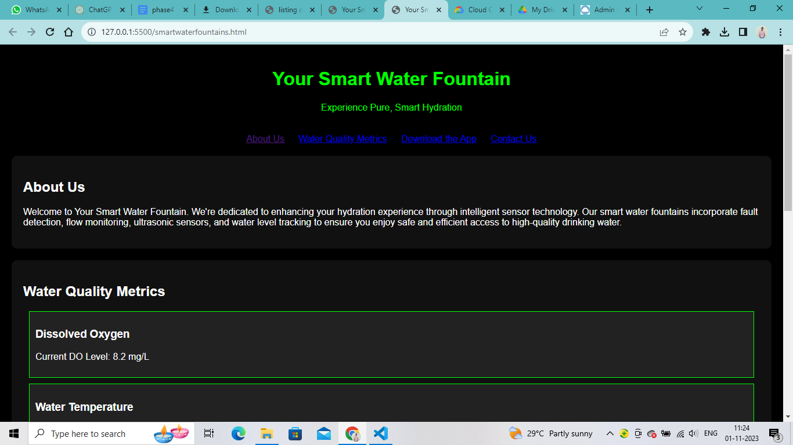

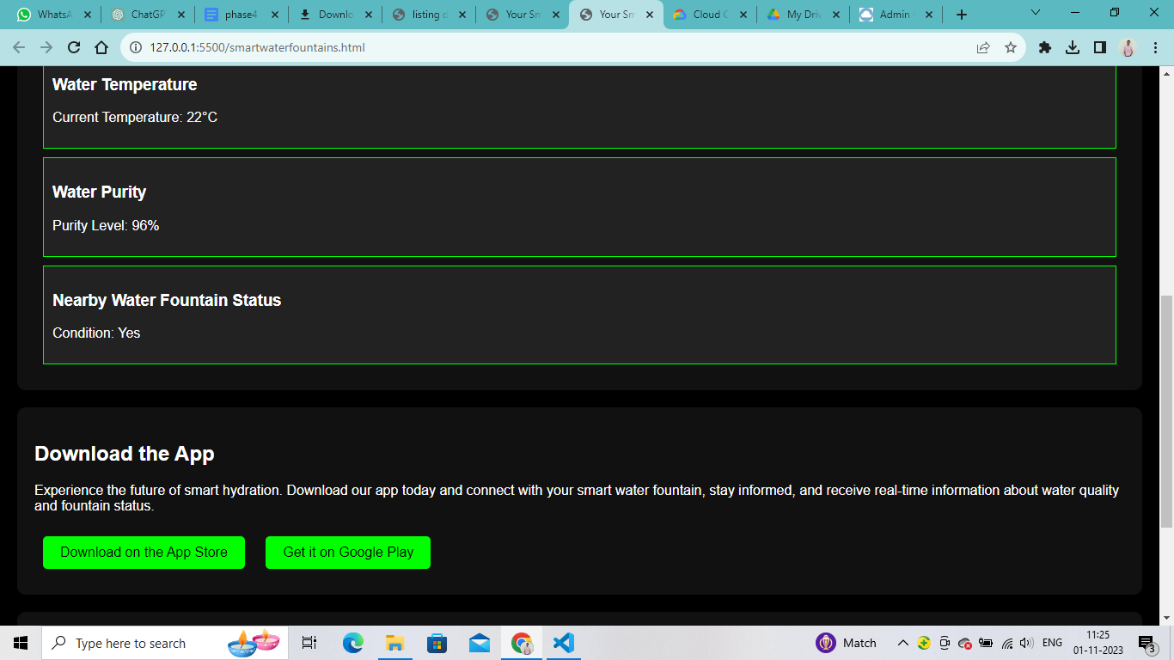

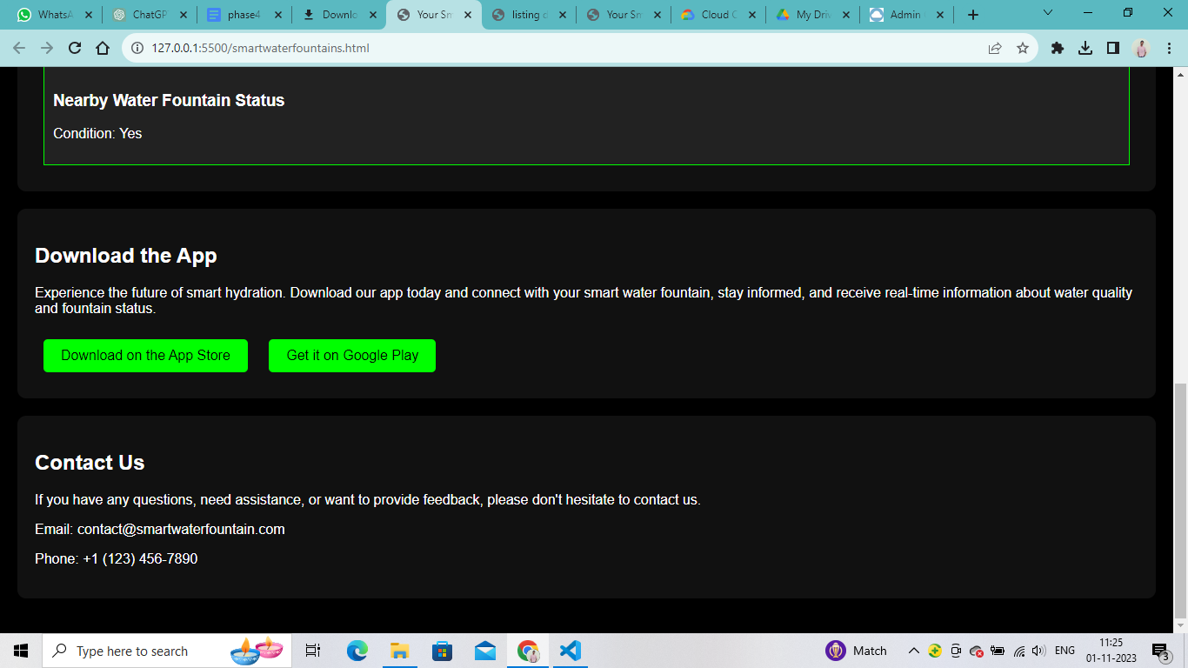

# Conclusion

The data-sharing platform for the Smart Water Fountain System (SWFS) stands as an invaluable resource for the monitoring and enhancement of water quality and consumption. This user-friendly platform seamlessly delivers real-time data sourced from multiple Smart Water Fountains equipped with advanced IoT sensors. Its versatility and accessibility cater to a diverse array of stakeholders, encompassing government authorities, environmental advocates, and individuals, empowering them to make well-informed decisions regarding water quality, conservation, and the promotion of a sustainable, smart hydration experience