TASK-1

PROMPT:

Create a Python function that converts an amount from one currency to another using exchange rates stored in a dictionary.collect input from the user.

Example:1 USD=72INR

10 USD=720INR

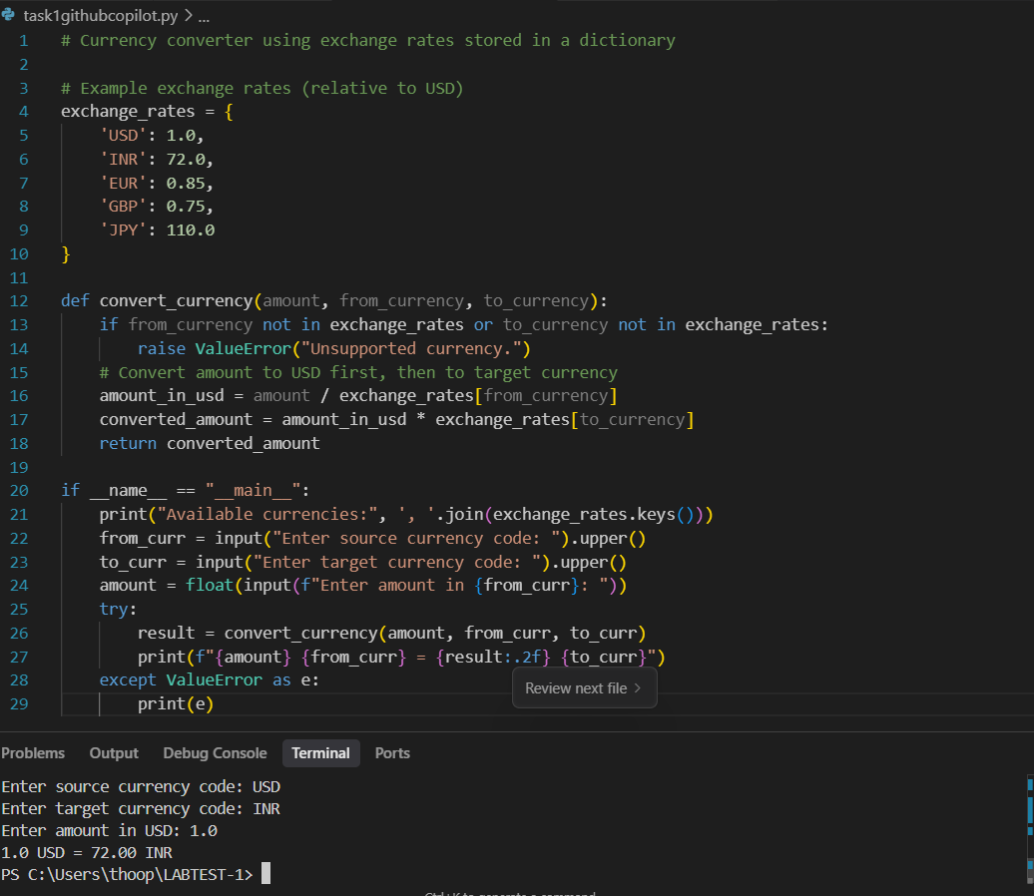

TASK-2

PROMPT:

Generate a Python program to extract all email addresses from a block of text using regular expressions.

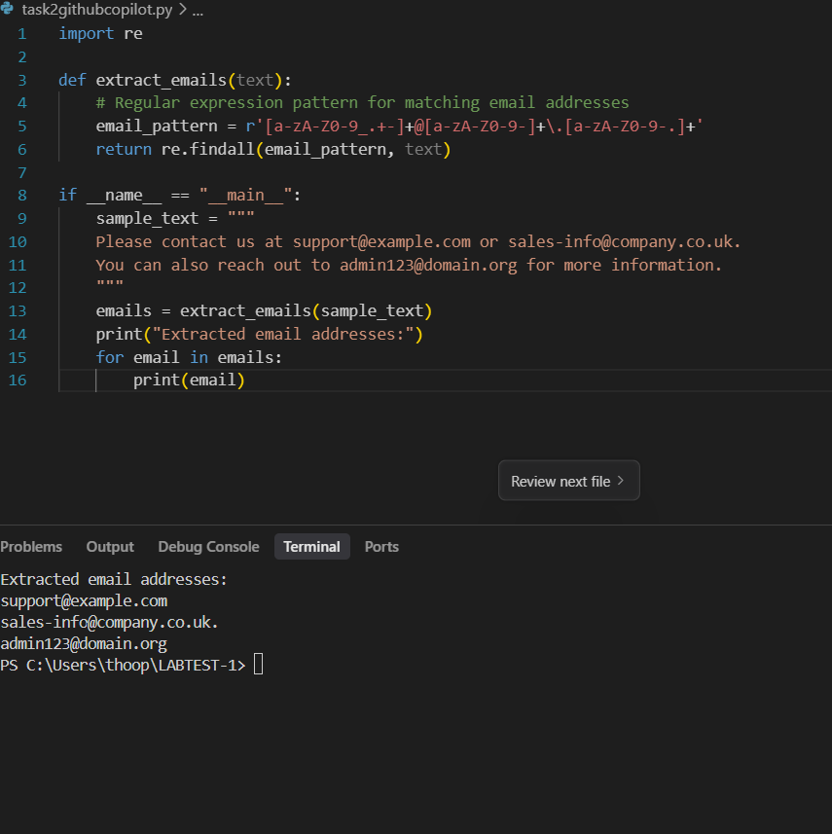

TASK-3

Prompt:

Given a list of movies with their genres, Write a Python function that recommends movies based on a user’s preferred genre.collect movies list and genere list from console.

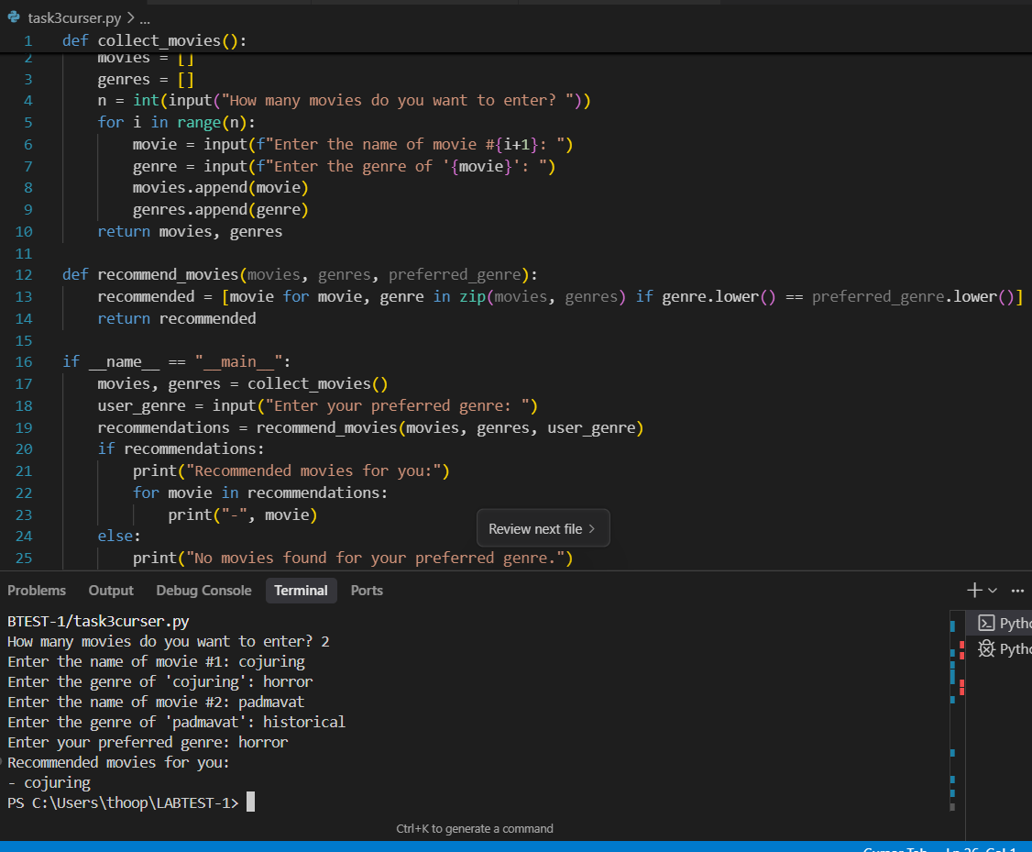

TASK-4

Prompt:

Generate Python code that reads a CSV file containing student names and marks in 3 subjects. Calculate the total and average marks for each student.

