Subgroup N
N.1 — [S13N1] Validate Sorting Algorithm with AI-Generated Test Cases
Scenario (AgriTech Analytics):
An agritech platform has a custom function that sorts lists of integers. Engineers want to
ensure the function works correctly across edge cases, but manually writing all test cases
is tedious. The task is to use AI-assisted tools to generate a robust test suite.
Your Task:
1. Review the provided sorting function for correctness:
def custom_sort(arr):
# naive implementation
for i in range(len(arr)):
for j in range(i+1, len(arr)):
if arr[i] > arr[j]:
arr[i], arr[j] = arr[j], arr[i]
return arr
2. Use AI-assisted tools (VSCode Copilot, Gemini, CursorAI) to:
o Suggest edge cases, randomized inputs, and special inputs.
o Generate at least 7 automated test cases covering:
▪ Empty list
▪ Single element
▪ Already sorted list
▪ Reverse sorted list
▪ List with duplicates
▪ Large numbers
▪ Negative numbers
3. Correct the function if AI highlights bugs or inefficiencies.
Constraints & Notes:
• Test suite should assert correct order.
• AI may assist in generating code for test cases or using pytest/unittest.
• Document reasoning for each generated test case.
Sample Input / Output Examples:
Input Expected Output
[] []
[1] [1]
[2,1,3] [1,2,3]
[5,5,2,2] [2,2,5,5]
[10,-1,0] [-1,0,10]
Acceptance Criteria:
• Function sorts correctly for all AI-generated test cases.
• Test cases are meaningful and cover edge conditions.
• Code and test suite are clean, documented, and reproducible.
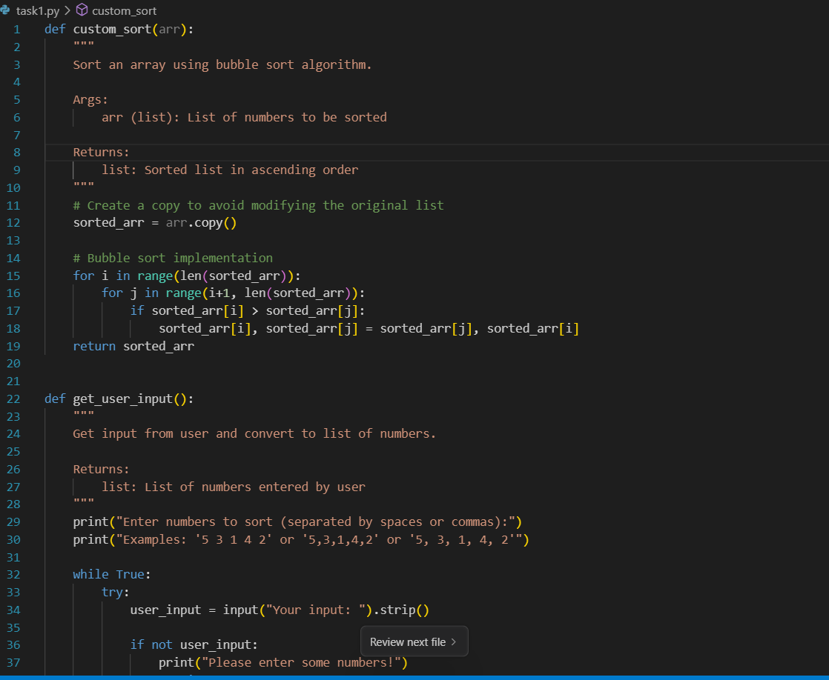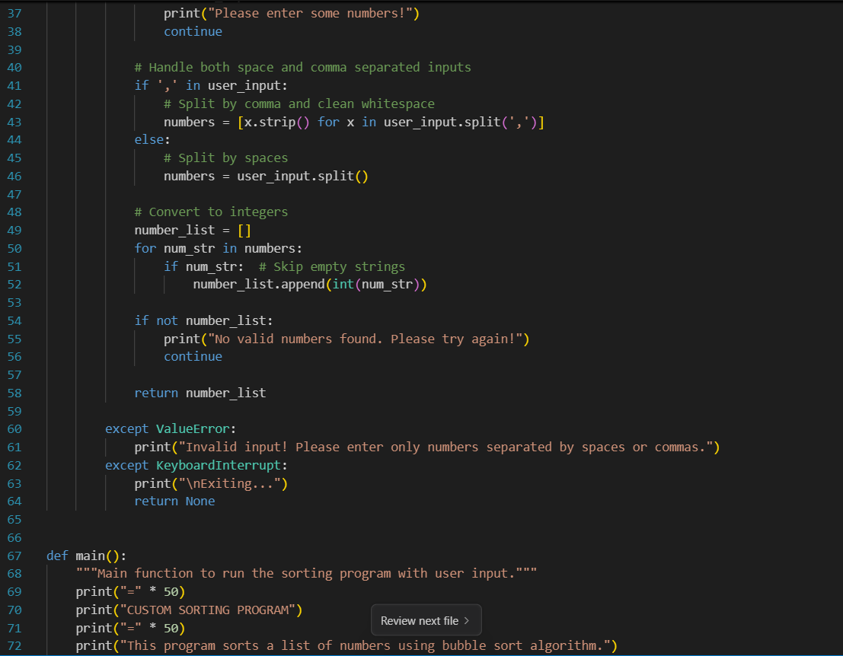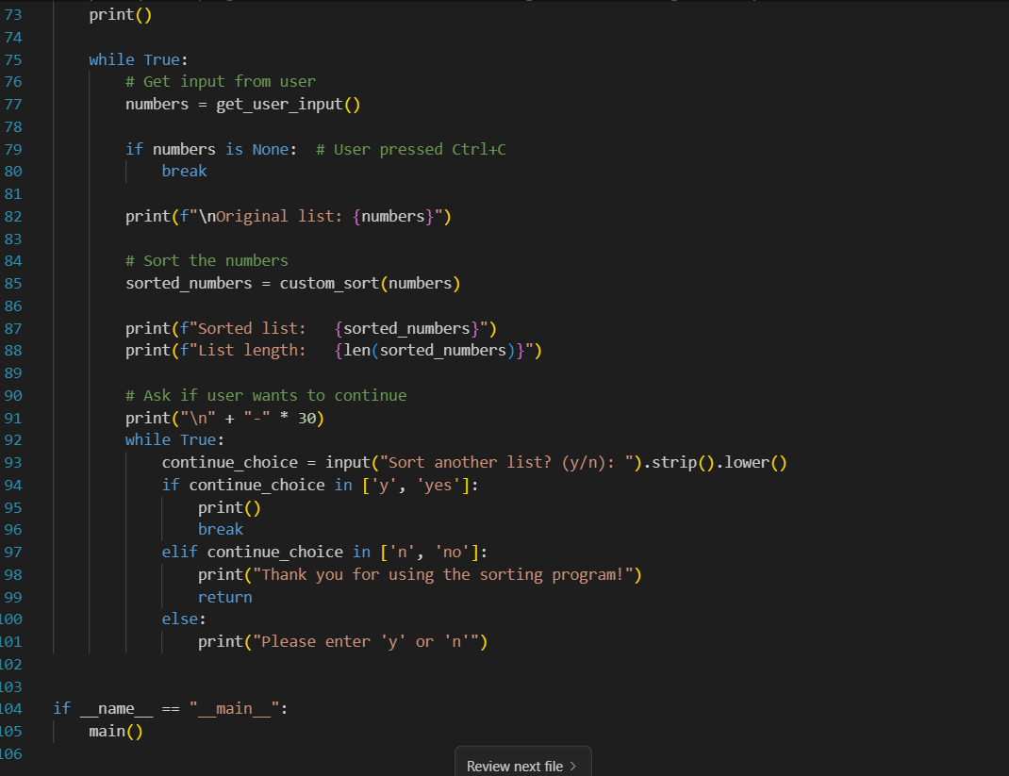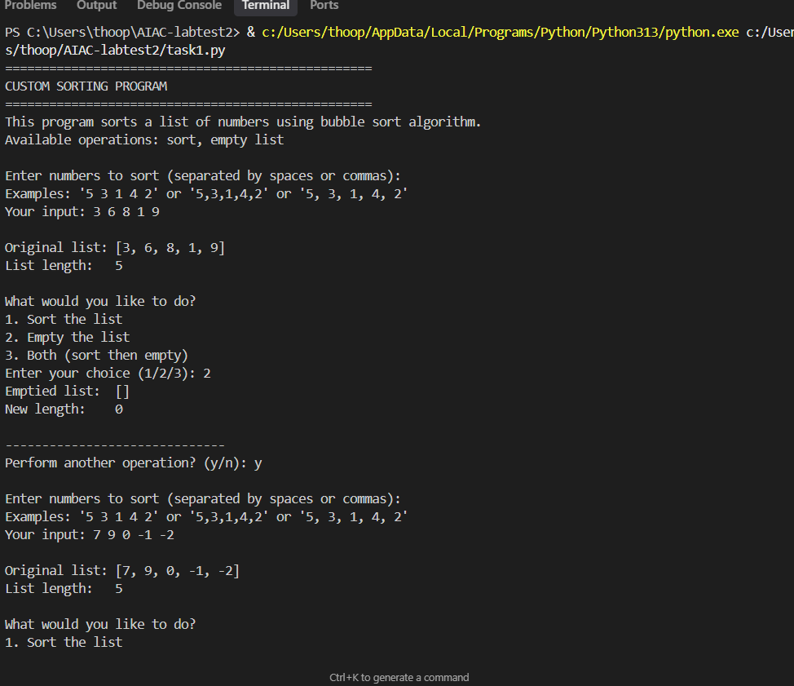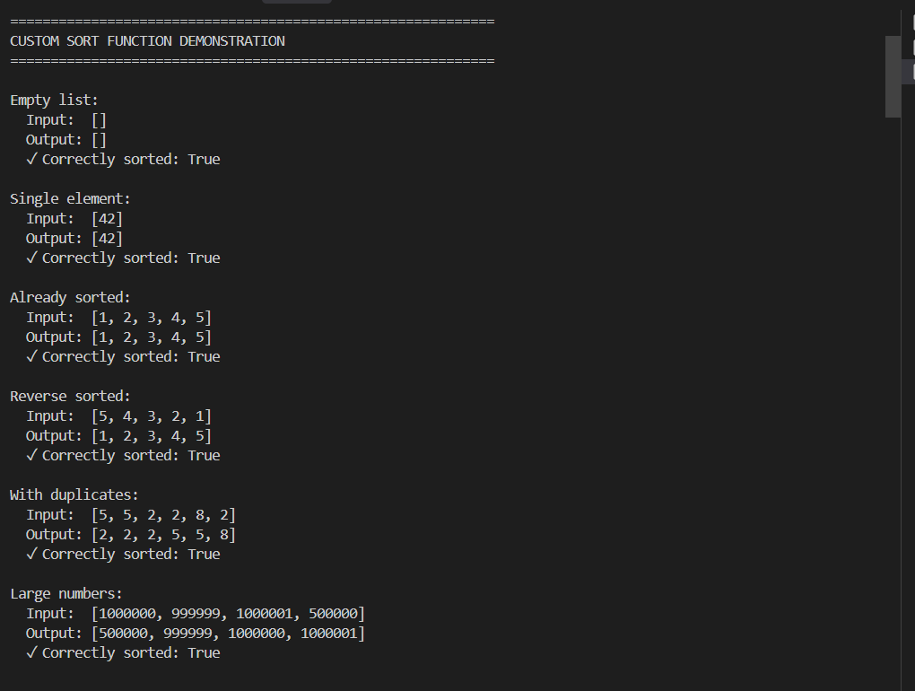

N.2 — [S13N2] Compute simple sentiment score
Scenario (agritech):
Context:
A lightweight agritech feedback analyzer uses a small lexicon to score sentiment.
Your Task:
Compute total sentiment using: good=+1, great=+2, bad=-1.
Data & Edge Cases:
Tokenize by spaces; strip simple punctuation.
AI Assistance Expectation:
Use AI to draft tests and implement a simple tokenizer.
Constraints & Notes:
Sum over tokens and return integer.
Sample Input
good product with bad packaging but great value
Sample Output
2
Acceptance Criteria: Correct total; punctuation stripped
----------------------
