**ML ASSIGNMENT 3**

**HARICHANDANA EPURI**

**HXE170000**

(B)

Monk 1 dataset

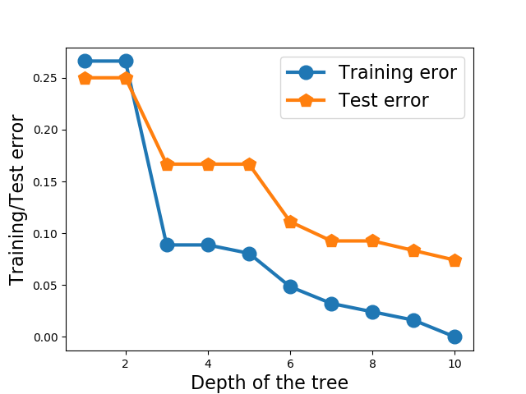

Monk 2 dataset

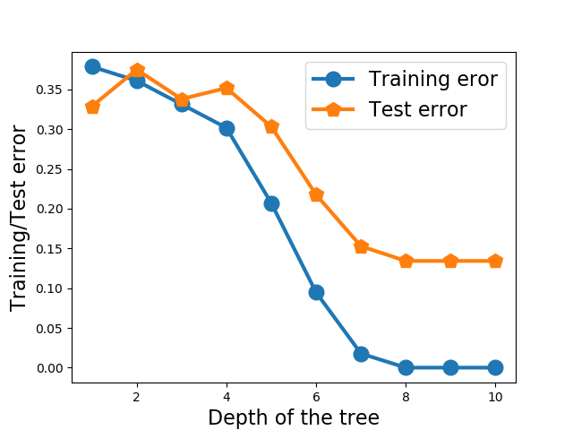

Monk 3 dataset

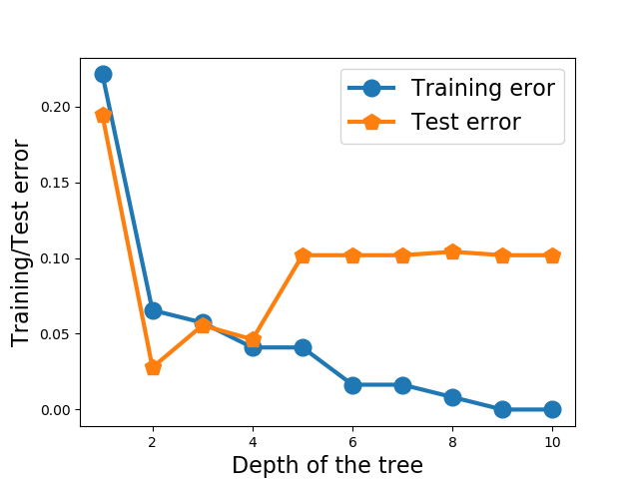

( C)

Decision Tree of depth 1:

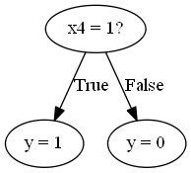

Confusion Matrix

[[216 0]

[108 108]]

Decision Tree of Depth 3:

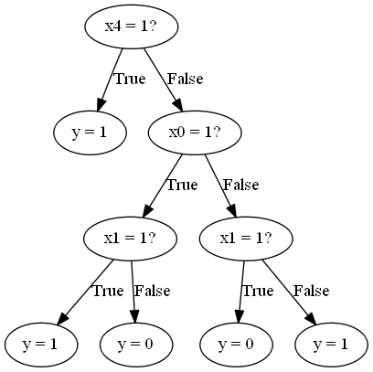

Confusion Matrix

[[144 72]

[ 0 216]]

Decision Tree of depth 5:

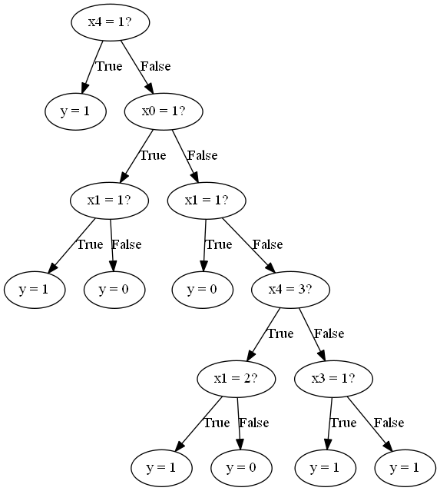

Confusion Matrix:

[[156 60]

[ 12 204]]

(D)

Using Scikit learn:

Depth 1:

[[216 0]

[108 108]]

Depth 3:

[[144 72]

[ 0 216]]

Depth 5:

[[168 48]

[ 24 192]]

(E)

Decision Tree of Depth 1:

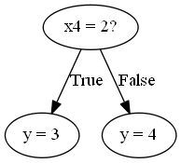

Confusion Matrix:

[[41 26]

[27 98]]

Decision Tree of Depth 3:

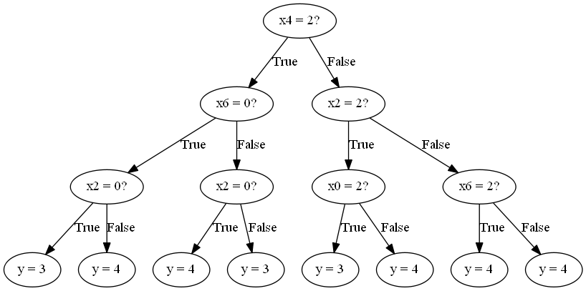

Confusion Matrix:

[[ 28 39]

[ 8 117]]

Decision Tree of Depth 5:

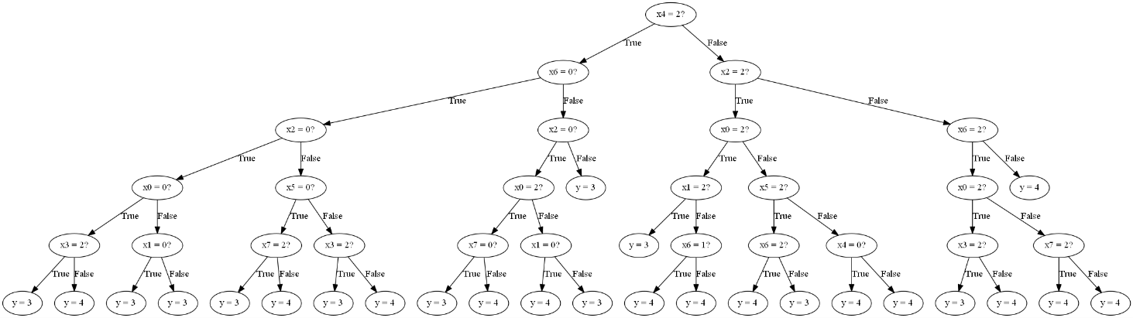

Confusion Matrix:

[[ 46 21]

[ 17 108]]

Using Scikit:

Confusion Matrix for depth 1:

[[41 26]

[27 98]]

Confusion Matrix for depth 3:

[[28 39]

[ 8 117]]

Confusion Matrix for depth 5:

[[ 46 21]

[ 17 108]]