**Semantic Web Lab 2 report**

**HXE170000**

Goal: Be able to create in-memory and persisted models with Jena.

High level design:

1. We have dealt with Gruff and Allegrograph.

2. Uploaded camera.owl file into gruff and have seen how the things work in gruff.

3. Created an in-memory and persisted model with Jena for H.G Wells and his famous 2 books and the movies/broadcast they were was made into and verified the generated model in Gruff.

Steps to run the project:

Import the project as a java project and run it. You will see the following files generated

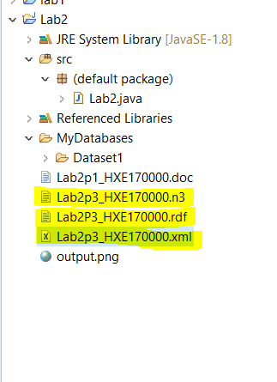

Following models are generated under MyDatabases/Dataset1

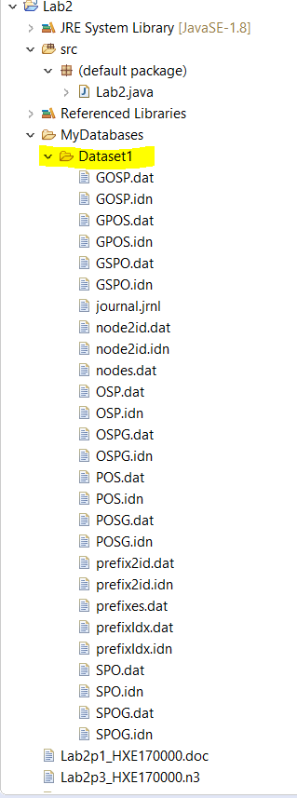

The XML output is as follows

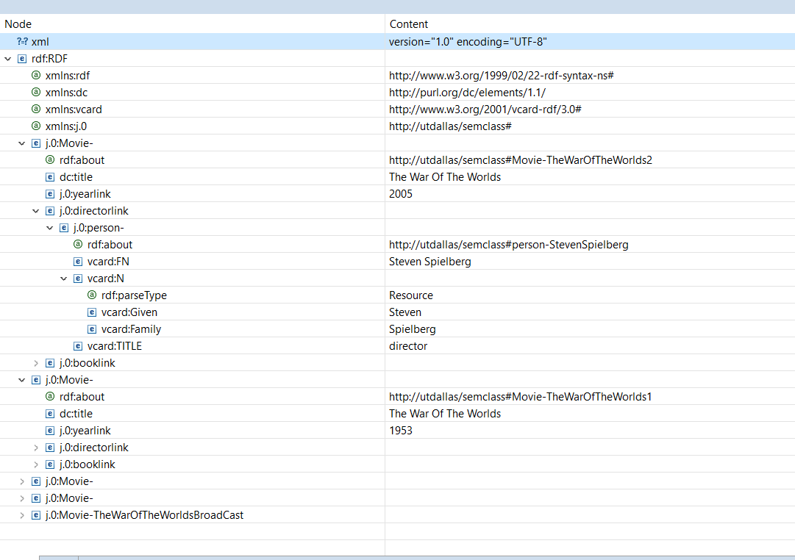

Model generated:

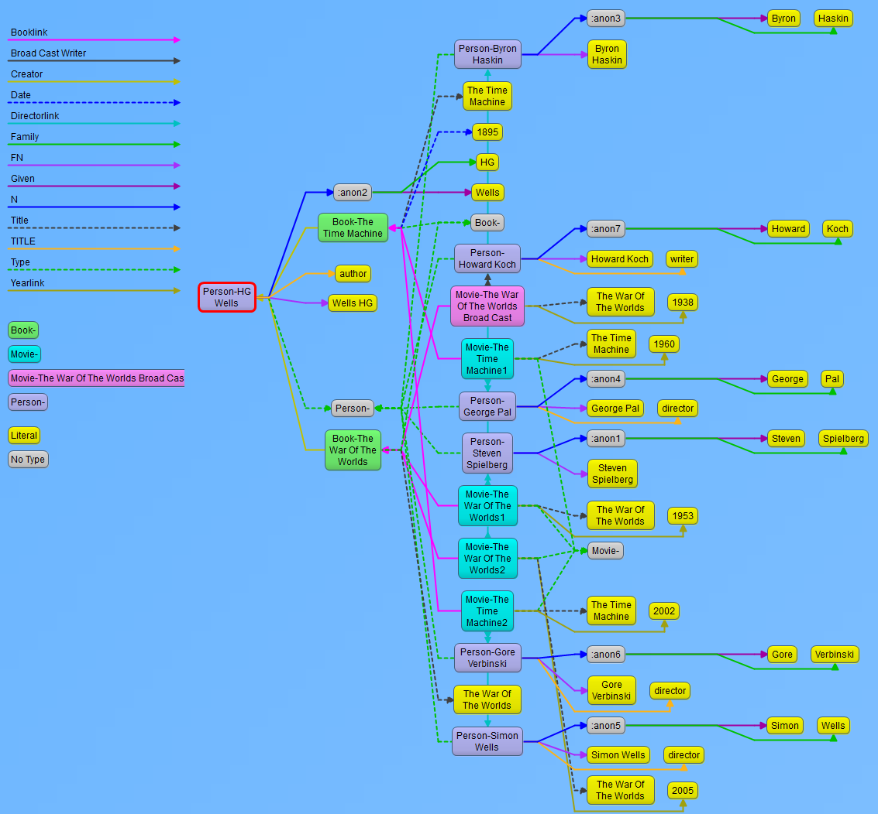

Conclusion: Learnt about gruff ,allegro and visualizing the data model we create