Plab Trainer Information Management Systems

We need your input on following scenarios

1. Step 2 Enroll course and Step 3 Course Payment Info are needed steps in Enrolling new student but they can be skipped to complete student registration.

Our concern: We understand that Step 2 Enroll Course and Step 3 Course Payment pages are needed but it leads to Data inconsistancy in the application.

If a User is allowed to skip Step 2 Enroll Course and if the user lands in Step 3 Course Payment page and enters some amount in Step 3 page then it means that without enrolling for a course User is entering payment for the course.

Current application assumes that a student is enrolling for atleast one course and course duration and fee is prefilled in step 2 and are currently Non Editable. ( Adding course, course fee, course duration is done in Add/List course page FMI attached screenshot no 4 and no 5)

We understand that you would like to make fields in step 2 Enroll Course editable. (Course duration, Course fee, Course discount , Course Amount)
Our concern: If we make the fields editable, adding fields while creating a new course in Add course and edit course page would be rendered useless.

We would need to make new data fields in our database to capture indiviual fields values since the field values for enroll course per student will be different for each student. This would also need singnificant changes in code (application).

In Step 3, we are calculating pending amount from course payment amount and course discount which is already fixed for a course. Since the step 2 Enroll course is having editable fields, per student course amount, course discount and course duration will vary and this would lead us difficulty in calculating pending amount. So we would like to know whether pending amount is entered manually or needs to be calculated by the application. Also , If course amount, course duration and course discount are editable fields is it going to be required fields?

If step2 and step 3 are made editable fields while Enrolling student then it would affect pages like reports, bookings etc. This would mean significant coding changes in current application.

Screenshot 1
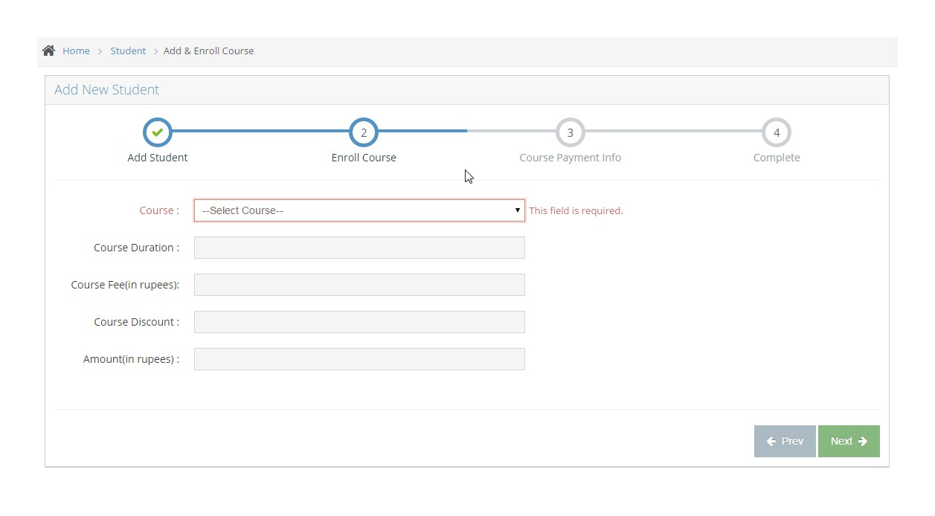
Screenshot 2
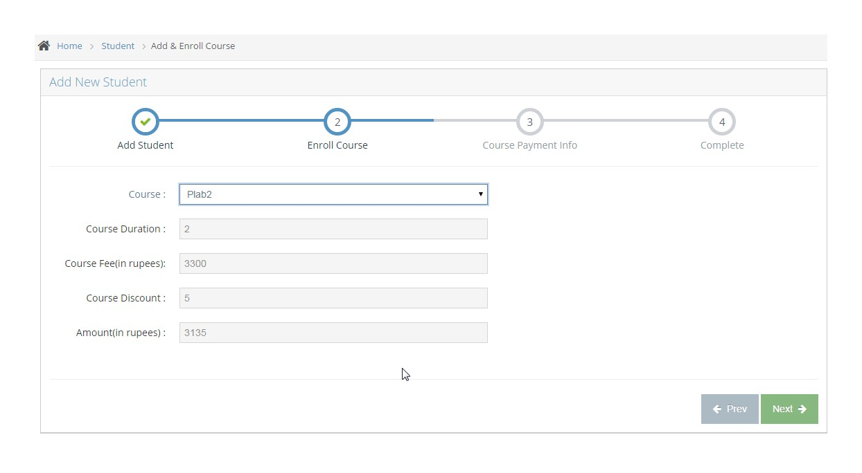

Screenshot 3
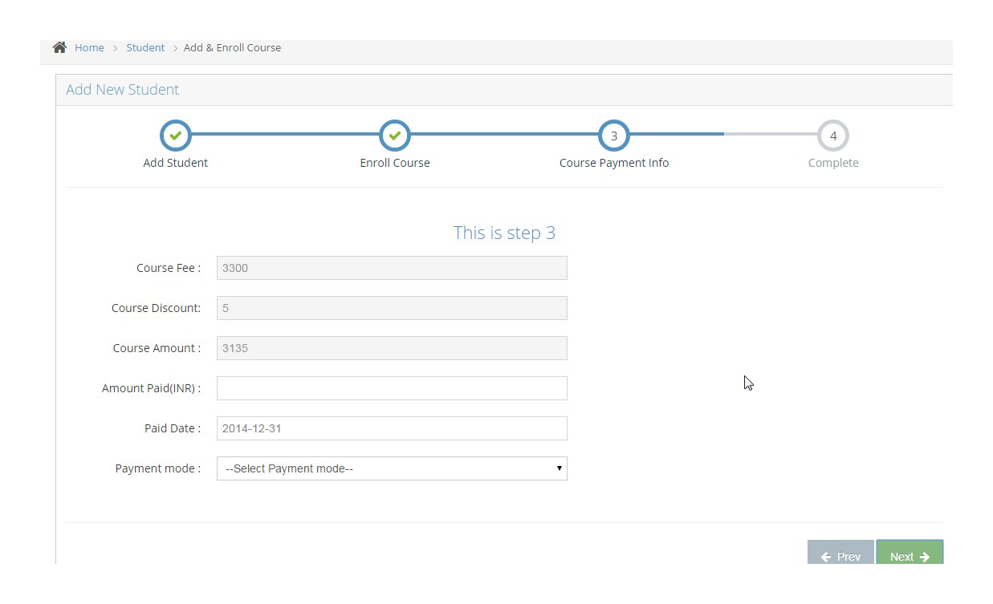

Screenshot 4
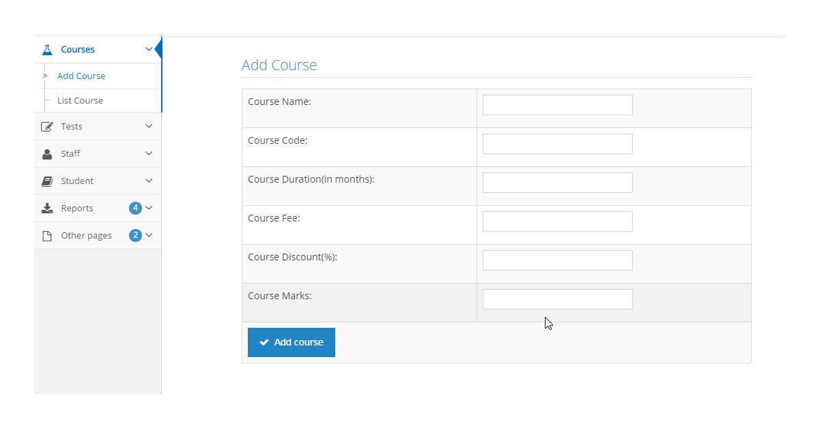

Screenshot 5
