**Flight-Booking**

1. Installed Django
2. Migrated Database connections
3. Created superuser
4. Run server
5. Fixed data connections and dependencies error – reportlab, Django version,

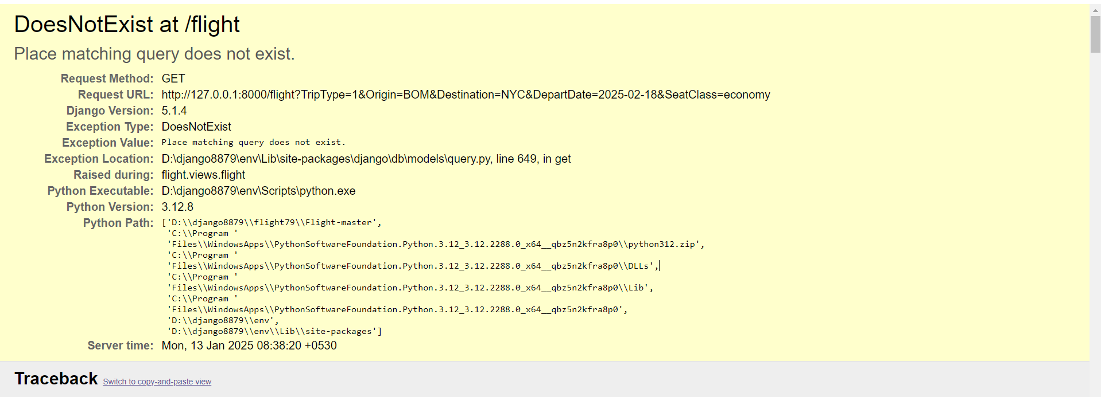

1. Checked the function of Flight App

* Created user login
* Using date selection booked the flight
* Booked using payment gateway process
* Then checked confirmed tickets

1. **Bugs fixed:**

* Account section user profile made cursor pointer event
* Adjusted styles and applied bootstrap css

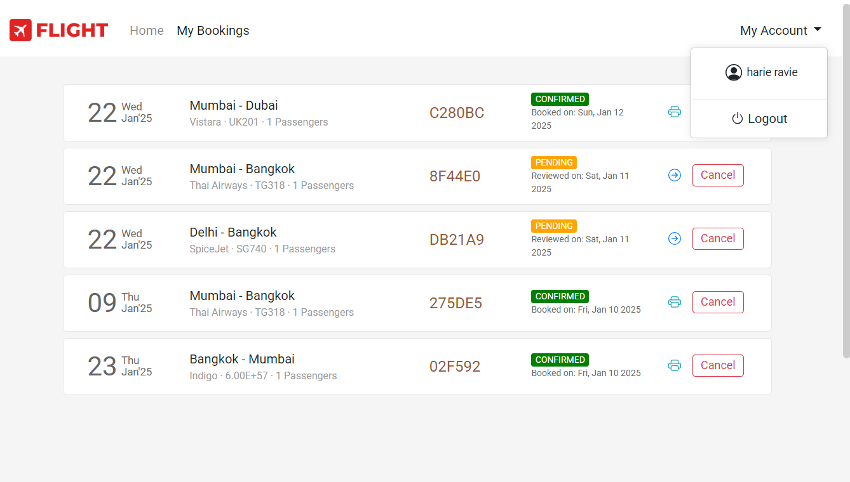

1. Analysing the workflow of Django framework files

* Views.py
* url.py
* templates
* models.py
* settings.py

1. Created user account details page using

* Created **Account.html** in **template folder**,
* Created **Account.css** in **Static/CSS folder**,
* Set URL path path("Flight/account", Views.account_view, name="account"), in **url.py** page
* Added function name account_view in **Views.py**

def account_view(request):  
 if request.user.is_authenticated:  
 return render(request, 'flight/account.html',{'page': 'account'})

* Added Active functionality for My Account in **layout.html**

<li class="nav-item dropdown my-account {% if page == 'account' %}active{% endif %}">