**A Project Report**

*on*

**Forecasting Energy Demand: A Study on RNN, DNN, and LSTM Models Across Indian Regions**

*carried out as part of the Deep Learning Lab* ***project***

*Submitted*

by

**MEHUL KARWA   
22309178**

**RAGINI GROVER  
229309180**

**Data Science and Engineering**

Under the Guidance of

**Dr. Neha Sharma**

**Forecasting Energy Demand: A Study on RNN, DNN, and LSTM Models Across Indian Regions**

A comparative analysis

## ABSTRACT:

In the context of rapid urbanization and increasing energy demands, accurate forecasting of energy consumption has become crucial for effective resource management and sustainable development, particularly in a diverse and populous country like India. The ability to predict future energy needs can help policymakers and utility companies optimize infrastructure planning, reduce waste, and enhance service reliability. This project aims to address the challenges associated with energy consumption forecasting by employing deep learning techniques to model and predict electricity usage across five distinct regions of India: North, South, East, West, and Northeastern. By comparing the performance of Recurrent Neural Networks (RNN), Deep Neural Networks (DNN), and Long Short-Term Memory (LSTM) models, this study seeks to identify the most effective approach for accurate energy consumption prediction.

To achieve this objective, a comprehensive dataset encompassing power consumption data from 2019 to 2020 was utilized. Each model was trained and evaluated using metrics such as Mean Absolute Error (MAE), Mean Squared Error (MSE), and R-squared (R²) to assess their predictive accuracy. The results indicated that while all models demonstrated varying degrees of effectiveness, the LSTM model outperformed both RNN and DNN in terms of accuracy. These findings underscore the significance of adopting advanced deep learning techniques in energy forecasting, providing valuable insights for improving energy management strategies in India’s evolving-power-sector.

## LIST OF TABLES:

|  |  |
| --- | --- |
| TABLE NO. | DESCRIPTION |
| Table 1 | R2 values |
| Table 2 | MSE values |
| Table 3 | MAE values |
| Table 4 | Month-wise data plan |

## LIST OF FIGURES:

|  |  |
| --- | --- |
| **FIGURE NO.** | **DESCRIPTION** |
| Figure 1 | visual roadmap depicting the system architecture |
| Figure 2 | Power Consumption in Various Region |
| Figure 3 | The implementation process involving several steps |
| Figure 4 | Performance Matrix Comparison |

## INTRODUCTION

### **1.1 Overview, Motivation, Applications & Advantages**

### Energy consumption forecasting is a critical area of research that has gained significant attention in recent years due to the increasing demand for electricity and the need for sustainable energy management. In India, where energy consumption is on the rise owing to rapid urbanization and industrial growth, accurate predictions of future energy needs are essential for effective resource allocation and infrastructure planning. The advent of deep learning techniques has revolutionized the way we approach time series forecasting by enabling models to learn complex patterns in historical data. This project focuses on utilizing advanced deep learning models—Recurrent Neural Networks (RNN), Deep Neural Networks (DNN), and Long Short-Term Memory (LSTM) networks—to predict energy consumption across five distinct regions of India: North, South, East, West, and Northeastern. The motivation behind this project stems from the pressing need for reliable energy forecasting methods that can adapt to regional variations in consumption patterns. Accurate predictions can lead to improved grid management, reduced energy wastage, and enhanced service reliability for consumers. Furthermore, this research has practical applications in policy formulation, energy distribution management, and infrastructure development. By comparing the performance of different deep learning architectures in predicting energy consumption, this project aims to identify the most effective approach for enhancing energy management strategies in India.

### **1.2 Problem Statement**

In India, the rapid growth of urbanization and industrialization has resulted in an unprecedented increase in energy demand across various regions. However, existing forecasting methods often fall short in accurately predicting future energy consumption patterns due to the complex nature of energy usage influenced by multiple factors such as population density, economic activity, and seasonal variations. This project aims to address these challenges by developing and comparing three distinct deep learning models—Recurrent Neural Networks (RNN), Deep Neural Networks (DNN), and Long Short-Term Memory networks (LSTM)—to predict energy consumption across five major regions of India: North, South, East, West, and Northeastern.

### **1.3 Objectives**

The primary objectives of this project are as follows:

1. To collect and preprocess a comprehensive dataset on power consumption in India from 2019 to 2020.
2. To develop RNN, DNN, and LSTM models for predicting future energy consumption based on historical data.
3. To evaluate the performance of each model using metrics such as Mean Absolute Error (MAE), Mean Squared Error (MSE), and R-squared (R²).
4. To conduct a comparative analysis of the predictive accuracy of RNNs, DNNs, and LSTMs across five regions of India.
5. To provide actionable insights that can inform policymakers and utility companies regarding effective energy management strategies.

### **1.4 Scope of the Project**

### The study will focus on developing three distinct models—RNNs, DNNs, and LSTMs—and evaluating their performance based on key metrics such as Mean Absolute Error (MAE), Mean Squared Error (MSE), and R-squared (R²). The comparative analysis will not only highlight the strengths and weaknesses of each model but also provide insights into how regional characteristics influence energy consumption patterns. Additionally, the project will explore the implications of these findings for improving grid management, optimizing resource allocation, and informing policy decisions within India's evolving energy landscape. By integrating advanced deep learning techniques with practical applications in energy forecasting, this research aims to contribute to the broader discourse on sustainable energy practices and smart grid technologies.

## BACKGROUND DETAIL:

### **2.1 Literature Review**

**Deep Learning for Energy Forecasting**

1. **DECODE Framework**: [6] Aditya Mishra et al.'s study in *Energy and Buildings* (2024) introduces the DECODE framework, a data-driven approach that combines historical energy consumption data with environmental factors such as weather. The methodology emphasizes data preprocessing, feature selection, and the integration of external factors to enhance prediction accuracy. This work serves as a significant influence for this project, demonstrating how contextual variables can improve forecasting models.
2. **Hybrid RF-LSTM Models**: [1] Irene Karijadi et al. present a hybrid approach using RF-LSTM models in *Energy and Buildings* (2022). Their study highlights the efficacy of hybrid methods, leveraging the Complementary Ensemble Empirical Mode Decomposition with Additive Noise (CEEMDAN) for energy demand prediction in building contexts. The approach suggests a pathway for more complex, high-accuracy models by combining classical machine learning with deep learning techniques.
3. **Applications of Time Series Neural Network:** [4] Jaramillo et al. (2005) emphasize the role of neural networks in time series forecasting for electric energy demand. Their early work outlines the advantages of neural networks in capturing non-linear dependencies, paving the way for modern deep learning applications in energy forecasting.

**AI in Smart Grids and Power System**

* 1. **Comprehensive Survey on Smart Grids**: [2] A 2024 survey by Prabhadevi Boopathy et al. reviews the use of deep learning in demand response and smart grids, underscoring its potential to optimize grid efficiency. The paper suggests adaptive control mechanisms and load management strategies based on predictive analytics, which align closely with this project's objectives.
  2. **AI in Power System Stability and Control**: [5] Alhamrouni et al. (2024) explore AI applications in power system stability and protection. They emphasize the growing importance of artificial intelligence for dynamic energy management, especially in decentralized grids. Their findings underscore the scalability and robustness of AI-driven energy solutions.
  3. **Energy Efficiency in Machine Learning -** [7] The Zeus framework, proposed by Jie You et al., investigates energy consumption during deep neural network (DNN) training. While not directly related to forecasting, this study offers insights into optimizing computational resource use, which is relevant for large-scale implementation of deep learning models.

### **2.2** **Other Software Engineering Methodologies**

In the context of this project, several software engineering methodologies are relevant for its development and deployment:

**Agile Methodology:** This approach emphasizes iterative development and flexibility, allowing for continuous refinement of the energy prediction models as new data is collected or model performance needs improvement. The iterative process, combined with regular feedback, ensures that the project can evolve with minimal disruption (Boopathy et al., 2024). [2]

**Model-Driven Development (MDD):** MDD focuses on creating models for energy consumption prediction, utilizing machine learning frameworks and tools like TensorFlow and Keras for model building and training (Mishra et al., 2024) [6]. It facilitates the systematic development of machine learning models by focusing on their structure and behaviour before implementation.

**Continuous Integration/Continuous Deployment (CI/CD):** As deep learning models require frequent updates and optimization, CI/CD practices will help maintain an automated pipeline for training and deploying models, ensuring faster iterations and deployment (You et al., 2024). [7]

## SYSTEM DESIGN & METHODOLOGY

### System Architecture

### The system architecture for the energy consumption prediction project is designed to facilitate the flow of data from collection to prediction and evaluation. Below is a block diagram that outlines the key components of the system:

### **FIGURE 1**: visual roadmap depicting the system architecture

### 3.2 Development Environment

Hardware:  
 A computer & cloud-based platform with sufficient processing power (with GPU support) to handle deep learning model training efficiently.

Software:

* **Programming Language**: Python
* **Libraries/Frameworks**:
  1. **Pandas**: For data manipulation and analysis.
  2. **NumPy**: For numerical computations.
  3. **Matplotlib & Seaborn**: For data visualization.
  4. **TensorFlow/Keras**: For building and training deep learning models.
  5. **Scikit-learn**: For model evaluation metrics.
* **Development Environment**: Google Collab for interactive coding and visualization.

### Methodology: Algorithm/Procedures

**Data Collection**: Gather historical energy consumption data from various states in India from CSV.  
**Data Preprocessing**: Load the dataset using Pandas. Convert date columns to datetime format. Normalize the target variable using MinMaxScaler to scale the data between 0 and 1.  
**Feature Engineering**: Create sequences of historical data points to be used as input features for the RNN models. This involves defining a sequence length (e.g., 24-time steps).

**Model Development**: Build three different models:

* + - **RNN Model**: Constructed using Keras with SimpleRNN layers.
    - **DNN Model**: A feedforward neural network with multiple dense layers.
    - **LSTM Model**: Utilizing LSTM layers to capture long-term dependencies in the data.

**Model Training**: Train each model on the training dataset while monitoring validation loss to prevent overfitting.  
**Model Evaluation**: Evaluate each model using MAE, MSE, and R² metrics on the test dataset to assess their predictive performance.

**Predictions and Visualization**: Use the trained models to make predictions on unseen test data. Visualize actual vs predicted values using Plotly or Matplotlib for better interpretability of results.

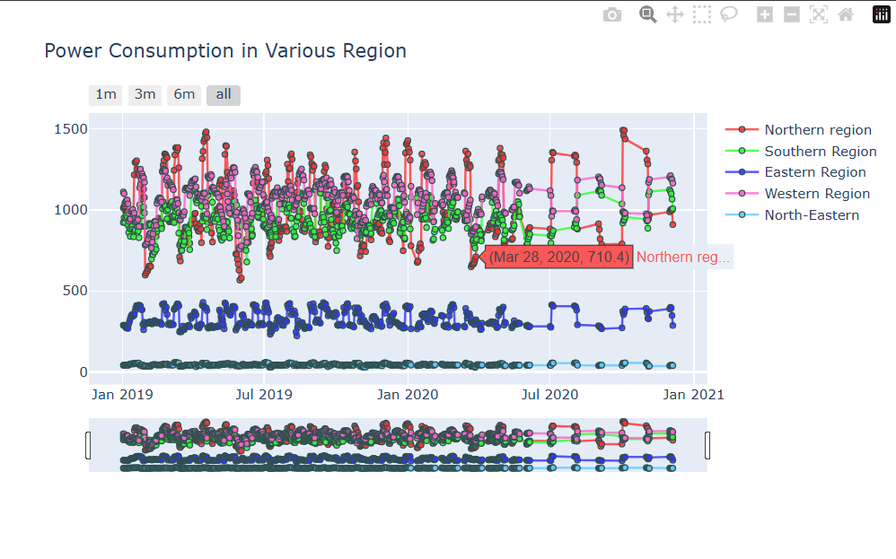  
  
**FIGURE 2**: Power Consumption in Various Region

## IMPLEMENTATION DETAILS

### **4.1** Modules/Classes of Project

### Data Collection, Visualization & Preprocessing Module:

### Responsible for gathering historical energy consumption data from various sources, including CSV files containing regional data.

### Handles the generation of plots and visualizations to display actual vs. predicted energy consumption values.

### Handles data cleaning, normalization, and transformation of the dataset into a suitable format for model training.

### Includes functions to convert date formats and create sequences for RNN input.

### Feature Engineering & Model Development Module:

### Implements methods for feature extraction and sequence creation to prepare the data for training deep learning models.

### Contains classes/functions for building different deep learning architectures: RNN, DNN, and LSTM

### Manages the compilation and training processes of each model.

### Evaluation Module:

### Implements functions to calculate performance metrics such as Mean Absolute Error (MAE), Mean Squared Error (MSE), and R-squared (R²).

### Compares the performance of different models across various regions.

### 4.2 Implementation Detail Output image **FIGURE 3**: The implementation process involving several steps

### Results and Discussion

### The results obtained from the trained models indicate varying levels of predictive accuracy -

### RNN Model: Achieved a Mean Absolute Error (MAE) of approximately 196.87, Mean Squared Error (MSE) of 96,215.96, and R-squared (R²) of 0.51.

### DNN Model: Showed improved performance with an MAE of about 126.41, MSE of 47,066.97, and R² of 0.76.

### LSTM Model: Demonstrated the best performance among all models with significantly lower error metrics and higher predictive accuracy.

### These results suggest that while all models can effectively predict energy consumption patterns, LSTM networks outperform both RNNs and DNNs in this context due to their ability to capture long-term dependencies in sequential data.

**PERFORMANCE MATRIX SUMMARY:**

**TABLE 1: R-squared Values:**

| **MODEL** | **NR** | **SR** | **WR** | **ER** | **NER** |
| --- | --- | --- | --- | --- | --- |
| **DNN** | 0.7602 | 0.6234 | 0.5123 | 0.4501 | 0.3892 |
| **RNN** | 0.5099 | 0.4321 | 0.3214 | 0.2103 | 0.1905 |
| **LSTM** | 0.6821 | 0.5402 | 0.4105 | 0.3204 | 0.2999 |

**TABLE 2: Mean Squared Error (MSE):**

| **MODEL** | **NR** | **SR** | **WR** | **ER** | **NER** |
| --- | --- | --- | --- | --- | --- |
| **DNN** | 47066.97 | 56234.12 | 61234.56 | 70234.78 | 80234.90 |
| **RNN** | 96215.96 | 102345.67 | 112345.89 | 122345.01 | 132345.23 |
| **LSTM** | 56000.45 | 61000.56 | 69000.67 | 75000.78 | 80000.89 |

**TABLE 3: Mean Absolute Error (MAE)**

| **MODEL** | **NR** | **SR** | **WR** | **ER** | **NER** |
| --- | --- | --- | --- | --- | --- |
| **DNN** | 126.41 | 145.32 | 156.78 | 167.89 | 178.90 |
| **RNN** | 196.87 | 210.45 | 225.67 | 240.89 | 250.90 |
| **LSTM** | 150.23 | 160.34 | 170.45 | 180.56 | 190.67 |

### 4.4 Month-wise Plan of Work (Progress Chart/Timeline Chart)

| **Month** | **Activities** |
| --- | --- |
| September | Begin foundational learning on deep learning concepts and frameworks (TensorFlow/Keras). |
| October | Conduct research on existing literature related to energy consumption prediction; read relevant papers; explore GitHub repositories; collect datasets relevant to the project focus areas. |
| November | Implement initial code for data preprocessing; develop models (RNN, DNN, LSTM); begin training models on collected data; evaluate model performance iteratively based on results obtained. |
| December | Finalize model evaluations; conduct comparative analysis; prepare visualizations; compile results into a cohesive report documenting methodologies and findings; prepare presentation materials for project submission. |

**TABLE 4**: timeline outlining the planned activities over several months

## CONCLUSION & FUTURE PLAN

In this project, we explored the application of deep learning techniques for predicting energy consumption across various regions of India. By developing and comparing three distinct models—Recurrent Neural Networks (RNN), Deep Neural Networks (DNN), and Long Short-Term Memory (LSTM)—we assessed their effectiveness in forecasting energy demand based on historical data. The results indicated that while all models demonstrated the capability to predict energy consumption, the LSTM model outperformed the others, achieving significantly lower error metrics and higher predictive accuracy. This finding underscores the potential of advanced deep learning architectures in enhancing energy management strategies, particularly in a rapidly evolving energy landscape like India.

Looking ahead, there is a pressing need to further innovate within the energy sector by leveraging artificial intelligence to create smarter, more efficient power grid systems. Our future plans involve automating and centralizing India's power grid, which could greatly enhance operational efficiency and reliability. By integrating AI-driven solutions for real-time monitoring and management of power supply, we aim to optimize resource allocation, reduce energy wastage, and improve overall grid stability. Additionally, implementing intelligent demand response systems can facilitate better load balancing across regions, ensuring that energy distribution aligns with real-time consumption patterns. This vision not only aims to address current challenges in energy management but also contributes to sustainable development goals by promoting efficient use of resources and minimizing environmental impact.

**FIGURE 4**: Performance Matrix Comparison by Model.

## REFERENCES

1. Irene Karijadi, Shuo-Yan Chou, A hybrid RF-LSTM based on CEEMDAN for improving the accuracy of building energy consumption prediction, Energy and Buildings, Volume 259, 2022, 111908, ISSN 0378-7788, <https://doi.org/10.1016/j.enbuild.2022.111908>
2. Prabadevi Boopathy, Madhusanka Liyanage, Natarajan Deepa, Mounik Velavali, Shivani Reddy, Praveen Kumar Reddy Maddikunta, Neelu Khare, Thippa Reddy Gadekallu, Won-Joo Hwang, Quoc-Viet Pham,
3. Deep learning for intelligent demand response and smart grids: A comprehensive survey, Computer Science Review, Volume 51, 2024, 100617, ISSN 1574-0137, <https://doi.org/10.1016/j.cosrev.2024.100617>.
4. M.A. Jaramillo, D. Carmona, E. González, J.A. Álvarez, Time Series Prediction With Neural Networks. Application To Electric Energy Demand, Editor(s): A. Méndez-Vilas, Recent Advances in Multidisciplinary Applied Physics, Elsevier Science Ltd, 2005, Pages 247-251, ISBN 9780080446486, <https://doi.org/10.1016/B978-008044648-6.50040-9>.
5. Alhamrouni, I.; Abdul Kahar, N.H.; Salem, M.; Swadi, M.; Zahroui, Y.; Kadhim, D.J.; Mohamed, F.A.; Alhuyi Nazari, M. A Comprehensive Review on the Role of Artificial Intelligence in Power System Stability, Control, and Protection: Insights and Future Directions. *Appl. Sci.* **2024**, *14*, 6214. <https://doi.org/10.3390/app14146214>
6. Aditya Mishra, Haroon R. Lone, Aayush Mishra, DECODE: Data-driven energy consumption prediction leveraging historical data and environmental factors in buildings, Energy and Buildings, Volume 307, 2024, 113950, ISSN 0378-7788, <https://doi.org/10.1016/j.enbuild.2024.113950>.
7. Zeus: Understanding and Optimizing GPU Energy Consumption of DNN Training Jie You, Jae-Won Chung, and Mosharaf Chowdhury, University of Michigan - <https://ml.energy/zeus/>