Typed text before image fixture.
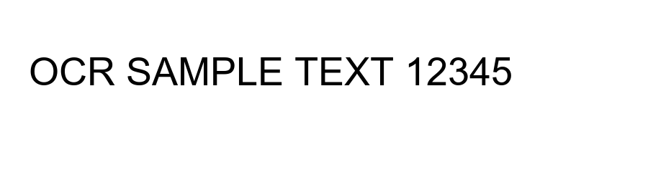
Typed text after image fixture.

