**Enhanced Lane Detection System for Road Safety Applications**

**Abstract:**

The project aims to develop a lane detection system that utilises known image processing techniques. This system enhances road safety. The system will incorporate image acquisition, preprocessing, noise reduction, edge detection, and lane marking identification. Techniques such as cosine transform, wavelet transform, Hough transform, canny edge detection and an adaptive line segment and river flow method are employed to ensure efficient detection.

**Methodology:**

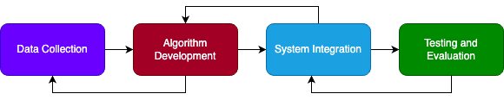

Data Collection

A comprehensive dataset of road images or videos will be gathered under various conditions.

Algorithm Development

|  |  |
| --- | --- |
|  | * Image Processing   + Histogram Equalization – enhancing grey scaling.   + De-blurring using a wiener filter. * Noise Reduction   + Cosine Transform.   + Wavelet Transform.   + Spatial Filter. * Edge Detection   + Canny Edge detection.   + Sobel Edge detection.   + Laplacian Edge detection.   + Prewitt Edge detection.   + Roberts Cross Edge detection.   + Scherr Edge detection. * Lane Detection   + Hough Transform.   + A Kalman filtering–based B-Spline tracking model.   + Adaptive line segment and river flow method. |

System Integration

HARDWARE: Jetson Nano/ Raspberry Pi.

SOFTWARE: Python and Necessary Libraries like OpenCV, scikit-image etc.,

Testing and Evaluation

System performance is evaluated using collected dataset along with processing time, accuracy, precision and recall.