**Enhanced Lane Detection System for Road Safety Applications**

**Abstract:**

The project aims to develop a lane detection system that utilises known image processing techniques. This system enhances road safety. The system will incorporate a series of stages, including image acquisition, preprocessing, noise reduction, edge detection, and lane marking identification.  The system will utilize a combination of advanced image processing techniques to ensure optimal performance. Cosine Transform will efficiently process periodic patterns in road markings, while Wavelet Transform will capture both fine and coarse details. Hough Transform will effectively detect lines and curves, and Canny Edge Detection will accurately identify edges. Finally, the Adaptive Line Segment and River Flow Method will combine the strengths of line segment detection and river flow algorithms to reliably track lane markings in various driving conditions.

**Methodology:**

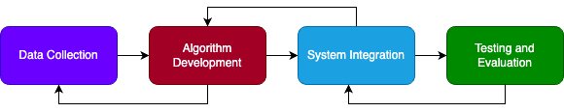

Data Collection

A comprehensive dataset of road images or videos will be gathered under various conditions.

Algorithm Development

|  |  |
| --- | --- |
|  | * Image Processing   + Histogram Equalization – enhancing grey scaling.   + De-blurring using a wiener filter. * Noise Reduction   + Cosine Transform.   + Wavelet Transform.   + Spatial Filter. * Edge Detection   + Canny Edge detection.   + Sobel Edge detection.   + Laplacian Edge detection.   + Prewitt Edge detection.   + Roberts Cross Edge detection.   + Scherr Edge detection. * Lane Detection   + Hough Transform.   + A Kalman filtering–based B-Spline tracking model.   + Adaptive line segment and river flow method. |

System Integration

SOFTWARE: Python and Necessary Libraries like OpenCV, scikit-image etc.,

Testing and Evaluation

System performance is evaluated using collected dataset along with processing time, accuracy, precision and recall.