**Solution**

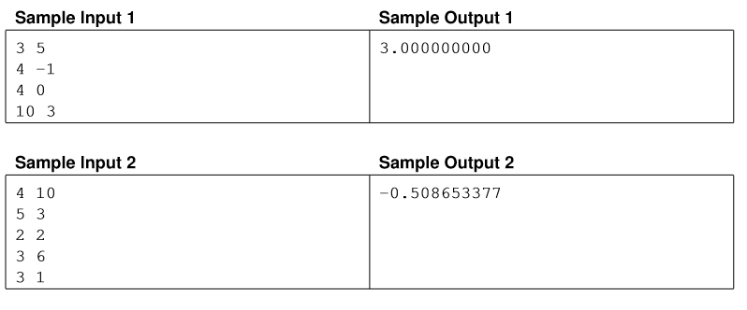

Sample Input and Output for “Need for Speed”

Given a guess for the value of c, we can compute the resulting distance that this would result in. If the guess of c was too high, the travelled distance will be too high (because in each segment travelled we’re over estimating the speed), and if the guess was too low, the travelled distance will be too low. We can therefore simply binary search for the correct value of c.

The potentially tricky part for binary searching is what lower and upper boundaries to use. If in some segment the speedometer read v, the value of c needs to be at least −v. Therefore, c must be at least − min v. For the upper bound, a common mistake was to assume that c could never be larger than 10⁶. This is almost true, but not quite — the maximum possible value is 10⁶ + 1000 (our true speed can be as large as 10⁶, but the reported readings of the speedometer can be −1000).