**Solution**

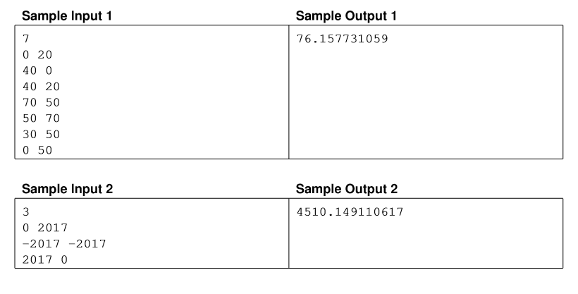Sample Input and Output for “Gotham needs your help”

The initial thought is an ideal landing strip should exist that passes between two polygon vertices. The proof is also relatively standard: you can elongate any landing strip until both ends hit the edge of the polygon and, keeping one end ﬁxed, rotate the landing strip — It increases the length in one of the rotational directions-until either the end of the edge is reached or the polygon is blocked by another vertex. Remember that the longest edge doesn’t automatically have to be a diagonal, in fact, both ends of the longest landing strip can be found in middles of polygon edges, as in the ﬁgure below.

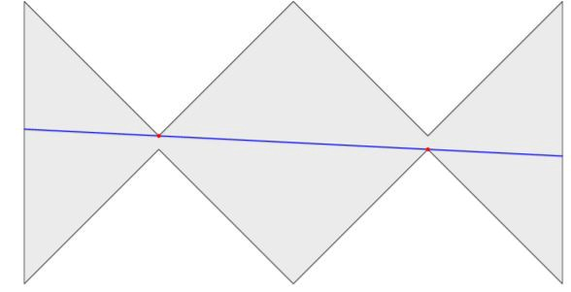

Given the n ≤ 200 limit, A cubic algorithm runs in time-so, the plan is to try out all pairs of points A, B, and find out first for each pair whether the interval AB is fully contained in the polygon, and if so, how much it can be extended.

This is simple in principle– for the first question, figure out if the polygon boundary crosses AB and find out the first position that the polygon boundary crosses the half-lines extending AB in either direction.

In action, the hardest part is to correctly distinguish the cases where the polygon boundary crosses the line AB, probably runs along the line for a while, and then veers away — either back to the same side it came from (in which case it didn’t cross the line), or to the other side (in which case it did cross the line). This requires some care in getting right (although the problem statement disallows subsequent collinear edges is made a little easier).