Ex. No: 1 Date: ______________
MULTI-PAGE STATIC WEBSITE FOR TN SCHOLARSHIP PORTAL USING
SEMANTIC HTML5

Aim
To design and develop a user-friendly multi-page static website for the Tamil Nadu Scholarship Portal using semantic HTML5 elements, providing scholarship information, eligibility criteria, student registration, and details about the portal.

Procedure
- Create the project folder: Create a folder named TNScholarshipPortal to store the four HTML files and related images.
- Design the Home Page (index.html): Use header for the portal title, nav for links to all pages, main and section for the welcome message and available scholarships, table elements to display scholarship types and purposes, and footer for copyright information.
- Design the Eligibility Page (eligibility.html): Use header, nav, main, and section to organize the eligibility information. Use a table with tr, th, and td to present the requirements for education, sports, and women scholarships. Use an ordered list to show the documents required.
- Design the Registration Page (register.html): Create a form to collect student details. Use fieldset and legend to group personal details, label and input for name, date of birth, email, phone, district, course, and marks, select and option for scholarship type, and buttons to submit or clear the form.
- Design the About Us Page (about.html): Use header, nav, main, section, and footer to maintain a consistent layout. Add sections describing the services, mission, objectives, and contact information of the TN Scholarship Portal.
- Implement page navigation: Add hyperlinks using the a element with suitable href attributes on all four pages so users can move between Home, Eligibility, Register, and About Us.
- Add images and visual presentation: Insert suitable banner images using the img element and use the sample website’s alignment, colors, headings, tables, and spacing to make the pages clear and consistent.
- Test the website: Open index.html in a web browser. Check that all four pages load correctly, navigation links work, images appear, the registration form fields are displayed, and the content is aligned neatly.

Scholarship HTML Code
The complete source code for all four pages is given below. The registration page (register.html) is included in full.

1. Home Page (index.html)
<!DOCTYPE html>
<html lang="en">
<head>
<meta charset="UTF-8">
<meta name="viewport" content="width=device-width, initial-scale=1.0">
<title>TN Scholarship - Home</title>
<center>
<img src="first.jpg" border=2 width=1000 height=220>
</head>
<body bgcolor="#EAF4FF">
<header>
<h1 align="center"><font color="#123B68">Tamil Nadu Scholarship Portal</font></h1>
<h3 align="center">Empowering Students Through Scholarships</h3>
</header>
<hr>
<nav align="center">
<a href="index.html">Home</a> |
<a href="eligibility.html">Eligibility</a> |
<a href="register.html">Register</a> |
<a href="about.html">About Us</a>
</nav>
<hr>
<main>
<section>
<h2>Welcome to TN Scholarship Portal</h2>
<p>Our portal helps students explore scholarship opportunities
for education, sports and women empowerment.</p>
</section>
<section>
<h2>Scholarships Available</h2>
<table border="1" cellpadding="10" align="center">
<tr bgcolor="#C8DFF5">
<th>Scholarship</th><th>Purpose</th>
</tr>
<tr>
<td>For students</td>
<td>Support for academic achievers</td>
</tr>
<tr>
<td>For Sports Man</td>
<td>Support for talented athletes</td>
</tr>
<tr>
<td>Women Scholarship</td>
<td>Encouraging girls' education</td>
</tr>
</table>
</section>
<section>
<footer>
<hr>
<p align="center">&copy; 2026 TN Scholarship Portal</p>
</footer>
</section>
</main>
</body>
</html>
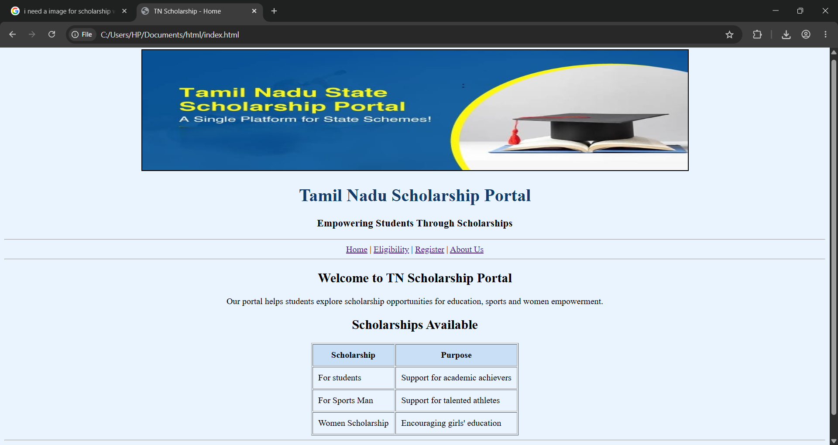

2. Eligibility Page (eligibility.html)
<!DOCTYPE html>
<html lang="en">
<head>
<meta charset="UTF-8">
<meta name="viewport" content="width=device-width, initial-scale=1.0">
<title>TN Scholarship - Eligibility</title>
</head>
<body bgcolor="#F0FFF4">
<header>
<h1 align="center"><font color="#176B45">Scholarship Eligibility</font></h1>
</header>
<hr>
<nav align="center">
<a href="index.html">Home</a> |
<a href="eligibility.html">Eligibility</a> |
<a href="register.html">Register</a> |
<a href="about.html">About Us</a>
</nav>
<hr>
<main>
<section>
<center>
<img src="second.jpg" width=1000 height=200>
<h2>Eligibility Criteria</h2>
<table border="1" cellpadding="10" align="center">
<tr bgcolor="#C8E6C9">
<th>Scholarship</th><th>Sample Requirements</th>
</tr>
<tr>
<td>Education</td>
<td>At least 80% marks in the previous examination
and family income less than 2lakh</td>
</tr>
<tr>
<td>Sports</td>
<td>Two or three state-level sports certificates and family income less than 3lakh</td>
</tr>
<tr>
<td>Women</td>
<td>Female student enrolled in a recognised course</td>
</tr>
</table>
</section>
<section>
<h2>Documents Required</h2>
<ol>
<li>Student identity proof</li>
<li>Previous examination mark sheet</li>
<li>School or college ID</li>
<li>Sports certificates, if applying for sports</li>
<li>Bank details, if required by the scheme</li>
</ol>
</section>
<section>
<p>These are sample project criteria. Check the official scheme
notification for actual eligibility and required documents.</p>
</section>
</main>
<footer>
<hr>
<p align="center">&copy; 2026 TN Scholarship Portal</p>
</footer>
</body>
</html>
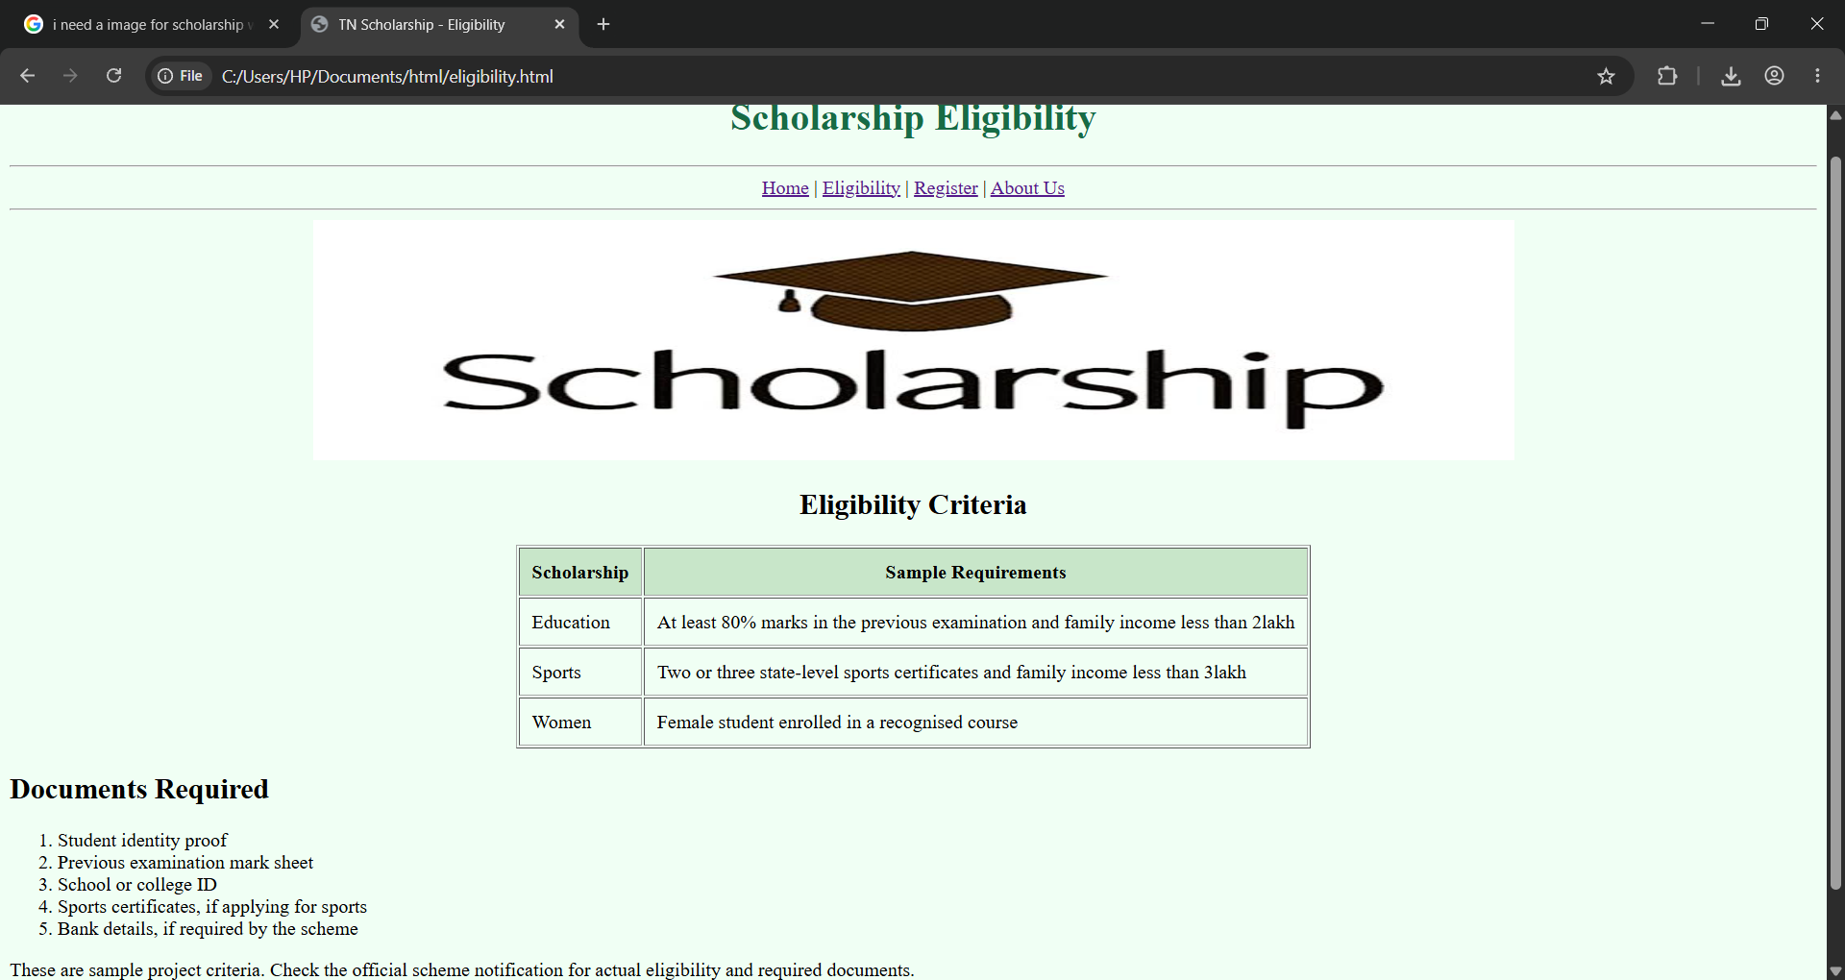

3. Registration Page (register.html)
<!DOCTYPE html>
<html lang="en">
<head>
<meta charset="UTF-8">
<meta name="viewport" content="width=device-width, initial-scale=1.0">
<title>TN Scholarship - Registration</title>
</head>
<body bgcolor="#FFF5E6">
<header>
<h1 align="center"><font color="#994D00">Student Registration</font></h1>
</header>
<hr>
<nav align="center">
<a href="index.html">Home</a> |
<a href="eligibility.html">Eligibility</a> |
<a href="register.html">Register</a> |
<a href="about.html">About Us</a>
</nav>
<hr>
<main>
<section>
<h2>Scholarship Application Form</h2>
<form action="#" method="get">
<fieldset>
<legend>Personal Details</legend>
<label for="name">Student Name:</label>
<input type="text" id="name" name="name" required><br><br>
<label for="dob">Date of birth:</label>
<input type="date" id="dob" name="dob" required><br><br>
<label for="email">Email:</label>
<input type="email" id="email" name="email" required><br><br>
<label for="phone">Phone:</label>
<input type="tel" id="phone" name="phone" required><br><br>
<label for="district">District:</label>
<input type="text" id="district" name="district" required><br><br>
<label for="course">Class/Course:</label>
<input type="text" id="course" name="course" required><br><br>
<label for="marks">Previous Exam Percentage:</label>
<input type="number" id="marks" name="marks" min="0" max="100"><br><br>
<label for="type">Scholarship Type:</label>
<select id="type" name="type" required>
<option value="">Select Scholarship</option>
<option value="education">Education</option>
<option value="sports">Sports</option>
<option value="women">Women</option>
</select><br><br>
<label for="certificate">Sports Certificates (if applicable):</label>
<input type="text" id="certificate" name="certificate"><br><br>
<button type="submit">Submit Application</button>
<button type="reset">Clear Form</button>
</fieldset>
</form>
</section>
</main>
<footer>
<hr>
<p align="center">&copy; 2026 TN Scholarship Portal</p>
</footer>
</body>
</html>
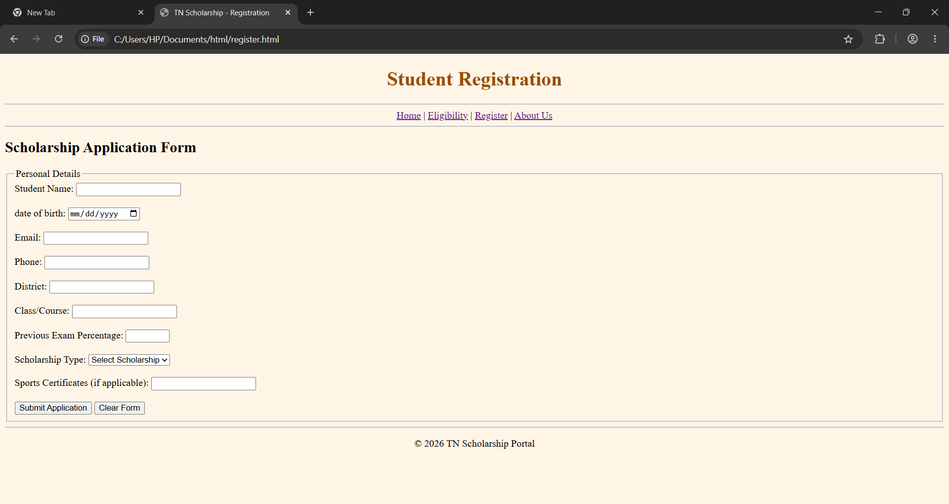

4. About Us Page (about.html)
<!DOCTYPE html>
<html lang="en">
<head>
<meta charset="UTF-8">
<meta name="viewport" content="width=device-width, initial-scale=1.0">
<title>TN Scholarship - About Us</title>
</head>
<body bgcolor="#F5F0FF">
<header>
<h1 align="center"><font color="#59359A">About Us</font></h1>
<h3 align="center">Supporting Every Student's Dream</h3>
</header>
<hr>
<nav align="center">
<a href="index.html">Home</a> |
<a href="eligibility.html">Eligibility</a> |
<a href="register.html">Register</a> |
<a href="about.html">About Us</a>
</nav>
<hr>
<main>
<section>
<img src="four.jpg" height=100 width=1000>
<h2>What we offer</h2>
<ul>
<li>Scholarship information: discover scholarships for different education levels.</li>
<li>Eligibility criteria: understand the requirements for each scholarship.</li>
</ul>
</section>
<section>
<h2>Our Mission</h2>
<p>Our mission is to help students discover educational
support, recognise sporting achievements and encourage
women to continue their education.</p>
</section>
<section>
<h2>Our Main Objectives</h2>
<ul>
<li>Provide scholarship information for students.</li>
<li>Explain eligibility criteria clearly.</li>
<li>Offer a simple registration form.</li>
<li>Encourage equal educational opportunities.</li>
</ul>
</section>
<section>
<h2>Contact Information</h2>
<p>For this project, contact the student website administrator
through your institution.</p>
</section>
</main>
<footer>
<hr>
<p align="center">&copy; 2026 TN Scholarship Portal</p>
</footer>
</body>
</html>
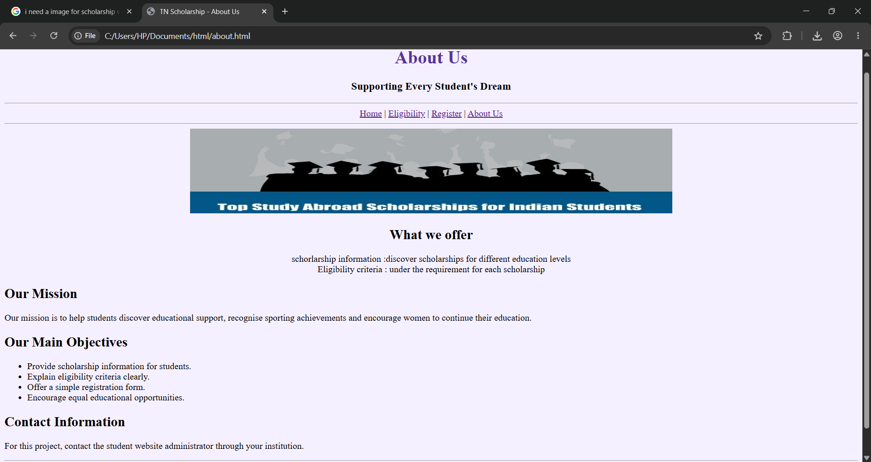

Result
Thus, a multi-page static website for the Tamil Nadu Scholarship Portal was designed and developed using semantic HTML5 elements.

