**Digital Nurture 4.0**

Week6 – React

# Mandatory Hands On

**File name:** **1. ReactJS-HOL**

**Program:**

* After the installation of the node, In vscode terminal or command prompt create a react app using the following command

npx create-react-app myfirstreactapp

* In vscode open the myfirstreactapp folder and modify the app.js.

**App.js:**

function App() {

  return (

    <div>

      <h1>Welcome to the first session of React</h1>

    </div>

  );

}

export default App;

* Run the following command in the terminal to execute.
* Then run the url http://localhost:3000 in the browser.

**Output:**

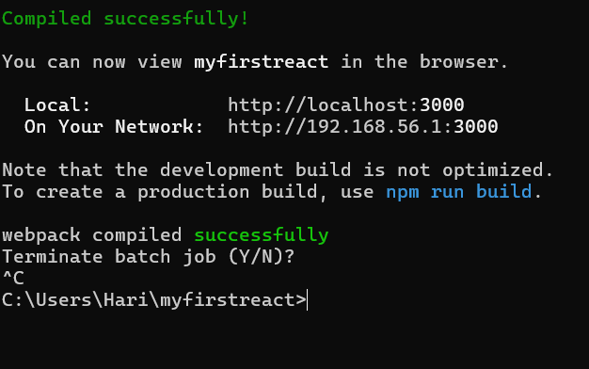

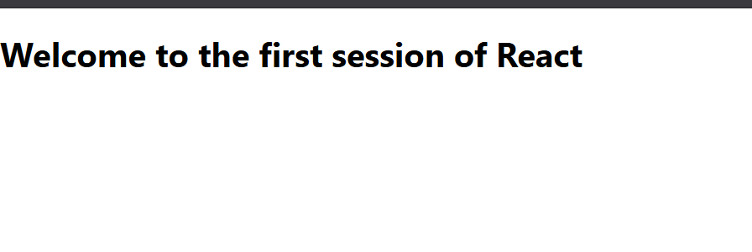

**File name: 2. ReactJS-HOL**

**Program:**

* In vscode terminal or command prompt create a react app using the following command

npx create-react-app studentapp

* In vscode open the studentapp folder and create a new folder in src/Components
* Inside the Components create Home.js

**Home.js:**

import React from 'react';

class Home extends React.Component {

render() {

return (

<div>

<h2>Welcome to the Home page of Student Management Portal</h2>

</div>

);

}

}

export default Home;

* Inside the Components create About.js

**About.js:**

import React from 'react';

class About extends React.Component {

render() {

return (

<div>

<h2>Welcome to the About page of the Student Management Portal</h2>

</div>

);

}

}

export default About;

* Inside the Components create Contact.js

**Contact.js:**

import React from 'react';

class Contact extends React.Component {

render() {

return (

<div>

<h2>Welcome to the Contact page of the Student Management Portal</h2>

</div>

);

}

}

export default Contact;

* In src/App.js write the following commands.

**App.js:**

import React from 'react';

import './App.css';

import Home from './Components/Home';

import About from './Components/About';

import Contact from './Components/Contact';

function App() {

return (

<div className="App">

<Home />

<About />

<Contact />

</div>

);

}

export default App;

* Run the following command to run the file

npm start

* Run the url http://localhost:3000 in the browser.

**Output:**

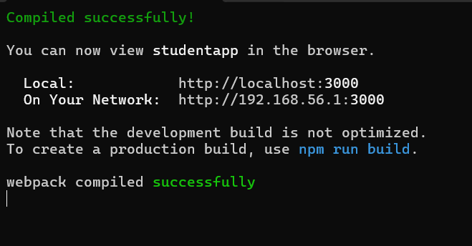



**File name: 3. ReactJS-HOL**

**Program:**

* Create a scorecalculatorapp in react using npx create-react-app scorecalculatorapp in terminal or cmd. Then open the folder in vs code and create Components and Stylesheets folder in src.
* In the Components folder create a file named

CalculateScore.js

**Calculator.js:**

import React from 'react';

import '../Stylesheets/mystyle.css';

function CalculateScore(props) {

const average = props.total / props.goal;

return (

<div className="score-box">

<h2>Student Score Report</h2>

<p><strong>Name:</strong> {props.name}</p>

<p><strong>School:</strong> {props.school}</p>

<p><strong>Total Score:</strong> {props.total}</p>

<p><strong>Goal Count:</strong> {props.goal}</p>

<p><strong>Average Score:</strong> {average.toFixed(2)}</p>

</div>

);

}

export default CalculateScore;

* In the Stylesheet folder create a file named mystyle.js

**Mystyle.js:**

.score-box {

background-color: #f0f8ff;

border: 2px solid #ccc;

padding: 20px;

width: 350px;

margin: 20px auto;

text-align: left;

font-family: Arial, sans-serif;

border-radius: 10px;

}

* In the src/App.js write the following code

**App.js:**

import React from 'react';

import './App.css';

import CalculateScore from './Components/CalculateScore';

function App() {

return (

<div className="App">

<CalculateScore name="Hari" school="ABC Public School" total={450} goal={5} />

</div>

);

}

export default App;

* In the terminal run npm start .
* Run the <http://localhost:3000> in the browser.

**Output:**

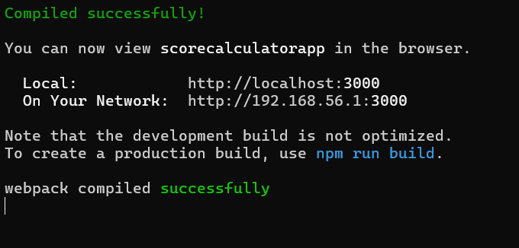

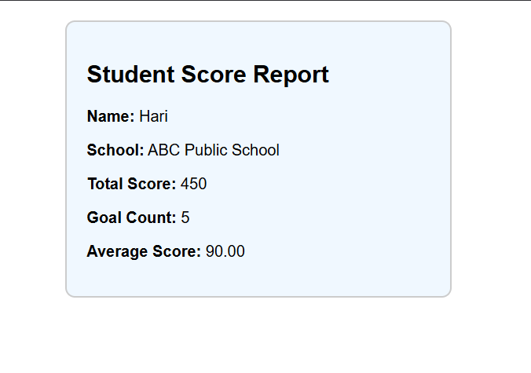

**File name:4.ReactJS-HOL**

**Program:**

* open vs code terminal or cmd and create blogapp in react using the following command npx create-react-app blogapp
* open the folder in vscode and create a post.js,posts.js in src folder .

**post.js:**

import React from 'react';

class Post extends React.Component {

render() {

return (

<div style={{ margin: '10px', padding: '15px', border: '1px solid #ccc' }}>

<h3>{this.props.title}</h3>

<p>{this.props.body}</p>

</div>

);

}

}

export default Post;

**posts.js:**

import React from 'react';

import Post from './Post';

class Posts extends React.Component {

constructor(props) {

super(props);

this.state = {

posts: [],

hasError: false

};

}

loadPosts = () => {

fetch('https://jsonplaceholder.typicode.com/posts')

.then(response => response.json())

.then(data => this.setState({ posts: data.slice(0, 10) })) // limit to 10 posts

.catch(error => {

console.error("Fetch error:", error);

this.setState({ hasError: true });

});

};

componentDidMount() {

this.loadPosts();

}

componentDidCatch(error, info) {

alert("An error occurred while loading posts.");

console.error(error, info);

this.setState({ hasError: true });

}

render() {

if (this.state.hasError) {

return <h2>Something went wrong.</h2>;

}

return (

<div>

<h2>Blog Posts</h2>

{this.state.posts.map(post => (

<Post key={post.id} title={post.title} body={post.body} />

))}

</div>

);

}

}

export default Posts;

* modify the src/App.js

**App.js:**

import React from 'react';

import './App.css';

import Posts from './Posts';

function App() {

return (

<div className="App">

<Posts />

</div>

);

}

export default App;

* run the npm start command in the terminal and run the url <http://localhost:3000> in the browser.

**Output:**

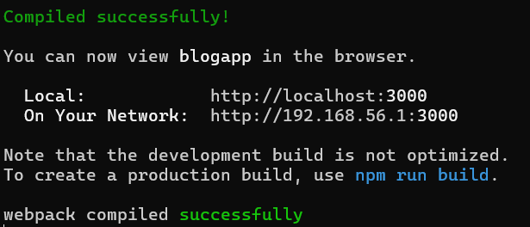

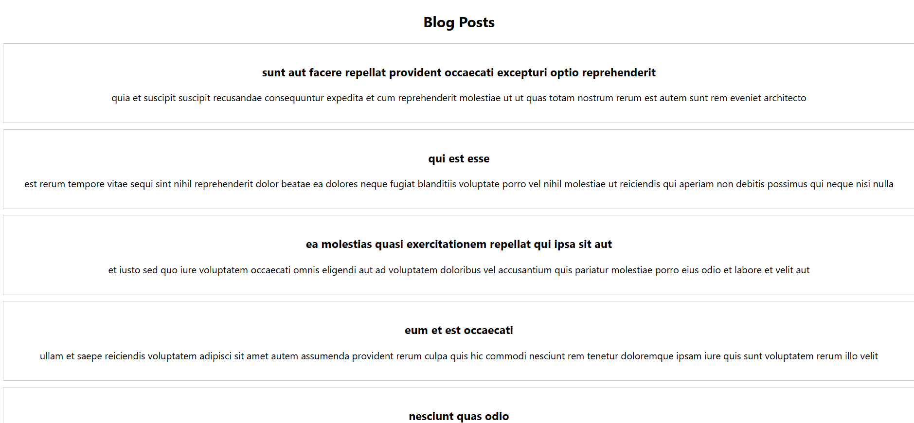

**File name: 5.ReactJS-HOL**

**Program:**

* Create a react app named cohortdashboard using the following command

npx create-react-app cohortdashboard

* Create Cohortdetails.js and CohortDetails.module.css in the src folder.

**CohortDetails.js:**

import React from 'react';

import styles from './CohortDetails.module.css';

function CohortDetails({ name, status, startDate, endDate }) {

const headingStyle = {

color: status === 'ongoing' ? 'green' : 'blue',

};

return (

<div className={styles.box}>

<h3 style={headingStyle}>{name}</h3>

<dl>

<dt>Status:</dt>

<dd>{status}</dd>

<dt>Start Date:</dt>

<dd>{startDate}</dd>

<dt>End Date:</dt>

<dd>{endDate}</dd>

</dl>

</div>

);

}

export default CohortDetails;

**CohortDetails.module.css:**

.box {

width: 300px;

display: inline-block;

margin: 10px;

padding: 10px 20px;

border: 1px solid black;

border-radius: 10px;

}

dt {

font-weight: 500;

}

* Modify the App.js in the src folder.

**App.js:**

import React from 'react';

import './App.css';

import CohortDetails from './CohortDetails';

function App() {

const cohortList = [

{

name: 'Java Full Stack',

status: 'ongoing',

startDate: '2024-07-01',

endDate: '2024-12-01'

},

{

name: 'React Bootcamp',

status: 'completed',

startDate: '2024-01-15',

endDate: '2024-06-15'

}

];

return (

<div className="App">

{cohortList.map((cohort, index) => (

<CohortDetails

key={index}

name={cohort.name}

status={cohort.status}

startDate={cohort.startDate}

endDate={cohort.endDate}

/>

))}

</div>

);

}

export default App;

* Run the npm start command in the terminal and the url <http://localhost:3000> in the browser.

**Output:**

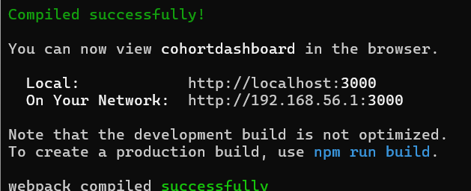

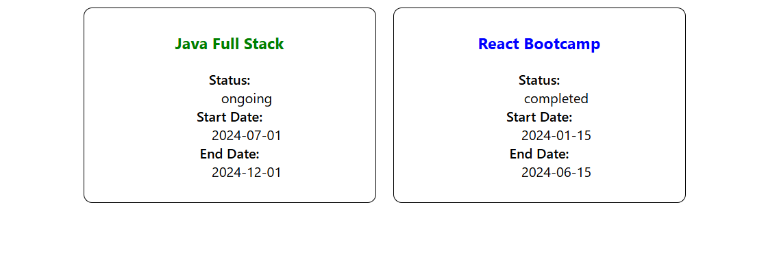

**File name: 6.ReactJS-HOL**

**Program:**

* Create react app named trainersapp using the following command

npx create-react-app trainersapp

* Then run cd trainersapp in terminal the run the npm install react-router-dom ,open folder in vs code.
* Create trainer.js, TrainersMock.js, Home.js, TrainerList.js, TrainerDetails.js in the in the src folder.

**trainer.js:**

class Trainer {

constructor(trainerId, name, email, phone, technology, skills) {

this.trainerId = trainerId;

this.name = name;

this.email = email;

this.phone = phone;

this.technology = technology;

this.skills = skills;

}

}

export default Trainer;

**TrainersMock.js:**

import Trainer from './trainer';

const trainers = [

new Trainer(1, 'Hari', 'hari@example.com', '9876543210', 'React', 'JS, JSX, Hooks'),

new Trainer(2, 'Priya', 'priya@example.com', '9123456780', 'Java', 'Spring, JPA'),

new Trainer(3, 'Ravi', 'ravi@example.com', '9876501234', 'Python', 'Flask, Django'),

];

export default trainers;

**Home.js:**

import React from 'react';

function Home() {

return (

<div>

<h2>Welcome to Cognizant Academy</h2>

<p>This portal contains trainer information.</p>

</div>

);

}

export default Home;

**TrainerList.js:**

import React from 'react';

import { Link } from 'react-router-dom';

function TrainerList({ trainers }) {

return (

<div>

<h2>Trainer List</h2>

<ul>

{trainers.map(trainer => (

<li key={trainer.trainerId}>

<Link to={`/trainer/${trainer.trainerId}`}>{trainer.name}</Link>

</li>

))}

</ul>

</div>

);

}

export default TrainerList;

**TrainerDetails.js:**

import React from 'react';

import { useParams } from 'react-router-dom';

import trainers from './TrainersMock';

function TrainerDetails() {

const { id } = useParams();

const trainer = trainers.find(t => t.trainerId === parseInt(id));

if (!trainer) {

return <h3>Trainer not found.</h3>;

}

return (

<div>

<h2>{trainer.name}'s Details</h2>

<p><strong>ID:</strong> {trainer.trainerId}</p>

<p><strong>Email:</strong> {trainer.email}</p>

<p><strong>Phone:</strong> {trainer.phone}</p>

<p><strong>Technology:</strong> {trainer.technology}</p>

<p><strong>Skills:</strong> {trainer.skills}</p>

</div>

);

}

export default TrainerDetails;

* Modify the App.js in the src folder

**App.js:**

import React from 'react';

import { BrowserRouter, Routes, Route, Link } from 'react-router-dom';

import Home from './Home';

import TrainerList from './TrainerList';

import TrainerDetails from './TrainerDetails';

import trainers from './TrainersMock';

function App() {

return (

<BrowserRouter>

<div>

<h1>Trainers Portal</h1>

<nav>

<Link to="/">Home</Link> | <Link to="/trainers">Trainers</Link>

</nav>

<hr />

<Routes>

<Route path="/" element={<Home />} />

<Route path="/trainers" element={<TrainerList trainers={trainers} />} />

<Route path="/trainer/:id" element={<TrainerDetails />} />

</Routes>

</div>

</BrowserRouter>

);

}

export default App;

* Run the folder using the npm start command in the terminal and run the url <http://localhost:3000/> in the browser.

**Output:**

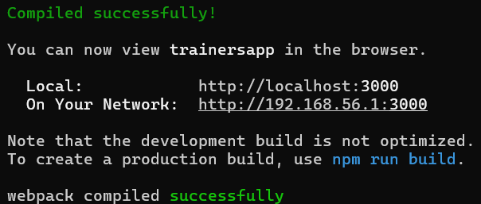

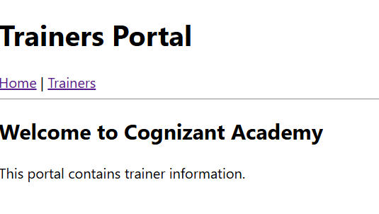

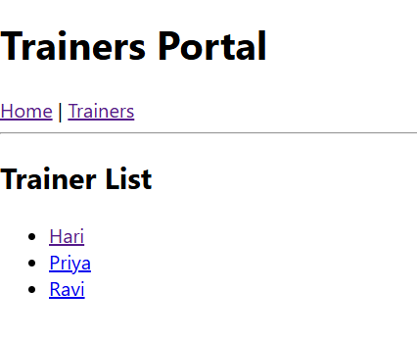

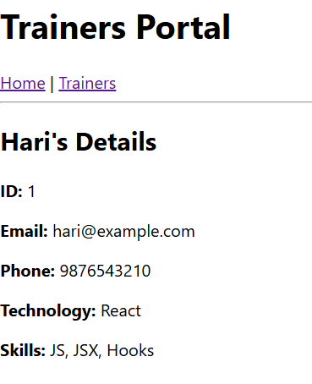

**File name: 7.ReactJS-HOL**

**Program:**

* Create a react app using the command

npx create-react-app shoppingapp

* Create Cart.js,OnlineShopping.js in the src folder.

**Cart.js:**

import React from 'react';

class Cart extends React.Component {

  render() {

    const { itemname, price, cellStyle } = this.props;

    return (

      <tr>

        <td style={cellStyle}>{itemname}</td>

        <td style={cellStyle}>{price}</td>

      </tr>

    );

  }

}

export default Cart;

**OnlineShopping.js:**

import React from 'react';

import Cart from './Cart';

class OnlineShopping extends React.Component {

  render() {

    const items = [

      { itemname: 'Laptop', price: 80000 },

      { itemname: 'TV', price: 120000 },

      { itemname: 'Washing Machine', price: 50000 },

      { itemname: 'Mobile', price: 30000 },

      { itemname: 'Fridge', price: 70000 }

    ];

    const tableStyle = {

      margin: '0 auto',

      borderCollapse: 'collapse',

      fontSize: '18px',

      color: 'green'

    };

    const cellStyle = {

      border: '1px solid gray',

      padding: '10px'

    };

    return (

      <div style={{ textAlign: 'center', marginTop: '40px' }}>

        <h2 style={{ color: 'green' }}>Items Ordered :</h2>

        <table style={tableStyle}>

          <thead>

            <tr>

              <th style={cellStyle}>Name</th>

              <th style={cellStyle}>Price</th>

            </tr>

          </thead>

          <tbody>

            {items.map((item, index) => (

              <Cart key={index} itemname={item.itemname} price={item.price} cellStyle={cellStyle} />

            ))}

          </tbody>

        </table>

      </div>

    );

  }

}

export default OnlineShopping;

* Modify the App.js in the src folder.

**App.js:**

import React from 'react';

import './App.css';

import OnlineShopping from './OnlineShopping';

function App() {

  return (

    <div className="App">

      <OnlineShopping />

    </div>

  );

}

export default App;

* Run the folder using npm start command and run the url <http://localhost:3000> in the browser.

**Output:**

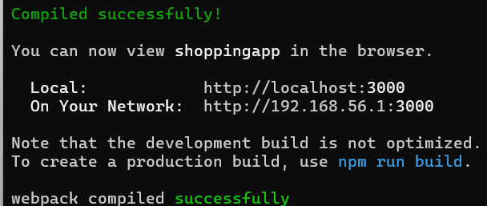

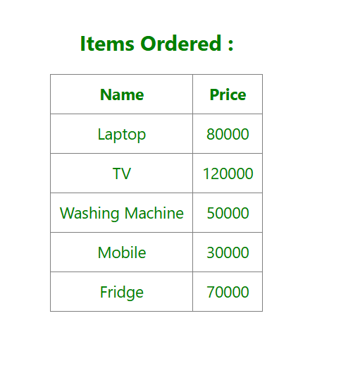

**File name: 8.ReactJS-HOL**

**Program:**

* Create react app named counterapp using the following command

Npx create-react-app counterapp

* Create CountPeople.js file in the src folder.

**CountPeople.js:**

import React from 'react';

class CountPeople extends React.Component {

  constructor(props) {

    super(props);

    this.state = {

      entrycount: 0,

      exitcount: 0

    };

  }

  UpdateEntry = () => {

    this.setState({ entrycount: this.state.entrycount + 1 });

  };

  UpdateExit = () => {

    this.setState({ exitcount: this.state.exitcount + 1 });

  };

  render() {

    const containerStyle = {

      display: 'flex',

      justifyContent: 'center',

      alignItems: 'center',

      marginTop: '100px',

      gap: '20px',

      fontSize: '18px'

    };

    return (

     <div style={containerStyle}>

  <button

    style={{

      padding: '10px 30px',

      marginRight: '10px',

      backgroundColor: 'green',

      color: 'white',

      fontSize: '18px',

      border: 'solid black',

      borderRadius: '5px'

    }}

    onClick={this.UpdateEntry}

  >

    Login

  </button>

  <span>{this.state.entrycount} people entered!!!</span>

  <button

    style={{

      padding: '10px 30px',

      marginLeft: '50px',

      backgroundColor: 'green',

      color: 'white',

      fontSize: '18px',

      border: 'solid black',

      borderRadius: '5px'

    }}

    onClick={this.UpdateExit}

  >

    Exit

  </button>

  <span>{this.state.exitcount} people left!!!</span>

</div>

    );

  }

}

export default CountPeople;

* Modify the App.js in the src folder.
* Run the folder using the npm start command and run the url <http://localhost:3000> in the browser.

**Output:**

