**Digital Nurture 4.0**

Week 7 – React

# Mandatory HandsOn

**File name: 9.ReactJS-HOL**

**Program:**

* Create a react app named cricketapp using the following command

npx create-react-app cricketapp

* Open the folder in the vs code and create a folder in the src folder named components.
* In the components folder create ListofPlayers.js,IndianPlayers.js and write the following code.

**ListofPlayers.js:**

import React from 'react';

const ListofPlayers = () => {

  const players = [

    { name: 'Rohit', score: 85 },

    { name: 'Virat', score: 95 },

    { name: 'Rahul', score: 65 },

    { name: 'Pant', score: 75 },

    { name: 'Shreyas', score: 50 },

    { name: 'Hardik', score: 88 },

    { name: 'Jadeja', score: 60 },

    { name: 'Ashwin', score: 78 },

    { name: 'Bumrah', score: 45 },

    { name: 'Shami', score: 82 },

    { name: 'Kuldeep', score: 55 },

  ];

  const filteredPlayers = players.filter(p => p.score < 70);

  return (

    <div>

      <h2>All Players:</h2>

      <ul>

        {players.map((p, index) => (

          <li key={index}>{p.name} - {p.score}</li>

        ))}

      </ul>

<h2>Filtered Players (score &lt; 70):</h2>

      <ul>

        {filteredPlayers.map((p, index) => (

          <li key={index}>{p.name} - {p.score}</li>

        ))}

      </ul>

    </div>

  );

};

export default ListofPlayers;

**IndianPlayers.js:**

import React from 'react';

const IndianPlayers = () => {

  const team = ['Rohit', 'Virat', 'Rahul', 'Pant', 'Shreyas', 'Hardik'];

  const [p1, p2, p3, p4, p5, p6] = team;

  const oddTeam = [p1, p3, p5];

  const evenTeam = [p2, p4, p6];

  const T20players = ['SKY', 'Gill'];

  const RanjiTrophyPlayers = ['Pujara', 'Rahane'];

  const mergedPlayers = [...T20players, ...RanjiTrophyPlayers];

  return (

    <div>

      <h2>Odd Team Players:</h2>

      <ul>

        {oddTeam.map((p, index) => <li key={index}>{p}</li>)}

      </ul>

      <h2>Even Team Players:</h2>

      <ul>

        {evenTeam.map((p, index) => <li key={index}>{p}</li>)}

      </ul>

      <h2>Merged Players:</h2>

      <ul>

        {mergedPlayers.map((p, index) => <li key={index}>{p}</li>)}

      </ul>

    </div>

  );

};

export default IndianPlayers;

* In src/App.js modify the code.

**App.js:**

// src/App.js

import React, { useState } from 'react';

import ListofPlayers from './components/ListofPlayers';

import IndianPlayers from './components/IndianPlayers';

function App() {

  const [flag, setFlag] = useState(true);

  return (

    <div className="App">

      <button onClick={() => setFlag(!flag)}>

        Toggle Component

      </button>

      {flag ? <ListofPlayers /> : <IndianPlayers />}

    </div>

  );

}

export default App;

**Output:**

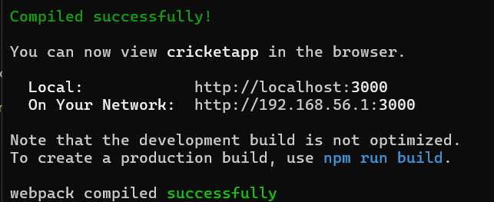

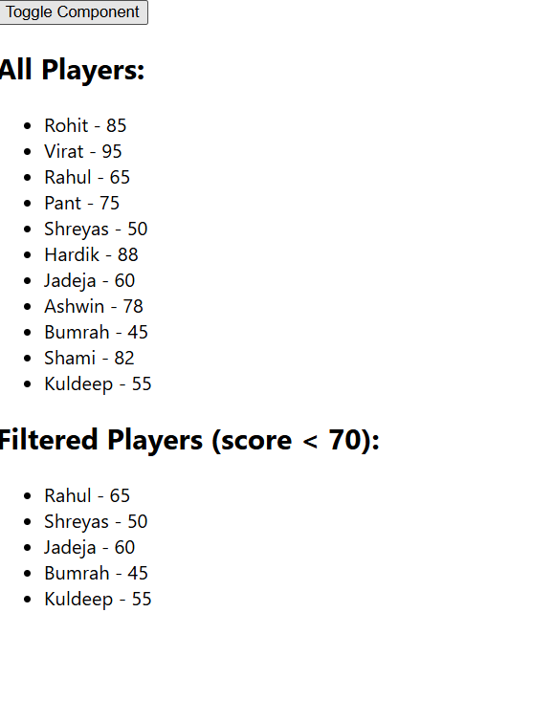

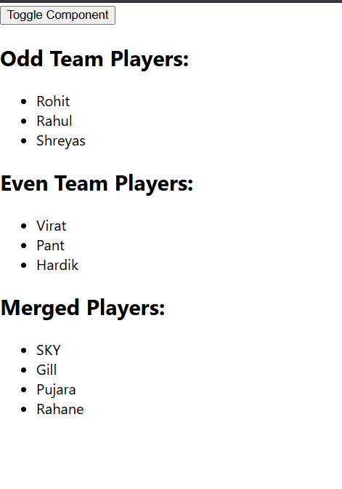

**File name: 10.ReactJS-HOL**

**Program:**

* Create a react app named officespacerentalapp using the following command

npx create-react-app officespacerentalapp

* open the folder in the vs code editor and in the src folder delete the app.css file and the logo.svg image ,then modify the App.js in src folder

**App.js:**

import React from 'react';

function App() {

  const officeList = [

    {

      name: "CozySpace Pvt Ltd",

      rent: 55000,

      address: "123, MG Road, Bengaluru",

      image: "https://imgs.search.brave.com/nBcb8YRR9m6j-N4wFEn_rEq3tLAYrTmGTmDs0_SbKFQ/rs:fit:500:0:1:0/g:ce/aHR0cHM6Ly9ob21l/dHJ1c3QuczMtYXAt/c291dGhlYXN0LTEu/YW1hem9uYXdzLmNv/bS9wdWJsaWMvcHJv/amVjdHMvNjk2Ny9C/cE92M1ZxZ1kxVU0y/MnczMTczNzM2MTc5/NTUwMC5qcGc"

    },

    {

      name: "SkyHub Solutions",

      rent: 75000,

      address: "22, Anna Salai, Chennai",

      image: "https://imgs.search.brave.com/sF0IpRCuxKB8CjWjRBhBj_jZW4RyeodrR0wfR35O2qg/rs:fit:500:0:1:0/g:ce/aHR0cHM6Ly9jb3dv/cmtlci5pbWdpeC5u/ZXQvcGhvdG9zL2lu/ZGlhL25vaWRhL3dv/cmtuZXN0LzQtMTU1/MTI1Njc1My5qcGc_/dz0zODUmaD0yODUm/cT05MCZhdXRvPWZv/cm1hdCxjb21wcmVz/cyZmaXQ9Y3JvcCZt/YXJrPS90ZW1wbGF0/ZS9pbWcvd21faWNv/bi5wbmcmbWFya3Nj/YWxlPTUmbWFya2Fs/aWduPWNlbnRlcixt/aWRkbGU"

    },

    {

      name: "WorkNest Co.",

      rent: 60000,

      address: "88, T-Nagar, Chennai",

      image: "https://imgs.search.brave.com/4cHvcuCqFCNJAulUSmiWxVgqaaZ-FNKX6s3eyE2Tf30/rs:fit:500:0:1:0/g:ce/aHR0cHM6Ly93d3cu/c2t5c3BhY2VvZmZp/Y2VzLmNvbS93cC1j/b250ZW50L3VwbG9h/ZHMvMjAxOS8xMi9J/TUdfMDM3NS5qcGc  "

    }

  ];

  return (

    <div style={{ padding: "20px", fontFamily: "Arial" }}>

      <h1>Office Space Rental App</h1>

      {officeList.map((office, index) => (

        <div key={index} style={{

          border: "1px solid #ccc",

          padding: "15px",

          marginBottom: "15px",

          borderRadius: "10px"

        }}>

          <img src={office.image} alt={office.name} style={{ width: "300px", height: "200px" }} />

          <h2>{office.name}</h2>

          <p><strong>Address:</strong> {office.address}</p>

          <p>

            <strong>Rent:</strong>{" "}

            <span style={{ color: office.rent < 60000 ? "red" : "green" }}>

              ₹{office.rent}

            </span>

          </p>

        </div>

      ))}

    </div>

  );

}

export default App;

* Run the folder using npm start command and run the url <http://localhost:3000in> the browser.

**Output:**

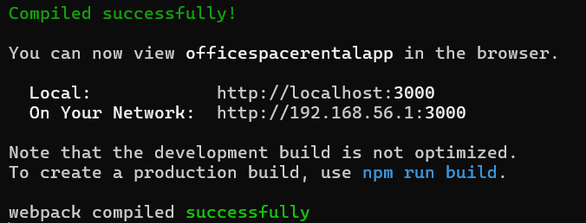

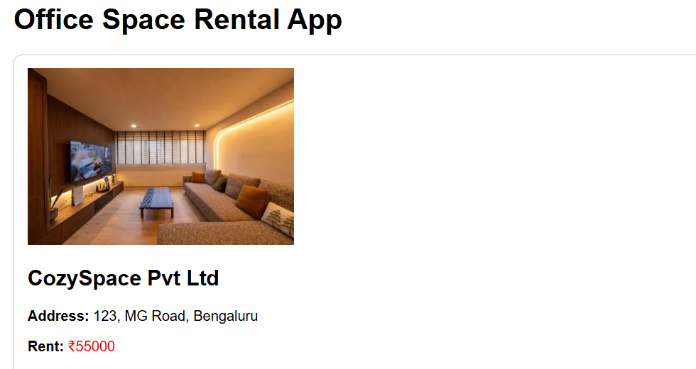

**File name: 11.ReactJS-HOL**

**Program:**

* Create a react app named eventexamplesapp using the command

npx create-react-app eventexamplesapp

* Open the folder in the vscode and create a folder named components insrc folder and create a CurrencyConverter.js in the components folder.

**CurrencyConverter.js:**

import React, { useState } from 'react';

function CurrencyConvertor() {

  const [rupees, setRupees] = useState('');

  const [currency, setCurrency] = useState('');

  const [euro, setEuro] = useState('');

  const handleSubmit = (e) => {

    e.preventDefault();

    const conversionRate = 0.011;

    const result = parseFloat(rupees) * conversionRate;

    setEuro(result.toFixed(2));

  };

  return (

    <div>

      <h2>Currency Convertor</h2>

      <form onSubmit={handleSubmit}>

        <label>Enter the amount in Rupees: </label>

        <input

          type="number"

          value={rupees}

          onChange={(e) => setRupees(e.target.value)}

        />

        <br />

        <label>Enter the Currency: </label>

        <input

          type="text"

          value={currency}

          onChange={(e) => setCurrency(e.target.value)}

        />

        <br />

        <button type="submit">Convert</button>

      </form>

      {euro && (

        <p>Converted amount in {currency || 'Euro'} is: {euro}</p>

      )}

    </div>

  );

}

export default CurrencyConvertor;

* Modify the App.js in the src folder.

**App.js:**

import React, { useState } from 'react';

import CurrencyConvertor from './components/CurrencyConvertor';

function App() {

  const [count, setCount] = useState(0);

  const increment = () => {

    setCount(count + 1);

    sayHello();

  };

  const sayHello = () => {

    alert("Hello! You clicked increment.");

  };

  const decrement = () => {

    setCount(count - 1);

  };

  const sayWelcome = (msg) => {

    alert(`Welcome Message: ${msg}`);

  };

  const handleSyntheticEvent = (e) => {

    e.preventDefault();

    alert("I was clicked (Synthetic Event)");

  };

  return (

    <div style={{ padding: "40px", fontFamily: "Arial" }}>

      <h1>React Event Handling Example</h1>

      <h2>Counter: {count}</h2>

      <button onClick={increment} style={{ marginRight: "10px" }}>Increment</button>

      <button onClick={decrement}>Decrement</button>

      <br /><br />

      <button onClick={() => sayWelcome("Welcome to React!")}>

        Say Welcome

      </button>

      <br /><br />

      <button onClick={handleSyntheticEvent}>

        Synthetic Event (onClick)

      </button>

      <br /><br />

      <CurrencyConvertor />

    </div>

  );

}

export default App;

* Run the project using the npm start command and run the url <http://localhost:3000/> in the browser.

**Output:**

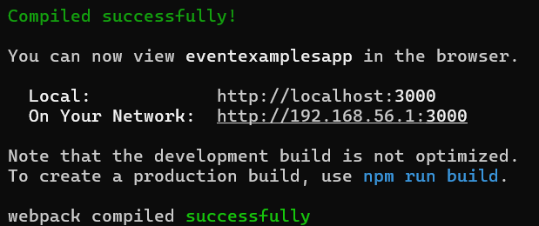

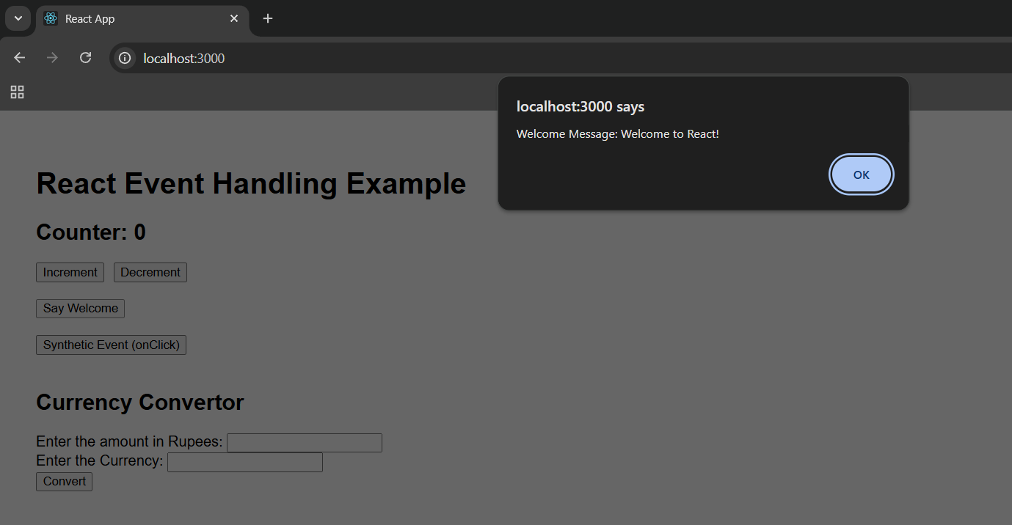

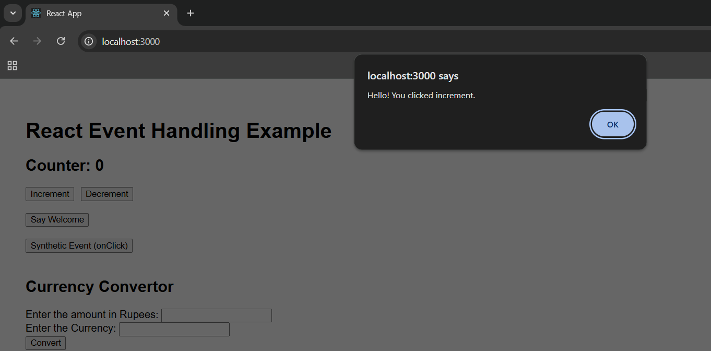

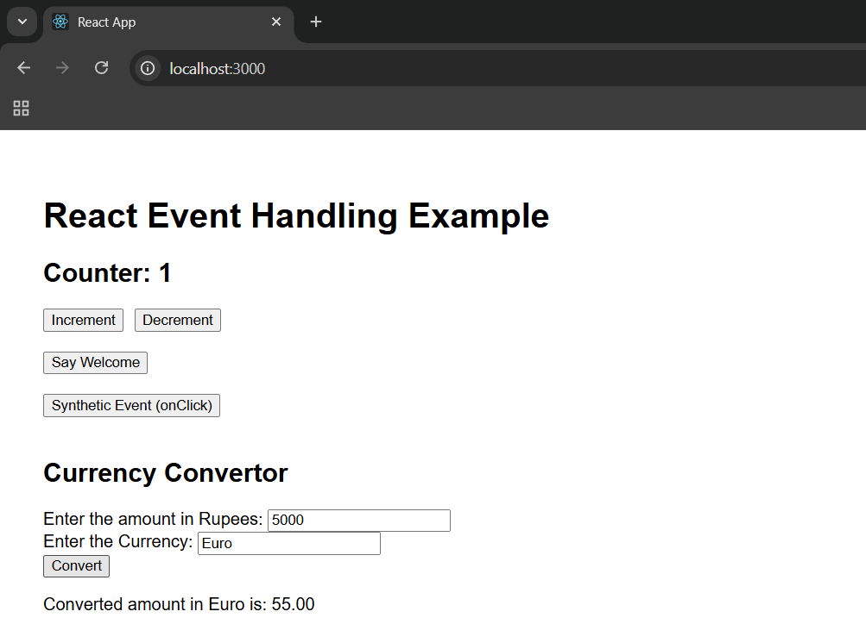

**File name: 12.ReactJS-HOL**

**Program:**

* Create a react project named ticketbookingapp using the command

npx create-react-app ticketbookingapp

* Open the folder in vs code editor and create a folder named components in src folder. In components folder Guestpage.js,UserPage.js.

**GuestPage.js:**

import React from 'react';

function GuestPage() {

  return (

    <div>

      <h2>Welcome Guest</h2>

      <p>Here are some available flight details:</p>

      <ul>

        <li>Flight 101 - Chennai to Delhi - ₹4500</li>

        <li>Flight 205 - Bengaluru to Mumbai - ₹3800</li>

        <li>Flight 303 - Kolkata to Hyderabad - ₹5000</li>

      </ul>

    </div>

  );

}

export default GuestPage;

**UserPage.js:**

import React from 'react';

function UserPage() {

  return (

    <div>

      <h2>Welcome User</h2>

      <p>You can now book tickets:</p>

      <ul>

        <li>Flight 101 - Book Now</li>

        <li>Flight 205 - Book Now</li>

        <li>Flight 303 - Book Now</li>

      </ul>

    </div>

  );

}

export default UserPage;

* Modify the App.js in the src folder.

**App.js:**

import React, { useState } from 'react';

import GuestPage from './components/GuestPage';

import UserPage from './components/UserPage';

function App() {

  const [isLoggedIn, setIsLoggedIn] = useState(false);

  const handleLoginLogout = () => {

    setIsLoggedIn(!isLoggedIn);

  };

  return (

    <div style={{ padding: "40px", fontFamily: "Arial" }}>

      <h1>Flight Ticket Booking App</h1>

      <button onClick={handleLoginLogout}>

        {isLoggedIn ? 'Logout' : 'Login'}

      </button>

      <hr />

      {isLoggedIn ? <UserPage /> : <GuestPage />}

    </div>

  );

}

export default App;

**Output:**

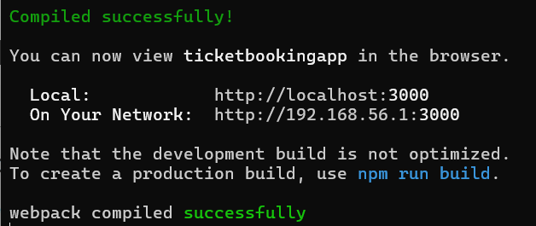

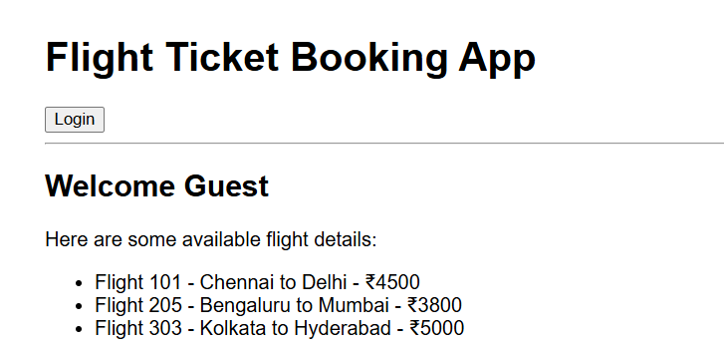

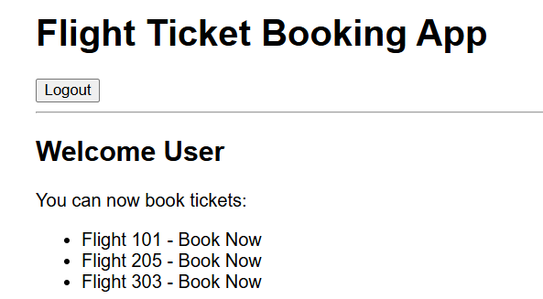

**File name: 13.ReactJS-HOL**

**Program:**

* Create a react project named bloggerapp using the command npx create-react-app bloggerapp.
* Open the folder in the vscode editor and create a folder named components in src folder.
* In components folder create BookDetails.js,BlogDetails.js,CourseDetails.js.

**BookDetails.js:**

import React from 'react';

function BookDetails() {

  return (

    <div>

      <h2>Book Details</h2>

      <ul>

        <li>Title: React Fundamentals</li>

        <li>Author: Dan Abramov</li>

        <li>Price: ₹450</li>

      </ul>

    </div>

  );

}

export default BookDetails;

**BlogDetails.js:**

import React from 'react';

function BlogDetails() {

  return (

    <div>

      <h2>Blog Details</h2>

      <ul>

        <li>Title: Why Learn React?</li>

        <li>Author: Sophie Alpert</li>

        <li>Date: July 2025</li>

      </ul>

    </div>

  );

}

export default BlogDetails;

**CourseDetails.js:**

import React from 'react';

function CourseDetails() {

  return (

    <div>

      <h2>Course Details</h2>

      <ul>

        <li>Name: Full Stack Web Development</li>

        <li>Duration: 3 Months</li>

        <li>Platform: Coursera</li>

      </ul>

    </div>

  );

}

export default CourseDetails;

* Modify the App.js in src folder.

**App.js:**

import React, { useState } from 'react';

import BookDetails from './components/BookDetails';

import BlogDetails from './components/BlogDetails';

import CourseDetails from './components/CourseDetails';

function App() {

  const [showBook, setShowBook] = useState(true);

  const [showBlog, setShowBlog] = useState(true);

  const [showCourse, setShowCourse] = useState(true);

  return (

    <div style={{ padding: "40px", fontFamily: "Arial" }}>

      <h1>Blogger App - Conditional Rendering</h1>

      <div style={{ marginBottom: "20px" }}>

        <label>

          <input

            type="checkbox"

            checked={showBook}

            onChange={() => setShowBook(!showBook)}

          />

          Show Book Details

        </label>

        <label style={{ marginLeft: "20px" }}>

          <input

            type="checkbox"

            checked={showBlog}

            onChange={() => setShowBlog(!showBlog)}

          />

          Show Blog Details

        </label>

        <label style={{ marginLeft: "20px" }}>

          <input

            type="checkbox"

            checked={showCourse}

            onChange={() => setShowCourse(!showCourse)}

          />

          Show Course Details

        </label>

      </div>

      <div style={{ display: "flex", gap: "0px", alignItems: "flex-start" }}>

        {showBook && (

          <div style={{ padding: "10px" }}>

            <BookDetails />

          </div>

        )}

        {showBlog && (

          <div style={{ padding: "10px", borderLeft: "3px solid green" }}>

            <BlogDetails />

          </div>

        )}

        {showCourse && (

          <div style={{ padding: "10px", borderLeft: "3px solid green" }}>

            <CourseDetails />

          </div>

        )}

      </div>

    </div>

  );

}

export default App;

* Run the project using npm start command and run the url <http://localhost:3000/> in the browser.

**Output:**

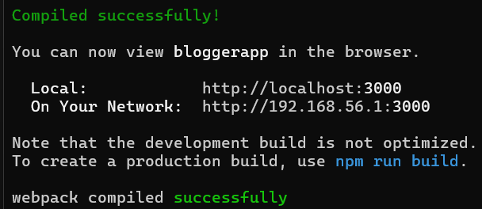

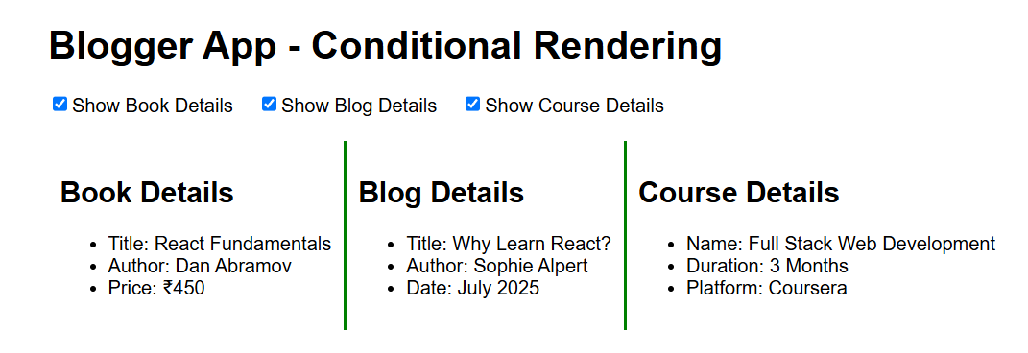

# Additional Important HandsOn

**File name: 14.ReactJS-HOL**

**Program:**

* Download and unzip ,Open the zip file vs code editor create a file ThemeContext.js in src folder and modify the files
* In the terminal install using the Command

npm install

npm start

* It will opoen the browser in the url http://localhost:3000/

**ThemeContext.js:**

import React from 'react';

const ThemeContext = React.createContext('light');

export default ThemeContext;

**EmployeesList.js:**

import React from 'react';

import EmployeeCard from './EmployeeCard';

function EmployeesList() {

  const employees = [

    { id: 1, name: 'John Doe', role: 'Frontend Developer' },

    { id: 2, name: 'Jane Smith', role: 'Backend Developer' }

  ];

  return (

    <div>

      {employees.map(emp => (

        <EmployeeCard key={emp.id} employee={emp} />

      ))}

    </div>

  );

}

export default EmployeesList;

**EmployeeCard.js:**

import React, { useContext } from 'react';

import ThemeContext from './ThemeContext';

function EmployeeCard({ employee }) {

const theme = useContext(ThemeContext);

const handleClick = () => {

alert(`Profile: ${employee.name}, Role: ${employee.role}`);

};

return (

<div style={{ marginBottom: '20px', padding: '10px' }}>

<h3>{employee.name}</h3>

<p>Role: {employee.role}</p>

<button

className={theme === 'light' ? 'light-btn' : 'dark-btn'}

onClick={handleClick}

>

View Profile

</button>

</div>

);

}

export default EmployeeCard;

**Index.js:**

import React from 'react';

import ReactDOM from 'react-dom';

import App from './App';

ReactDOM.render(

  <App />,

  document.getElementById('root')

);

**App.css:**

.light-btn {

  background-color: #f0f0f0;

  color: black;

  border: 1px solid gray;

  padding: 8px;

}

.dark-btn {

  background-color: #333;

  color: white;

  border: 1px solid black;

  padding: 8px;

}

**App.js:**

import React, { useState } from 'react';

import EmployeesList from './EmployeesList';

import ThemeContext from './ThemeContext';

import './App.css';

function App() {

  const [theme, setTheme] = useState('light');

  const toggleTheme = () => {

    setTheme(prev => (prev === 'light' ? 'dark' : 'light'));

  };

  return (

    <ThemeContext.Provider value={theme}>

      <div className="App">

        <h1>Employee Management</h1>

        <button onClick={toggleTheme}>

          Toggle Theme

        </button>

        <EmployeesList />

      </div>

    </ThemeContext.Provider>

  );

}

export default App;

* Now the page will show the employee profiles .

**Output:**

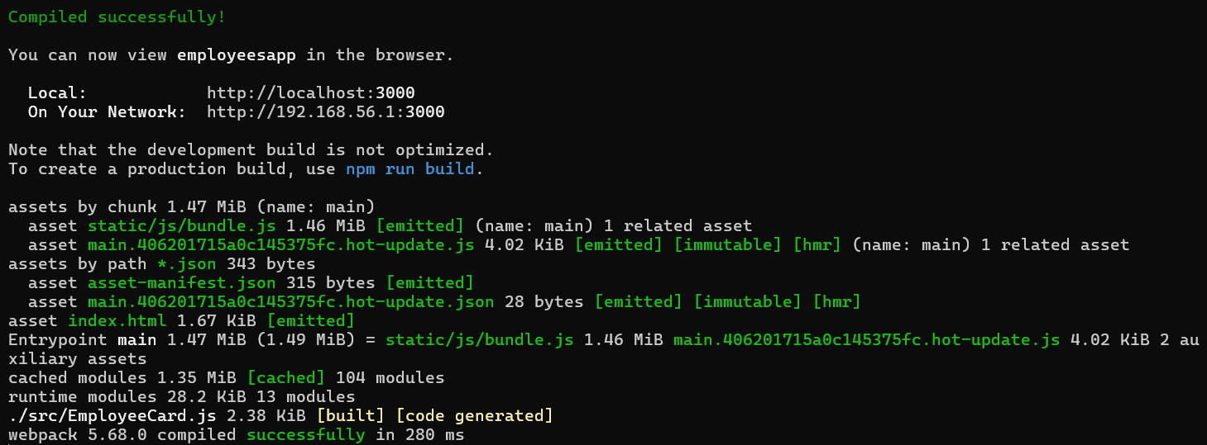

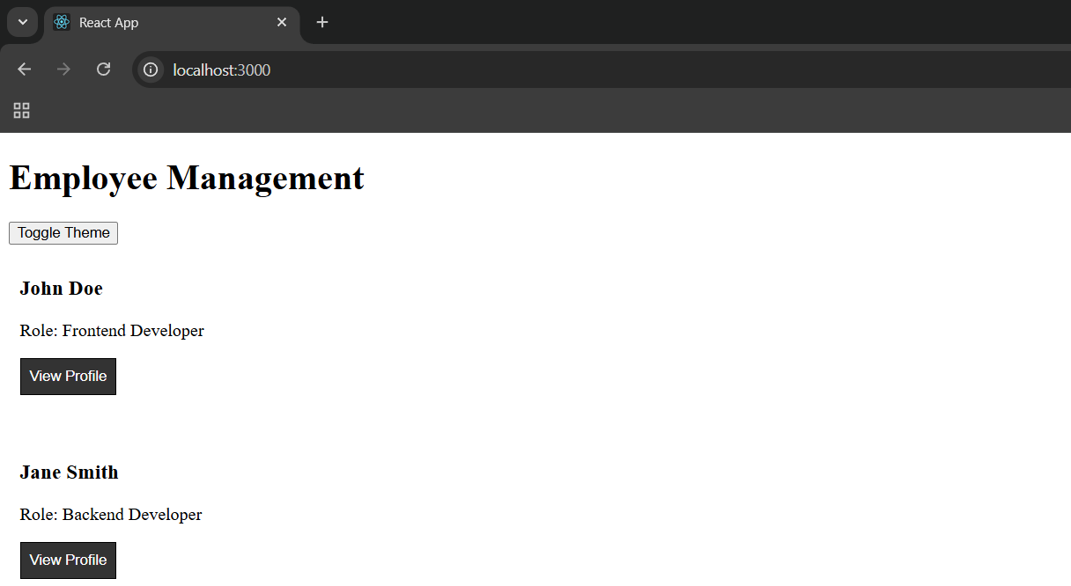

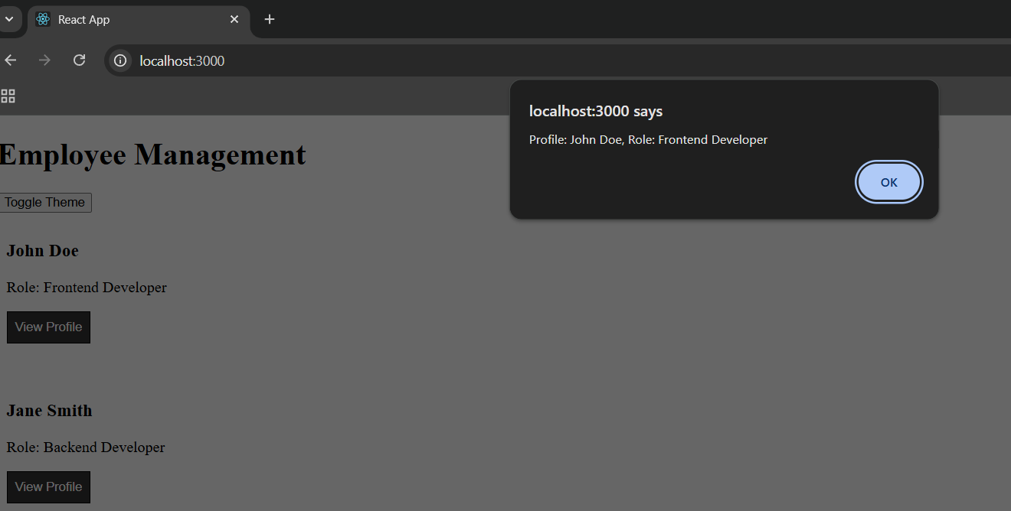

**File name: 15.ReactJS-HOL**

**Program:**

* Create a react app named ticketraisingapp using the following command

npx create-react-app ticketraisingapp

* Open the folder in the vscode editor and create a folder components in src folder. In components folder create file ComplaintRegister.js

**ComplaintRegister.js:**

import React, { useState } from 'react';

function ComplaintRegister() {

  const [employeeName, setEmployeeName] = useState('');

  const [complaint, setComplaint] = useState('');

  const handleSubmit = (e) => {

    e.preventDefault();

    const refNumber = Math.floor(100000 + Math.random() * 900000);

    alert(`Complaint registered successfully!\nReference Number: ${refNumber}`);

    setEmployeeName('');

    setComplaint('');

  };

  return (

    <div style={{

      textAlign: 'center',

      display: 'flex',

      flexDirection: 'column',

      alignItems: 'center',

      justifyContent: 'center',

      minHeight: '100vh'

    }}>

      <h2 style={{ color: 'red' }}>Register your complaints here!!!</h2>

      <form onSubmit={handleSubmit} style={{ width: '400px' }}>

        <div style={{ marginBottom: '20px' }}>

          <label>Employee Name:</label><br />

          <input

            type="text"

            value={employeeName}

            onChange={(e) => setEmployeeName(e.target.value)}

            required

            style={{ width: '100%', padding: '8px' }}

          />

        </div>

        <div style={{ marginBottom: '20px' }}>

          <label>Complaint:</label><br />

          <textarea

            rows="4"

            cols="50"

            value={complaint}

            onChange={(e) => setComplaint(e.target.value)}

            required

            style={{ width: '100%', padding: '8px' }}

          />

        </div>

        <button type="submit" style={{ padding: '10px 20px' }}>

          Submit Complaint

        </button>

      </form>

    </div>

  );

}

export default ComplaintRegister;

* Modify the App.js in the src folder.

**App.js:**

import React from 'react';

import ComplaintRegister from './components/ComplaintRegister';

function App() {

  return (

    <div className="App" style={{ padding: "30px", fontFamily: "Arial" }}>

      <h1>Ticket Raising App</h1>

      <ComplaintRegister />

    </div>

  );

}

export default App;

* Run the folder using npm start command and the url <http://localhost:3000/> in the browser.

**Output:**

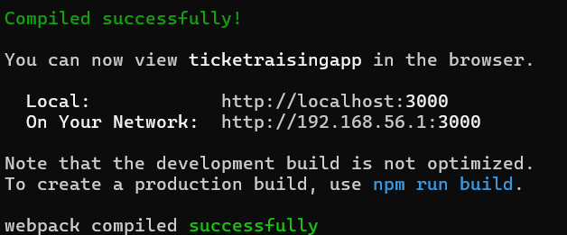

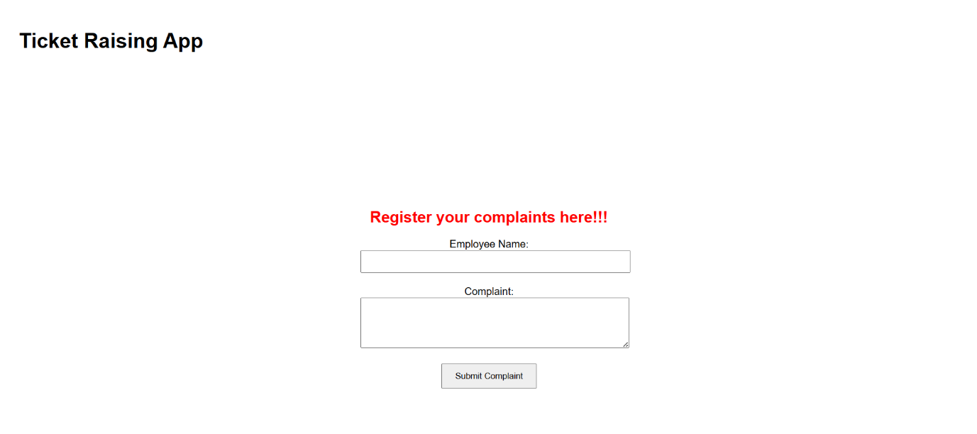

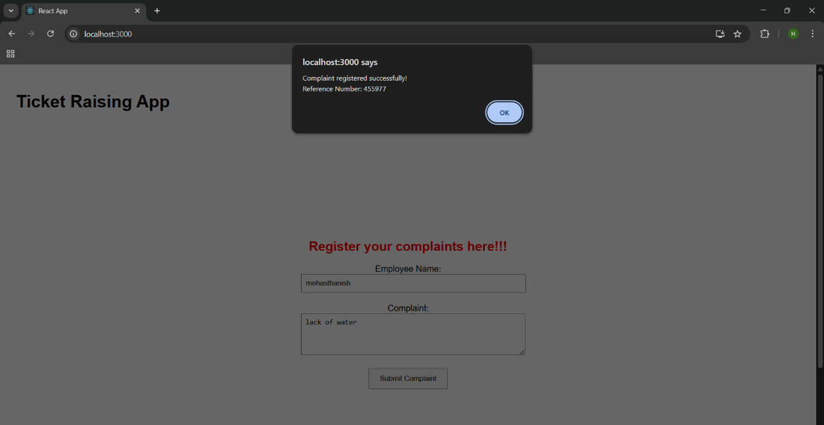

**File name: 16.ReactJS-HOL**

**Program:**

* Create a react app named mailregisterapp using command npx create-react-app mailregisterapp
* Open the folder in the vscode editor
* Create a folder components in src folder and create a file register.js in components folder.

**Register.js:**

import React, { useState } from 'react';

function Register() {

  const [name, setName] = useState('');

  const [email, setEmail] = useState('');

  const [password, setPassword] = useState('');

  const [errors, setErrors] = useState({});

  const validate = () => {

    let errors = {};

    if (name.trim().length < 5) {

      errors.name = 'Name must be at least 5 characters';

    }

    if (!email.includes('@') || !email.includes('.')) {

      errors.email = 'Email must contain "@" and "."';

    }

    if (password.length < 8) {

      errors.password = 'Password must be at least 8 characters';

    }

    return errors;

  };

  const handleSubmit = (e) => {

    e.preventDefault();

    const validationErrors = validate();

    setErrors(validationErrors);

    if (Object.keys(validationErrors).length === 0) {

      alert('Registration Successful!');

      setName('');

      setEmail('');

      setPassword('');

    }

  };

  return (

    <div style={{ width: '400px', margin: '0 auto', padding: '20px' }}>

      <h2 style={{ color: 'blue', textAlign: 'center' }}>Register Here</h2>

      <form onSubmit={handleSubmit}>

        <div>

          <label>Name:</label><br />

          <input

            type="text"

            value={name}

            onChange={(e) => setName(e.target.value)}

          />

          {errors.name && <p style={{ color: 'red' }}>{errors.name}</p>}

        </div>

        <div>

          <label>Email:</label><br />

          <input

            type="email"

            value={email}

            onChange={(e) => setEmail(e.target.value)}

          />

          {errors.email && <p style={{ color: 'red' }}>{errors.email}</p>}

        </div>

        <div>

          <label>Password:</label><br />

          <input

            type="password"

            value={password}

            onChange={(e) => setPassword(e.target.value)}

          />

          {errors.password && <p style={{ color: 'red' }}>{errors.password}</p>}

        </div>

        <br />

        <button type="submit">Register</button>

      </form>

    </div>

  );

}

export default Register;

* Modify the App.js in src folder

**App.js:**

import React from 'react';

import Register from './components/register';

function App() {

  return (

    <div className="App">

      <Register />

    </div>

  );

}

export default App;

* Run the app using the npm start command and run the url <http://localhost:3000/> in the browser.

**Output:**

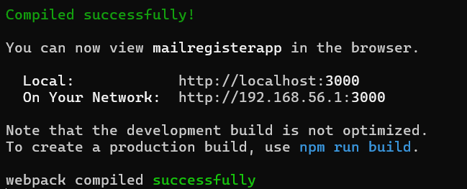

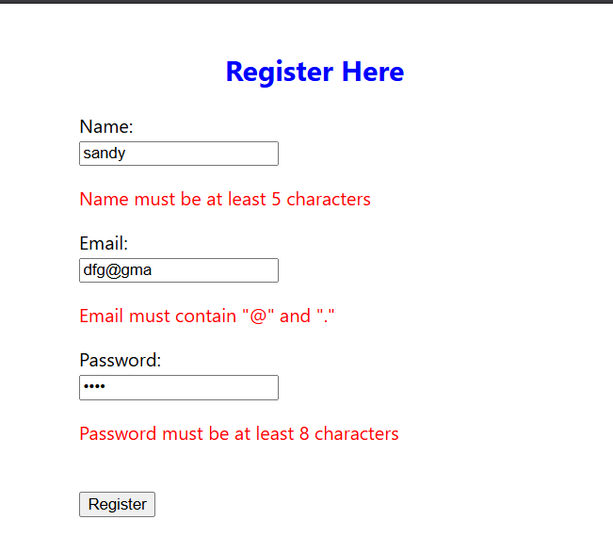

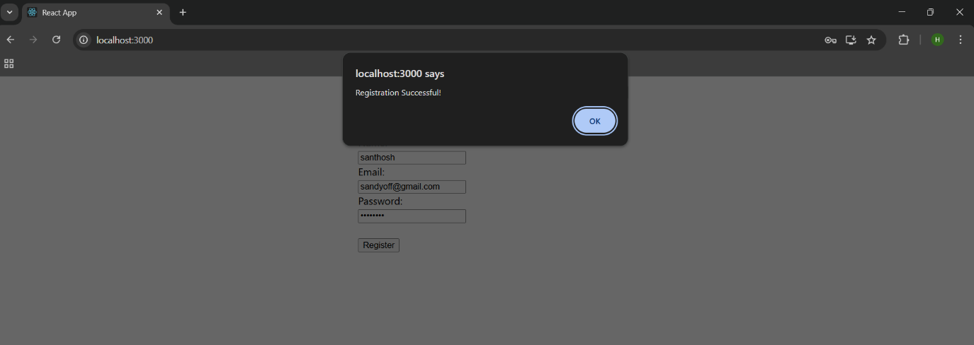

**File name: 17.ReactJS-HOL**

**Program:**

* Create a react app named fetchuserapp using the command npx create-react-app fetchuserapp
* Open the app in the vs code editor and create folder named components and create a file GetUser.js in components folder.

**GetUser.js:**

import React, { Component } from 'react';

class Getuser extends Component {

  constructor(props) {

    super(props);

    this.state = {

      firstName: '',

      imageUrl: '',

    };

  }

  componentDidMount() {

    // Generate a random ID between 1 and 70 (pravatar supports 1–70)

    const randomId = Math.floor(Math.random() * 70) + 1;

    const fakeNames = ['Alice', 'Bob', 'Charlie', 'David', 'Eva', 'Frank', 'Grace', 'Henry'];

    const randomName = fakeNames[Math.floor(Math.random() * fakeNames.length)];

    this.setState({

      firstName: randomName,

      imageUrl: `https://i.pravatar.cc/150?img=${randomId}`,

    });

  }

  render() {

    const { firstName, imageUrl } = this.state;

    return (

      <div style={{ textAlign: 'center', marginTop: '50px' }}>

        <h2>User Profile    </h2>

        <p><strong>First Name:</strong> {firstName}</p>

        {imageUrl ? (

          <img src={imageUrl} alt="User" width="150" height="150" style={{ borderRadius: '50%' }} />

        ) : (

          <p>Loading image...</p>

        )}

      </div>

    );

  }

}

export default Getuser;

* Modify the App.js in src folder.

**App.js:**

import React from 'react';

import Getuser from './components/GetUser';

function App() {

  return (

    <div className="App">

      <Getuser />

    </div>

  );

}

export default App;

* Run the app using the npm start command and run the url <http://localhost:3000/> in the browser.

**Output:**

