EMSENSING TECHNOLOGIES PRIVATE LIMITED

DEVICE MASTER FILE

DRIPSET

[As per Part-III, App-I, 4th schedule of Medical Device Rule- 2017]
Emsensing technologies private limited, C3A, IHub building, AMTZ Campus, Pragati Maidan, VM Steel project S. O, Visakhapatnam, Andhra Pradesh – 530031

 | Name | Designation | Signature | Date
Prepared by | CH. Rebcha Jashmitha | Quality and Regulatory engineer |  | 10/07/2026
Reviewed by | Dr. A. Lakshmi Sangeetha | QA/RA Head |  | 10/07/2026
Approved by | Dr. A. Balaji Ganesh | Director/CEO |  | 10/07/2026

CHAPTER 1
- Executive summary
DripSet is an IV monitoring and control device.
Manual or software enabled motor driven IV - fluid Infusion controller or DripSet (brand name) is an IV monitoring and controlling device consisting of two enclosures connected by electrical wires.
- The upper enclosure is made up of ABS, features a protection shield for the display board, a knob (encoder) for adjusting input values like flow rates, infusion time, and volume, and two push buttons for power and pause functions. The bottom enclosure houses the motor (stepper, 3.3V), OLED display board (1.5-inch), main PCB, and a Li-ion battery (1500 mAh, 3.7V).
- It also includes two sensors: A (hall sensor) for motor position detection and B (air bubble sensor) for sensing air bubbles in the IV tube. Additionally, sensor C is located in the upper enclosure.

  - Device Description- intended use, indication for use, classification, shelf life
Intended use
DripSet is intended to be attached to the Drip enclosure by the twin clamp placed in the lower groove of the device. The IV- tube inbuilt with the drip chamber will pass through the controlling part of this Device. This device shall be intended for use in healthcare settings to monitor and control the flow rate of intravenous (IV) fluids.

Indication for use
The Dripset, a manual or software enabled Motor driven IV- Fluid infusion controller, is indicated for use by the trained nurse in a hospital to set up for the control of IV- fluid in patients.

Classification
The risk-based classification for the device DripSet is Class C (Moderate to High risk).

Shelf life
Manual or software enabled motor driven IV - fluid Infusion
controllers have a shelf life of 5 years.

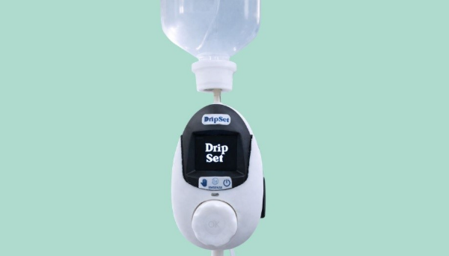

  - Sterilization Information
DripSet only attaches to the drip chamber of the IV tube and does not come into direct contact with the patient, fluids, or bloodstream. Since the device does not penetrate the body or interact with sterile pathways, there is no risk of introducing contaminants into the patient’s system. The device functions as an external monitoring and control system, and so it does not require any sterility for operation. Standard cleaning protocols are sufficient to ensure the device remains the same for use.
Therefore, we declare that the Dripset does not meet the criteria for sterilization and so the validation data is not required.

  - Risk Management
Emsensing establishes the risk acceptability criteria and risk management plan. Emsensing establishes and maintains the process for risk management and maintains risk register file (ETPL/F/28) related to the process and product.
Reference:
SOP for Risk Management (ETPL/SOP/QMS/10)
Risk register file (ETPL/F/28)

Risk Identification
Based on the Context (Area/Activity), risks are identified by the QA/RA Head in consultation with Top Management. Based on the threats, the Risks are identified. Risks will be identified (not limited to) from the process listed down below:
- Compliance to applicable regulatory requirements
- Design input stage
- Design and Development stages
- Selection of Materials
- Preparation and maintaining of Medical Device File
- Validation and re-validation of the process
- Supplier – Selection, Evaluation, Re-evaluation, Performance Monitoring
- Supplier including Outsourced Process Control.
- Supplier not fulfilling purchasing requirements
- Purchasing of components and constituent parts
- Availability of components and constituent parts after delivery
- Verification of the purchased products
- Storing conditions, FIFO
- Product realization process
- Software installation control
- Inspection / Testing before releasing
- Calibration of the Equipment
- Packing & Labeling specification
- Shipping and Handling
- Operation and Handling Methods (end customer)
- Handling of customer complaints
- Actions for Internal / External Non-Conformances
- Negative Feedback
- Upskilling
- QMS Implementation
Risk analysis
Risk analysis involves consideration of the causes and sources of risk, their positive and negative consequences, and the likelihood/probability that those consequences can occur. This is done by the QR engineer in consultation with the Director/CEO.

Risk Evaluation
Risk evaluation involves comparing the level of risk found during the analysis process with risk criteria established when the context was considered and done by the QA/RA Head.
Severity: Assess the potential impact of each risk on patient safety, ranging from minor discomfort to life-threatening conditions.
Likelihood: Determine the probability of each risk occurrence based on device history, user feedback, and industry standards.

Risk treatment/ mitigation
Risk Treatment is suggested by the QR in consultation with top management (Director/CEO). Risk treatment involves a cyclical process of:
- assessing a risk treatment/mitigation;
- deciding whether residual risk levels are tolerable;
- if not tolerable, generating a new risk treatment/mitigation; and
- assessing the effectiveness of that treatment/mitigation.
Risk Monitoring and reporting
- Implement a system for continuous monitoring of device performance and user feedback to identify emerging risks
Reference: SOP for Customer feedback (ETPL/SOP/QMS/05)
- Establish a reporting mechanism for adverse events and device malfunctions, ensuring compliance with regulatory requirements.

Review and Improvement
- Regularly review the risk management plan considering new data, technological advancements, and regulatory changes.
- Update risk control measures based on effectiveness and introduced new controls as necessary.

  - Clinical Evaluation
DripSet has a predicate device, so it does not require any clinical evidence.

  - Design examination certificate, declaration of conformity 1
Design and patent of DripSet is wholly owned by the Emsensing Technologies Pvt Ltd as ‘INTERNET OF THINGS ENABLED DETACHABLE INTRAVENOUS FLUID FLOW MONITOR AND CONTROL DEVICE’

  - Marketing history
Not into the market yet.

  - Domestic Price
Selling price: INR 29999 including 5% GST

  - List of regulatory approvals
- Test License by May 2024
License No: SW/MD/MD-13/2024/00000135
- Manufacturing license: 15/12/2025
License No.: MFG/MD/2025/000821

  - Safety and performance related information Safety
- Ensure the device is powered off before cleaning.
- Disconnect the Dripset device from any power source or the IV set.
- Remember, the device should not be immersed in any liquid.
- Use a soft, dry, lint-free cloth to gently wipe the external surface of the device. This will help remove dust and superficial contaminants.
- For more stubborn stains or residues, slightly dampen the cloth (not wet) with a mild detergent solution or isopropyl alcohol. Ensure the cloth is only mildly damp to prevent any liquid from entering the device or damaging the electronic components.
- Wipe down the device with this slightly damp cloth and then follow immediately with a dry cloth.
- It’s essential that no moisture remains on the device. After cleaning with a slightly damp cloth, ensure the device is entirely dried using a dry cloth.
Performance related information
The performance of the device is based on the following parameters,
- Increment counting
- Flow range
- Volume to be infused selector
- Pause infusion facility
- Free flow protection
- Air Bubble detection
- OLED test

CHAPTER 2

- Device description and product specifications
  - Descriptive information
Manual or software enabled motor driven IV - fluid Infusion controller or DripSet (brand name) is an IV monitoring and controlling device consisting of two enclosures connected by electrical wires.
- The upper enclosure is made up of ABS, features a protection shield for the display board, a knob (encoder) for adjusting input values like flow rates, infusion time, and volume, and two push buttons for power and pause functions. The bottom enclosure houses the motor (stepper, 3.3V), OLED display board (1.5-inch), main PCB, and a Li-ion battery (1500 mAh, 3.7V).
- It also includes two sensors: A (hall sensor) for motor position detection and B (air bubble sensor) for sensing air bubbles in the IV tube. Additionally, sensor C is located in the upper enclosure.

  - Product specifications
General Specifications
- Device Type: Integrated hardware, firmware, and software device
- Primary Use: Monitoring and controlling fluid flow through IV tubes for patients
- Communication: Encrypted communication with centralized cloud mo, web consoles, and mobile devices
- Authentication: Two-factor authentication for device control via mobile phone or web console

Power and Connectivity
- Power On Mechanism: Touch power button
- Power Sources: Battery supply or AC power (via power adaptor)
- Wi-Fi Connectivity: When a valid mobile network is available near the device, it connects automatically.
- Automatic connection to pre-stored SSID and credentials
- 60-second wait time for new SSID connection, manual entry through a webpage
- Scans for Wi-Fi only upon power on

Operational modes
The device has only one operating mode:
Normal Mode - Wi-Fi can be enabled when remote monitoring and control are required. Enabling Wi-Fi does not change the operating mode of the device.

User Interface and Control
Main Screen Displays
- Wi-Fi and BLE connectivity status
- Flow health and battery percentage
- Flow rate in ml/min, infusion time, volume infused (VTBI), and RPM
- Control Mechanism: Rotary button with push option
- Adjustable Settings: Flow rate, infusion time, drip quantity
- Transition time of 1.5 minutes between steady-state flows
Monitoring and Alerts
- Flow Monitoring: Auto-adjusts based on drop count and pressure levels
- Error Detection: Monitors sensor data, displays error messages, and stops flow in case of issues
- Infusion Completion: Signals through display messages, mobile app, web interface, and buzzer sound
Additional Features
- Centralized Application: Cloud-based application for monitoring and controlling devices in a healthcare setting
- Mobile Interface: Allows healthcare professionals to control the device via smartphones
- Transition Time: 1.5 minutes to switch between steady-state flow values
- Reset Functionality: Under development to allow resetting of set values
- A removable clamp has been incorporated in the back enclosure of the device to facilitate proper positioning and secure holding of the infusion tube during insertion and operation.
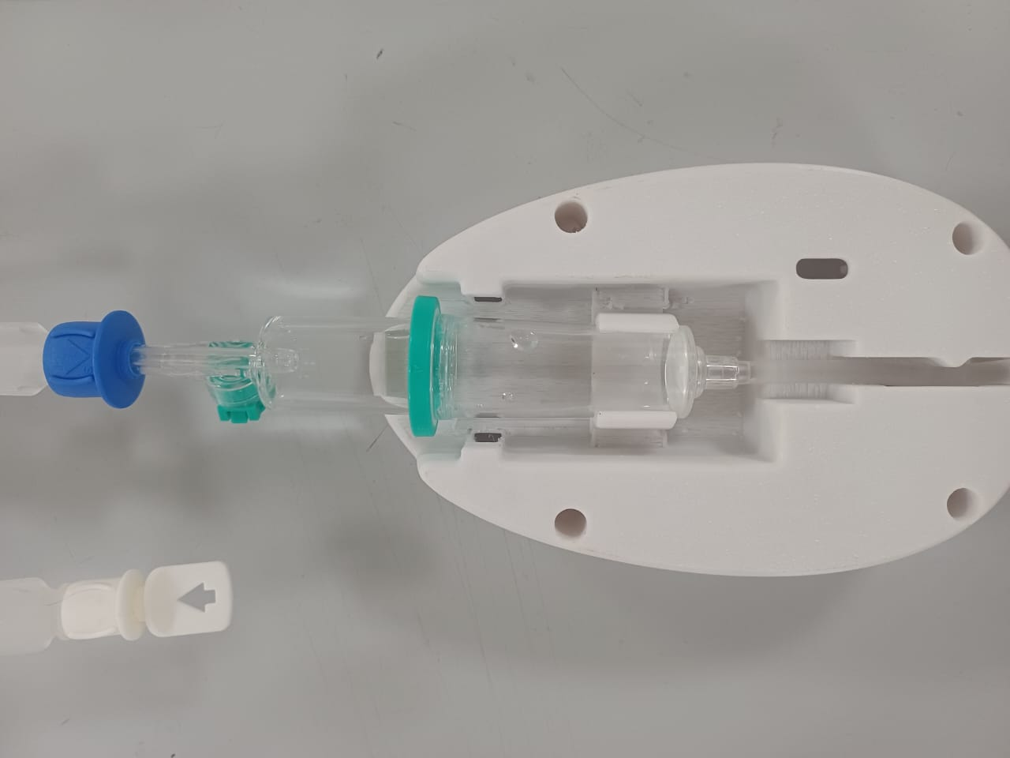
Operation Procedure
- Power On and Initial Setup: Displays the logo and welcome message, prompts for saline insertion.
- Volume Setting: User selects total volume from preset options (100, 250, 500, 750, 1000 ml).
- Mode Selection: Options to choose between remote and manual modes.
- Flow Rate and Infusion Time Adjustment: Through rotary button with real-time display updates.
- Custom Drip Quantity Selection: Options for custom flow rate or infusion time.
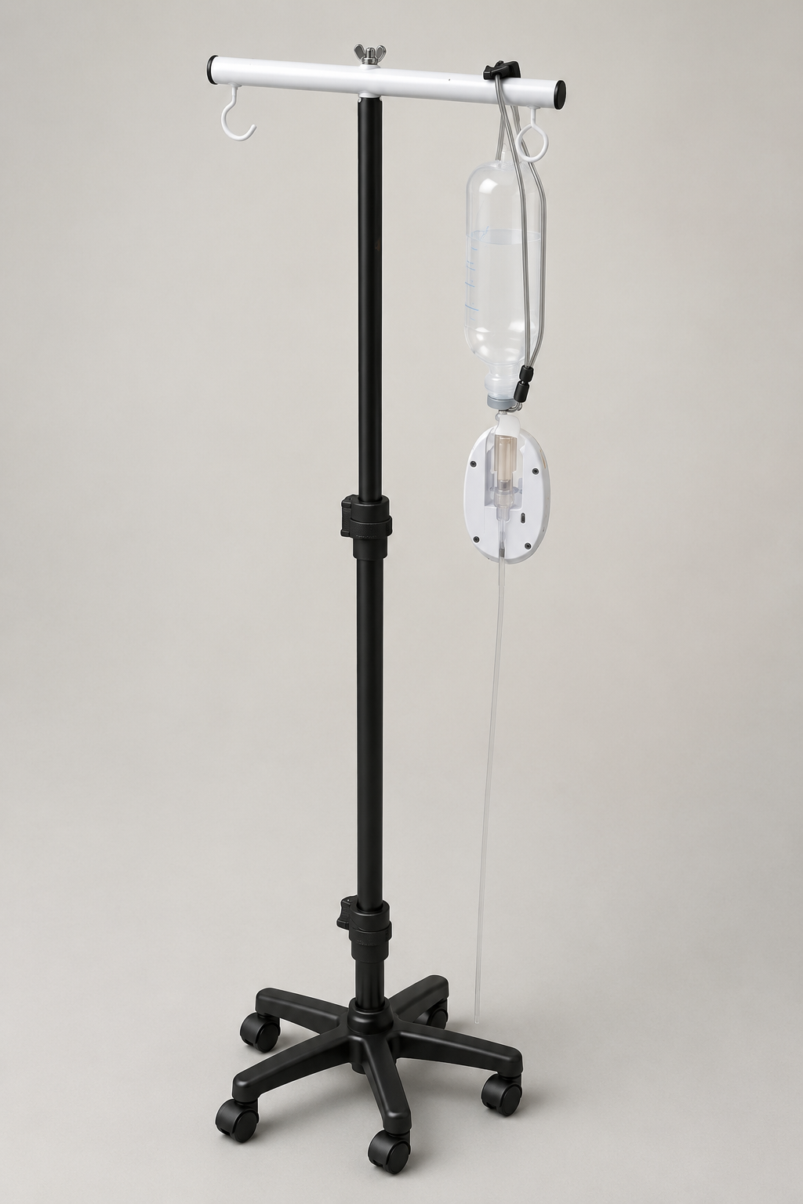
Safety and Security
- Data Security: Encrypted data transmission for enhanced security and patient privacy.
- Device Security: Secure connection protocols for Wi-Fi

  - Reference to the previous or similar generation of device
S. No | Manufacturer name | Devic name | Intended use | Country and regulatory status | Class
1 | Emsensing technologies private limited | Dripset (Brand name) Manual or software enabled motor driven IV-fluid infusion controller  (Generic name) | DripSet is intended to be attached to the Drip chamber by the twin clamp placed in the lower groove of the device. The IV- tube inbuilt with the DRIP chamber will pass through the controlling part of this Device. This device shall be intended for use in healthcare settings to monitor and control the flow rate of intravenous (IV) fluids in | India  Manufacturing license approved | Class C
2 | VTitan Corporation Private Limited | Accuflow Drip Control | Accuflow Drip monitor is intended to be used with the gravity infusion system in care areas to provide accurate and reliable measurement of infusion flow to the patient with the detection of blockage in flow (occlusion) and IV bag empty detection features | India  License no: MFG/MD/2022/ 000296  Issued on: 24 june 2022 | Class C

CHAPTER 3
- Labelling
  - Original Label and Packaging Configuration
- Brand and Product Name: "Dripset".
- Description: "Manual or software enabled motor driven IV- fluid infusion controller".
- Manufacturer's Details: Emsensing Technologies Private Limited, C3 IHub Building, AMTZ Campus, Medivalley, Pragati Maidan, Visakhapatnam 530031, AP, India.
- Batch numbers to be added
- Manufacture Date: Date of Manufacturing
- Regulatory Compliance Marks: Symbols indicating compliance with relevant health and safety regulations.
- Usage Symbols: Do not expose to direct sunlight, do not immerse in liquid or make it wet, do not use with unstable power connections
- QR Code/URL: Link to detailed electronic instructions for use (IFU) and additional resources.
- Bar Code: For inventory and retail purposes.
Reference: SOP for packaging and labelling (ETPL/SOP/QMS/44)
Packaging configuration
Reference: SOP for Preserving conformity of the product (ETPL/SOP/QMS/27)

Primary packaging
- The device is enclosed in a sterile, tamper-evident packaging that maintains sterility until opened.
- Materials are durable to protect against punctures and moisture.

Secondary packaging
- A sturdy box or carton that houses the primary package, providing additional protection during shipping and handling.
- It includes space for the inclusion of accessories like clamps and user manuals.

Packaging Inserts
- A quick start guides with basic setup and usage instructions.
- Detailed user manual with comprehensive usage, maintenance, and safety information.
- Warranty and service information.

Protective materials
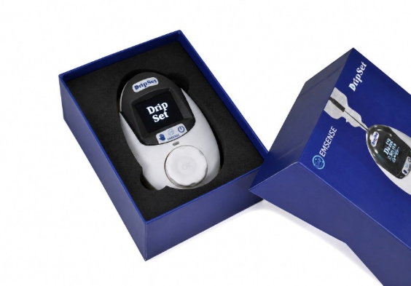
Use of shock-absorbing materials like foam inserts to secure the device within the box, especially important for delicate components.

  - Instruction for Use
Getting started
- Check the packaging for any signs of damage. Do not use it if the package is compromised.
- Carefully remove the DripSet and all accompanying accessories from the box.
- The device and all components are intact. Report any discrepancies or damages immediately.
Initial setup
- Download and install the API from google play store or Apple in the Mobile phone, accordingly.
- Create login credentials in the cloud web server by specifying device code and other user information.
- Connect the device to a power source using the provided power adapter or ensure the battery is fully charged if operating wirelessly.
- Press the touch power button to turn on the DripSet. The welcome screen should display the logo and initialization details.
- Follow on-screen instructions to connect to Wi-Fi or pair with a Bluetooth-enabled device for remote monitoring and control.
Preparing for infusion
- Properly insert the IV-infusion tube into the device according to the diagram in the user manual.
- Ensure the IV line is properly primed to remove any air bubbles and prevent air embolism.
- Use the rotary button to set the desired flow rate, infusion time, and total volume to be infused (VTBI). Confirm settings by pressing the button.
Starting the infusion
- Double-check the flow rate, volume, and time settings on the display screen.
- Press the start button to commence fluid infusion. The device will automatically regulate the flow rate as per the set parameters.

During infusion
- Regularly monitor the infusion progress, checking the device screen for flow rate, infused volume, and remaining time.
- If necessary, adjust the flow rate or volume by pausing the infusion and modifying the settings using the rotary button.

Completing the Infusion
- The device will alert and stop automatically once the set volume has been infused.
- Safely remove the IV tube from the device and the patient's access point, following standard safety protocols.
Post-Infusion
- Clean the device according to the maintenance instructions provided, readying it for its next use.
- Turn off the DripSet by pressing and holding the power button. Disconnect from the power source if not in use.

Troubleshooting and Alarms
Refer to the service manual (ETPL/MN/02) for common issues such as alarm meanings, connectivity problems, or flow errors, and follow the recommended actions.

Safety Precautions
Always adhere to the safety guidelines provided, including contraindications, warnings, and precautions to avoid potential risks.

  - Product brochure

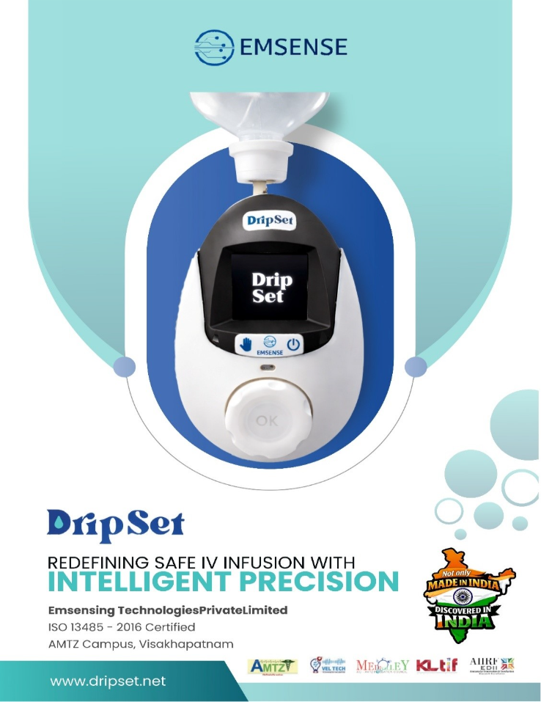

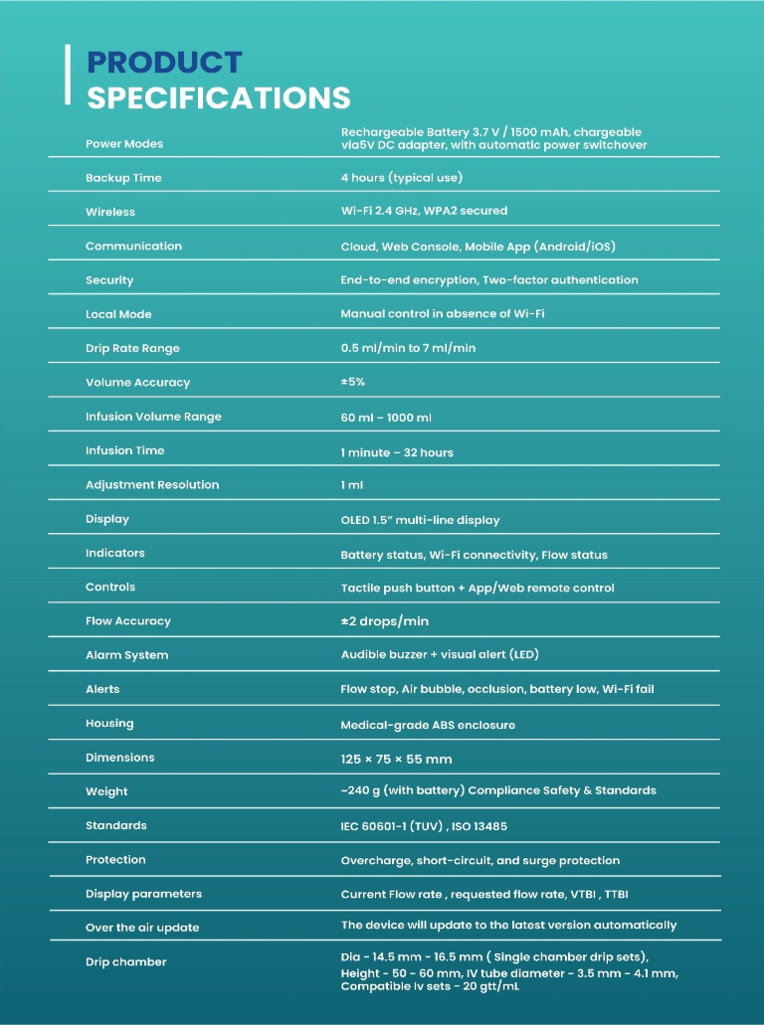

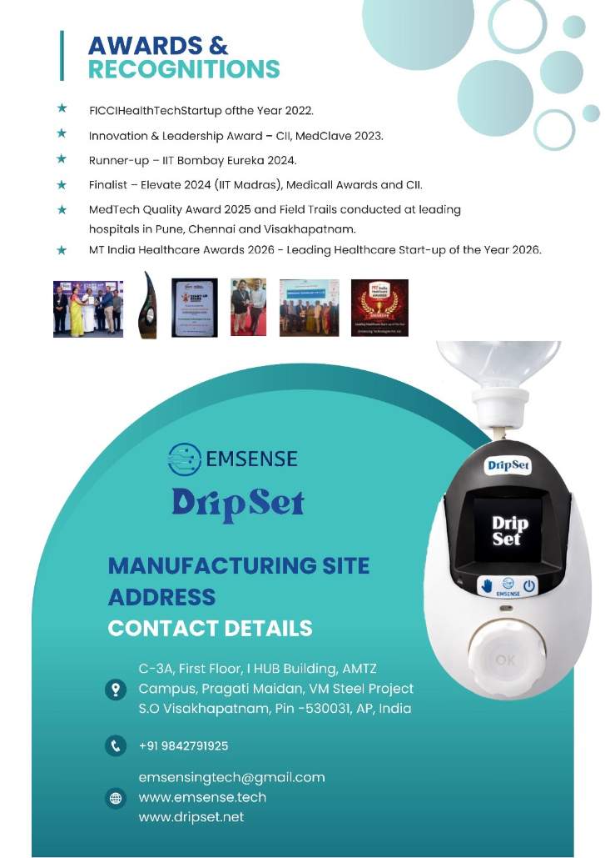

  - Product material
DripSet is made of acrylonitrile butadiene styrene (ABS)

CHAPTER 4
- Design and manufacturing information

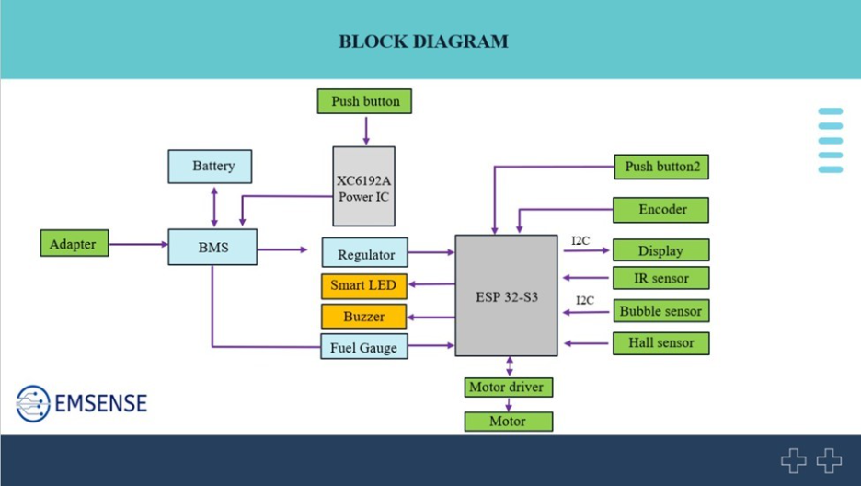

  - Device design
BMS - Battery Management System
IC - Integrated Circuit
LED - Light Emitting Diode
ESP - Electronic Stability Program
IR - Infrared

PCB layout
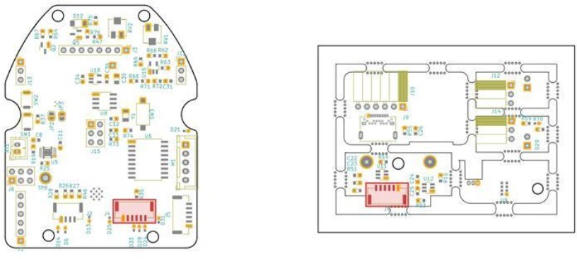

  - Manufacturing process
Raw material inspection
- Raw materials which are delivered from the vendor will go through a quality check to make sure the materials are as per our design requirements
- Enclosures will be visually inspected for any sort of physical damage, scratches or dust.
- PCB will be inspected for proper components, power connections and any damages
- Dimensions will be verified for both enclosures and PCB
- Personnel who perform the quality check will be wearing a proper ESD apron set.
Assembly process
- Only defect free and approved raw materials are used for the assembly of product
- Only clean and qualified tools are used for assembly.
- Personnel who perform the product assembly will be wearing a proper ESD apron set
Firmware programming
- Priorly validated and qualified firmware is embedded into the product
- Final product along with the firmware and software will go through a quality test to ensure that the device, firmware and software align.

Labelling
- Labelling of the product includes name, manufacturer details, manufacturing month and year, batch no, storage conditions and warnings
- Proper placement of label with adequate information will be verified

Packaging
- Packaging of the final product includes bubble wrap and specific packaging box to confirm the safety of the device
- Product will be packed along with the accessories, brochures and manuals
- Proper labelling and packaging will be verified by personnel before moving to the dispatch section

Storage
- Both the raw materials and the final product is stored away from the exposure to direct sunlight
- Raw materials and the final product will be covered always to prevent dust
- Any of the materials will not be exposed to extreme temperature or inappropriate environment
- The material such as raw material, in-process, final products, packing material etc., which are affected by the normal environmental condition viz. contamination, dust, oxidation, etc., are held in stores in original packed conditions under controlled ambient temperature. They are issued to the designer similarly for processing.
- ETPL will protect the product from contamination or damage by designing and constructing suitable packaging/containers.

Manufacturing process flow chart

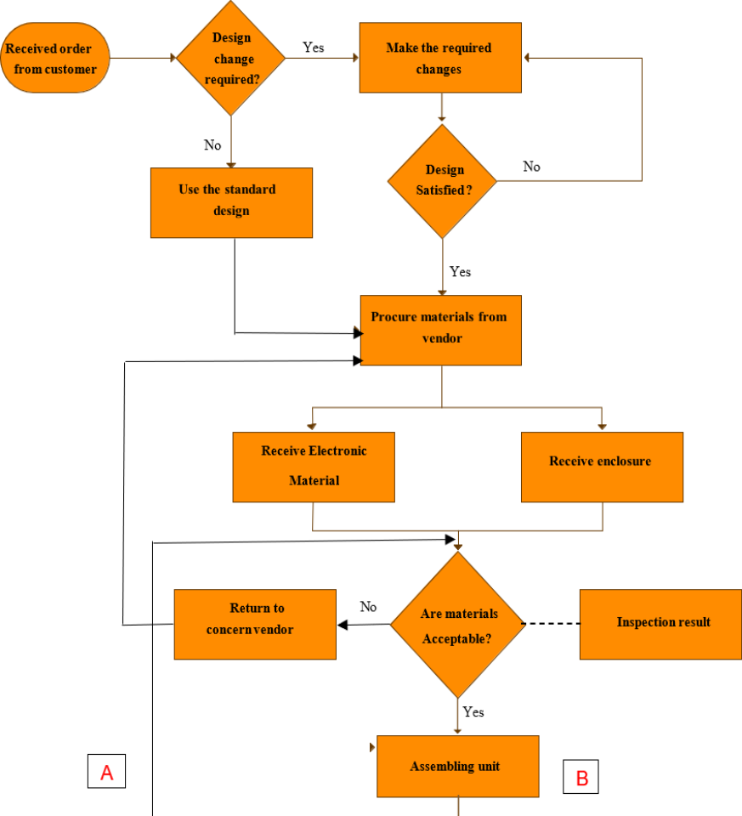

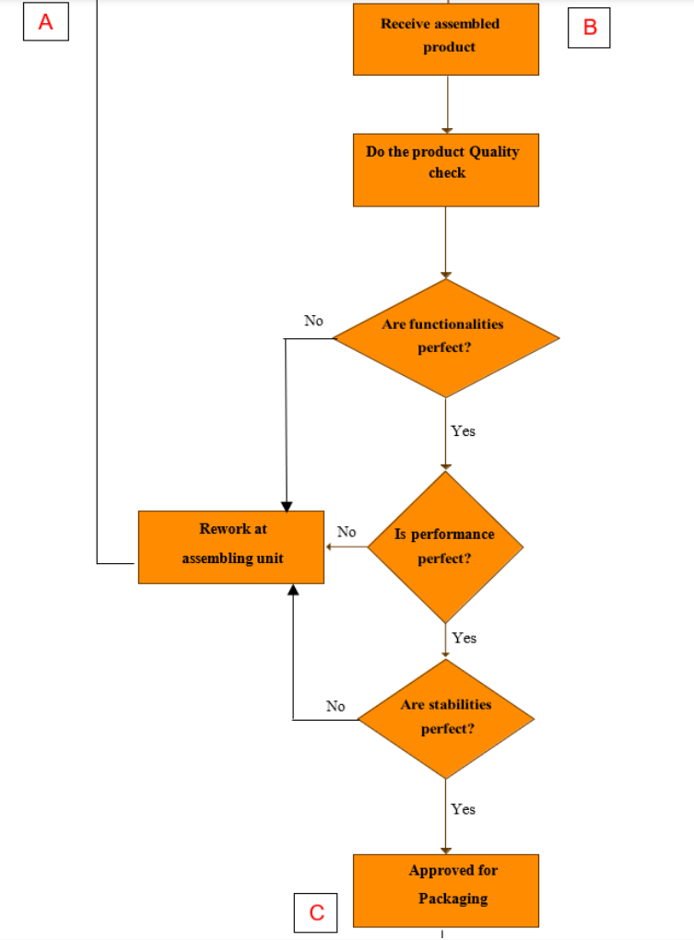

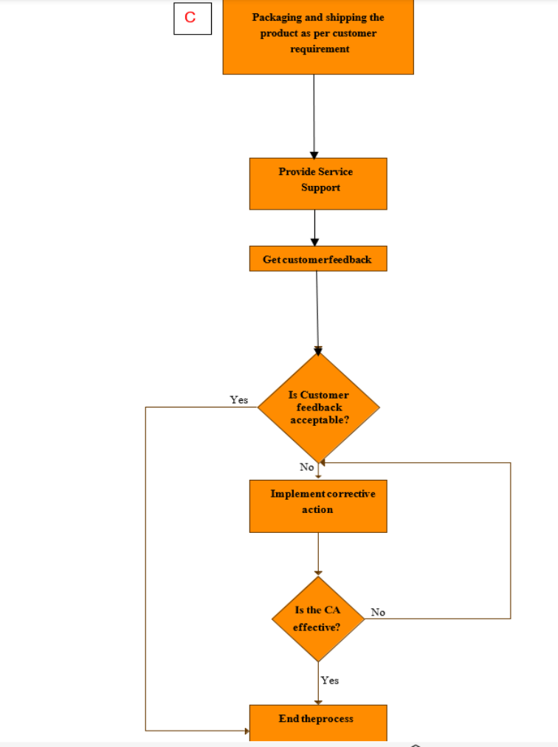

CHAPTER 5
- Essential Principle Checklist
Refer Essential Principle Checklist
CHAPTER 6
- Risk Analysis and Control Summary (ETPL/SOP/QMS/10) (ETPL/F/28) \\
Risk Identification
- Device Malfunction
- Inaccurate flow rate, unintended infusion stoppage, failure to detect air in line.
- Potential Causes: Software errors, mechanical failure, sensor inaccuracies.
- Connectivity Issues
- Loss of remote monitoring/control, delayed alarm notifications.
- Potential Causes: WiFi/Bluetooth interference, service outages, compatibility issues.
- Power Failure
- Unexpected device shutdown, interruption in therapy.
- Potential Causes: Battery depletion, faulty power adapter, power surge.
- User Error
- Incorrect setup, wrong infusion parameters, misinterpretation of alarms.
- Potential Causes: Inadequate training, complex interface, ambiguous instructions.
Risk Evaluation
- We evaluate the impact of each identified risk, from minor (no injury) to critical (potential for serious harm.
- We estimate the likelihood of each risk occurrence, considering device design, user environment, and historical data.
Risk control measures
- Device Malfunction
- We implement robust software testing, regular device maintenance, and real-time monitoring of device performance.
- Connectivity Issues
We provide manual control options, ensure device functionality in the absence of connectivity, and use reliable communication protocols.
- Power Failure
We incorporated battery status indicators, provide visual/audible low battery alerts, and are designed for safe shutdown.
- User Error
We simplify the user interface, provide comprehensive training, and clear, concise instructions for use.
Residual risk evaluation
We ensure that residual risks are acceptable within the context of the device's intended use and the overall benefit risk balance.
Risk benefit Analysis
We conduct a risk benefit analysis to justify the use of the device, considering the effectiveness of risk control measures and the clinical benefits it offers, periodically.
Risk Management and Monitoring
We implement a post market surveillance system to monitor the device's performance in real world settings and update the risk management file as necessary.
Documentation
We maintain comprehensive documentation of all risk management activities, including risk assessments, control measures, and post market surveillance findings, to support continuous improvement and regulatory compliance.

CHAPTER 7
- Verification and validation
  - General
We confirm that the DripSet meets all defined user needs, intended uses, and specified requirements by including laboratory testing, functional testing, and performance testing to ensure the device operates safely and as intended under all anticipated conditions.
  - Biocompatibility
DripSet is only attached to the drip chamber of the IV tube and does not touch the patient or enter the body in any way. Since the device does not interact with IV fluids or the patient, there is no risk of chemical substances leaching from the device into the IV fluid and subsequently entering the patient's bloodstream. Dripset functions as an external monitoring and control device, regulating and monitoring fluid flow without modifying the composition of the IV fluid or affecting biological tissues. The device is not made of any materials that generate particulates or contaminants
Therefore, we declare that the Dripset does not meet the criteria for bio-compatibility concerns, and so the validation data is not required.
  - Medicinal Substances
Dripset only attaches to the IV-drip chamber and does not contact the patient’s body, eliminating the need to track specific medicinal substances. Since it operates based on physical flow parameters (e.g., drop count, flow rate, volume), it does not require data on the type, concentration, or pharmacological properties of the IV fluids. Dripset ensures proper infusion rate regardless of the type of IV fluid. DripSet does not analyze or modify the chemical composition of the substances being infused.
Therefore, we declare that the medicinal substance data is unnecessary for its core functionality.
  - Biological safety
DripSet is only attached to the drip chamber of the IV tube which does not contact the patient’s skin, bloodstream, or internal organs in any of the ways. Dripset does not come into direct contact with IV fluids preventing the contamination or leaching of harmful substances. Since the device does not interface with the patient’s body, there is no risk of adverse reactions due to materials used in the device (e.g., cytotoxicity, sensitization, and irritation).
According to the risk assessment, potential hazards associated with this device are negligible or non-existent.
Therefore, we declare that the Dripset does not meet the criteria for biological safety concerns and so the data is not required.
  - Sterilization
Sterilization is not required as Emsensing does not manufacture any sterile medical devices.
  - Software verification and validation
We ensured that the software components are specified, designed, and tested to be safe, reliable, and perform as intended by applying a structured software development lifecycle approach, including requirements analysis, design verification, code review, static and dynamic analysis, and system testing, in reference to standard ISO/IEC 62304 standard. Conducted an internal software analysis and generated a report.
Reference: SOP for software validation (ETPL/SOP/QMS/31)
Software Validation Form (ETPL/F/80)
  - Animal studies
Animal studies are not required.
  - Stability Data
The DripSet device is a non-invasive, non-sterile, reusable, IoT-enabled intravenous fluid monitoring and control device. The declared shelf life of 5 years is based on component-level technical specifications, risk analysis, and environmental robustness validated through pre-compliance testing (TUV Rheinland, 2025). Below is a detailed justification derived from the specifications of components used in the device.
- Battery – WLY103048 • 1500 mAh • 3.7V lithium-ion battery Single Cell • Supplier: Robu.in • Chemistry: Lithium-Polymer Rechargeable • Rated Charge Cycles: ≥ 500 full cycles • Expected Usage: 1 cycle per 3 days ~ 120 cycles/year → ~600 cycles in 5 years (well within limit) • Self-Discharge: < 3% per month at ambient storage • Shelf Life: Manufacturer data supports 3–5 years under optimal storage • Temperature Range: Charging 0 to 45°C, Discharging -20 to 60°C
The battery is well-suited for long-term use and supports a 5-year operational expectancy under hospital conditions.
- Stepper Motor – 28BYJ-48 DC 5V • Supplier: Robu.in • Rated Lifespan: > 1 million operation cycles • Expected Daily Cycles: Approx. 3 cycles/day → 1000 cycles/year → 5000 cycles in 5 years Page 1 of 160 • Duty Cycle: Low RPM, intermittent operation (drip monitoring adjustments only) • Load Profile: Minimal load – used for dropping adjustment control only.
The motor’s heat is dissipated through the space near the motor shaft. The motor’s mechanical and electrical life significantly exceeds usage demands, making it durable over 5+ years of operation.
- Display – Wave share 1.5-inch OLED, 128×128 • Supplier: Robu.in • Display Type: OLED
Resolution: 128x128 pixels • Rated Life: > 20,000 operating hours • Usage Pattern: 8 hours/day x 365 days → ~3000 hrs/year → ~15,000 hrs in 5 years Within expected operational time frame. OLED remains functional and clear within a defined lifetime.
- Communication Module – ESP32-S3-WROOM-1 • Rated Operating Life: No inherent wear-out mechanism • Supplier: Digi key • Storage Conditions: -40°C to 85°C • Qualification: Industrial-grade RF module with proven long-term operation in IoT applications.
Suitable for long-term embedded use; functionality not affected by shelf storage.
- Enclosure and Housing Material • Material: Medical-grade ABS/PC blend • Environmental Tolerance: Withstands indoor conditions of 15°C to 45°C and RH 40–65%. • Degradation Risk: No significant discoloration or structural change under dry, shaded storage.
Stable under hospital-use and storage environments; material lifetime supports 5-year shelf duration.
- Evidence from TUV Pre- Compliance Testing • Testing Body: TÜV Rheinland (India) Pvt. Ltd. • Standards Applied: IEC 60601-1-2:2014+A1:2020, EN 55011:2016+A2:2021/CISPR 11:2024
- Tests Passed: • Radiated and Conducted Emission • Power Frequency Magnetic Field Immunity • Surge Immunity, EFT, and ESD Page 2 of 160 •Voltage Dips & Interruptions Device passed critical electrical and environmental robustness standards required for medical
  - Clinical Evidence
We don’t require clinical evidence since DripSet has a predicate device.
  - Post Marketing Surveillance Data
Reference: SOP for post market surveillance (ETPL/SOP/QMS/24)
We shall validate that the device continues to perform as intended and remains safe in the post market phase by implementing a post market surveillance system to collect and analyze data on the device's performance and safety from real world use. This includes customer feedback, complaint handling, and adverse event reporting, and feeding into the continuous improvement process.
ANNEXURE 1
MEASURING AND MONITORING
- Procedure for customer feedback (ETPL/SOP/QMS/05)
- Procedure for complaint handling (ETPL/SOP/QMS/06)
- Procedure for reporting to regulatory authorities (ETPL/SOP/QMS/15)
- Procedure for internal audit (ETPL/SOP/QMS/03)
- Procedure for measuring and monitoring of process (ETPL/SOP/QMS/22)
- Procedure for measuring and monitoring of product (ETPL/SOP/QMS/23)
- Procedure for post market surveillance process (ETPL/SOP/QMS/24)

