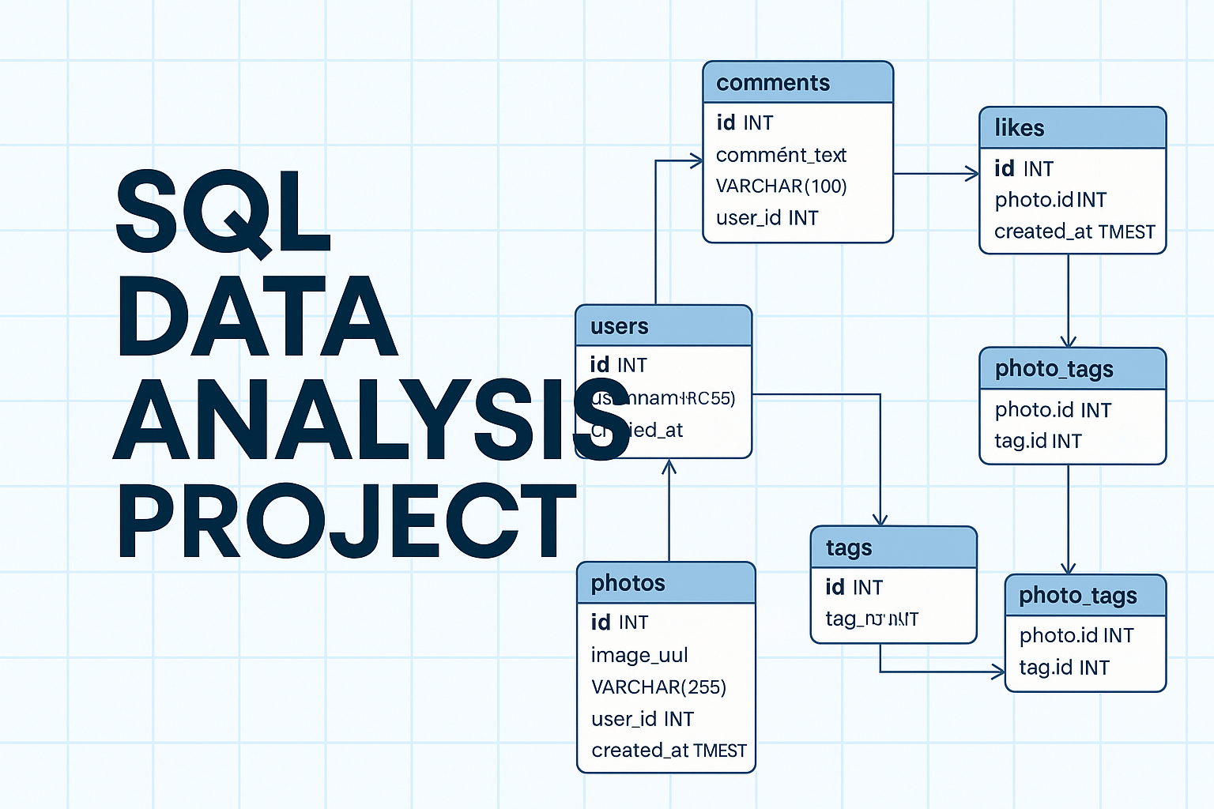
Project Overview
This project focuses on building and analysing a structured SQL database that models user engagement on a social media platform. The goal was to understand real data relationships — through systematic querying and analysis.
A normalized relational schema was created with proper key constraints and rules to maintain integrity across all entities. The dataset was imported and analysed using core SQL operations — JOIN, GROUP BY, HAVING, CASE, and nested subqueries. It explores multiple aspects of engagement, including user activity, photo performance, follower networks, hashtag usage, and posting trends. Analytical queries were structured to answer real data questions.
Tools and Technologies Used
- MySQL – For database creation, data import, validation, and all analytical querying.
- CSV Files – Used as raw data sources for user, post, comment, like, follow, and tag information.
- (Optional) Excel / Power BI – Can be integrated later for visualization or dashboard reporting.
All work was completed using standard MySQL syntax and relational design principles to maintain portability and clarity across database systems.

Entities and Relationships Overview

1. USERS
Purpose: Stores account-level information about every registered user on the platform.
Columns:
- id → Primary Key. Unique identifier for each user.
- username → The display name or handle (e.g., @Hariharan).
- created_at → Timestamp for when the user joined.
Relationships:
- One-to-Many → PHOTOS
  - A single user can upload many photos.
  - photos.user_id → users.id
  - Type: One-to-Many
  - Behavior: If a user is deleted, all their photos are also deleted (ON DELETE CASCADE).
- One-to-Many → COMMENTS
  - A user can write multiple comments.
  - comments.user_id → users.id
  - Type: One-to-Many
  - Behavior: Deleting a user removes all their comments.
- One-to-Many → LIKES
  - A user can like many photos.
  - likes.user_id → users.id
  - Type: One-to-Many (from user perspective, Many-to-Many overall)
- Self-Referential Many-to-Many → FOLLOWS
  - A user can follow multiple other users and be followed by many.
  - follows.follower_id and follows.followee_id both reference users.id
  - Type: Many-to-Many (Self-Join)
  - Behavior: Deleting a user removes all related follow records.

2. PHOTOS
Purpose: Stores all uploaded photos and metadata about them.
Columns:
- id → Primary Key.
- image_url → Path or link to the photo.
- user_id → Foreign key connecting photo to the uploader.
- created_at → Upload timestamp.
Relationships:
- Many-to-One → USERS
  - Each photo belongs to one user.
  - photos.user_id → users.id
  - Type: Many-to-One (user has many photos)
- One-to-Many → COMMENTS
  - A photo can have many comments.
  - comments.photo_id → photos.id
  - Type: One-to-Many
- One-to-Many → LIKES
  - A photo can receive multiple likes.
  - likes.photo_id → photos.id
  - Type: One-to-Many
- Many-to-Many → TAGS
  - Implemented via the bridge table photo_tags.
  - photo_tags.photo_id → photos.id
  - Type: Many-to-Many
  - A photo can have multiple tags, and a tag can be on multiple photos.

3. COMMENTS
Purpose: Stores text comments that users make on photos.
Columns:
- id → Primary Key.
- comment_text → The content of the comment.
- user_id → Foreign key referencing the author.
- photo_id → Foreign key referencing the photo commented on.
- created_at → Timestamp of comment creation.
Relationships:
- Many-to-One → USERS
  - A comment belongs to one user.
  - comments.user_id → users.id
  - Type: Many-to-One
- Many-to-One → PHOTOS
  - A comment belongs to one photo.
  - comments.photo_id → photos.id
  - Type: Many-to-One

4. LIKES
Purpose: Stores each “like” action — when a user likes a photo.
Columns:
- user_id → Foreign key referencing the liker.
- photo_id → Foreign key referencing the liked photo.
- created_at → Timestamp of the like action.
Primary Key:
- Composite key (user_id, photo_id) → ensures a user can like a photo only once.
Relationships:
- Many-to-One → USERS
  - Each like is given by a single user.
  - likes.user_id → users.id
  - Type: Many-to-One
- Many-to-One → PHOTOS
  - Each like is associated with one photo.
  - likes.photo_id → photos.id
  - Type: Many-to-One
Overall Effect:
This table represents a Many-to-Many relationship between users and photos —
implemented as a join table (likes).

5. FOLLOWS
Purpose: Represents user-to-user following relationships.
Columns:
- follower_id → The user who follows another user.
- followee_id → The user being followed.
- created_at → Timestamp of when the follow occurred.
Primary Key:
- Composite (follower_id, followee_id) → prevents duplicate follows.
Relationships:
- Self-Referential Many-to-Many → USERS
  - Both follower_id and followee_id reference users.id.
  - Type: Many-to-Many (Self-Join)
  - Behavior: When a user is deleted, all their follow records are removed.
Interpretation:
Each record describes:
“User A follows User B.”

6. TAGS
Purpose: Stores all hashtags used across photos.
Columns:
- id → Primary Key.
- tag_name → Unique hashtag (e.g., #travel, #sunset).
- created_at → Timestamp when the tag was created or first used.
Relationships:
- Many-to-Many → PHOTOS (via PHOTO_TAGS)
  - A tag can appear on multiple photos.
  - photo_tags.tag_id → tags.id
  - Type: Many-to-Many

7. PHOTO_TAGS
Purpose: Bridge table that connects photos and tags.
Columns:
- photo_id → Foreign key referencing the photo.
- tag_id → Foreign key referencing the tag.
Primary Key:
- Composite (photo_id, tag_id) → ensures no duplicate tagging.
Relationships:
- Many-to-One → PHOTOS
  - Each entry links to one photo.
  - photo_tags.photo_id → photos.id
  - Type: Many-to-One
- Many-to-One → TAGS
  - Each entry links to one tag.
  - photo_tags.tag_id → tags.id
  - Type: Many-to-One
Overall Effect:
This table creates a Many-to-Many link between photos and tags.

Summary of Relationship Types
- USERS ↔ PHOTOS — One-to-Many
- USERS ↔ COMMENTS — One-to-Many
- USERS ↔ LIKES — One-to-Many
- USERS ↔ USERS (FOLLOWS) — Many-to-Many
- PHOTOS ↔ COMMENTS — One-to-Many
- PHOTOS ↔ LIKES — One-to-Many
- PHOTOS ↔ TAGS (PHOTO_TAGS) — Many-to-Many

ER Diagram
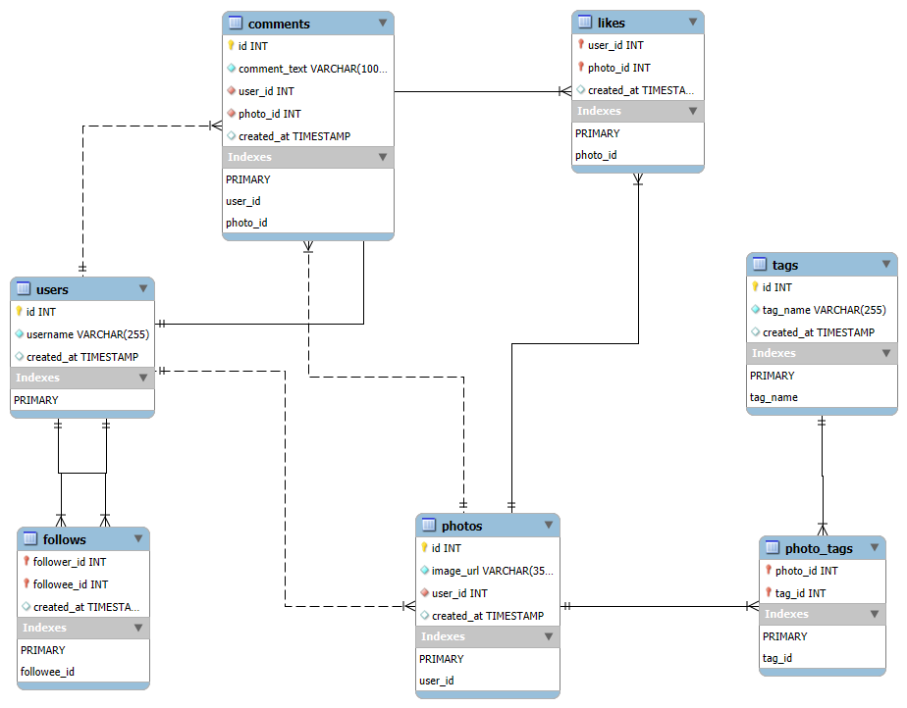

PROJECT INSIGHTS & INTERPRETATION

User Insights and Registration Behavior
- Oldest users → Identify long-term loyal users → Offer loyalty rewards or ambassador roles.
- Most registration day → Signups peak on weekends → Run ad campaigns and onboarding pushes then.
- Monthly registration → Growth varies by month → Focus promotions during low-growth periods.

User Activity and Posting Behavior
- Users who never posted → Inactive users → Re-engagement through reminders or incentives.
- Average posts per user → Low average (≈1–2) → Encourage more posting via challenges or content ideas.
- User ranking by posts → Few creators dominate uploads → Recognize and retain them as key contributors.
- Users with ≥1 post → Smaller active segment → Monitor retention among active users closely.

Engagement and Interaction Analysis
- Most liked photo → Top-performing content → Analyze for visual trends and replicate success.
- Top hashtags → Most used tags (#travel, #sunset, etc.) → Guide brands on trending topics.
- Users liking every photo → Possible bots → Flag for spam or automation check.
- Users never commented → Passive audience → Nudge toward engagement using interactive content.
- Comment count per user → Engagement distribution → Identify conversational users for community events.

Bot vs Celebrity Behavior
- % bots & silent users → <2% bots, ~25% silent → Balance engagement by pruning fake accounts and encouraging real interaction.

Follower and Network Relationships
- Top followers → Influencers → Prioritize for partnerships or promotions.
- Following > followers → Growth seekers → Suggest follower exchange or community boosts.
- Self-follows removed → Data cleaning → Maintain authentic relationship metrics.

Content Engagement Analysis
- % photos with likes → ~75% engagement rate → Good baseline; push visibility for remaining 25%.
- Unliked/uncommented photos → Low-visibility posts → Promote via explore or recommendation algorithms.
- Users liking own posts → Self-boosting → Ignore or adjust engagement scoring.
- Comment-like ratio → Likes > comments → Focus on features encouraging conversation depth.

Photo Popularity Metrics
- photo_popularity table → Centralized engagement data → Simplifies reporting and analytics.
- Top 10 photos → Most engaging content → Showcase for platform highlights or discovery feed.

Average Engagement Analysis
- Avg likes per user’s photo → Measures content quality → Reward users with high average engagement.

Commenting Behavior
- Commented on all liked photos → Highly genuine users → Recognize as trusted or verified users.

Tag Insights
- Tags on every photo → Platform-wide trends → Promote related campaigns.
- Frequent tag pairs → Common content themes → Use to suggest tag recommendations to users.

Temporal Insights
- Likes per month (2017) → Consistent growth → Reflects platform expansion; maintain activity rhythm.
- Weekday vs weekend posts → Higher weekend activity → Schedule features and campaigns accordingly.

High Engagement User Segmentation
- active_users view → Users with ≥10 posts, ≥50 likes → Core community; retain with loyalty perks.
- High-engagement list → Top performers → Track for influencer or content ambassador roles.

User Engagement Summary
- Posts, likes, comments combined → Confirms 1–9–90 pattern → Focus on motivating passive users to engage more.

- SQL Data Analysis
- Relational Database Design
- Data Modeling & Normalization
- Joins, Aggregations, and Subqueries
- User Engagement Analytics
- Analytical Query Optimization
- MySQL Project Implementation

