**LIST OF EXPERIMENTS(DFA)**

COURSE CODE : CSA1381

COURSE NAME : THEORY OF COMPUTATION

NAME: R.Hariharan REG NUM: 192110182

Experiment 13:

Design PDA using simulator to accept the input string aabb

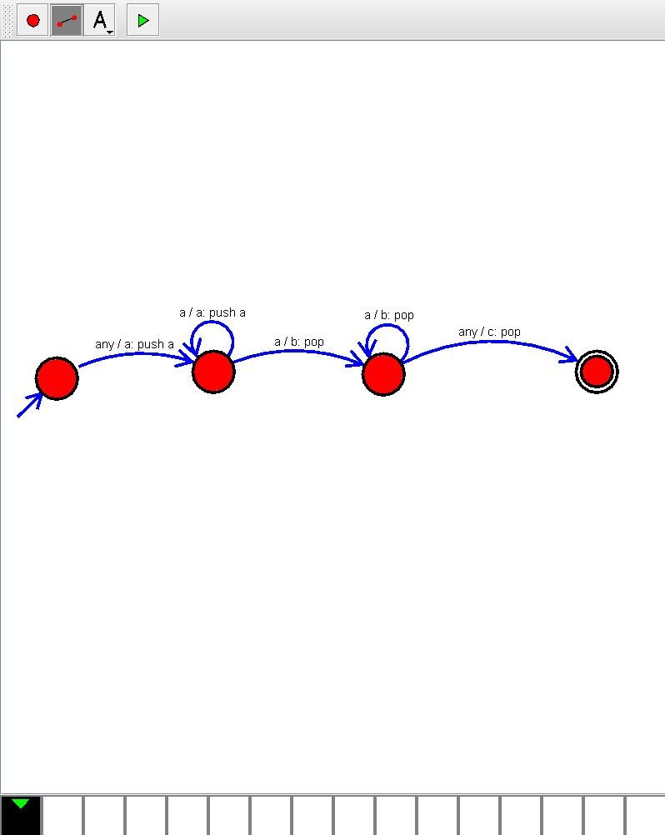

Experiment 14:

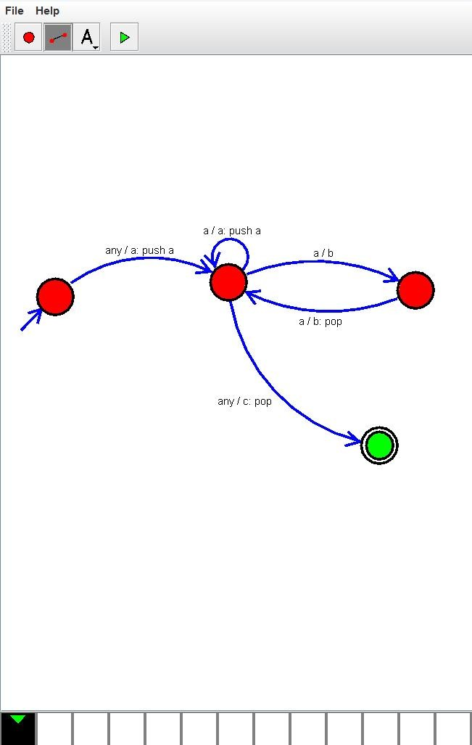Design PDA using simulator to accept the input string anb2n

Experiment 31:

Design PDA using simulator to accept the input string anbn