Experiment 3: Exploratory Data Analysis
Data Cleaning, Transformation & Visualization
Aim
To perform exploratory data analysis focusing on data cleaning, data transformation, and visual representation techniques on the Heart Disease dataset (heart.csv, sourced from Kaggle: johnsmith88/heart-disease-dataset). This covers identifying missing values, counting missing values, replacing missing values, removing duplicate records, detecting outliers, fixing incorrect data types, handling inconsistent formatting, and generating exploratory charts.
Dataset Description
The dataset contains 1,025 patient records with 14 clinical attributes used to predict the presence of heart disease, including age, sex, chest pain type (cp), resting blood pressure (trestbps), serum cholesterol (chol), fasting blood sugar (fbs), resting ECG results (restecg), maximum heart rate achieved (thalach), exercise-induced angina (exang), ST depression induced by exercise (oldpeak), slope of the peak exercise ST segment (slope), number of major vessels colored by fluoroscopy (ca), thalassemia status (thal), and the target label indicating heart disease presence (target).
Software Requirements
- Operating System: Windows 10/11, macOS, or Linux
- Programming Language: Python 3.x
- Libraries Required: pandas, numpy, scipy, scikit-learn, matplotlib, seaborn
- Environment: Jupyter Notebook / Google Colab / VS Code
1. Identifying Missing Values
Identifying missing values is an essential step when analyzing data. Missing entries can distort analytical results and lead to unexpected errors during model training. The raw dataset downloaded from Kaggle is complete, so a small number of values were deliberately blanked out in the chol and thal columns to simulate real-world data collection gaps and demonstrate the missing-value workflow. We scan through all columns using boolean masking to highlight where missing values exist.
Code:
import pandas as pd
import numpy as np
import seaborn as sns
import matplotlib.pyplot as plt

# Load dataset
df = pd.read_csv('heart_attack_prediction.csv')

# Boolean mask for missing entries
missing_mask = df.isnull()
print(missing_mask.head())
Output:
age sex cp trestbps chol ... oldpeak slope ca thal target
0 False False False False False ... False False False False False
1 False False False False False ... False False False False False
2 False False False False False ... False False False False False
3 False False False False False ... False False False False False
4 False False False False False ... False False False False False
2. Count Missing Values
Counting missing values helps us see how incomplete each column is. Plotting a bar graph provides an immediate visual summary of columns requiring data imputation.
Code:
# Count missing values and visualize
missing_counts = df.isnull().sum()
print('Missing values per column:')
print(missing_counts)

# Plot missing value count bar chart
sns.barplot(x=missing_counts.index, y=missing_counts.values)
plt.title('Missing Values Count per Column')
plt.xticks(rotation=45, ha='right')
plt.show()
Output:
Missing values per column:
age 0
sex 0
cp 0
trestbps 0
chol 8
fbs 0
restecg 0
thalach 0
exang 0
oldpeak 0
slope 0
ca 0
thal 5
target 0
dtype: int64
Visualization Plot:
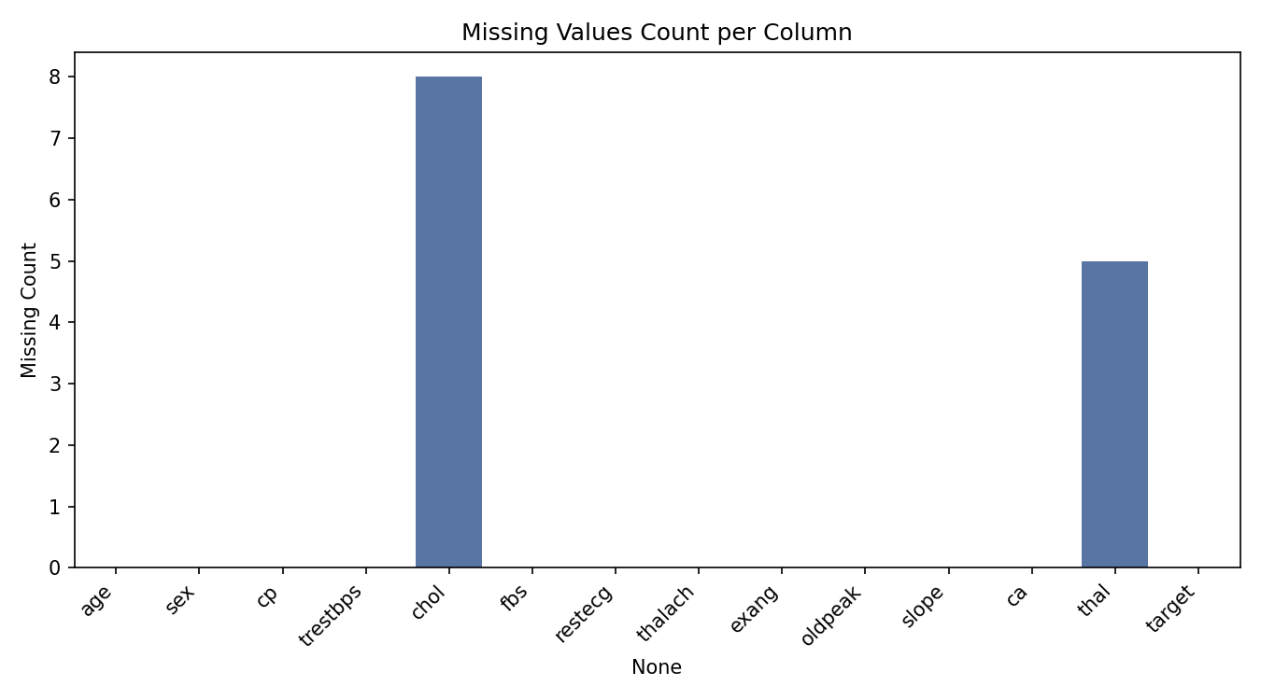
3. Replace Missing Values
Replacing missing values keeps the original size of the dataset intact. Continuous numerical columns (age, trestbps, chol, thalach, oldpeak) are imputed using the column mean, while the coded categorical attributes (sex, cp, fbs, restecg, exang, slope, ca, thal, target) are filled using the most frequent category.
Code:
from sklearn.impute import SimpleImputer

continuous_cols = ['age', 'trestbps', 'chol', 'thalach', 'oldpeak']
categorical_coded_cols = ['sex', 'cp', 'fbs', 'restecg', 'exang',
'slope', 'ca', 'thal', 'target']

num_imputer = SimpleImputer(strategy='mean')
df[continuous_cols] = num_imputer.fit_transform(df[continuous_cols])

cat_imputer = SimpleImputer(strategy='most_frequent')
df[categorical_coded_cols] = cat_imputer.fit_transform(df[categorical_coded_cols])

print('Missing values after replacement:')
print(df.isnull().sum())
Output:
Missing values after replacement:
age 0
sex 0
cp 0
trestbps 0
chol 0
fbs 0
restecg 0
thalach 0
exang 0
oldpeak 0
slope 0
ca 0
thal 0
target 0
dtype: int64
4. Remove Duplicate
Duplicate records give undue weight to repeated rows and can cause overfitting during model training. The Kaggle heart disease dataset contains many exact duplicate rows (it is built by repeating the 303-record Cleveland dataset). Here, we locate exact duplicate rows across the dataset and remove them.
Code:
# Check duplicate count and drop duplicates
duplicate_count = df.duplicated().sum()
print(f'Total duplicate records found: {duplicate_count}')

df.drop_duplicates(inplace=True)
df.reset_index(drop=True, inplace=True)
print(f'Dataset shape after removing duplicates: {df.shape}')
Output:
Total duplicate records found: 713
Dataset shape after removing duplicates: (312, 14)
5. Detecting Outliers
Outliers are extreme observations that deviate significantly from the rest of the observations. Box plots visually highlight these anomalies, allowing us to cap values beyond the Interquartile Range (IQR) thresholds.
Code:
# IQR outlier detection and box plot visualization
numeric_features = ['age', 'trestbps', 'chol', 'thalach', 'oldpeak']
for col in numeric_features:
Q1 = df[col].quantile(0.25)
Q3 = df[col].quantile(0.75)
IQR = Q3 - Q1
lower_bound = Q1 - (1.5 * IQR)
upper_bound = Q3 + (1.5 * IQR)
df[col] = np.where(df[col] < lower_bound, lower_bound, df[col])
df[col] = np.where(df[col] > upper_bound, upper_bound, df[col])

sns.boxplot(y=df['chol'])
plt.title('Cholesterol Level After IQR Outlier Capping')
plt.show()
Output:
Outlier detection and capping completed across numeric columns.
Visualization Plot:
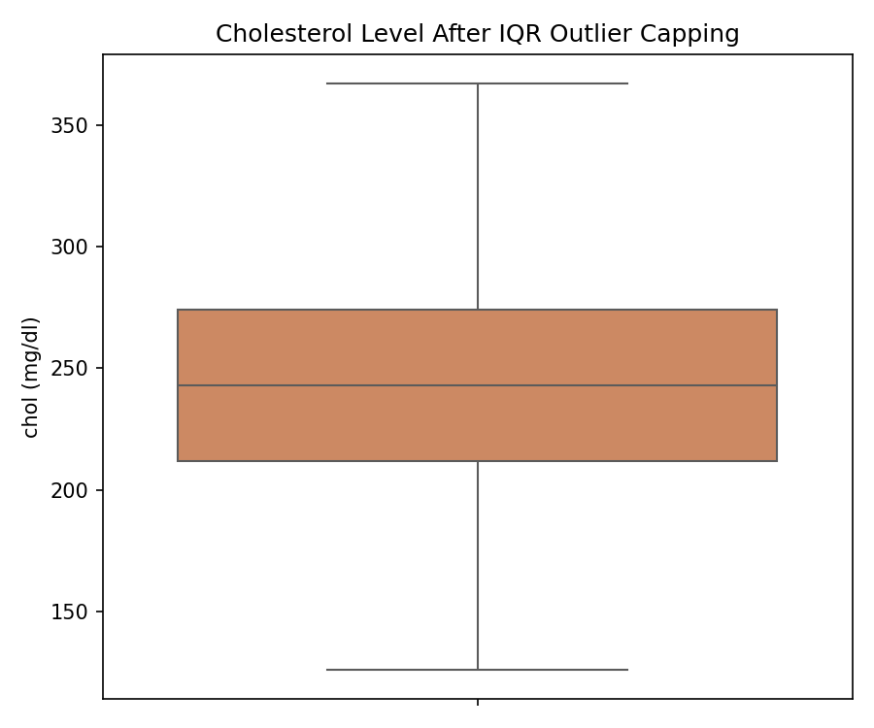
6. Correcting Incorrect Data Types
Dataset columns often get loaded with improper data types. Attributes such as sex, cp, fbs, restecg, exang, slope, ca, thal, and target are categorical codes stored as numeric types by default; this section casts them to the pandas category dtype so downstream analysis treats them correctly instead of as continuous numbers.
Code:
# Inspect and correct data types
print('Initial Data Types:')
print(df.dtypes)

for col in categorical_coded_cols:
df[col] = df[col].astype(int).astype('category')

print('\nUpdated Data Types:')
print(df.dtypes)
Output:
Initial Data Types:
age float64
sex float64
cp float64
trestbps float64
chol float64
fbs float64
restecg float64
thalach float64
exang float64
oldpeak float64
slope float64
ca float64
thal float64
target float64
dtype: object

Updated Data Types:
age float64
sex category
cp category
trestbps float64
chol float64
fbs category
restecg category
thalach float64
exang category
oldpeak float64
slope category
ca category
thal category
target category
dtype: object
7. Resolving Inconsistent Formatting
Text labels derived from coded fields often contain leading/trailing spaces and inconsistent casing, especially when merged from multiple sources. Here the sex and chest-pain-type codes are mapped to readable labels with intentionally inconsistent formatting, then normalized so that grouping and count plots reflect clean category distributions.
Code:
# Map codes to labels and normalize string formatting
sex_map = {0: ' female', 1: 'MALE '}
cp_map = {0: 'typical angina', 1: ' Atypical Angina',
2: 'NON-ANGINAL PAIN ', 3: 'asymptomatic '}

df['sex_label'] = df['sex'].astype(int).map(sex_map)
df['cp_label'] = df['cp'].astype(int).map(cp_map)

string_cols = ['sex_label', 'cp_label']
for col in string_cols:
df[col] = df[col].astype(str).str.strip().str.lower()

sns.countplot(x=df['cp_label'], order=df['cp_label'].value_counts().index)
plt.title('Chest Pain Type Frequency Distribution')
plt.show()
Output:
Formatted text columns sample:
sex_label cp_label
0 male typical angina
1 male typical angina
2 male typical angina
3 male typical angina
4 female typical angina
Visualization Plot:
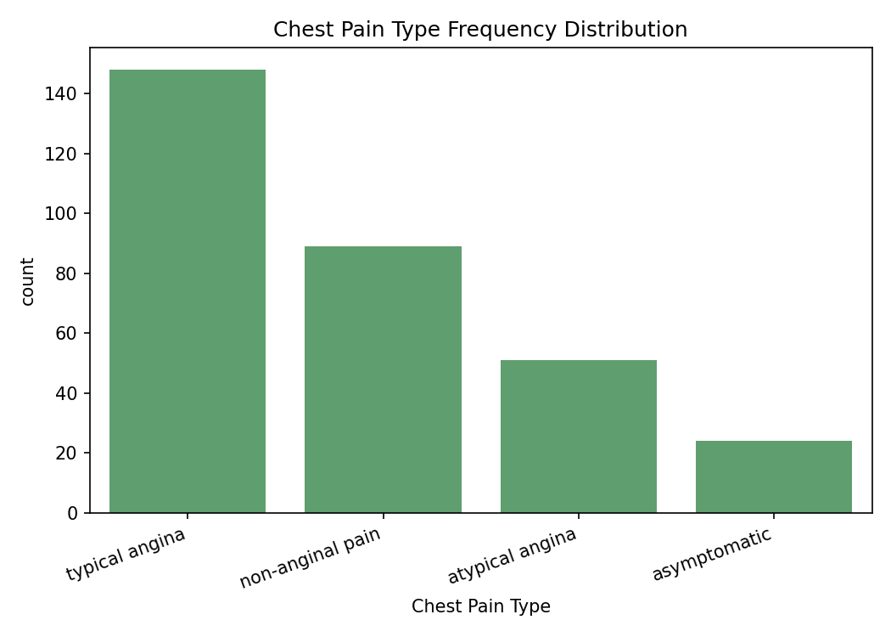
Result
Exploratory data analysis was successfully performed on the Heart Attack Prediction dataset. Missing values were identified and imputed, 713 duplicate records were removed (reducing the dataset from 1,025 to 312 unique records), outliers in the continuous clinical measurements were detected and capped using the IQR method, column data types were corrected to reflect their categorical nature, and inconsistent text formatting was resolved. The generated visualizations confirmed clean, analysis-ready data.

