HR DATA ANALYSIS DASHBOARD

ABSTRACT
Human Resource (HR) departments manage large volumes of employee-related data. This project focuses on developing an HR Data Analysis Dashboard that visualizes employee salary, education, job roles, promotions, training, and travel details. The dashboard helps HR professionals make data-driven decisions and improve organizational efficiency.
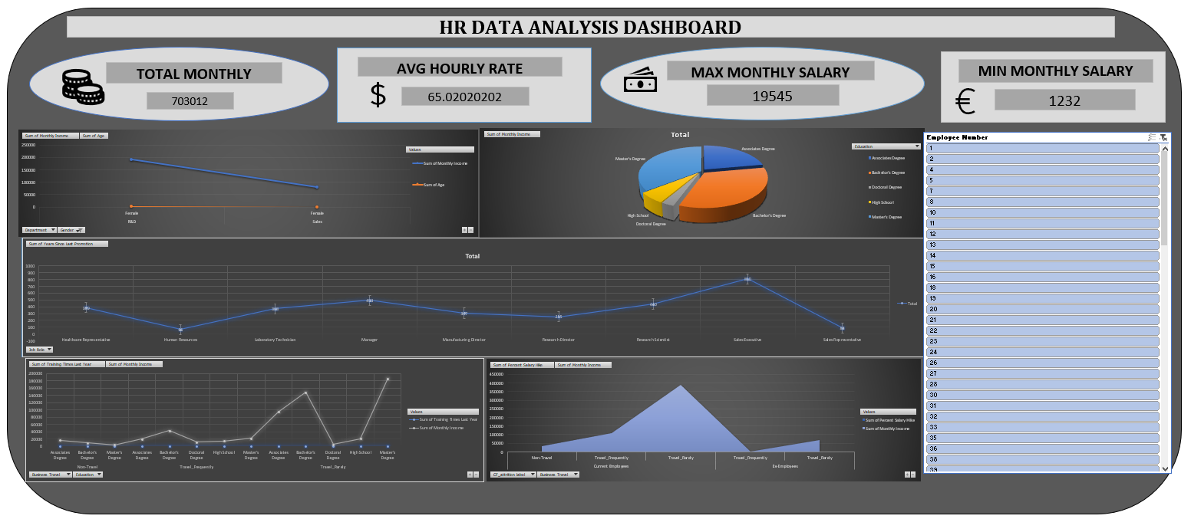
INTRODUCTION
This project focuses on building an *HR Data Analysis Dashboard* that provides a clear and interactive overview of employee information. By using data visualization techniques, complex HR data is transformed into easy-to-understand charts and Key Performance Indicators (KPIs). This enables HR professionals to analyze employee salary patterns, education levels, promotions, training effectiveness, and business travel requirements efficiently.
PROBLEM STATEMENT
- Difficulty in analyzing large volumes of HR datasets
- Lack of quick and clear insights into employee salaries and promotions
- Dependence on manual reporting, which increases errors and delays
- Limited visibility into employee qualifications and training impact
OBJECTIVES
- To analyze HR data using data visualization tools
- To calculate and display important HR Key Performance Indicators (KPIs)
- To understand salary distribution across job roles and education levels
- To evaluate promotion history and training trends

DATASET DESCRIPTION
The dataset contains employee details such as age, gender, department, job role, monthly income, hourly rate, education, business travel, training history, and promotion details. The data is cleaned and structured for analysis.

DATA PREPROCESSING & CLEANING

Before creating the dashboard, the dataset was cleaned and processed using the following steps:

Removal of duplicate employee records

Handling missing or incomplete values

Formatting numerical and categorical fields

Creating calculated values such as total income and averages

Validating the data for accuracy and consistency

KEY PERFORMANCE INDICATORS
- Total Monthly Income
- Average Hourly Rate
- Maximum Monthly Salary
- Minimum Monthly Salary
- Employee Count

DASHBOARD VISUALIZATIONS
The dashboard includes line charts, pie charts, and area charts to analyze salary trends, education distribution, promotion gaps, training impact, and travel-based income variations.
ADVANTAGES
The system reduces manual effort, improves accuracy, saves time, and provides clear insights for HR planning.
LIMITATIONS
The dashboard uses static data and does not include real-time updates or predictive analytics.
APPLICATIONS
- HR analytics
- salary planning
- promotion analysis
- training evaluation and workforce optimization.

CONCLUSION
The HR Data Analysis Dashboard successfully transforms raw HR data into visual insights, helping HR professionals make informed decisions.

FUTURE SCOPE
Future enhancements include attrition prediction, performance analysis, real-time data integration, and AI-based HR insights.

