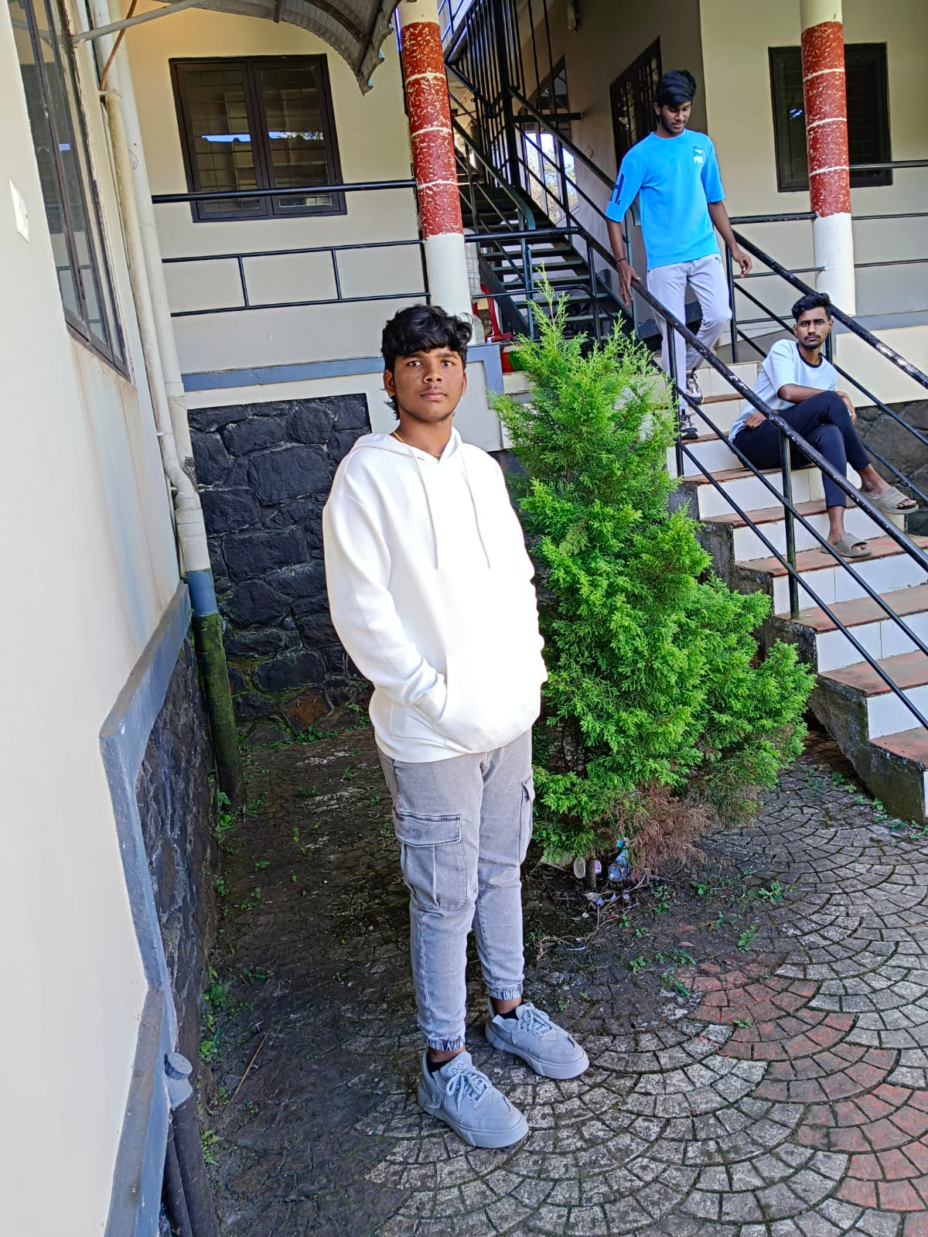

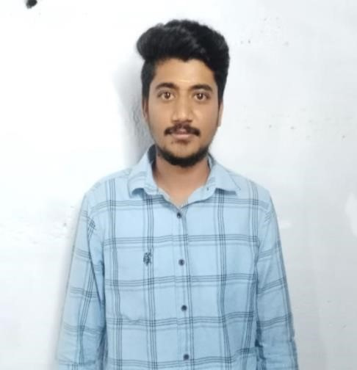

.



Hariharan M

COMPUTER

APPLICATIONS

(

BCA

)

**Contact:**

Ph

.no

9042534959

Mail Id

:

haridonhari2006@gmail.com

41/5 Odathurai,

Near post office street,

,

Gobi,Erode-638 455.

-

**TECHNICAL**

**SKILLS:**

C and C++

Java

**CE**

**RTIFICATES**

**:**

Linked in

Kabaddi

**PERSONAL**

**TRAITS:**

•

Positive minded

•

Critical thinking &

problem

solving

•

A good initiator.

EDUCATION

Bachelors of

COMPUTER

A

PPLICATIONS

BCA

(

)

Nandha Art

s And Science

College

2023

-

26

with the

percentage of

8%

55. 8

Hsc 2nd y

Year in

,

S.M.Government High

School in 2022-23

In the group of

COMPUTER

APPLICATIONS

with percentage

Of 70%

SSLC in,

S.M. Government High

School in 2020-21

With the percentage

INTERNSHIP

web development

course

DECLARATION

:

I

hereby

furnishing

the

above

details

are

true to the best of

my

knowledge



