

**Cloud Computing**

Year 4 Semester 2

Assignment 2

**<ECS Service and Load Balancer with Docker>**

Hariharan V

IT17044400

Bachelor of Science (Honors) in Information Technology.

# Department of Information Technology

Sri Lanka Institute of Information Technology Sri Lanka.

25th September 2020

Firstly, we must create an account in docker hub.

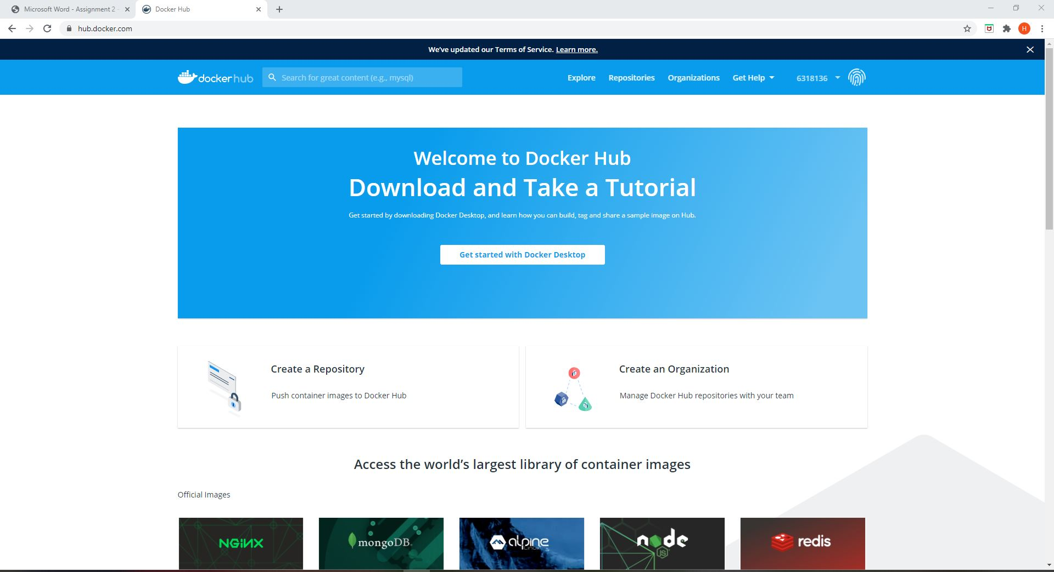

Then we must create a public repository.

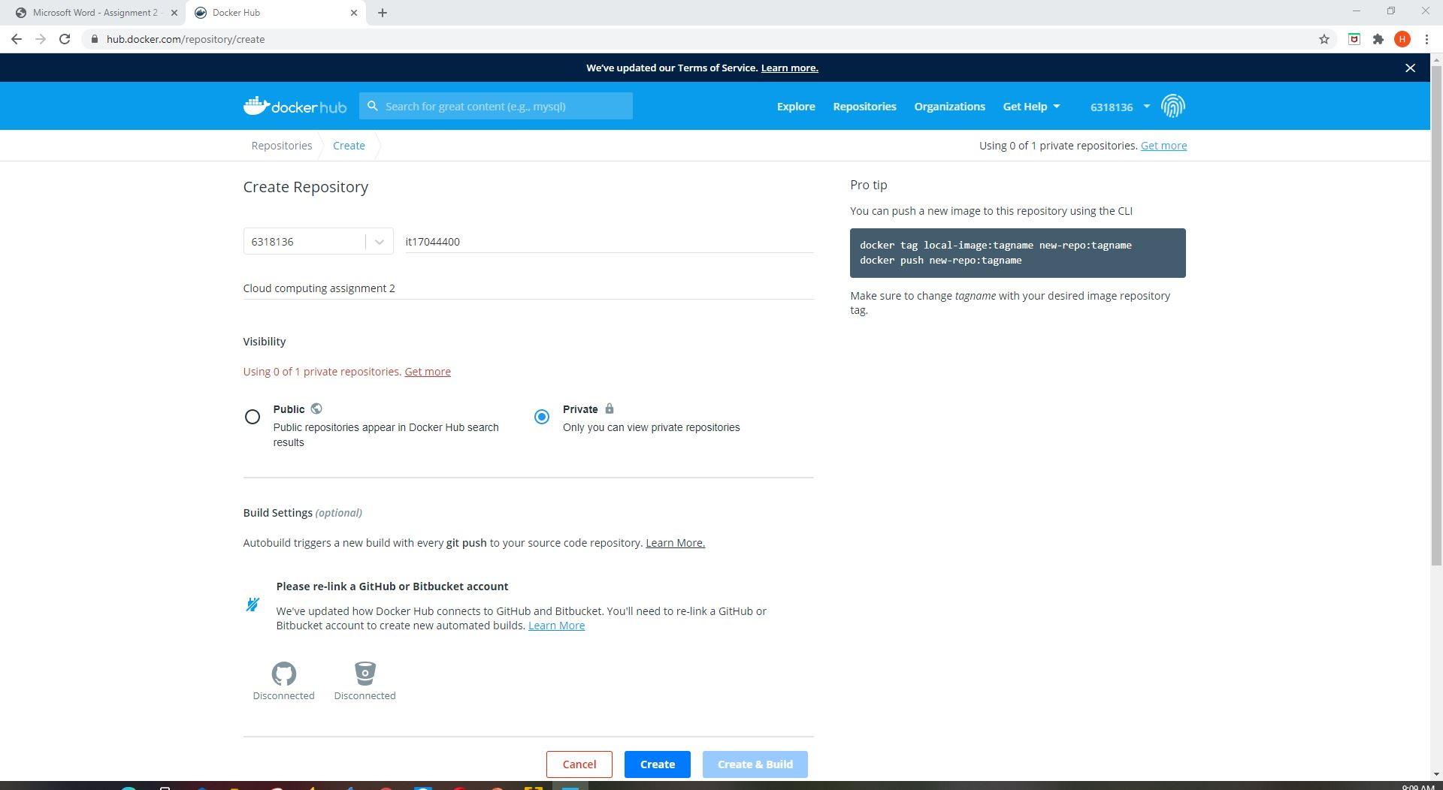

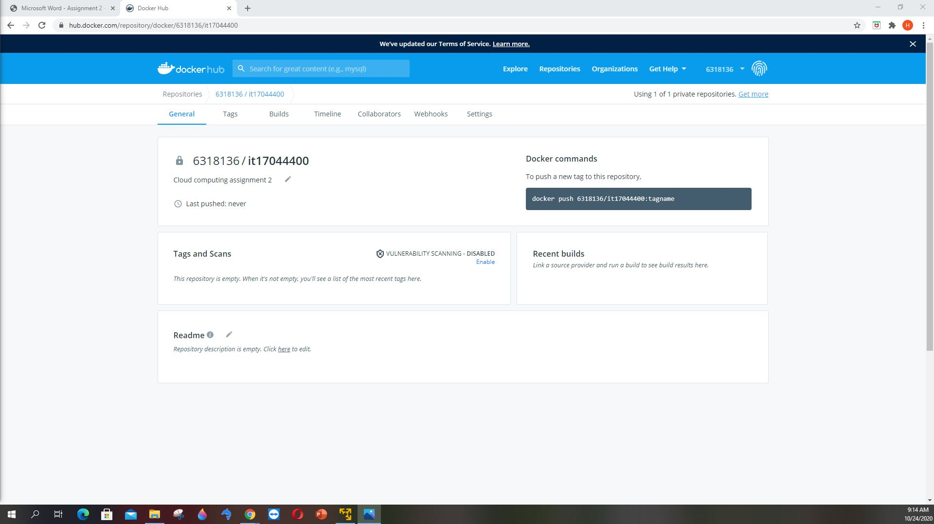

Create an access token in docker hub.

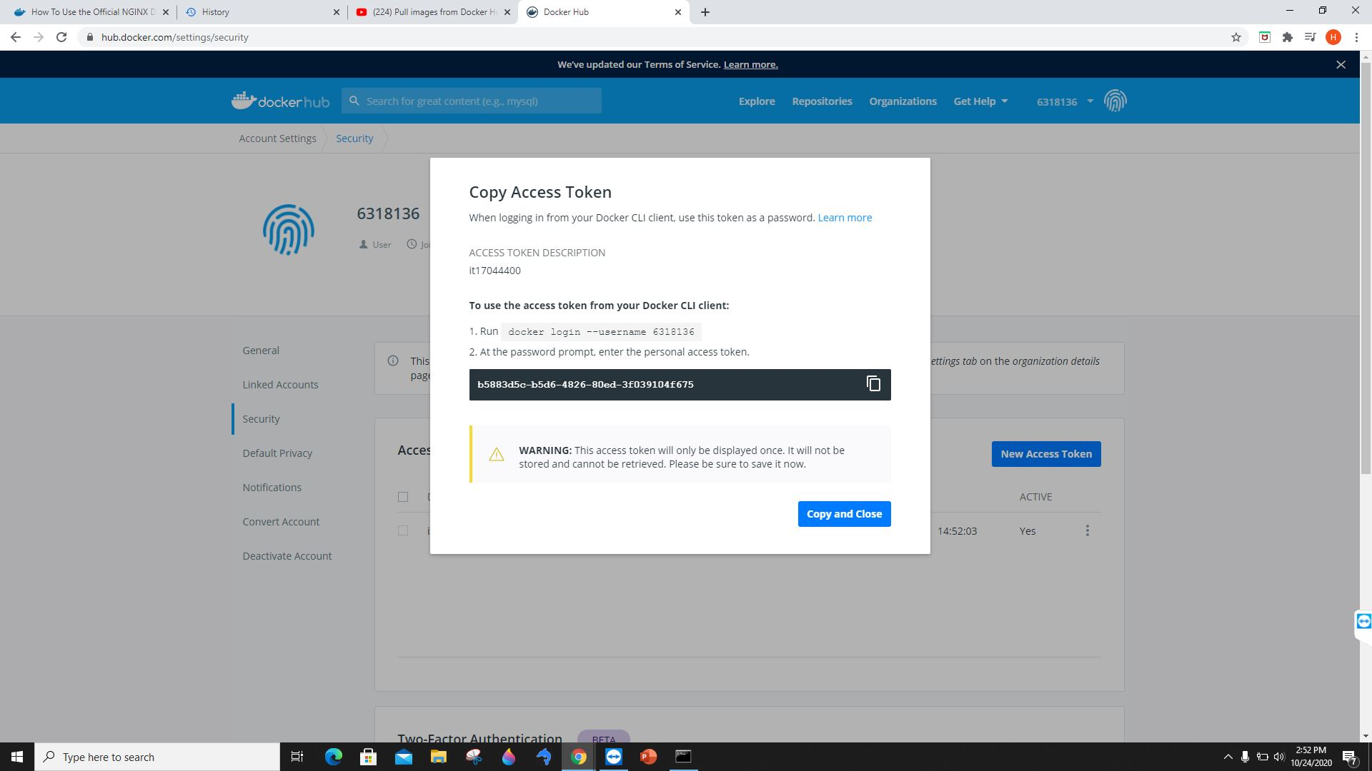

Create the docker file and html file in local machine

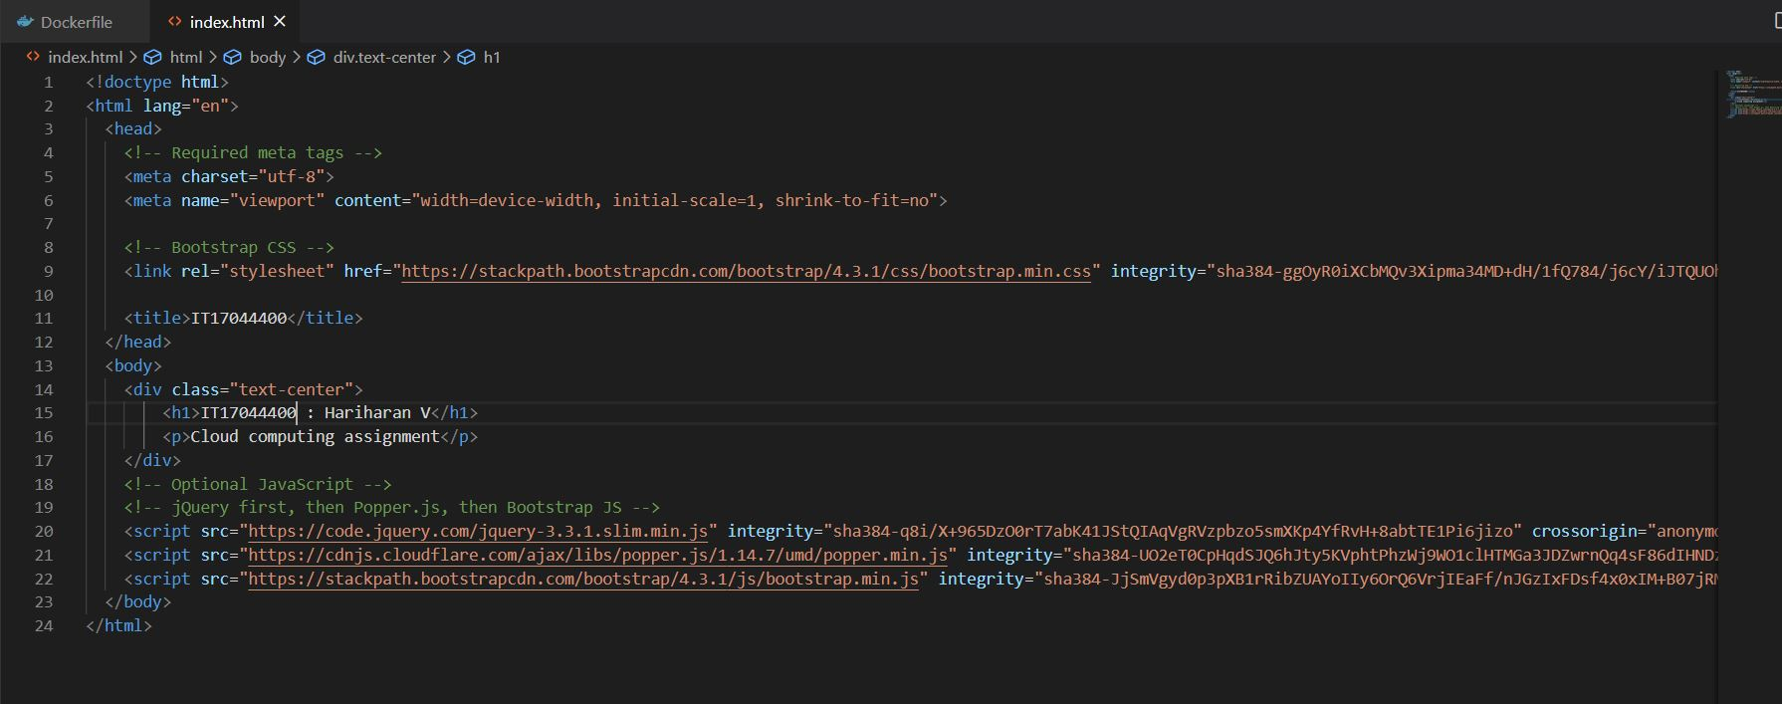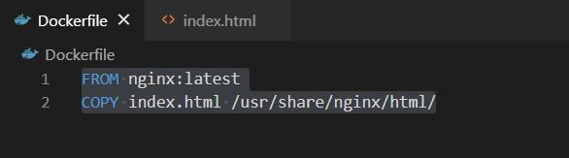

Login using access token generated from docker hub build it and push it to the docker hub.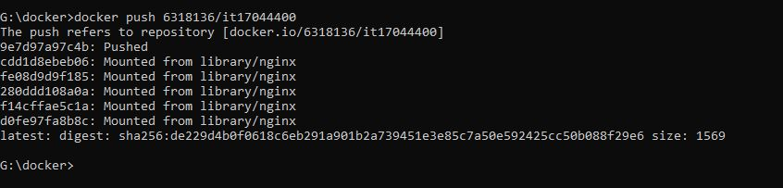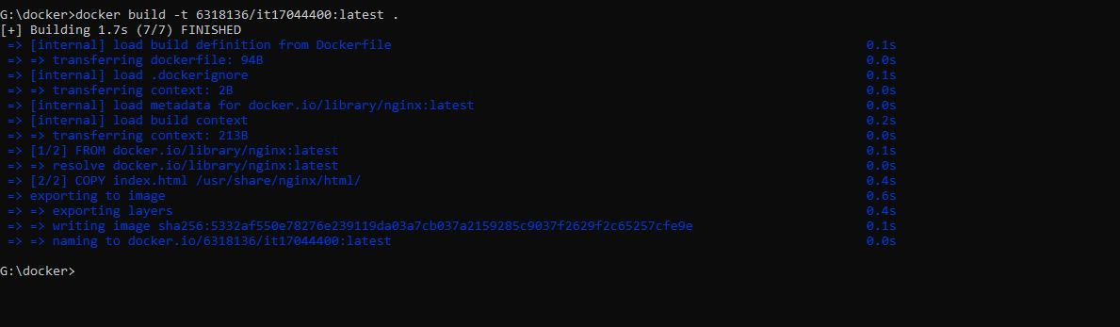

Docker hub has the recent push.

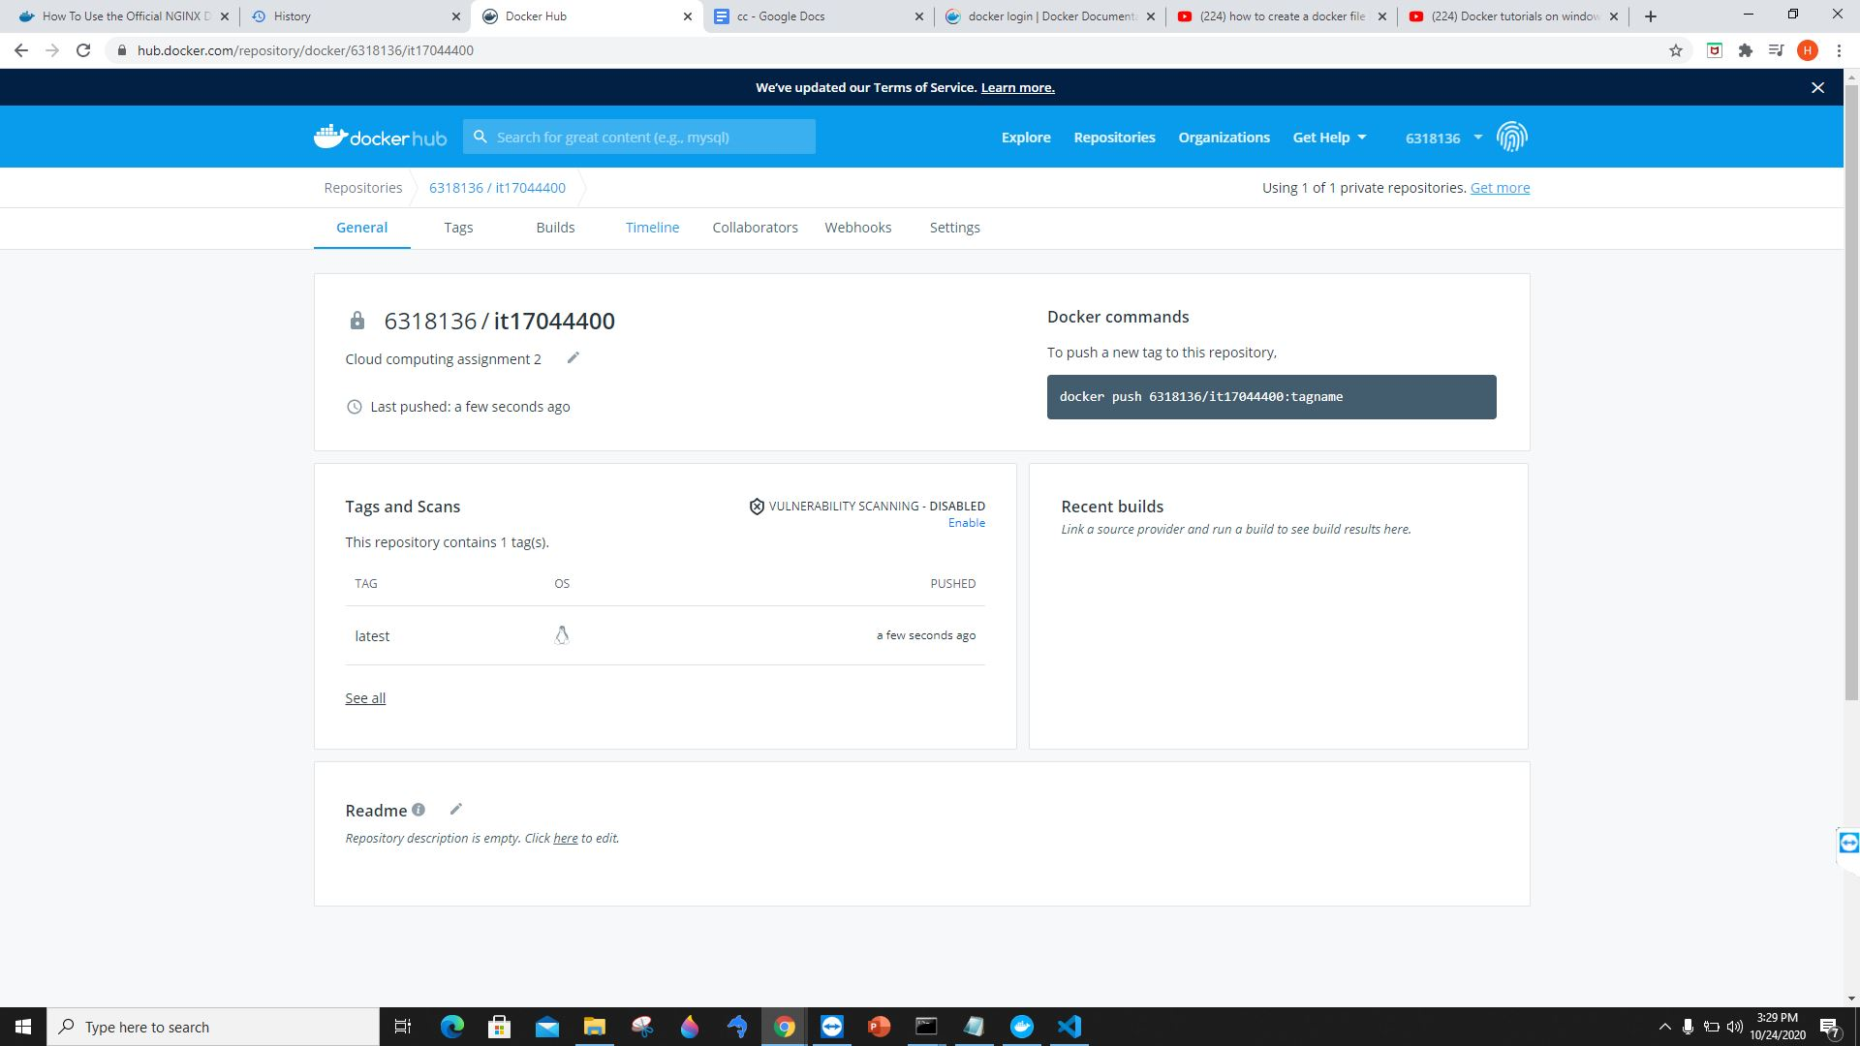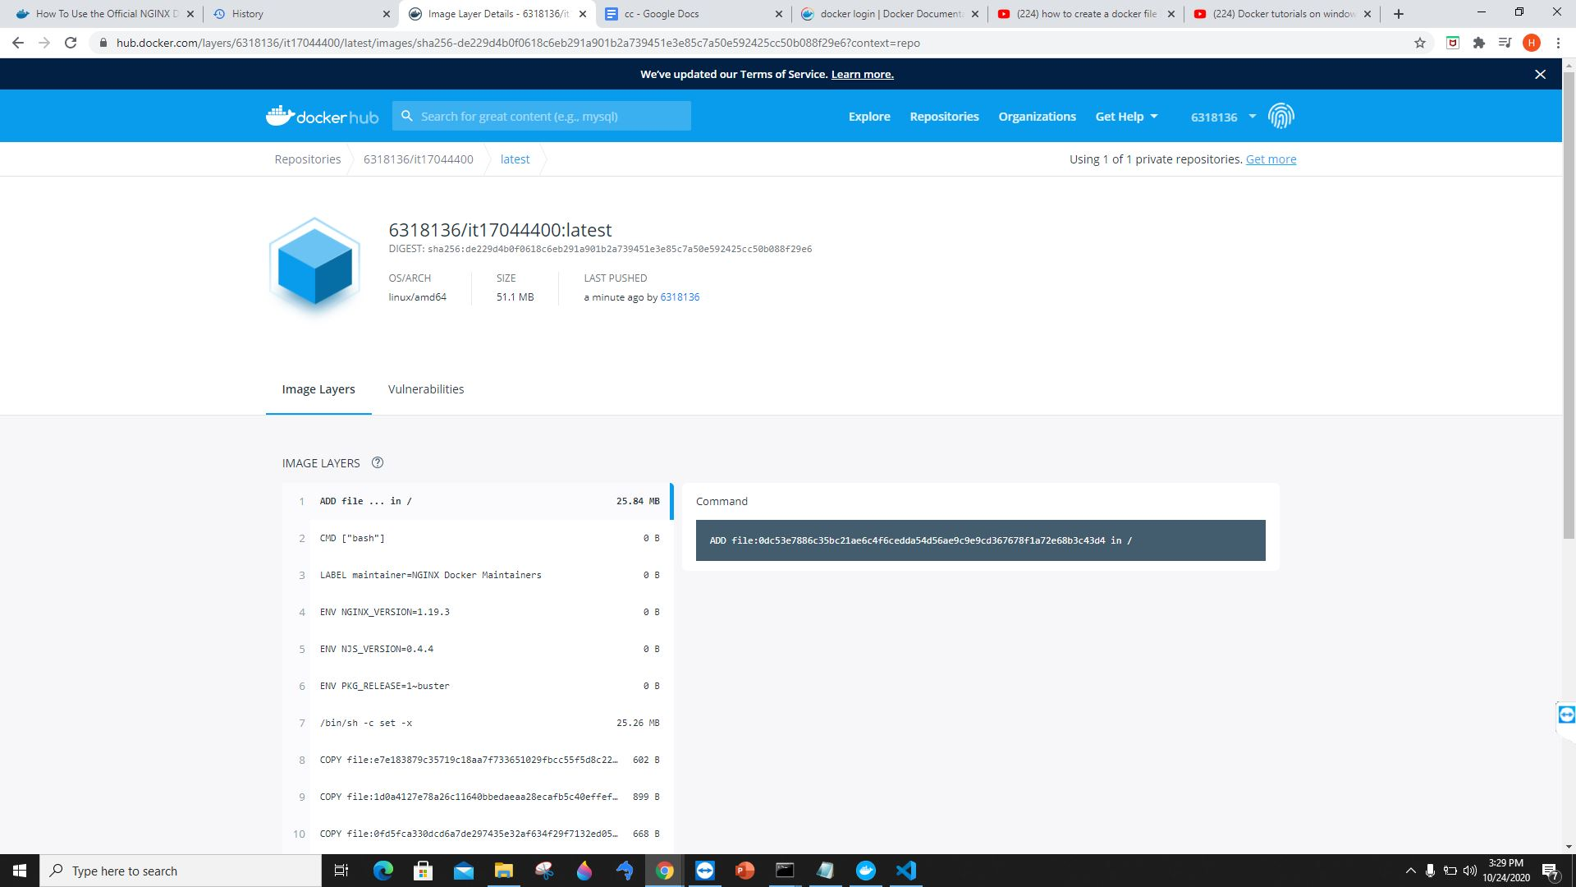

Create a cluster in ECS.

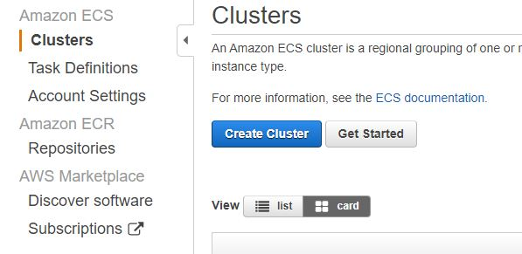

Select networking only and click next and create cluster.

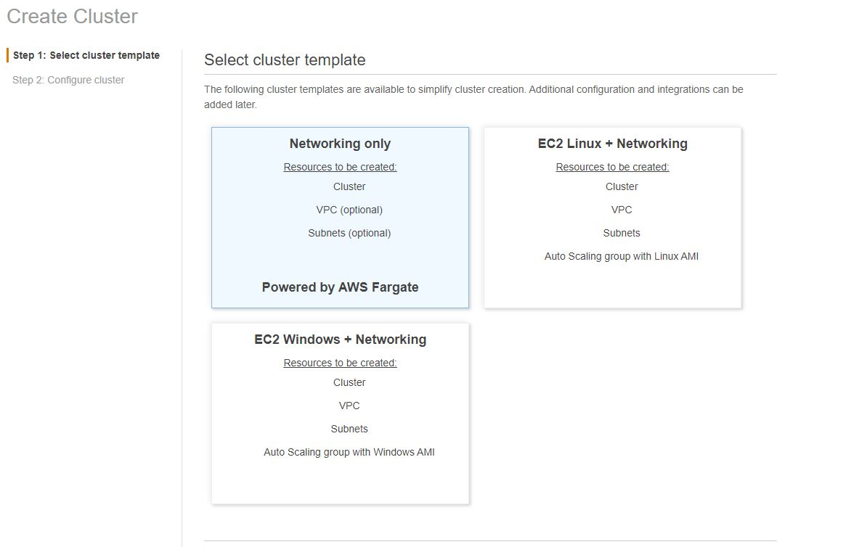

Successfully created a cluster.

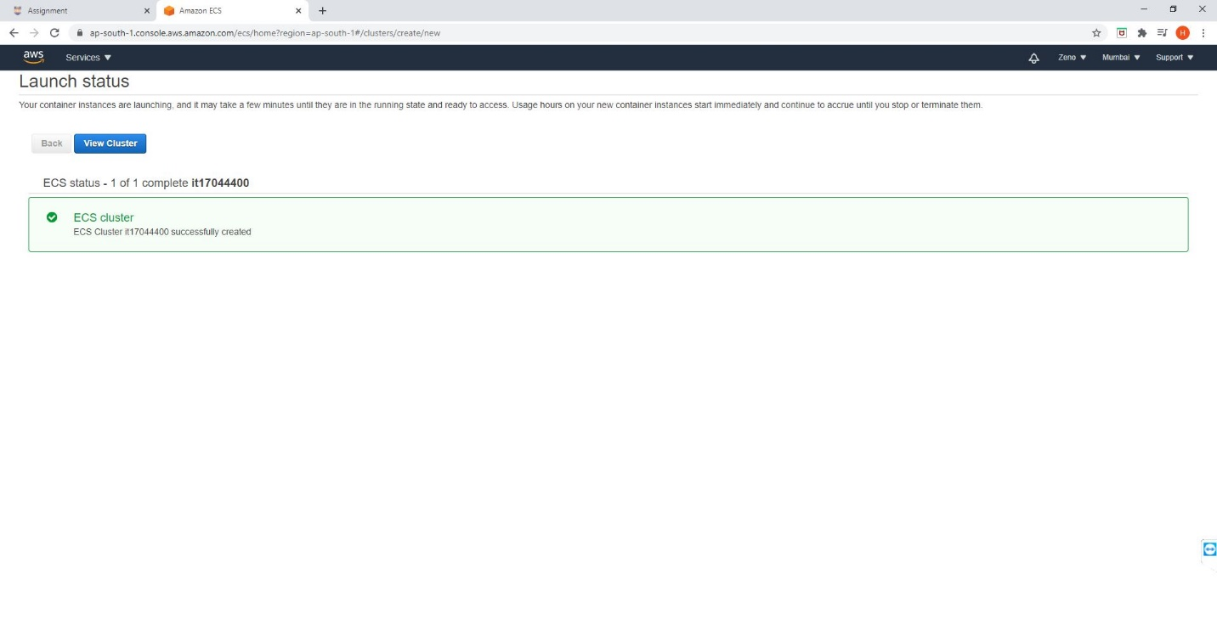

Add a container

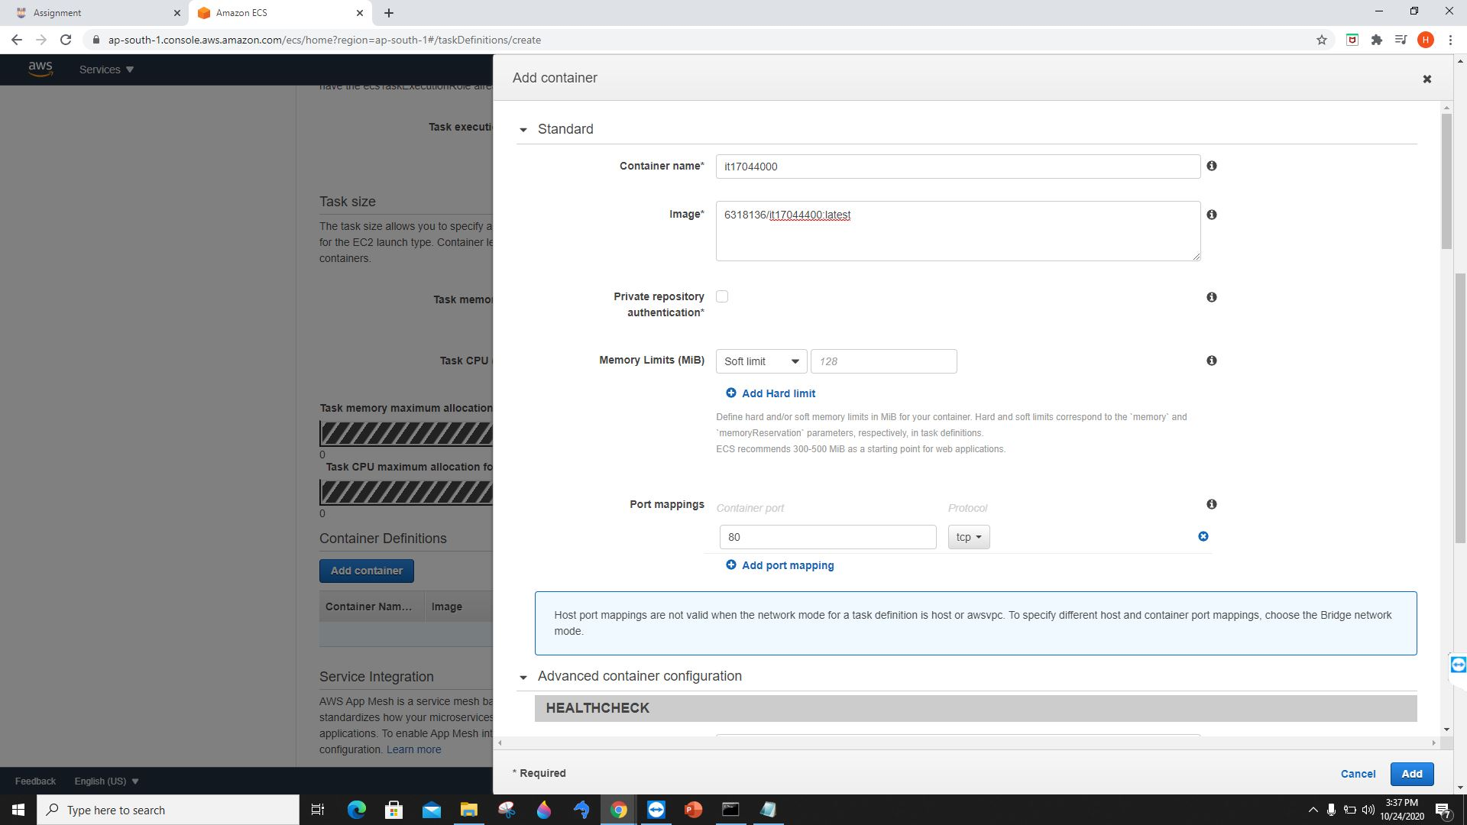

Launch status

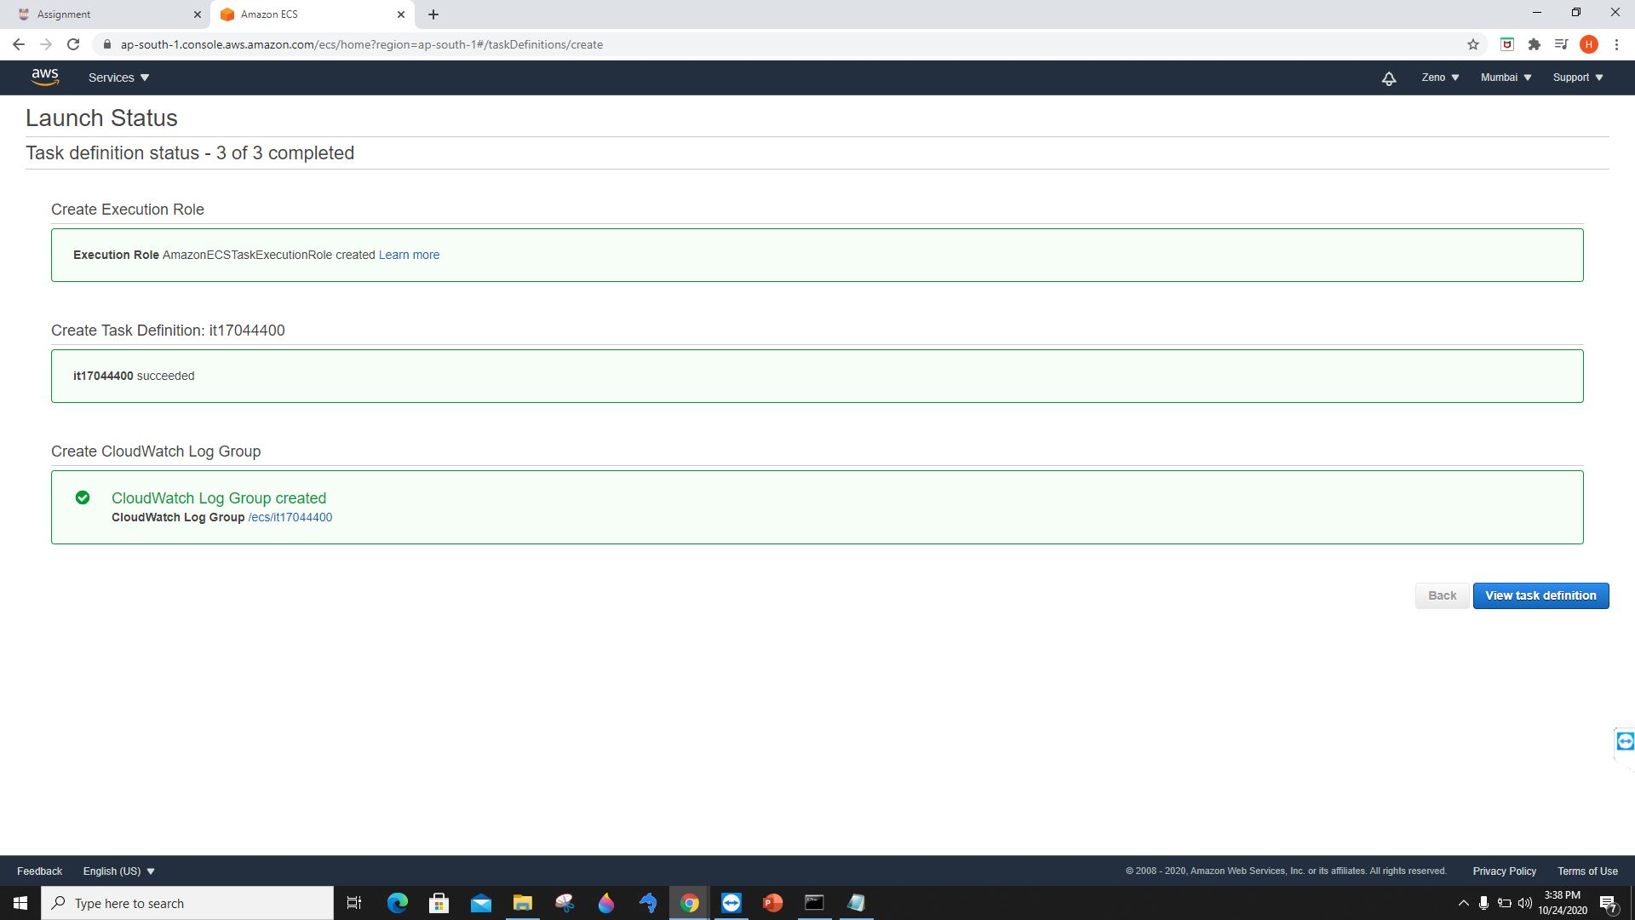

Create service

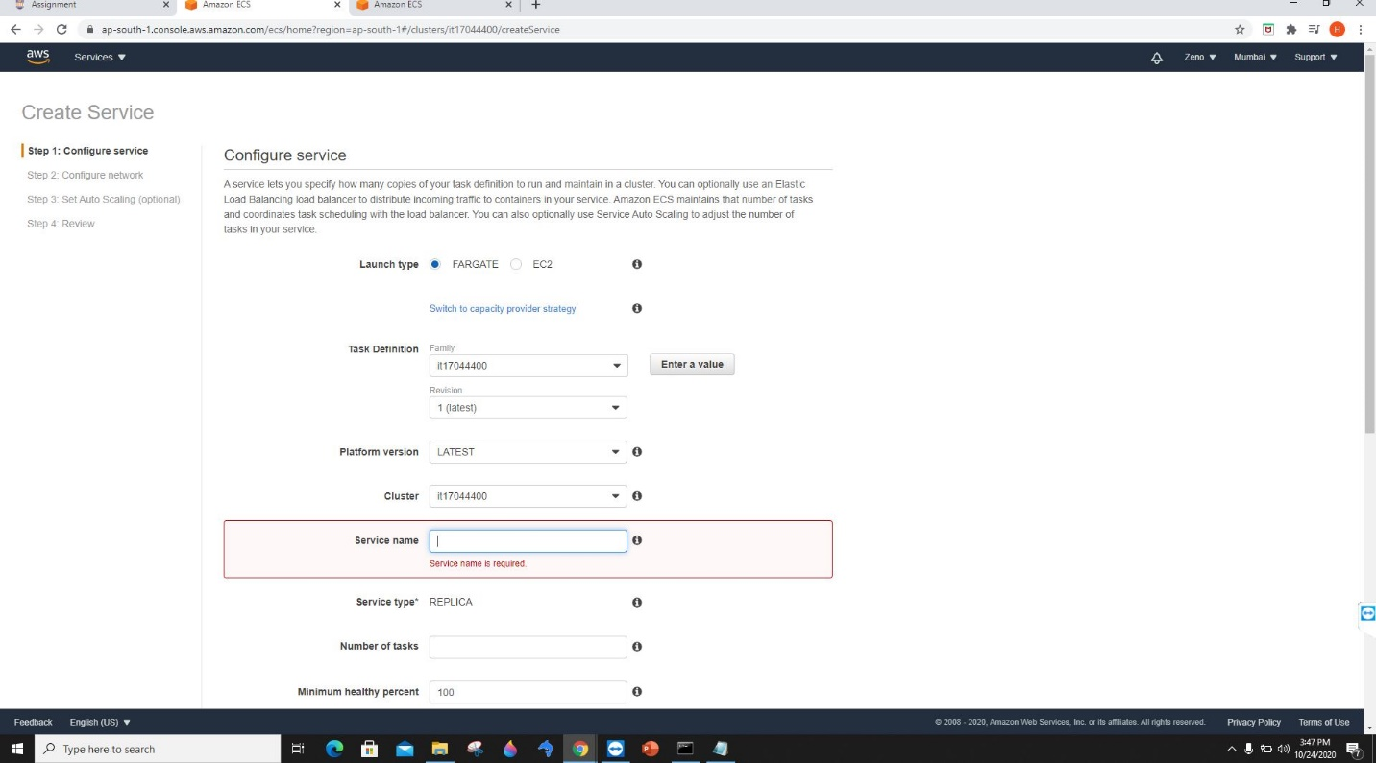

Configure security groups

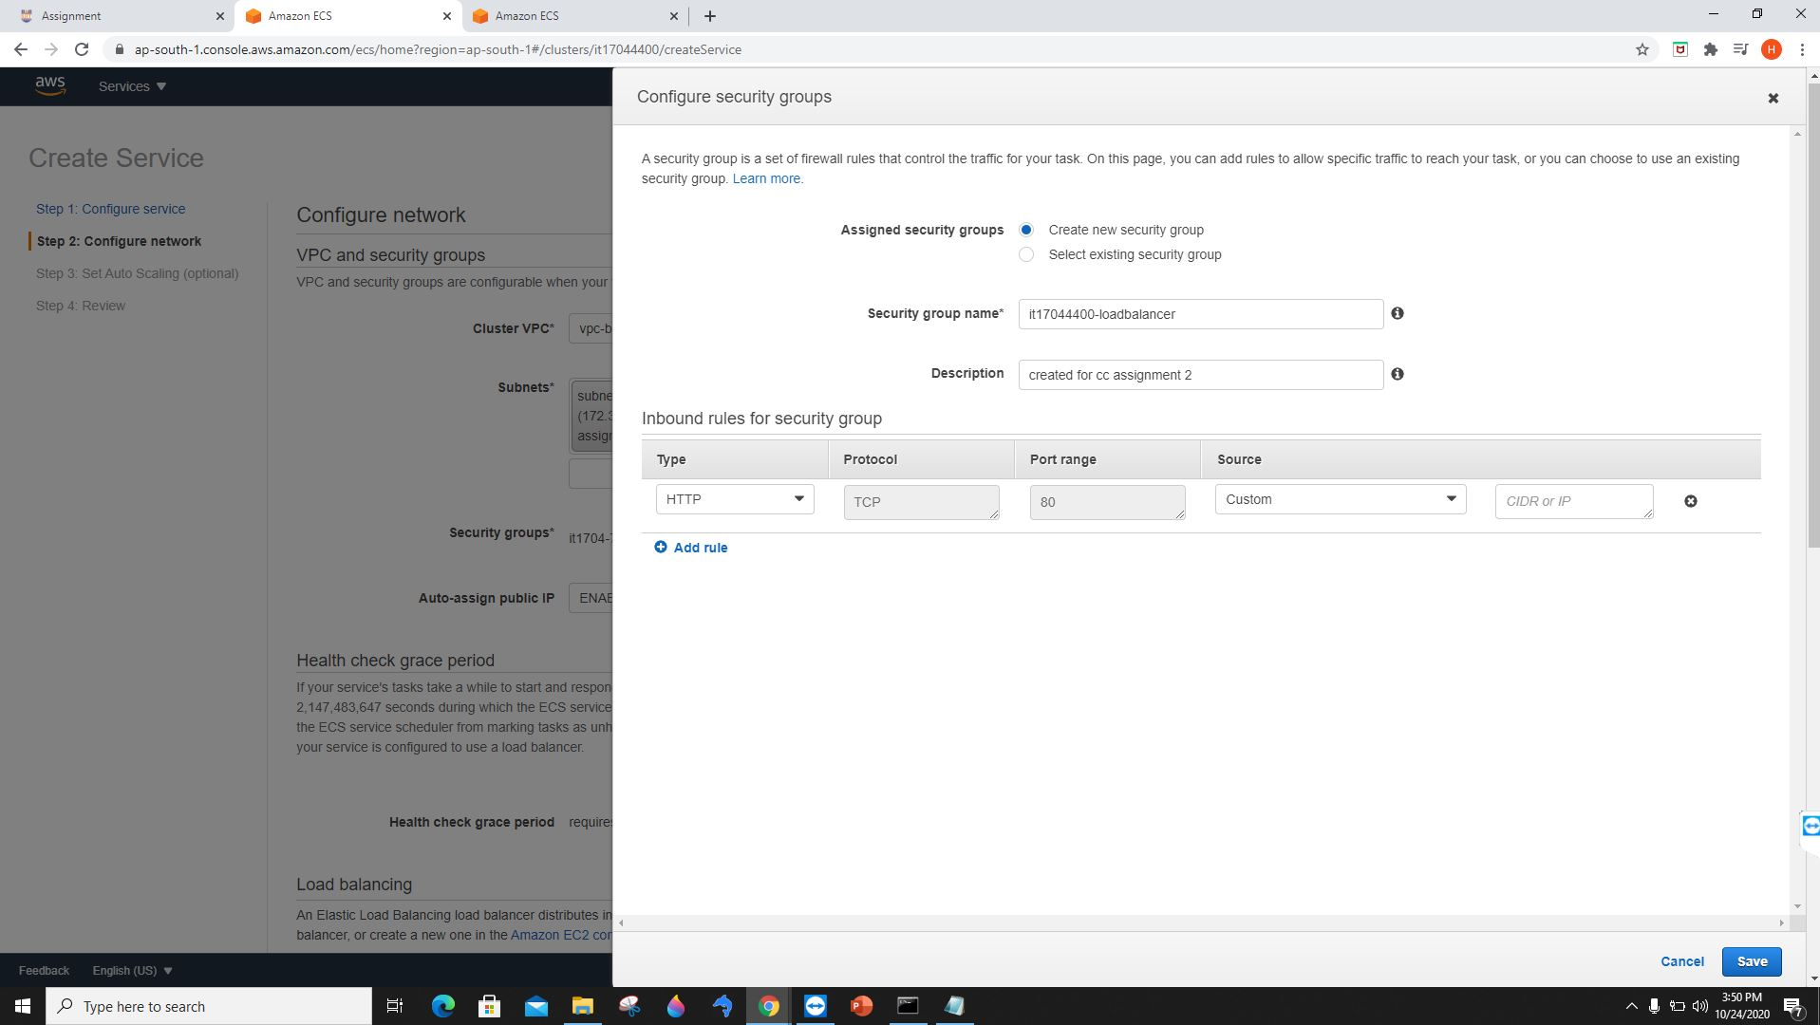

Launch status

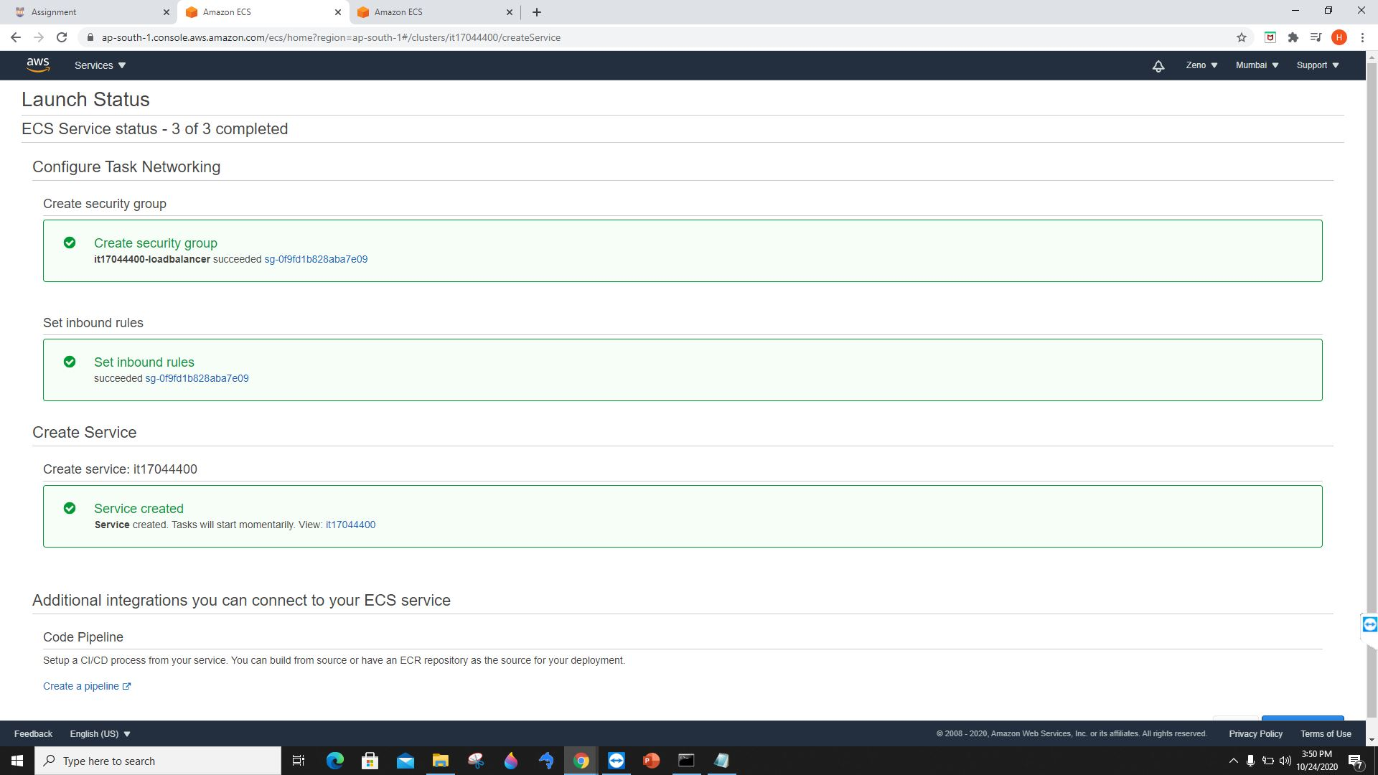

Create a load balancer and add it.

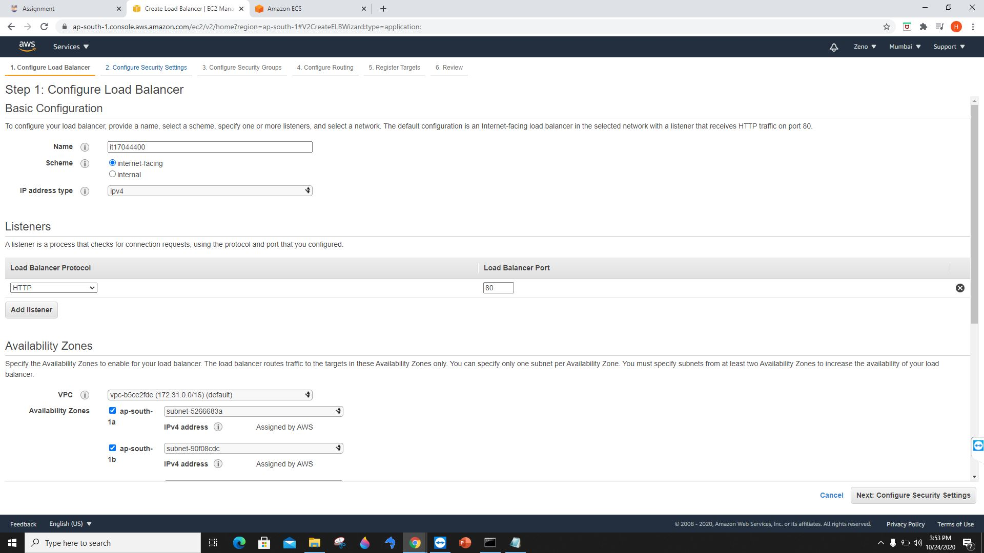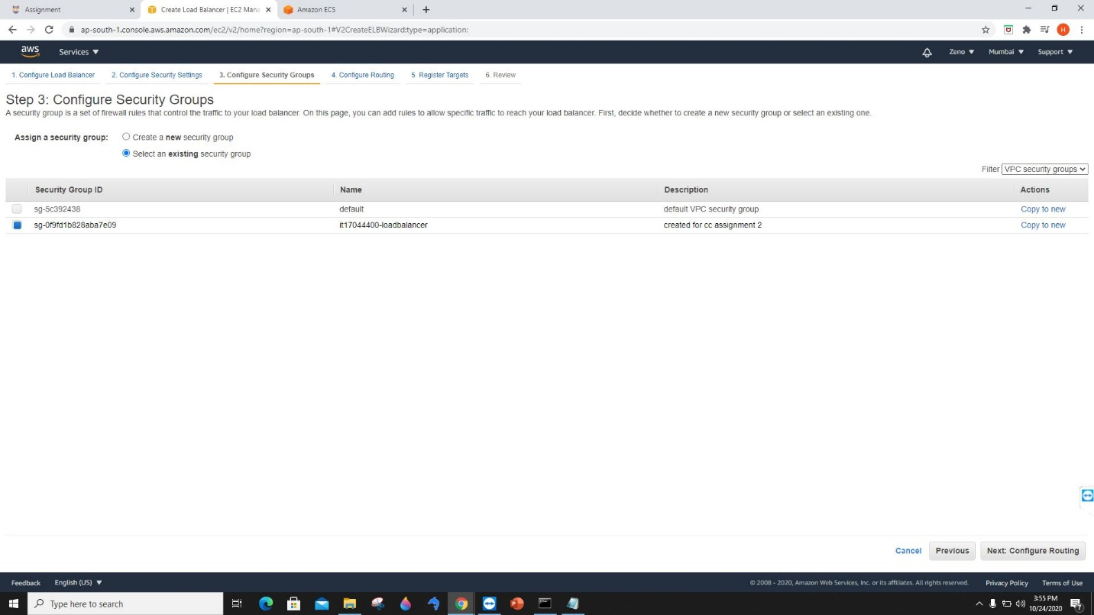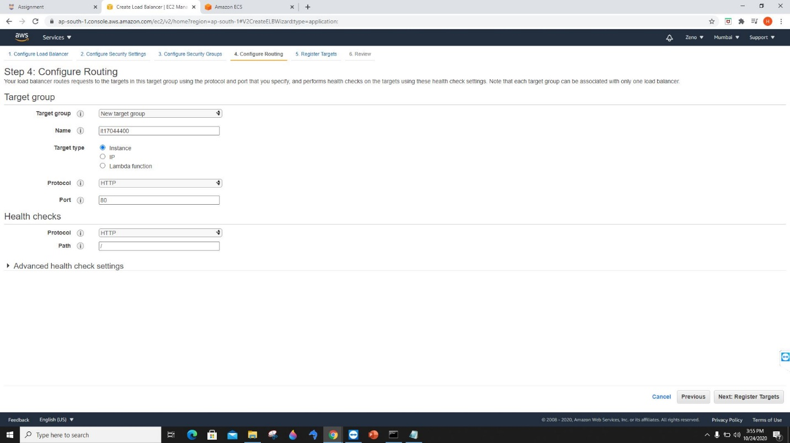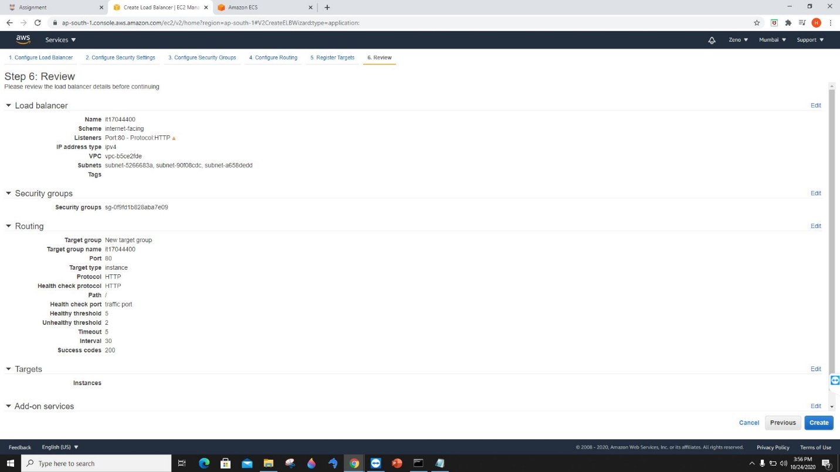

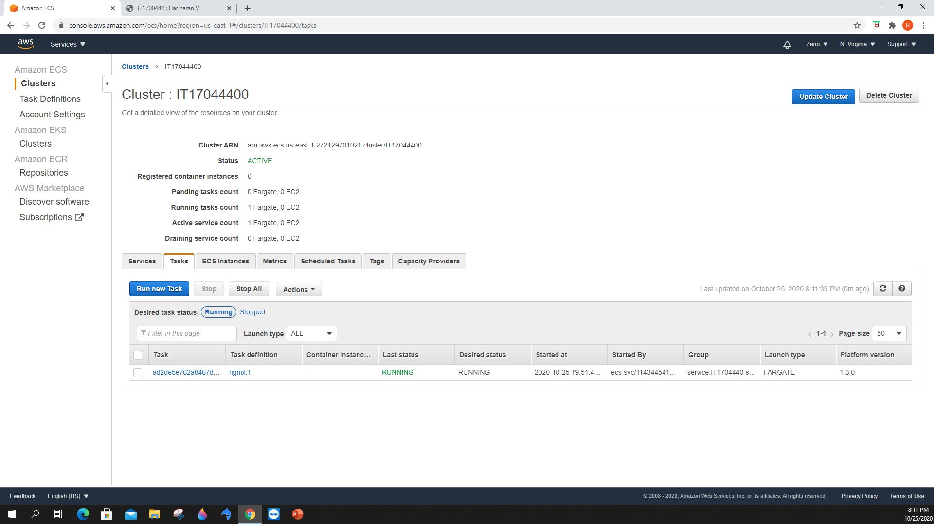

Cluster, services and tasks are running.

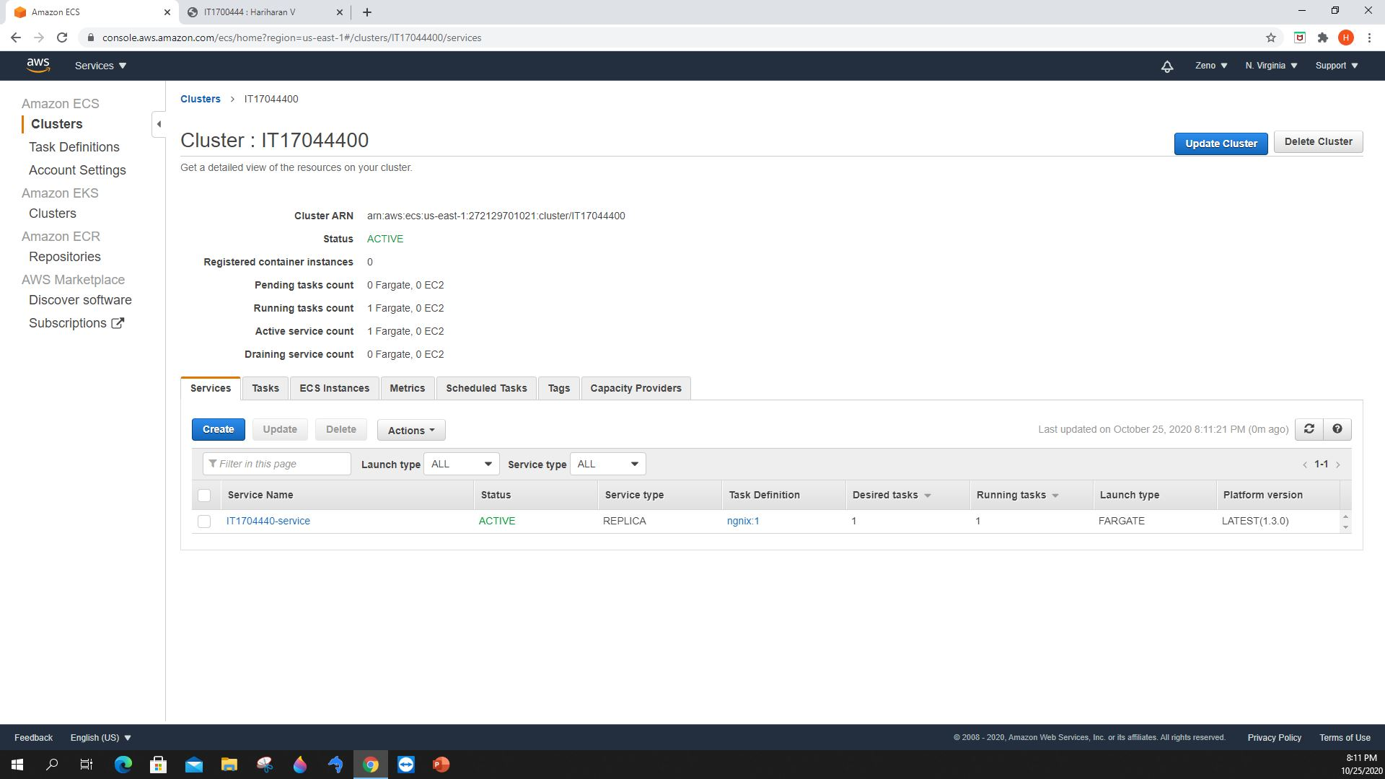

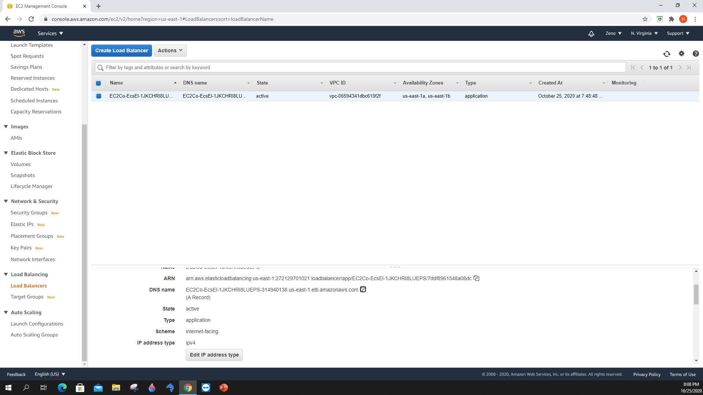

Loaded static web page from ECS.

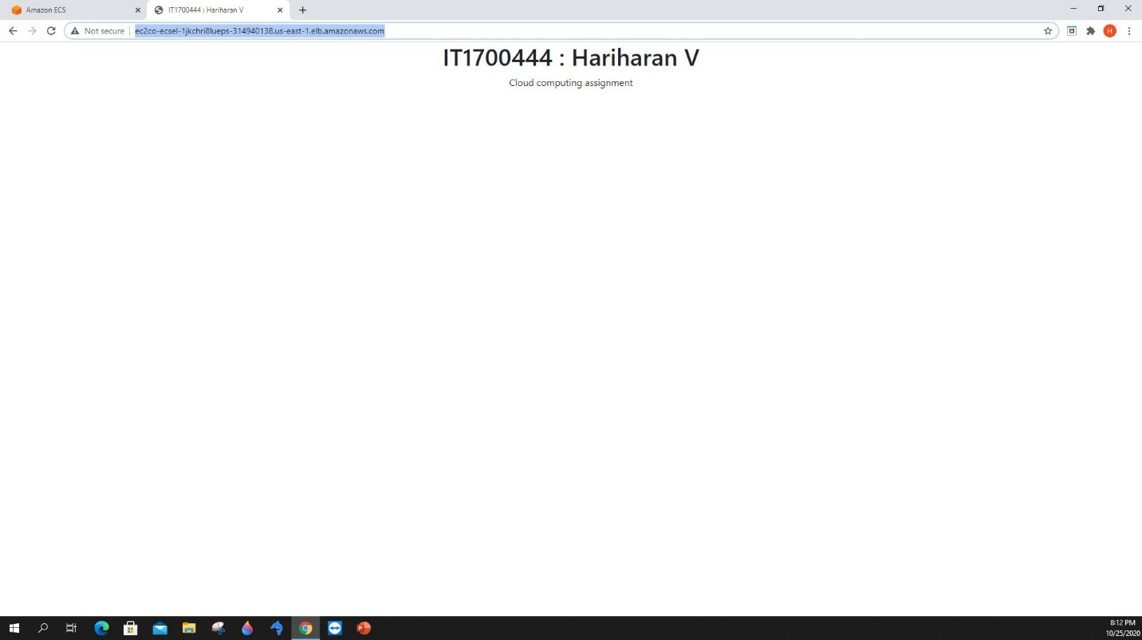

Docker repository: https://hub.docker.com/repository/docker/6318136/it17044400

Site endpoint: http://ec2co-ecsel-1jkchri8lueps-314940138.us-east-1.elb.amazonaws.com/