1. **Home Page**

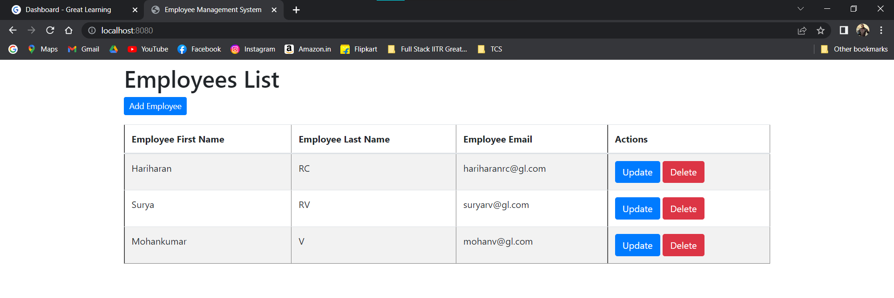

1. **Create Employee**

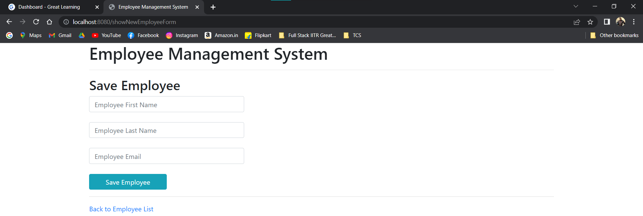

1. **Update (Surya is changed to SuryaPrasath in first name & email)**

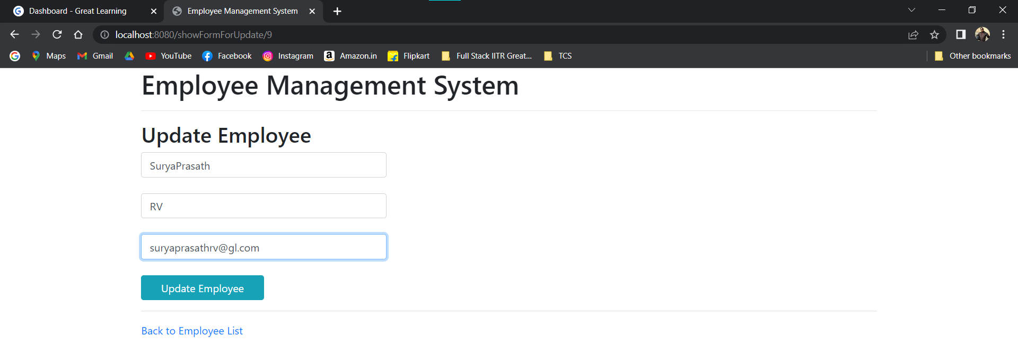

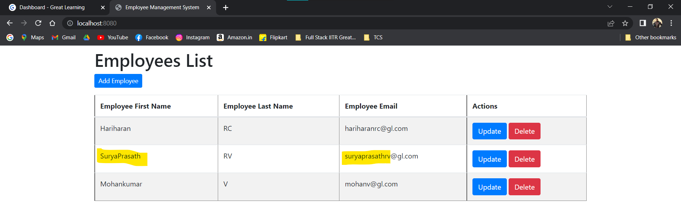

**Database: -**

