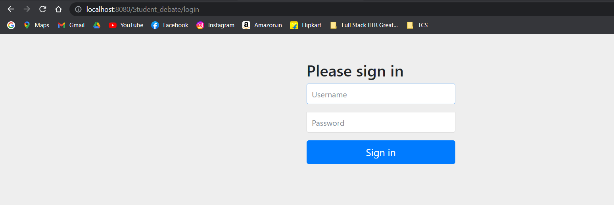

**Using Admin login access to Update and Delete**

**Added few student names**

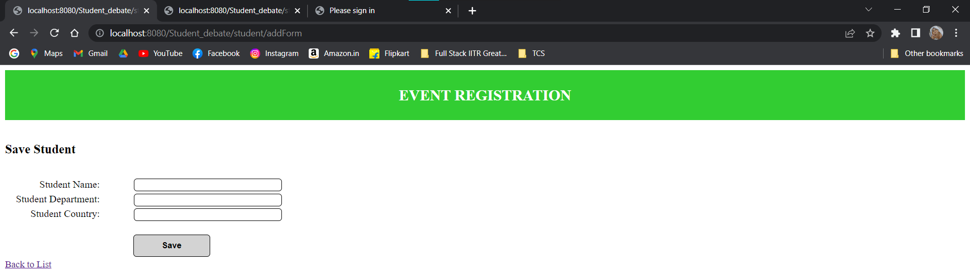

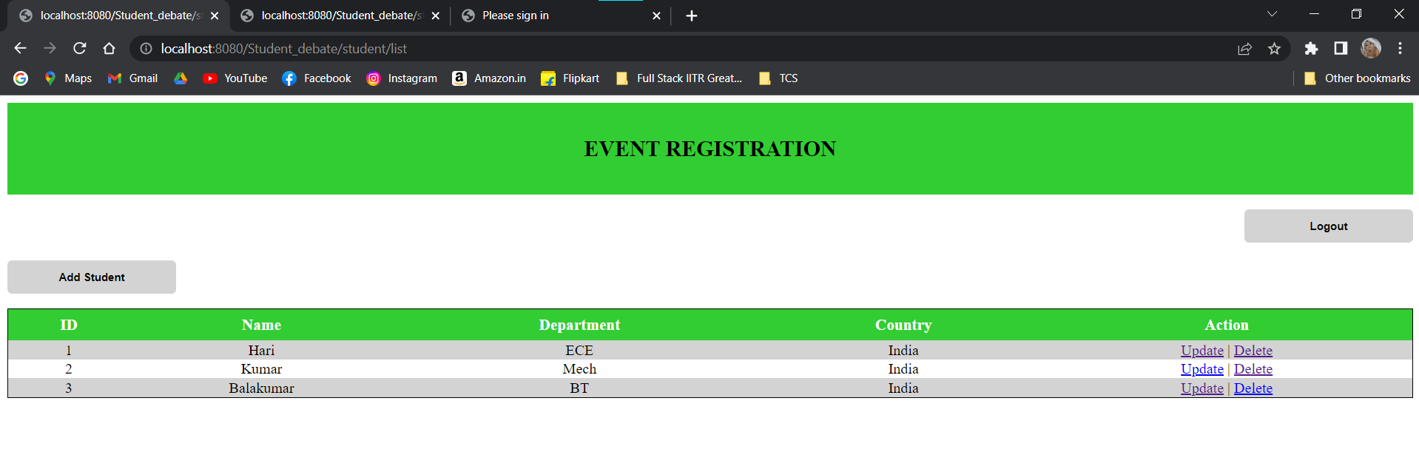

**Name Hari is updated as Hariharan using Admin access**

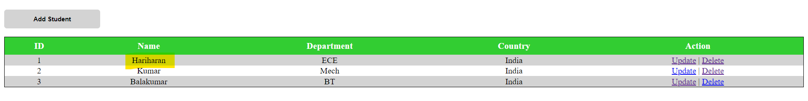

**Delete student name – Balakumar**

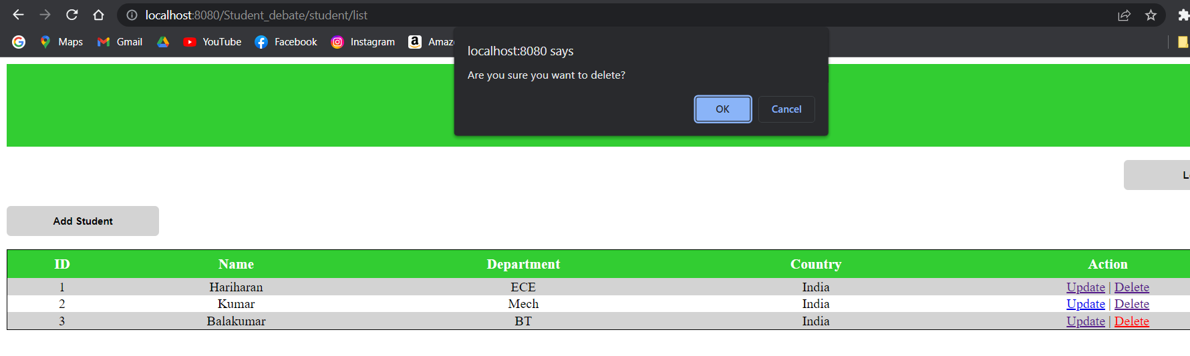

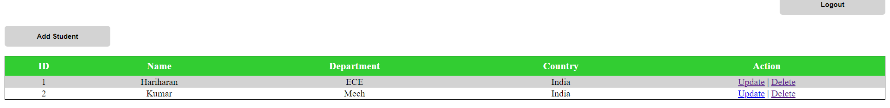

**Logged using User access:**

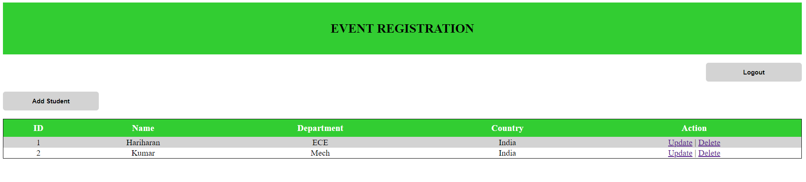

**Trying to update a student name:**

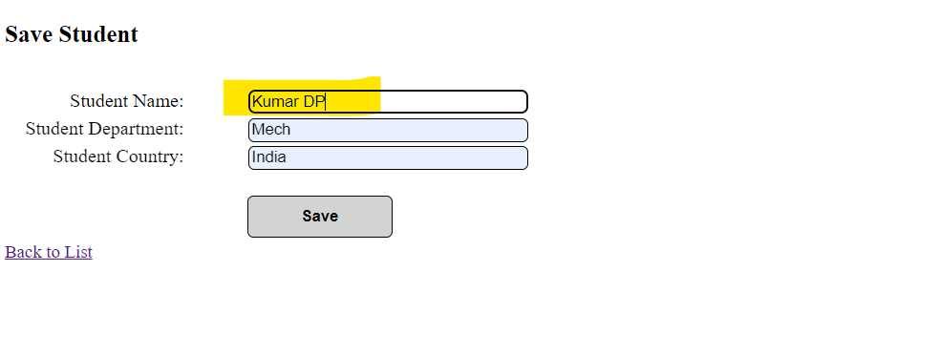

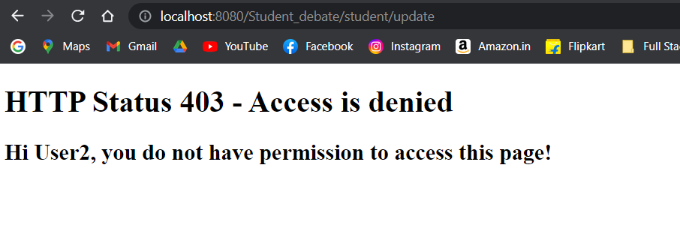

**Trying to delete a student name:**

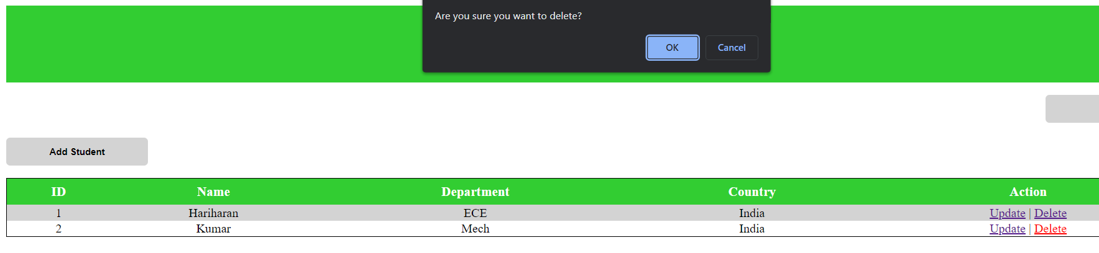

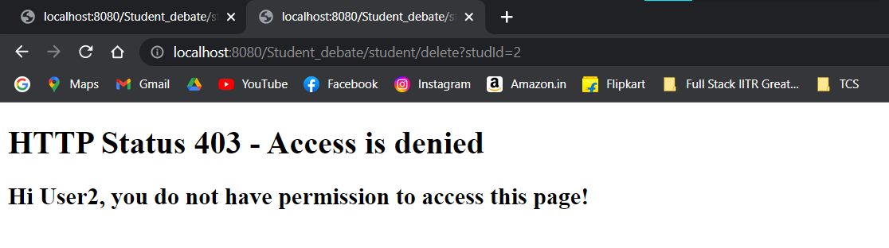

**Corresponding SQL table details:**

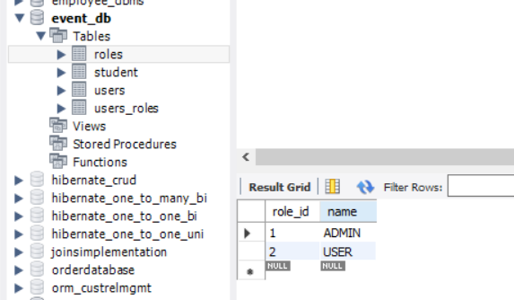

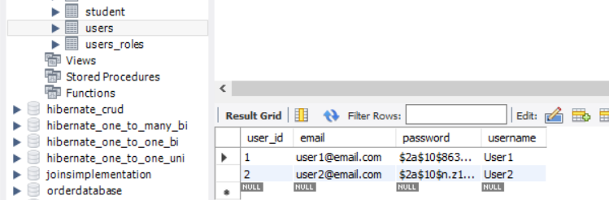

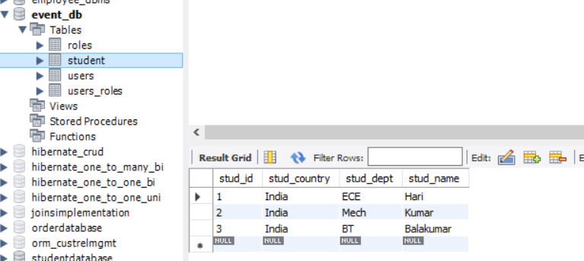

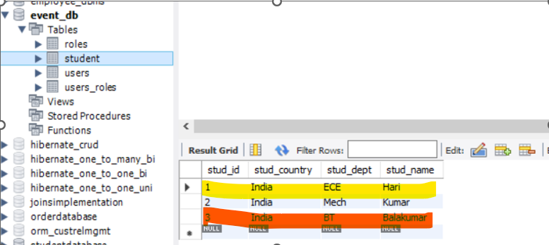

**After performing Update, Delete using admin rights**

