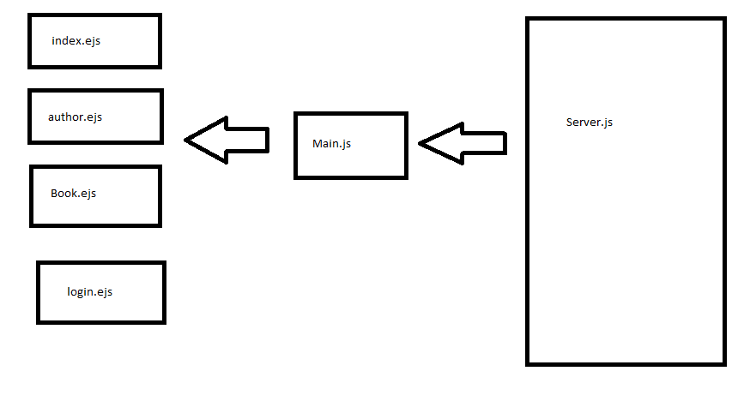

Server.js acts as server here and all the business logic has been written in this file. As this is the very basic and simple application I decided to keep all the server and backend logic in this file.

Main.js acts as a client to talk to the server. The entire front end screens send the request through main.js and it sends the request and get the response back to EJS frontend files. These files are located Bookface/public folder

View files – index.ejs, author.ejs, book.ejs and login.ejs. Frontend files I have not concentrated on the designing part (CSS and fancy widgets) as this coursework is more about functionality rather than design. These files are located Bookface/view folder.

Rests of the stuff are supporting libraries. Downloaded using npm install.