**Creating Microservices for account and loan**

## **1. Create Account Microservice**

1. Visit 👉<https://start.spring.io>
2. Fill in:  
   * **Group**: com.cognizant
   * **Artifact**: account
3. Select dependencies:  
   * **Developer Tools** > Spring Boot DevTools
   * **Web** > Spring Web
4. Click **Generate**, and extract the ZIP file.
5. Place the account folder inside D:\microservices\
6. Open **Eclipse**:  
   * File > Import > Existing Maven Projects
   * Browse to D:\microservices\account
   * Click Finish

### **Implement Controller for Account Service**

1. In src/main/java/com/cognizant/account/ create a class named AccountController.java

**package** com.cognizant.account;

**import** org.springframework.web.bind.annotation.*;

**import** java.util.Map;

**import** java.util.HashMap;

@RestController

@RequestMapping("/accounts")

**public** **class** AccountController {

@GetMapping("/{number}")

**public** Map<String, Object> getAccountDetails(@PathVariable String number) {

Map<String, Object> response = **new** HashMap<>();

response.put("number", number);

response.put("type", "savings");

response.put("balance", 234343);

**return** response;

}

}

**AccountApplication.java**

package com.cognizant.account;

import org.springframework.boot.SpringApplication;

import org.springframework.boot.autoconfigure.SpringBootApplication;

@SpringBootApplication

public class AccountApplication {

public static void main(String[] args) {

SpringApplication.run(AccountApplication.class, args);

}

}

Run the application by right-clicking the main class AccountApplication.java > Run As > Spring Boot App.

Open browser:  
  
http://localhost:8080/accounts/00987987973432

**OUTPUT:**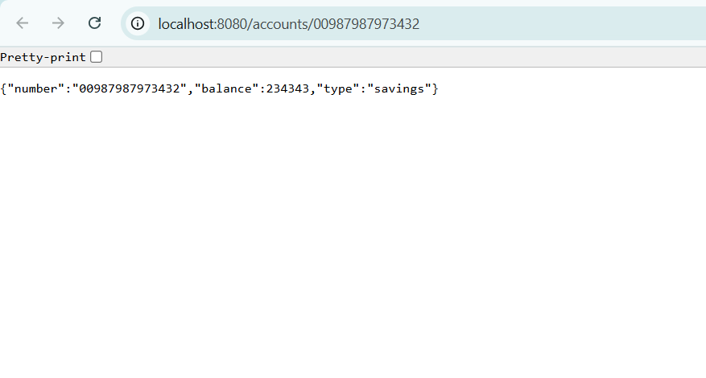

## **2. Create Loan Microservice**

Repeat steps as done for Account service:

1. Go to<https://start.spring.io>
2. Fill:  
   * Group: com.cognizant
   * Artifact: loan
3. Add dependencies:  
   * DevTools
   * Spring Web
4. Generate, extract ZIP, and move loan folder to:  
     
   D:\microservices\

5. Import into Eclipse: File > Import > Existing Maven Projects

### **Implement Controller for Loan Service**

1. In src/main/java/com/cognizant/loan/, create LoanController.java

**package** com.cognizant.loan;

**import** org.springframework.web.bind.annotation.*;

@RestController

@RequestMapping("/loans")

**public** **class** LoanController {

@GetMapping("/{number}")

**public** Loan getLoan(@PathVariable String number) {

**return** **new** Loan(number, "car", 400000, 3258, 18);

}

**static** **class** Loan {

**private** String number;

**private** String type;

**private** **double** loan;

**private** **int** emi;

**private** **int** tenure;

**public** Loan(String number, String type, **double** loan, **int** emi, **int** tenure) {

**this**.number = number;

**this**.type = type;

**this**.loan = loan;

**this**.emi = emi;

**this**.tenure = tenure;

}

// Getters

**public** String getNumber() { **return** number; }

**public** String getType() { **return** type; }

**public** **double** getLoan() { **return** loan; }

**public** **int** getEmi() { **return** emi; }

**public** **int** getTenure() { **return** tenure; }

}

}

**AccountApplication.java**

package com.cognizant.account;

import org.springframework.boot.SpringApplication;

import org.springframework.boot.autoconfigure.SpringBootApplication;

@SpringBootApplication

public class AccountApplication {

public static void main(String[] args) {

SpringApplication.run(AccountApplication.class, args);

}

}

### **Change Port for Loan Microservice**

1. Open src/main/resources/application.properties
2. Add:

server.port=8081

Run the application by right-clicking the main class LoanApplication.java > Run As > Spring Boot App.

Loan:

<http://localhost:8081/loans/H00987987972342>

**OUTPUT:**

