SUMMARY REPORT:

1. Most of users created their accounts through guest invite.

2**. is adopted people opted for marketting drip?**

Only few people enabled for marketing drip being considered as adopted.

3**. people invited by users is getting adopted ?**

Precentage of people invited by users is converted into adopted users is 0.127

4**.is there chance of getting adopted user when people is invited by user id?**

there is no influence of invite by userids in becoming adopted users

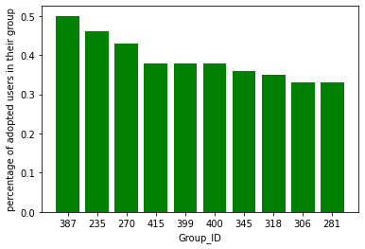5**. In which organisation where most of the people are adopted users?**

Top ten groups having

high amount of adopted

users

* 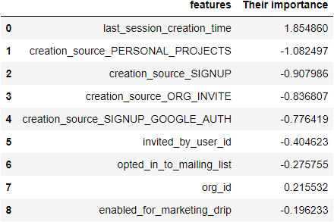**factors predict future user**

adoption .