PRODUCT SALES ANALYSIS
Project Objective:
The objective of a product sales analysis is to leverage data and insights to optimize sales strategies, enhance decision-making, improve customer experience, identify key performance indicators, detect patterns and trends, optimize inventory management, analyze sales channels, conduct competitive analysis, assess risks, and foster a culture of continuous improvement, ultimately driving revenue growth and ensuring sustained competitiveness in the market.
Design Thinking Process:
1. Empathiz:
- Understand user needs and pain points through research and interviews.
2. Define:
- Identify key features and success metrics.
3. Ideate:
- Brainstorm solutions and create prototypes.
4. Prototype:
- Develop interactive prototypes and iterate based on feedback.
5. Test:
- Conduct usability testing and refine the design based on results.
Development Phases:

1. Planning:
- Define project scope, objectives, and budget.
2. Development:
- Build the mobile app with required features.
3. Testing and QA:
- Thoroughly test and resolve issues.
4. Deployment:
- Launch the app and implement marketing.
5. Iterative Improvement:
- Continuously gather feedback and release updates to enhance the app's performance and features.

Code:
import numpy as np
import pandas as pd
import os
for dirname, _, filenames in os.walk('/kaggle/input'):
for filename in filenames:
print(os.path.join(dirname, filename))
/kaggle/input/product-sales-data/statsfinal.csv

About Dataset
Greetings , fellow analyst ! REC corp LTD. is small-scaled business venture established in India. They have been selling FOUR PRODUCTS for OVER TEN YEARS . The products are P1, P2, P3 and P4. They have collected data from their retail centers and organized it into a small csv file , which has been given to you. The excel file contains about 8 numerical parameters :
- Q1- Total unit sales of product 1
- Q2- Total unit sales of product 2
- Q3- Total unit sales of product 3
- Q4- Total unit sales of product 4
- S1- Total revenue from product 1
- S2- Total revenue from product 2
- S3- Total revenue from product 3
- S4- Total revenue from product 4
sales.jpg

Importing libraries
import pandas as pd
import numpy as np
import seaborn as sns
import matplotlib.pyplot as plt
pd.options.display.max_columns=50
sns.set(style="darkgrid")

Importing data
df=pd.read_csv("/kaggle/input/product-sales-data/statsfinal.csv")
df.head(5)
Unnamed: 0 Date Q-P1 Q-P2 Q-P3 Q-P4 S-P1 S-P2 \
0 0 13-06-2010 5422 3725 576 907 17187.74 23616.50
1 1 14-06-2010 7047 779 3578 1574 22338.99 4938.86
2 2 15-06-2010 1572 2082 595 1145 4983.24 13199.88
3 3 16-06-2010 5657 2399 3140 1672 17932.69 15209.66
4 4 17-06-2010 3668 3207 2184 708 11627.56 20332.38
S-P3 S-P4
0 3121.92 6466.91
1 19392.76 11222.62
2 3224.90 8163.85
3 17018.80 11921.36
4 11837.28 5048.04

Workflow
- Understanding the data
- Data cleaning
- Exploratory Data Analysis
- Insights
# Fethcing rows and columns
df.shape
(4600, 10)
# fetching column names
df.columns
Index(['Unnamed: 0', 'Date', 'Q-P1', 'Q-P2', 'Q-P3', 'Q-P4', 'S-P1', 'S-P2',
'S-P3', 'S-P4'],
dtype='object')
# basic info
df.info()
<class 'pandas.core.frame.DataFrame'>
RangeIndex: 4600 entries, 0 to 4599
Data columns (total 10 columns):
# Column Non-Null Count Dtype
--- ------ -------------- -----
0 Unnamed: 0 4600 non-null int64
1 Date 4600 non-null object
2 Q-P1 4600 non-null int64
3 Q-P2 4600 non-null int64
4 Q-P3 4600 non-null int64
5 Q-P4 4600 non-null int64
6 S-P1 4600 non-null float64
7 S-P2 4600 non-null float64
8 S-P3 4600 non-null float64
9 S-P4 4600 non-null float64
dtypes: float64(4), int64(5), object(1)
memory usage: 359.5+ KB
# Checking null values
df.isnull().sum()
Unnamed: 0 0
Date 0
Q-P1 0
Q-P2 0
Q-P3 0
Q-P4 0
S-P1 0
S-P2 0
S-P3 0
S-P4 0
dtype: int64

No Null values
# Checking Dtypes
df.dtypes
Unnamed: 0 int64
Date object
Q-P1 int64
Q-P2 int64
Q-P3 int64
Q-P4 int64
S-P1 float64
S-P2 float64
S-P3 float64
S-P4 float64
dtype: object

date is in object we have to change it to datetime
df.duplicated().sum()
0

There is no duplicate values
## Basic statistical info
df.describe().T
count mean std min 25% 50% \
Unnamed: 0 4600.0 2299.500000 1328.049949 0.00 1149.750 2299.500
Q-P1 4600.0 4121.849130 2244.271323 254.00 2150.500 4137.000
Q-P2 4600.0 2130.281522 1089.783705 251.00 1167.750 2134.000
Q-P3 4600.0 3145.740000 1671.832231 250.00 1695.750 3202.500
Q-P4 4600.0 1123.500000 497.385676 250.00 696.000 1136.500
S-P1 4600.0 13066.261743 7114.340094 805.18 6817.085 13114.290
S-P2 4600.0 13505.984848 6909.228687 1591.34 7403.535 13529.560
S-P3 4600.0 17049.910800 9061.330694 1355.00 9190.965 17357.550
S-P4 4600.0 8010.555000 3546.359869 1782.50 4962.480 8103.245
75% max
Unnamed: 0 3449.250 4599.00
Q-P1 6072.000 7998.00
Q-P2 3070.250 3998.00
Q-P3 4569.000 6000.00
Q-P4 1544.000 2000.00
S-P1 19248.240 25353.66
S-P2 19465.385 25347.32
S-P3 24763.980 32520.00
S-P4 11008.720 14260.00
df.sample(2)
Unnamed: 0 Date Q-P1 Q-P2 Q-P3 Q-P4 S-P1 S-P2 \
2256 2256 26-08-2016 668 3679 3033 1252 2117.56 23324.86
727 727 13-06-2012 5178 1157 2916 426 16414.26 7335.38
S-P3 S-P4
2256 16438.86 8926.76
727 15804.72 3037.38
# Changing dtype
from datetime import datetime as dt
df[df["Date"]=="31-9-2010"]
Unnamed: 0 Date Q-P1 Q-P2 Q-P3 Q-P4 S-P1 S-P2 \
109 109 31-9-2010 4986 342 4978 558 15805.62 2168.28
S-P3 S-P4
109 26980.76 3978.54
df['Date'] = pd.to_datetime(df['Date'], errors='coerce')
df[df['Date'].isnull()]
Unnamed: 0 Date Q-P1 Q-P2 Q-P3 Q-P4 S-P1 S-P2 S-P3 \
109 109 NaT 4986 342 4978 558 15805.62 2168.28 26980.76
170 170 NaT 4632 3930 523 1581 14683.44 24916.20 2834.66
473 473 NaT 2242 401 5926 789 7107.14 2542.34 32118.92
534 534 NaT 325 3476 4588 1771 1030.25 22037.84 24866.96
836 836 NaT 1003 256 1346 1449 3179.51 1623.04 7295.32
897 897 NaT 2509 2666 4146 593 7953.53 16902.44 22471.32
1200 1200 NaT 597 709 5470 1994 1892.49 4495.06 29647.40
1261 1261 NaT 7681 1235 347 1087 24348.77 7829.90 1880.74
1564 1564 NaT 5333 833 3494 618 16905.61 5281.22 18937.48
1625 1625 NaT 3870 2779 3246 1290 12267.90 17618.86 17593.32
1928 1928 NaT 3583 2111 4225 1401 11358.11 13383.74 22899.50
1989 1989 NaT 7516 3423 3116 458 23825.72 21701.82 16888.72
2291 2291 NaT 7891 741 2280 1068 25014.47 4697.94 12357.60
2352 2352 NaT 2457 3144 533 1184 7788.69 19932.96 2888.86
2655 2655 NaT 3512 2851 4072 1597 11133.04 18075.34 22070.24
2716 2716 NaT 6094 3798 5849 881 19317.98 24079.32 31701.58
3019 3019 NaT 1727 2645 5715 1295 5474.59 16769.30 30975.30
3080 3080 NaT 7360 2974 2717 1127 23331.20 18855.16 14726.14
3383 3383 NaT 3195 2525 5918 1003 10128.15 16008.50 32075.56
3444 3444 NaT 2660 2674 2732 934 8432.20 16953.16 14807.44
3746 3746 NaT 4713 1227 4065 403 14940.21 7779.18 22032.30
3807 3807 NaT 870 3463 798 851 2757.90 21955.42 4325.16
4110 4110 NaT 3511 2609 1543 853 11129.87 16541.06 8363.06
4171 4171 NaT 506 3333 3897 574 1604.02 21131.22 21121.74
4474 4474 NaT 6964 1873 5481 1336 22075.88 11874.82 29707.02
4535 4535 NaT 4600 2006 3796 1426 14582.00 12718.04 20574.32
S-P4
109 3978.54
170 11272.53
473 5625.57
534 12627.23
836 10331.37
897 4228.09
1200 14217.22
1261 7750.31
1564 4406.34
1625 9197.70
1928 9989.13
1989 3265.54
2291 7614.84
2352 8441.92
2655 11386.61
2716 6281.53
3019 9233.35
3080 8035.51
3383 7151.39
3444 6659.42
3746 2873.39
3807 6067.63
4110 6081.89
4171 4092.62
4474 9525.68
4535 10167.38
## Filling the NaT values with average of time
df["Date"].fillna(df["Date"].mean(),inplace=True)
df['Date'].isnull().sum()
0
df.dtypes
Unnamed: 0 int64
Date datetime64[ns]
Q-P1 int64
Q-P2 int64
Q-P3 int64
Q-P4 int64
S-P1 float64
S-P2 float64
S-P3 float64
S-P4 float64
dtype: object
#fetching month,day of week, weekday
df["month"]=df["Date"].dt.month_name()
df["day"]=df["Date"].dt.day_name()
df["dayoftheweek"]=df["Date"].dt.weekday
df["year"]=df["Date"].dt.year
df.sample()
Unnamed: 0 Date Q-P1 Q-P2 Q-P3 Q-P4 S-P1 S-P2 \
3465 3465 2019-12-21 5308 3408 2721 1262 16826.36 21606.72
S-P3 S-P4 month day dayoftheweek year
3465 14747.82 8998.06 December Saturday 5 2019
## Droping column unnamed as it is not usefull for us
df.drop(columns=["Unnamed: 0"],inplace=True)
df.sample()
Date Q-P1 Q-P2 Q-P3 Q-P4 S-P1 S-P2 S-P3 \
2978 2018-08-20 3047 3768 5824 1721 9658.99 23889.12 31566.08
S-P4 month day dayoftheweek year
2978 12270.73 August Monday 0 2018
df.corr().T
Q-P1 Q-P2 Q-P3 Q-P4 S-P1 S-P2 \
Q-P1 1.000000 0.002422 -0.005650 -0.059365 1.000000 0.002422
Q-P2 0.002422 1.000000 0.003729 0.013082 0.002422 1.000000
Q-P3 -0.005650 0.003729 1.000000 -0.006693 -0.005650 0.003729
Q-P4 -0.059365 0.013082 -0.006693 1.000000 -0.059365 0.013082
S-P1 1.000000 0.002422 -0.005650 -0.059365 1.000000 0.002422
S-P2 0.002422 1.000000 0.003729 0.013082 0.002422 1.000000
S-P3 -0.005650 0.003729 1.000000 -0.006693 -0.005650 0.003729
S-P4 -0.059365 0.013082 -0.006693 1.000000 -0.059365 0.013082
dayoftheweek -0.012221 -0.010037 0.012546 -0.003351 -0.012221 -0.010037
year -0.000866 0.008556 0.005632 -0.009436 -0.000866 0.008556
S-P3 S-P4 dayoftheweek year
Q-P1 -0.005650 -0.059365 -0.012221 -0.000866
Q-P2 0.003729 0.013082 -0.010037 0.008556
Q-P3 1.000000 -0.006693 0.012546 0.005632
Q-P4 -0.006693 1.000000 -0.003351 -0.009436
S-P1 -0.005650 -0.059365 -0.012221 -0.000866
S-P2 0.003729 0.013082 -0.010037 0.008556
S-P3 1.000000 -0.006693 0.012546 0.005632
S-P4 -0.006693 1.000000 -0.003351 -0.009436
dayoftheweek 0.012546 -0.003351 1.000000 0.000159
year 0.005632 -0.009436 0.000159 1.000000
plt.figure(figsize=(10,10))
sns.heatmap(df.corr(),annot=True)
<AxesSubplot:>
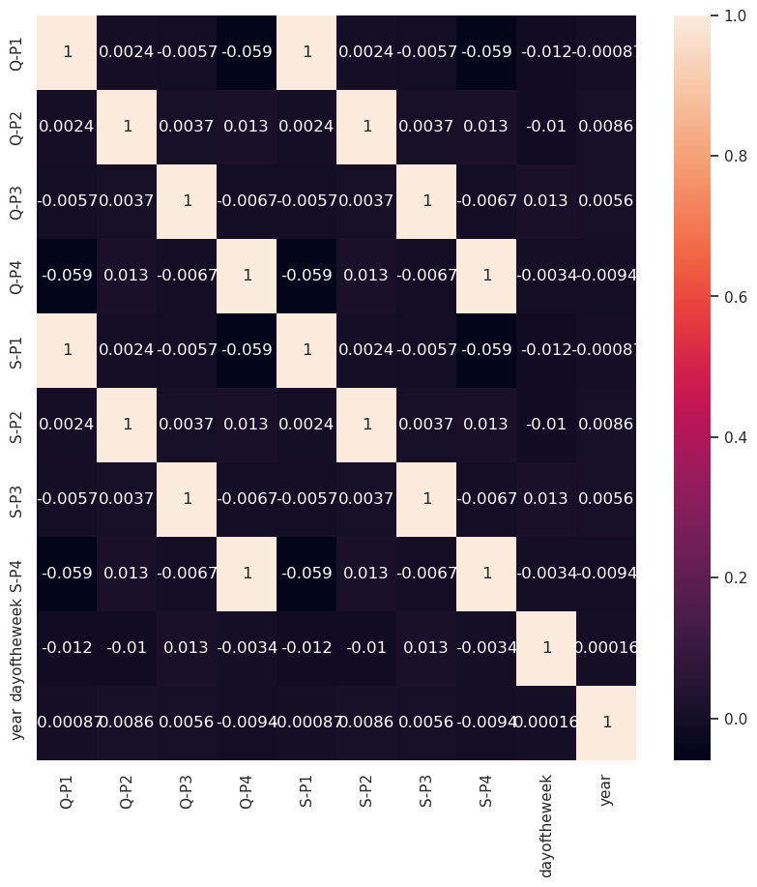

There is no strong correlation between the columns
for i in df.columns:
print(i,"---------",df[i].unique())
Date --------- ['2010-06-13T00:00:00.000000000' '2010-06-14T00:00:00.000000000'
'2010-06-15T00:00:00.000000000' ... '2023-01-02T00:00:00.000000000'
'2023-02-02T00:00:00.000000000' '2023-03-02T00:00:00.000000000']
Q-P1 --------- [5422 7047 1572 ... 1227 3122 1234]
Q-P2 --------- [3725 779 2082 ... 3404 841 3143]
Q-P3 --------- [ 576 3578 595 ... 4825 3588 5899]
Q-P4 --------- [ 907 1574 1145 ... 1161 1151 1112]
S-P1 --------- [17187.74 22338.99 4983.24 ... 3889.59 9896.74 3911.78]
S-P2 --------- [23616.5 4938.86 13199.88 ... 21581.36 5331.94 19926.62]
S-P3 --------- [ 3121.92 19392.76 3224.9 ... 26151.5 19446.96 31972.58]
S-P4 --------- [ 6466.91 11222.62 8163.85 ... 8277.93 8206.63 7928.56]
month --------- ['June' 'January' 'February' 'March' 'April' 'May' 'July' 'August'
'September' 'October' 'November' 'December']
day --------- ['Sunday' 'Monday' 'Tuesday' 'Wednesday' 'Thursday' 'Friday' 'Saturday']
dayoftheweek --------- [6 0 1 2 3 4 5]
year --------- [2010 2016 2011 2012 2013 2014 2015 2017 2018 2019 2020 2021 2022 2023]
df.sample()
Date Q-P1 Q-P2 Q-P3 Q-P4 S-P1 S-P2 S-P3 S-P4 \
2659 2017-04-10 2964 3484 4267 1140 9395.88 22088.56 23127.14 8128.2
month day dayoftheweek year
2659 April Monday 0 2017
# Total unit sales Product 1, Product 2, Product 3, Product 4
q = df[["Q-P1","Q-P2","Q-P3","Q-P4"]].sum()
print(q)
plt.figure(figsize=(8,8))
plt.pie(q,labels=df[["Q-P1","Q-P2","Q-P3","Q-P4"]].sum().index,shadow=True,autopct="%0.01f%%",textprops={"fontsize":20},wedgeprops={'width': 0.8},explode=[0,0,0,0.3])
plt.legend(loc='center right', bbox_to_anchor=(1.2, 0.8));
Q-P1 18960506
Q-P2 9799295
Q-P3 14470404
Q-P4 5168100
dtype: int64
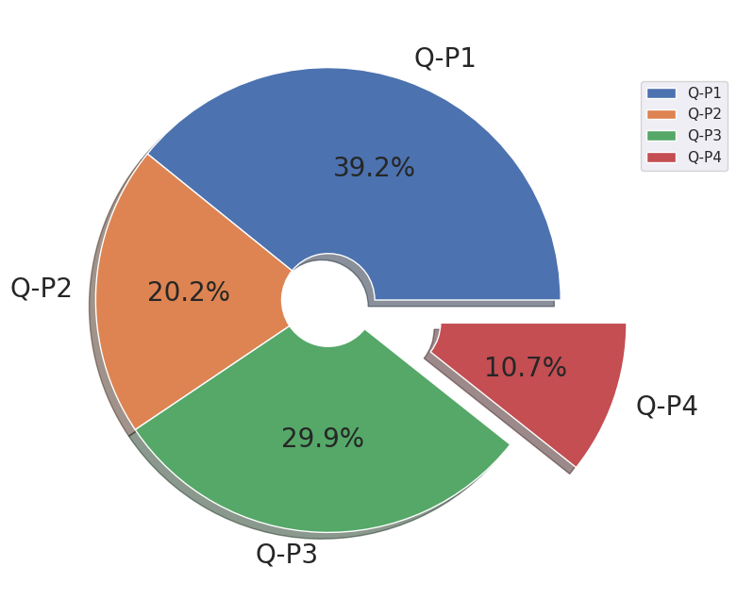
# which is the most occuring month
print(df["month"].value_counts())
plt.figure(figsize=(10,10))
sns.countplot(x="month",data=df,edgecolor="black")
plt.xticks(rotation=90);
October 411
January 399
July 398
June 385
August 385
September 385
November 385
December 385
March 380
May 379
April 367
February 341
Name: month, dtype: int64
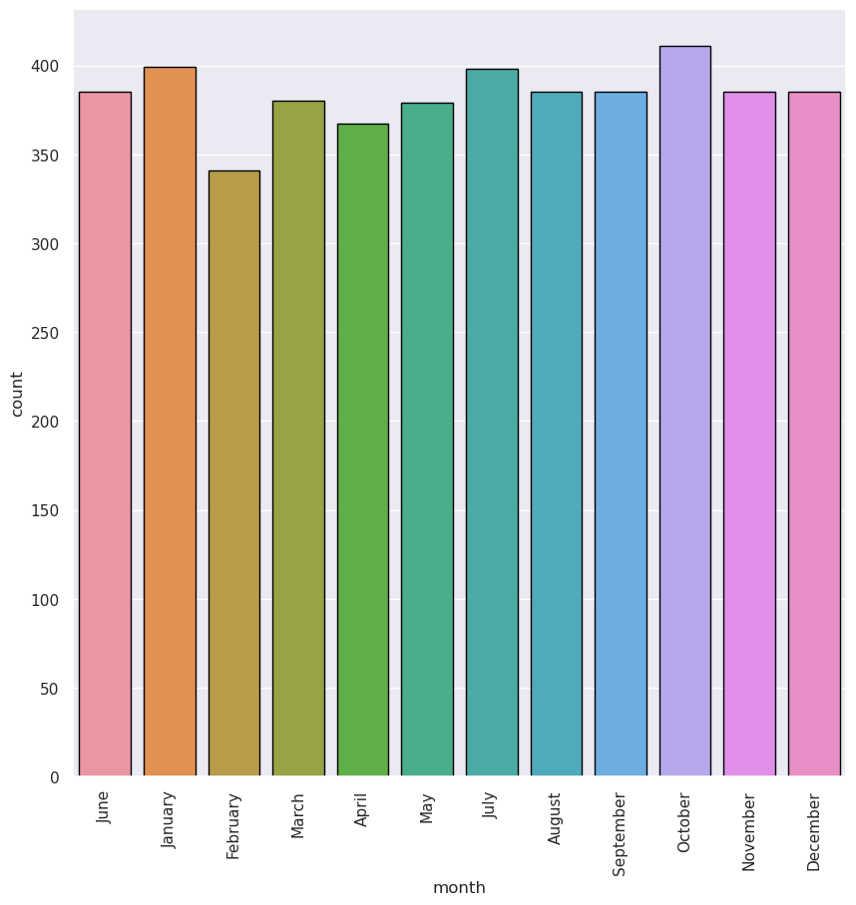
# which is the most occuring Day
print(df["day"].value_counts())
plt.figure(figsize=(10,10))
sns.countplot(x="day",data=df,edgecolor="black")
plt.xticks(rotation=90);
Friday 680
Wednesday 655
Sunday 654
Thursday 654
Tuesday 653
Monday 652
Saturday 652
Name: day, dtype: int64
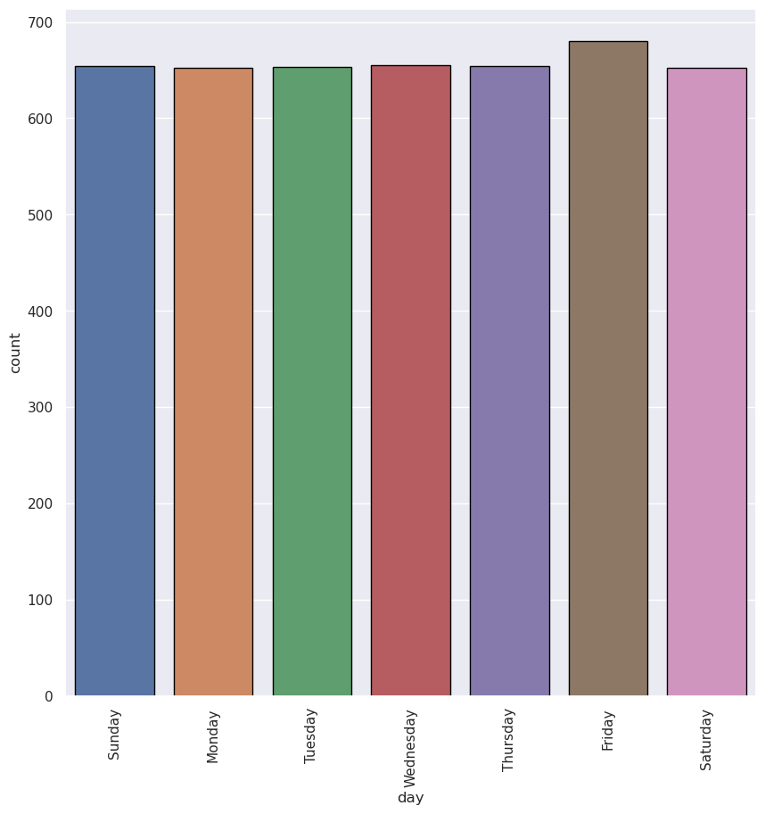
# which is the most occuring year
print(df["year"].value_counts())
plt.figure(figsize=(10,10))
sns.countplot(x="year",data=df,edgecolor="black")
plt.xticks(rotation=90);
2016 387
2011 362
2013 362
2014 362
2015 362
2017 362
2018 362
2019 362
2021 362
2022 362
2012 361
2020 361
2010 199
2023 34
Name: year, dtype: int64
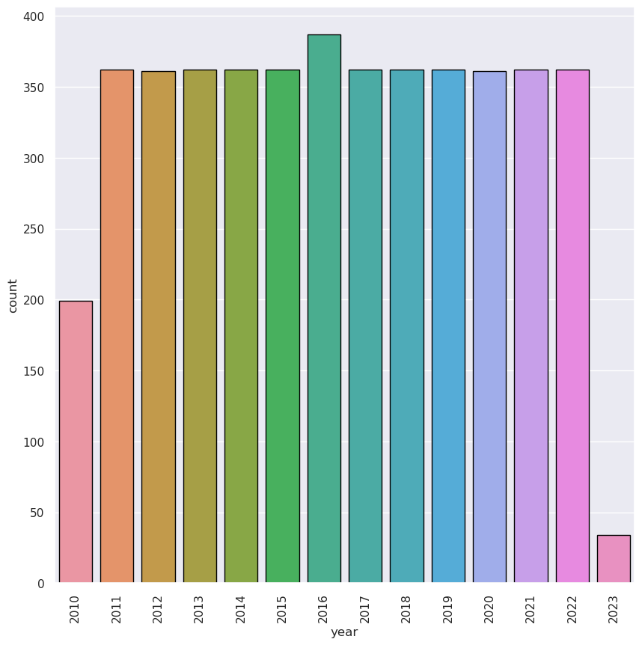
# Monthly distrubution of revenue
sns.relplot(x="month",y="S-P1",data=df,kind="line",height=10,color="red")
plt.xticks(rotation=90);
sns.relplot(x="month",y="S-P2",data=df,kind="line",height=10,color="blue")
plt.xticks(rotation=90);
sns.relplot(x="month",y="S-P3",data=df,kind="line",height=10,color="green")
plt.xticks(rotation=90);
sns.relplot(x="month",y="S-P4",data=df,kind="line",height=10,color="purple")
plt.xticks(rotation=90);
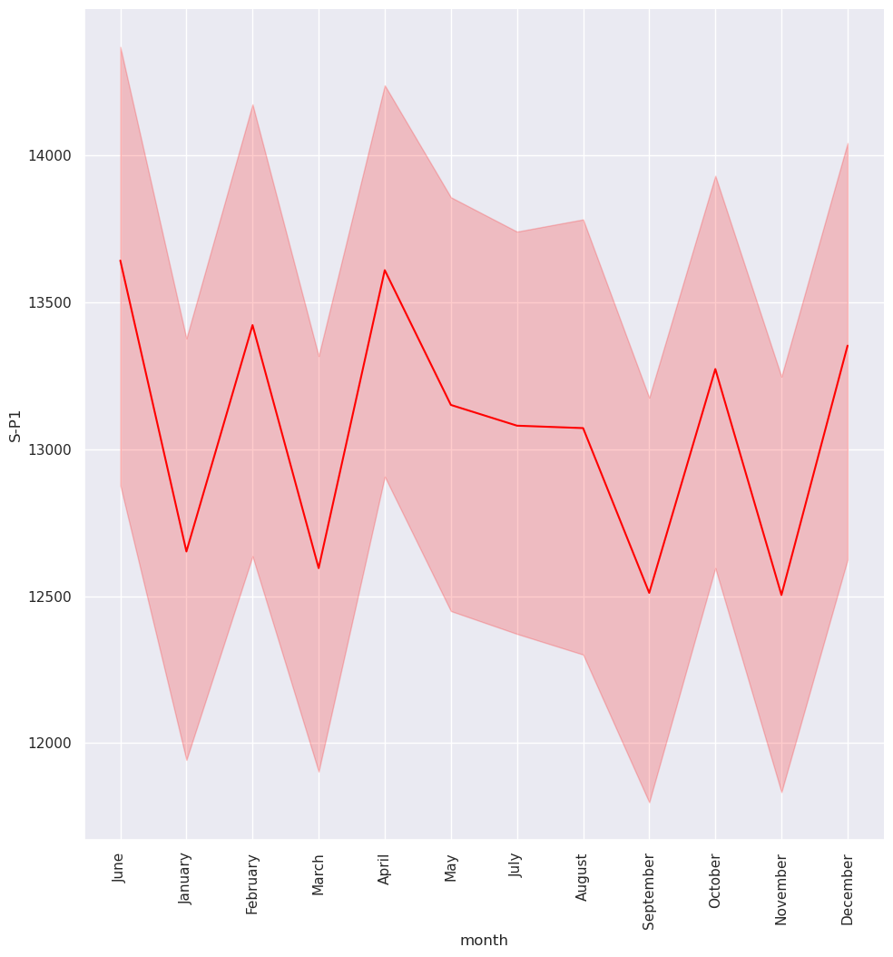
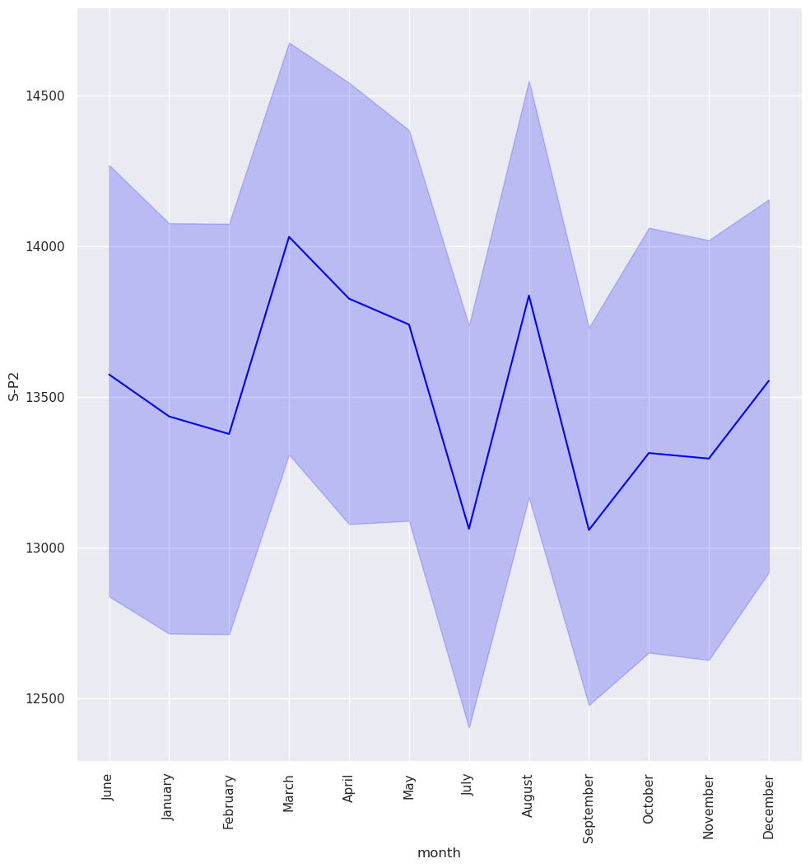
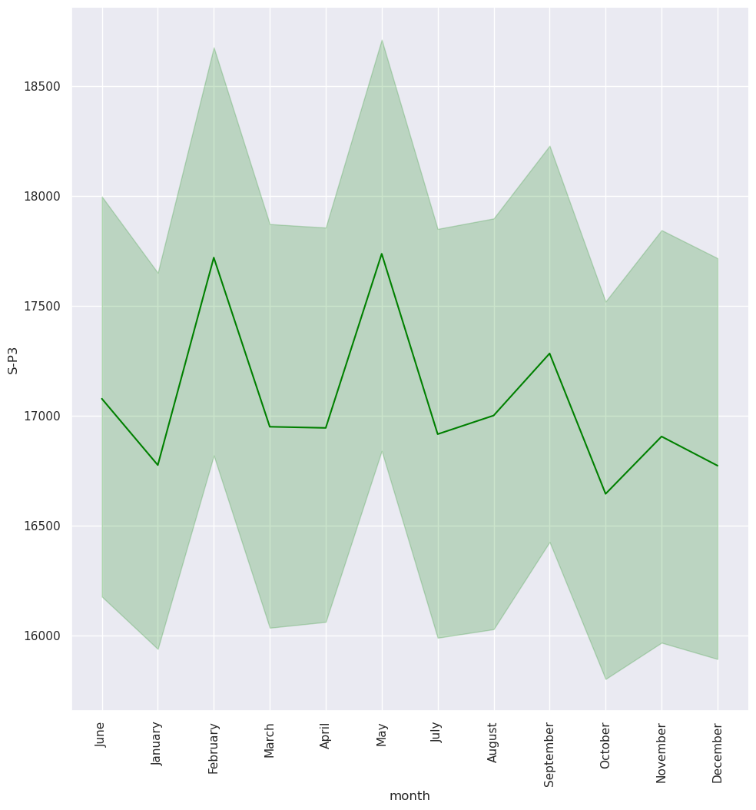
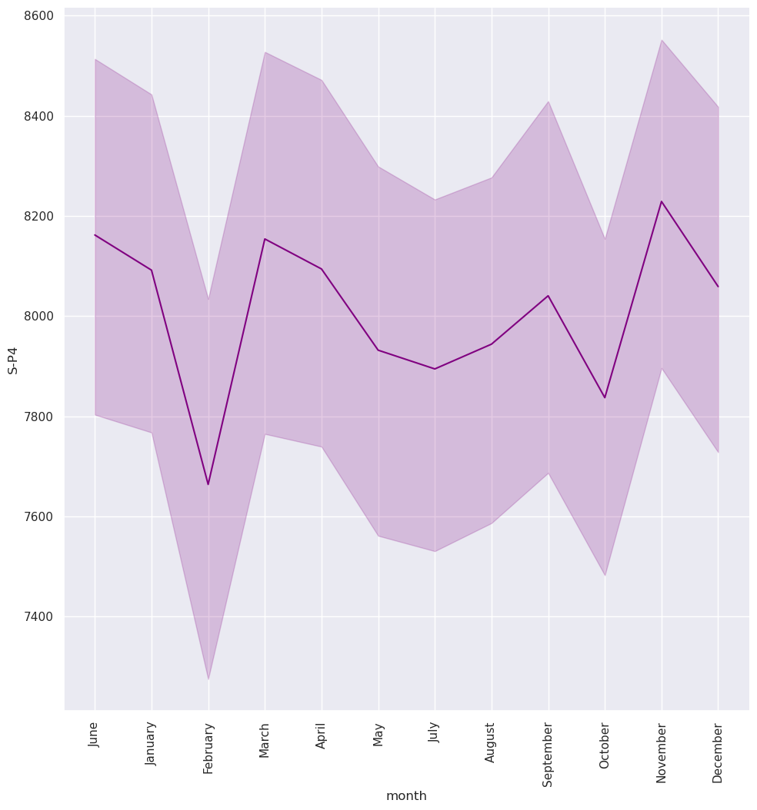
## In which month revenue was it peak
df.groupby("month")[["S-P1","S-P2","S-P3","S-P4"]].sum()
S-P1 S-P2 S-P3 S-P4
month
April 4994236.73 5074402.86 6218523.18 2970628.94
August 5032438.40 5327280.10 6545224.52 3058499.06
December 5140424.45 5218441.32 6457398.84 3102797.75
February 4576731.88 4561845.56 6042134.70 2613444.46
January 5048012.61 5360970.86 6693223.04 3228692.16
July 5205647.20 5199104.32 6732490.94 3142091.18
June 5251837.27 5226404.36 6574600.92 3142454.81
March 4786119.89 5332035.10 6440791.96 3098619.57
May 4983870.83 5207752.08 6722008.66 3006278.94
November 4813933.47 5119068.16 6508476.92 3168215.50
October 5454847.24 5472326.62 6840809.64 3221134.36
September 4816704.05 5027898.96 6653906.36 3095696.27
df.sample()
Date Q-P1 Q-P2 Q-P3 Q-P4 S-P1 S-P2 S-P3 S-P4 \
3525 2020-02-20 1270 889 885 274 4025.9 5636.26 4796.7 1953.62
month day dayoftheweek year
3525 February Thursday 3 2020
## In which month unit sales were more in Product 1, Product 2, Product 3, Product 4
df.groupby ("month")[["Q-P1","Q-P2","Q-P3","Q-P4"]].sum()
Q-P1 Q-P2 Q-P3 Q-P4
month
April 1575469 800379 1147329 416638
August 1587520 840265 1207606 428962
December 1621585 823098 1191402 435175
February 1443764 719534 1114785 366542
January 1592433 845579 1234912 452832
July 1642160 820048 1242157 440686
June 1656731 824354 1213026 440737
March 1509817 841015 1188338 434589
May 1572199 821412 1240223 421638
November 1518591 807424 1200826 444350
October 1720772 863143 1262142 451772
September 1519465 793044 1227658 434179
week_t=df[df["dayoftheweek"]<5]
weekend_t=df[df["dayoftheweek"]>=5]
print(week_t.groupby("day")[["S-P1","S-P2","S-P3","S-P4"]].sum())
S-P1 S-P2 S-P3 S-P4
day
Friday 8913637.41 9267831.02 11428877.58 5463169.99
Monday 8636791.80 8864347.08 11064892.06 5292577.61
Thursday 8577981.96 8909481.54 10951554.44 5043013.35
Tuesday 8433525.06 8738326.90 11156338.30 5384854.07
Wednesday 8693537.97 8908067.72 11017830.20 5086827.20
plt.figure(figsize=(10,10),dpi=100)
plt.subplot(2,2,1)
sns.barplot(x="day",y="S-P1",data=week_t,edgecolor="black",estimator=sum)
plt.xticks(rotation=45);
plt.subplot(2,2,2)
sns.barplot(x="day",y="S-P2",data=week_t,edgecolor="black",estimator=sum)
plt.xticks(rotation=45);
plt.subplot(2,2,3)
sns.barplot(x="day",y="S-P3",data=week_t,edgecolor="black",estimator=sum)
plt.xticks(rotation=45);
plt.subplot(2,2,4)
sns.barplot(x="day",y="S-P4",data=week_t,edgecolor="black",estimator=sum)
plt.xticks(rotation=45)
plt.subplots_adjust(hspace=0.5);
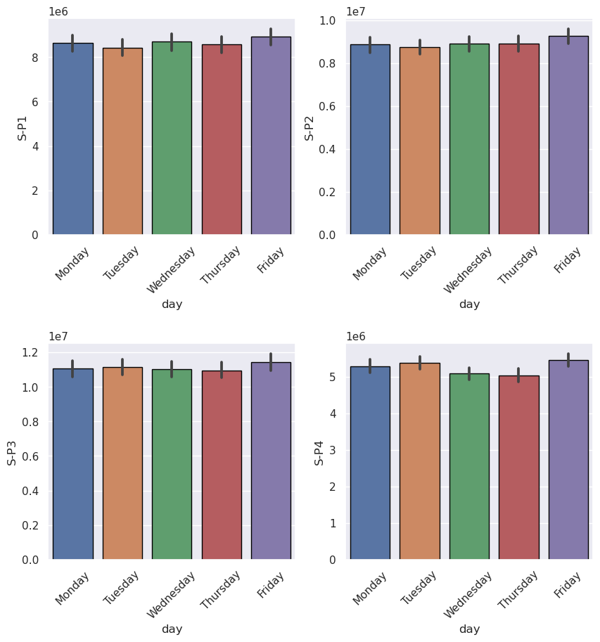
print(weekend_t.groupby("day")[["S-P1","S-P2","S-P3","S-P4"]].sum())
S-P1 S-P2 S-P3 S-P4
day
Saturday 8409578.88 8853201.36 11796375.26 5339977.85
Sunday 8439750.94 8586274.68 11013721.84 5238132.93
plt.figure(figsize=(10,10),dpi=100)
plt.subplot(2,2,1)
sns.barplot(x="day",y="S-P1",data=weekend_t,edgecolor="black",estimator=sum)
plt.xticks(rotation=45);
plt.subplot(2,2,2)
sns.barplot(x="day",y="S-P2",data=weekend_t,edgecolor="black",estimator=sum)
plt.xticks(rotation=45);
plt.subplot(2,2,3)
sns.barplot(x="day",y="S-P3",data=weekend_t,edgecolor="black",estimator=sum)
plt.xticks(rotation=45);
plt.subplot(2,2,4)
sns.barplot(x="day",y="S-P4",data=weekend_t,edgecolor="black",estimator=sum)
plt.xticks(rotation=45)
plt.subplots_adjust(hspace=0.5);
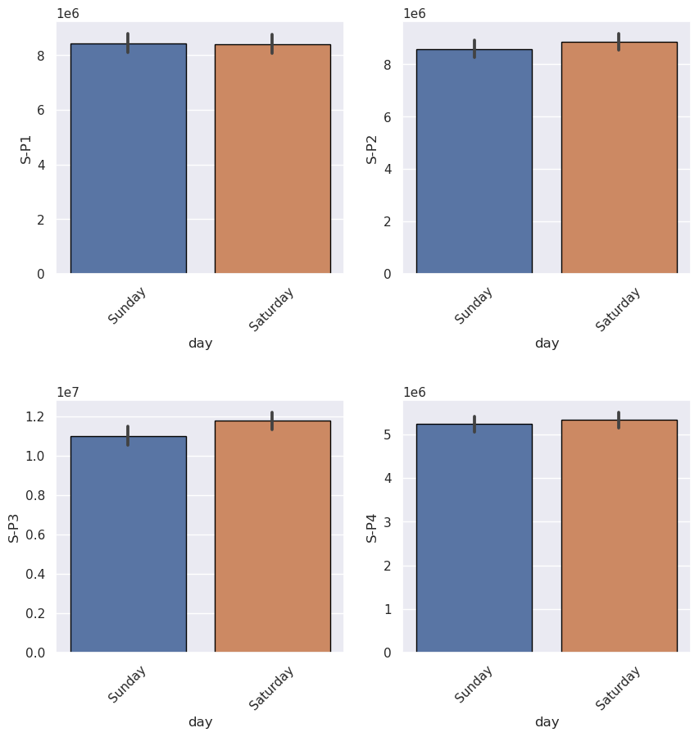
# In which year revenue was the highest
df.groupby("year")[["S-P1","S-P2","S-P3","S-P4"]].agg(["sum"])
S-P1 S-P2 S-P3 S-P4
sum sum sum sum
year
2010 2543459.01 2720100.92 3385462.08 1567523.37
2011 4542819.22 4741147.10 6235075.86 2921603.06
2012 4771163.83 4861987.50 6173911.16 2965210.14
2013 4833682.57 4771369.88 6017809.74 2868491.69
2014 4954522.97 4979797.38 6265406.18 2865119.20
2015 4669720.66 4833806.20 5987988.90 2933224.96
2016 5096066.64 5313116.54 6507718.12 3096444.92
2017 4628545.53 5085909.96 6269568.74 2969944.46
2018 4825792.44 4727313.22 6198517.96 2824392.64
2019 4681354.56 4946303.16 6106237.04 2912519.44
2020 4732093.58 4904826.88 6343643.88 2984618.00
2021 4758100.26 4948382.68 6294208.06 2894394.98
2022 4591000.05 4797040.54 5993479.36 2760400.89
2023 476482.70 496428.34 650562.60 284665.25
plt.figure(figsize=(10,10),dpi=100)
plt.subplot(2,2,1)
sns.barplot(x="year",y="S-P1",data=df,edgecolor="black",estimator=sum)
plt.xticks(rotation=90);
plt.subplot(2,2,2)
sns.barplot(x="year",y="S-P2",data=df,edgecolor="black",estimator=sum)
plt.xticks(rotation=90);
plt.subplot(2,2,3)
sns.barplot(x="year",y="S-P3",data=df,edgecolor="black",estimator=sum)
plt.xticks(rotation=90);
plt.subplot(2,2,4)
sns.barplot(x="year",y="S-P4",data=df,edgecolor="black",estimator=sum)
plt.xticks(rotation=90)
plt.subplots_adjust(hspace=0.5);
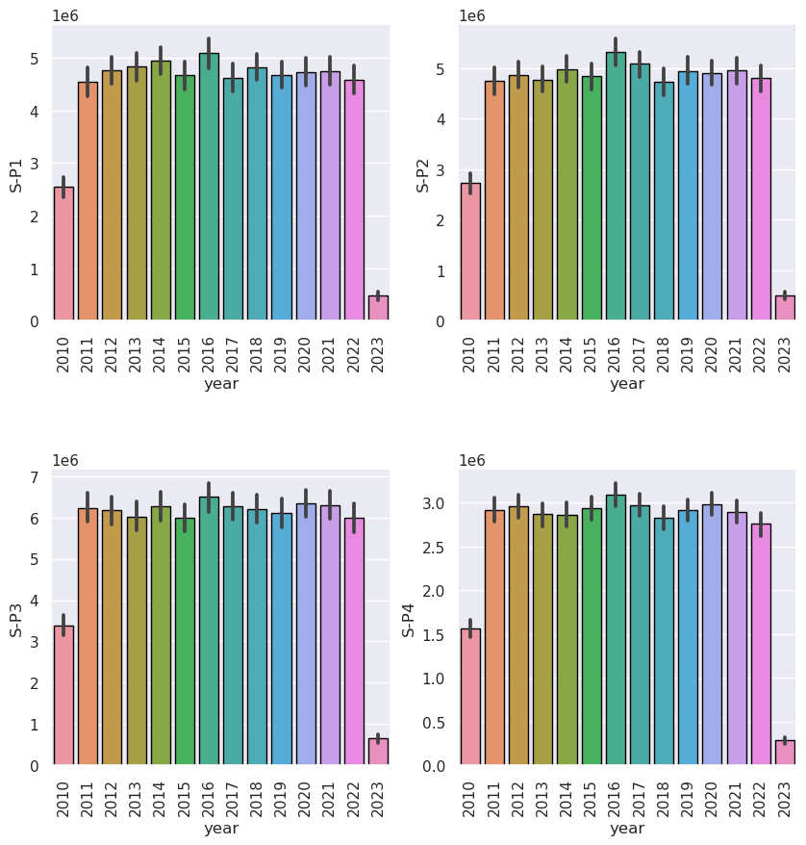
## What was the avg revenue, maximum and min
df[["S-P1","S-P2","S-P3","S-P4"]].agg(["sum","max","min","mean"])
S-P1 S-P2 S-P3 S-P4
sum 6.010480e+07 6.212753e+07 7.842959e+07 3.684855e+07
max 2.535366e+04 2.534732e+04 3.252000e+04 1.426000e+04
min 8.051800e+02 1.591340e+03 1.355000e+03 1.782500e+03
mean 1.306626e+04 1.350598e+04 1.704991e+04 8.010555e+03
plt.figure(figsize=(10,10),dpi=100)
plt.subplot(2,2,1)
sns.barplot(x="day",y="Q-P1",data=week_t,edgecolor="black",estimator=sum)
plt.xticks(rotation=45);
plt.subplot(2,2,2)
sns.barplot(x="day",y="Q-P2",data=week_t,edgecolor="black",estimator=sum)
plt.xticks(rotation=45);
plt.subplot(2,2,3)
sns.barplot(x="day",y="Q-P3",data=week_t,edgecolor="black",estimator=sum)
plt.xticks(rotation=45);
plt.subplot(2,2,4)
sns.barplot(x="day",y="Q-P4",data=week_t,edgecolor="black",estimator=sum)
plt.xticks(rotation=45)
plt.subplots_adjust(hspace=0.5);
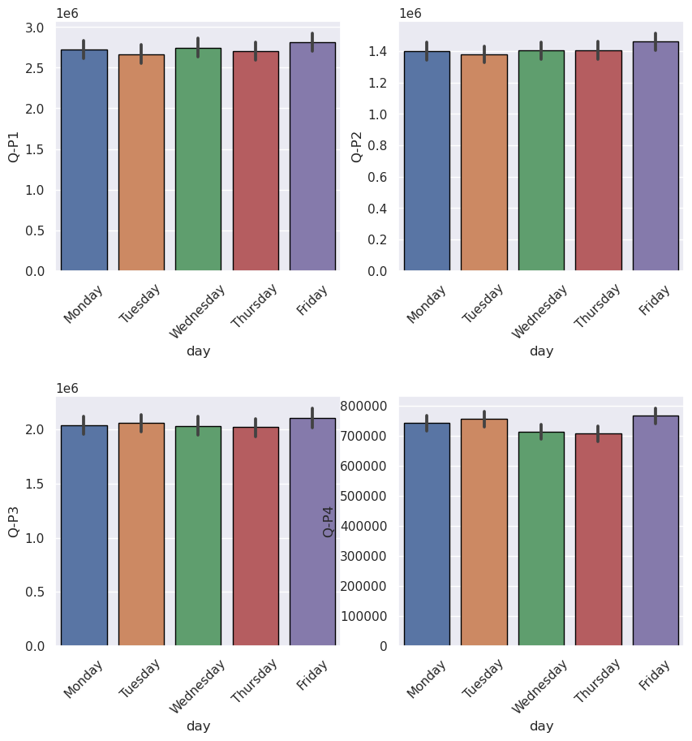

Replicating an analysis and generating visualizations in IBM Cognos involves several steps. Here is a general guide on how to perform this:

1. Access IBM Cognos:
- Log in to your IBM Cognos environment using your credentials.

2. Data Source Connection:
- Ensure that you have a connection to the data source you want to analyze. This may involve setting up a database connection, uploading data files, or connecting to a cloud-based data source.

3. Create a New Report or Dashboard:
- To start your analysis, you can create a new report or dashboard depending on your requirements. Reports are typically used for more structured, paginated outputs, while dashboards are more interactive and suitable for visualizations.

4. Select Data:
- Choose the dataset or data source you want to analyze. This may involve importing tables or datasets into your report or dashboard.

5. Build Queries:
- Create one or more queries to extract and manipulate the data you need for your analysis. You can use the Query Studio or Report Studio, depending on your expertise and requirements.

6. Create Visualizations:
- Once you have your data, you can start creating visualizations. IBM Cognos provides a wide range of visualization options, such as charts, graphs, tables, and maps. Here's how you can do it:

- In Report Studio:
- Drag and drop data items onto the report page.
- Select the data items you want to visualize and choose the appropriate visualization type from the toolbar.
- Customize the visualization by configuring properties, such as axes, colors, labels, and formatting.

- In Dashboard:
- Create a new dashboard page.
- Add widgets to the page and connect them to your data source.
- Configure each widget with the data and visualization type you want to use.

7. Customize Visualizations:
- You can further customize your visualizations by adjusting various settings, like titles, legends, data series, and appearance. You can also apply filters and drill-through options to make your analysis more interactive.

8. Interactivity and Filterin:
- To enhance user interactivity, add filters and prompts that allow users to dynamically change data on the fly.

9. Aggregations and Calculations:
- Perform any necessary aggregations or calculations on the data to derive insights. You can use Cognos functions and expressions for this purpose.

10. Create a Layout:
- Design the layout of your report or dashboard, arranging visualizations, text, and other elements to tell a compelling data-driven story.

11. Testing and Validation:
- Test your report or dashboard to ensure that it accurately represents the data and provides meaningful insights.

12. Save and Share:
- Save your report or dashboard in IBM Cognos so that you can access it later. You can also schedule reports to be generated and distributed automatically.

13. Distribute and Share:
- Share your analysis and visualizations with others by publishing the report or dashboard. You can publish them to a Cognos server or export them as PDFs, Excel files, or other formats for distribution.

14. Scheduling and Automation (Optional):
- If needed, you can set up scheduled refreshes and automated distribution of reports to relevant stakeholders.

15. **Collaborate and Collaborative Features (Optional)**:
- Take advantage of Cognos' collaboration features to share insights, annotations, and comments with other users.

Remember that the specific steps and options may vary depending on your version of IBM Cognos and the edition you are using (e.g., Cognos Analytics, Cognos BI, etc.). Make sure to consult the official IBM Cognos documentation for your version to get detailed instructions tailored to your setup and requirements.

IBM COGNOS VISUALIZATION:
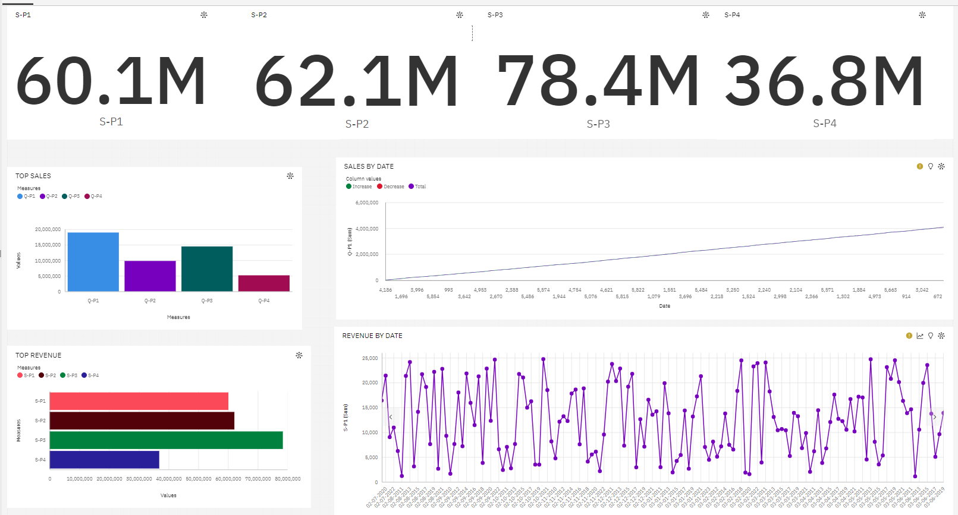
INSIGHTS:
1. Sales Revenue:
1.1 Product-wise Sales Revenue:
- Product 1 sales revenue: $60.1 million
- Product 2 sales revenue: $62.1 million
- Product 3 sales revenue: $78.4 million
- Product 4 sales revenue: $36.8 million
1.2 Ranking of Products by Sales Revenue:
- Notably, Product 3 emerges as the frontrunner in sales revenue, achieving a remarkable $78.4 million.
- In contrast, Product 4 lags behind with the lowest sales revenue of $36.8 million.
2.1 Product-wise Sales Quantity:
- Product 1 sales quantity: Approximately 60,000,000 units
- Product 2 sales quantity: Approximately 62,000,000 units
- Product 3 sales quantity: Approximately 80,000,000 units
- Product 4 sales quantity: Approximately 40,000,000 units
2.2 Ranking of Products by Sales Quantity:
- Product 3 dominates in sales quantity, with a staggering estimated 80,000,000 units sold.
- Conversely, Product 4 resides at the bottom of the list, with roughly 40,000,000 units sold.
3. Sales Revenue Fluctuations:
3.1 Sales Revenue on July 7, 2020:
- A significant milestone occurred on July 7, 2020, as sales revenue notably exceeded $20,000.
3.2 Sales Revenue After 2 Years (July 7, 2022):
- Surprisingly, a sharp decline was witnessed two years later, in July 7, 2022, as the sales revenue dropped to below $10,000.
3.3 Notable Sales Revenue Figures:
- On June 1, 2019, the sales revenue was recorded at $6,000.
- By June 3, 2019, an increase to $10,000 was observed.
- It is intriguing to note that sales revenue remained constant on October 2 in both 2017 and 2019.
3.4 Peak Sales Revenue:
A noteworthy trend emerged in the years 2018, 2013, and 2020 when sales revenue reached its zenith at $25,000

Conclusion:
A product sales analysis model implemented using IBM Cognos offers organizations a comprehensive and flexible solution for gaining insights into their sales performance. With powerful data visualization capabilities, real-time analytics, customization, and collaboration features, IBM Cognos empowers businesses to understand their sales trends, optimize decision-making, and drive revenue growth. The platform's ability to automate reporting, ensure data security, and scale with an organization's needs makes it a valuable tool for businesses of all sizes. By utilizing a product sales analysis model within IBM Cognos, companies can continuously improve their sales strategies, enhance competitiveness, and make data-driven decisions that lead to success in today's dynamic market.

