Y.HARIKA

LIST OF OPEN PORTS
- 445 (TCP)
- 22 (TCP)
- 3389 (TCP)
- 80 (TCP)
- 443 (TCP)
- 23 (TCP)
- 53 (TCP/UDP)
- 21 (TCP)
- 3306 (TCP)
- 1433 (TCP)
- 161 (UDP)
- 162 (UDP)
- 389 (TCP)

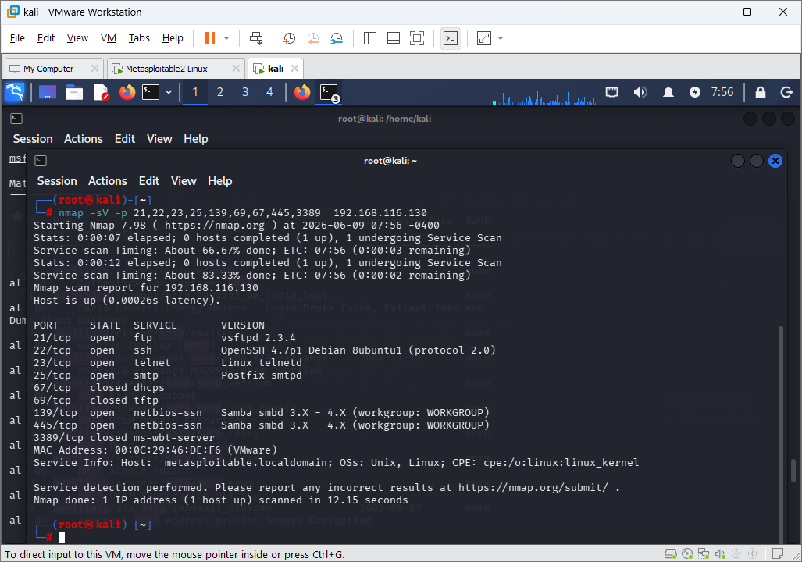

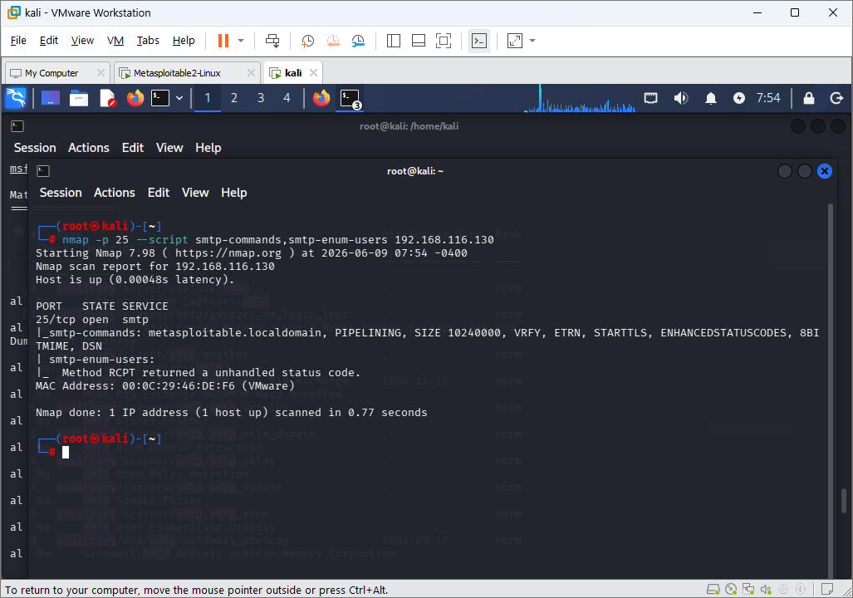

SMTP
NMAP SCAN FOR SMTP

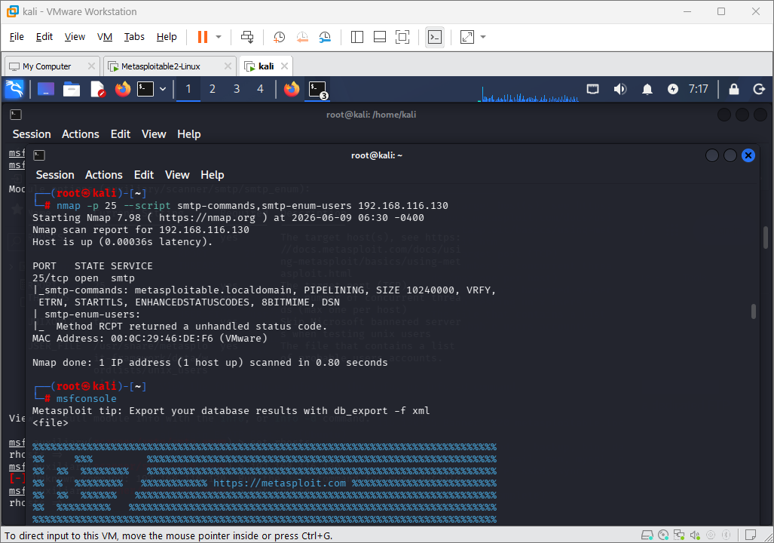

LIST OF msfconsole AUXILIARY SMTP

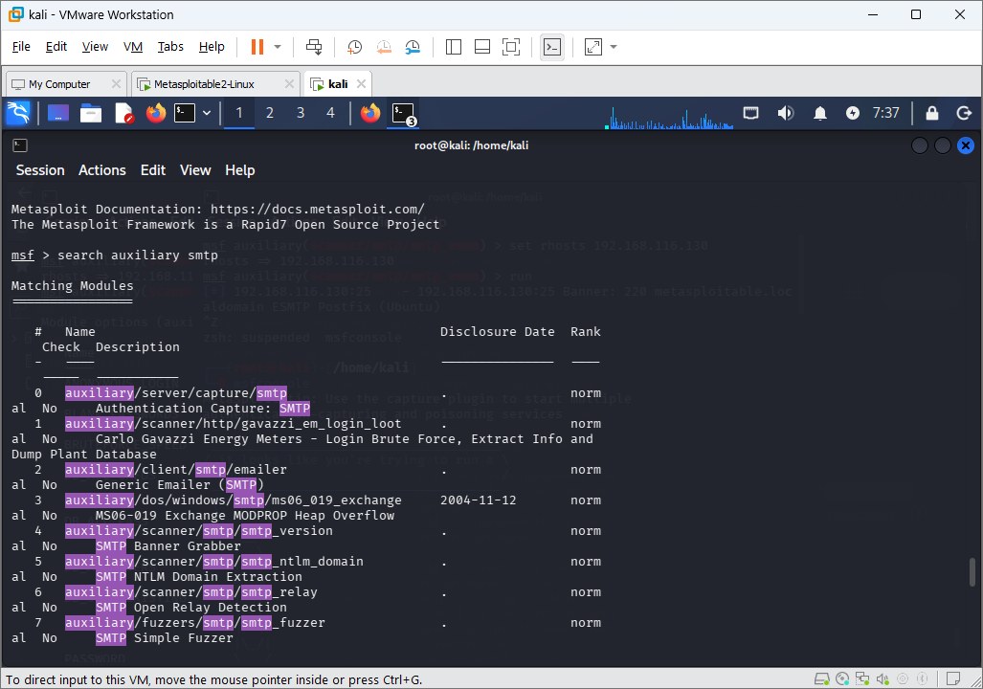

SEARCH OF AUXILIARY SMTP

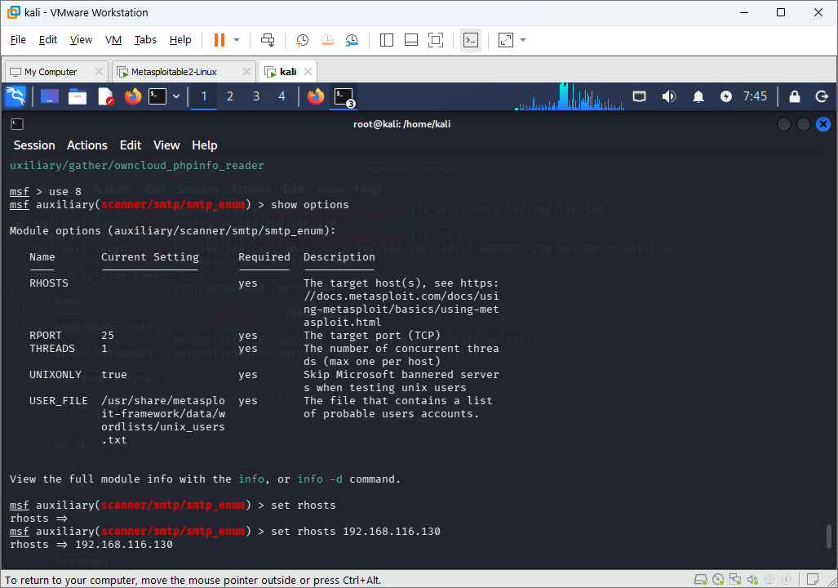

SET RHOSTS

EXECUTION OF SMTP

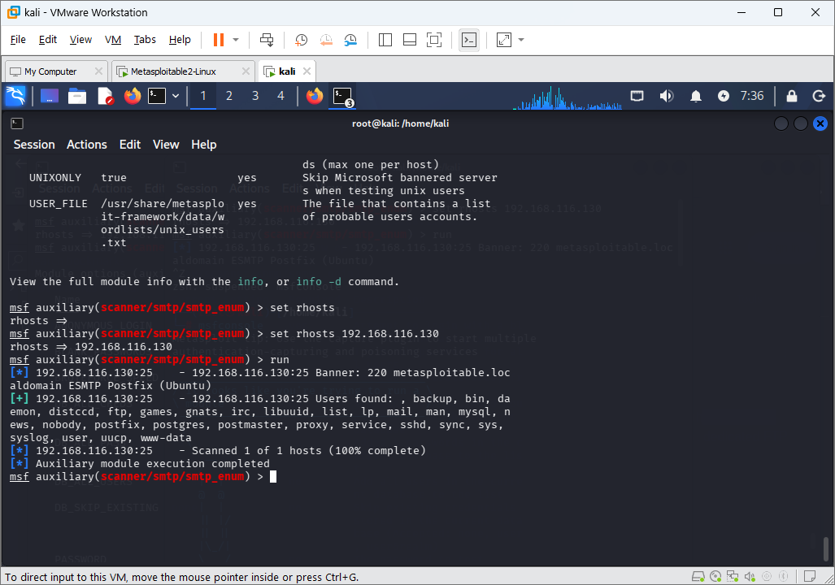

SNMP
LIST OF msfconsole AUXILIARY SNMP
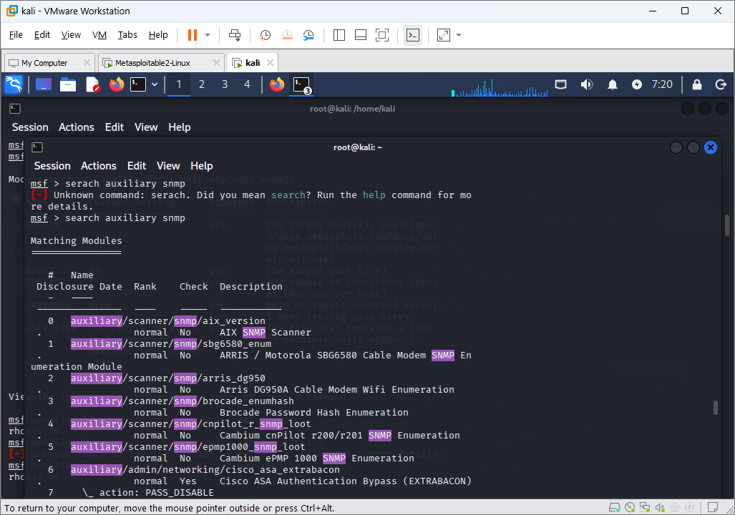

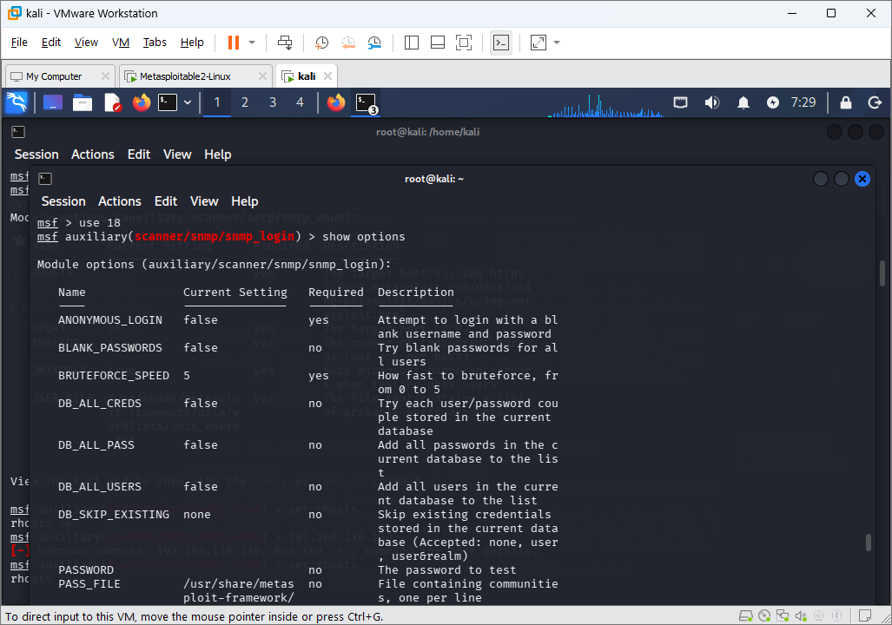

SNMP AUXILIARY OPTIONS
SET RHOSTS FOR SNMP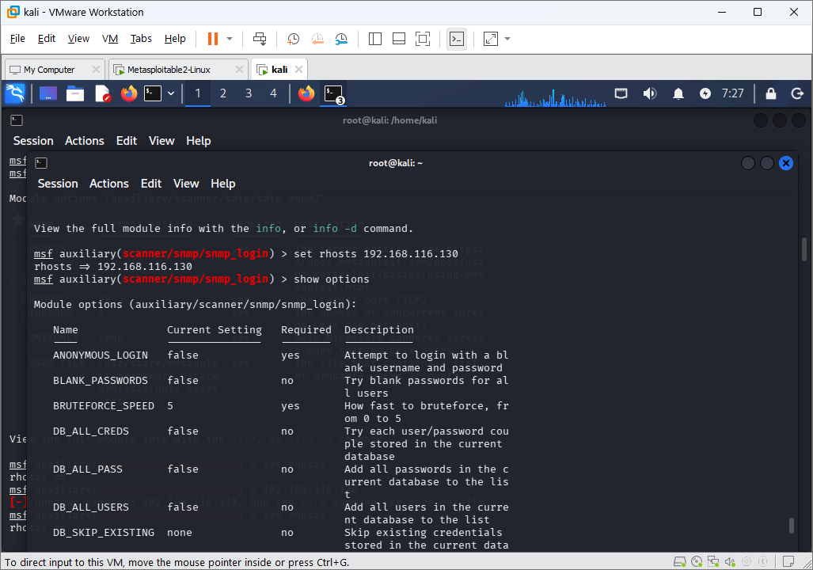

SNMP EXECUTION