**Ideation Phase**

**Brainstorm & Idea Prioritization**

|  |  |
| --- | --- |
| Date | 13 July 2025 |
| Team ID | SWUID20250174963 |
| Project Name | Freelancing Application MERN |
| Maximum Marks | 4 Marks |

**Brainstorm & Idea Prioritization:**

Brainstorming provides a free and open environment that encourages everyone within a team to participate in the creative thinking process that leads to problem solving. Prioritizing volume over value, out-of-the-box ideas are welcome and built upon, and all participants are encouraged to collaborate, helping each other develop a rich amount of creative solutions.

**Step-1: Team Gathering, Collaboration and Select the Problem Statement**

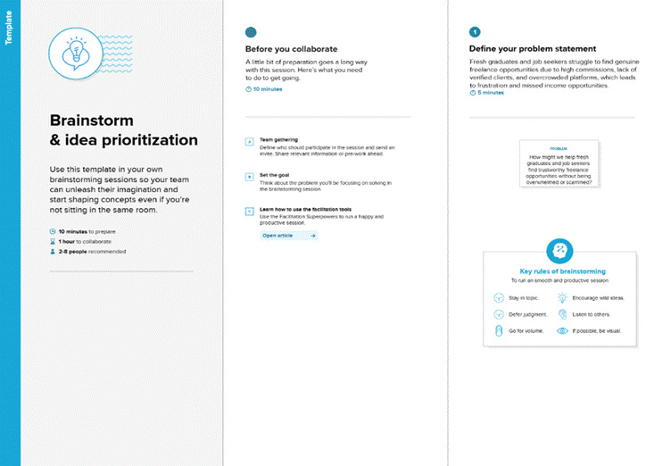

**Step-2: Brainstorm, Idea Listing and Grouping**

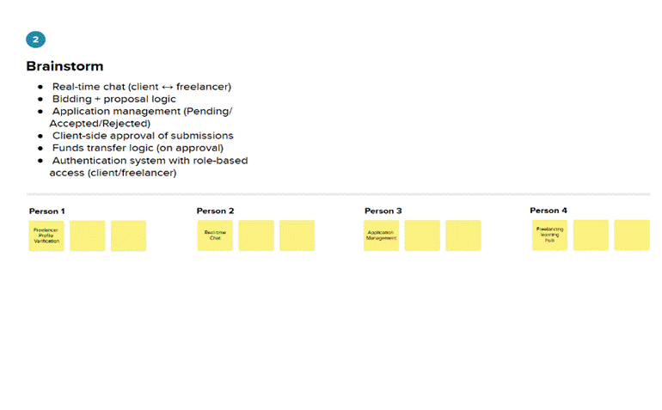

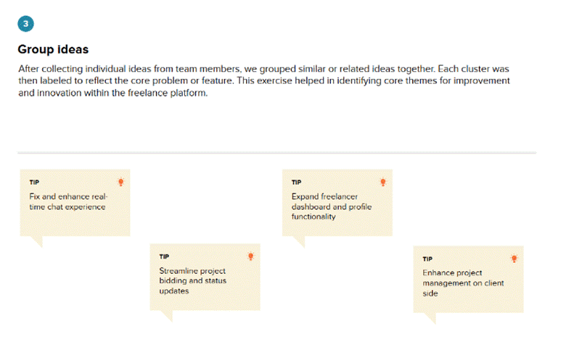

**Step-3: Idea Prioritization**

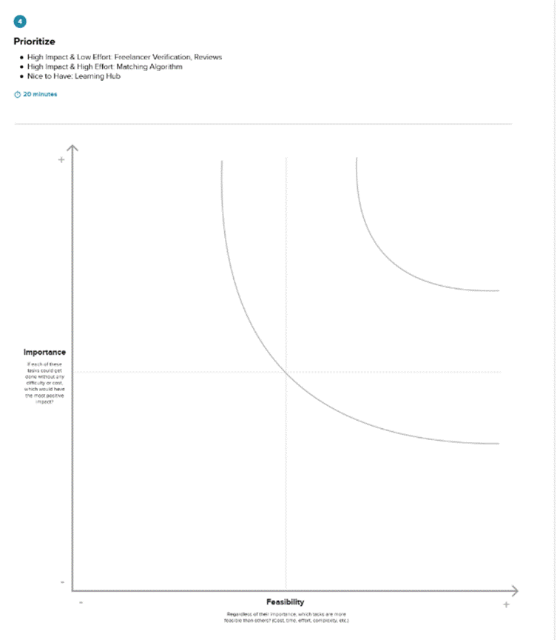

**Ideation Phase**

**Define the Problem Statements**

|  |  |
| --- | --- |
| Date | 13 July 2025 |
| Team ID | SWUID20250174963 |
| Project Name | Freelancing Application MERN |
| Maximum Marks | 2 Marks |

**Customer Problem Statement:**

To define the core problems freelancers face while searching for jobs online, and use those insights to guide the development of Freelance Finder.

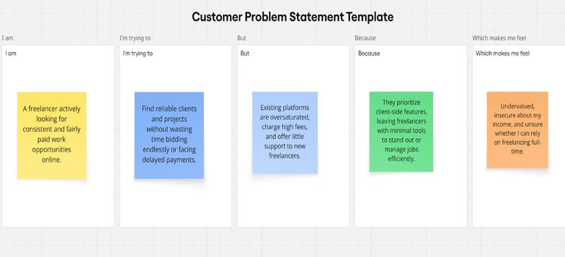

|  |  |  |  |  |  |
| --- | --- | --- | --- | --- | --- |
| **Problem**  **Statement(PS)** | **I am (Customer)** | **I’m trying to** | **But** | **Because** | **Which makes me feel** |
| PS-1 | Freelance Web Developer | Find stable and fairly paid project opportunities | Competition on big platforms is intense | Most clients prefer low-cost bids | Frustrated, undervalued |
| PS-2 | Freelance Graphic Designer | Present my portfolio and connect with genuine clients | Portfolio options are restricted | Limited branding and custom display features | Invisible in the market |
| PS-3 | Client or Recruiter | Hire skilled freelancers for short-term work | Existing platforms are cluttered and expensive | Platform fees are high and trust-building is hard | Annoyed, hesitant |
|  | Freelancer using your platform | Get live project updates and client responses | No real-time communication in most systems | Delays lead to confusion or dropouts | Disconnected, confused |

**Ideation Phase**

**Empathize & Discover**

|  |  |
| --- | --- |
| Date | 13 July 2025 |
| Team ID | SWUID20250174963 |
| Project Name | Freelancing Application MERN |
| Maximum Marks | 4 Marks |

**Empathy Map Canvas:**

Understand the needs, frustrations, and behaviors of freelance professionals seeking consistent work through a platform like Freelance Finder.

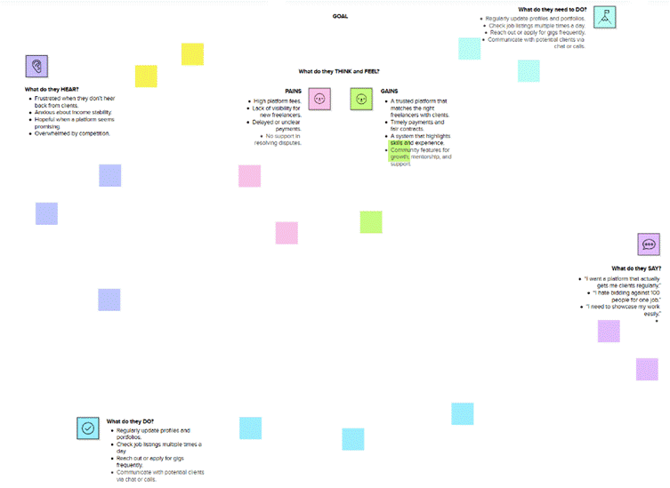

**User Acceptance Testing (UAT)**

|  |  |
| --- | --- |
| Date | 13-07-2025 |
| Team ID | SWUID20250174963 |
| Project Name | Freelancing Application MERN |
| Maximum Marks |  |

### Project Overview

1. **Project Name:** Freelancing Application MERN
2. **Version:** v1.0.0
3. **Description:** A full-stack MERN-based freelance platform enabling clients to post jobs and hire freelancers. The system includes real-time chat, secure authentication, job status tracking, bidding, profile management, and fund management features.
4. **Testing Period:** 2025-07-08 to 2025-07-13

### Testing Scope

The UAT scope includes verification of the following modules:

1. User Registration and Login
2. Freelancer and Client Profile Creation
3. Projects Posting and Application Process
4. Real-Time Messaging System (via Socket.io)
5. Project Status Transitions: *Available → In Progress → Submitted → Completed*
6. Fund Update after Project Completion
7. Skill and Profile Editing (Freelancer)
8. Client-side Project Assignment
9. Admin Panel (basic scope)
10. UI Responsiveness (Homepage, Auth Page, Chat Popup)

### Requirements to be Tested

|  |  |
| --- | --- |
| **Role** | **Requirement** |
| **Freelancer** | Can view posted projects, send bids, chat, and submit completed work. |
| **Client** | Can post projects, view applications, assign freelancers, approve submissions. |
| **User** | Secure login, clean dashboard, messaging, profile update. |
| **Admin** | Can view reported issues, manage users (basic placeholder). |

### 

### Testing Environment

1. **Base URL:**http://localhost:6001
2. **Frontend:** React.js
3. **Backend:** Express.js + MongoDB
4. **Socket Layer:** Socket.io
5. **Credentials**:
   1. **Freelancer**: test.freelancer@example.com / password123
   2. **Client**: test.client@example.com / password123
   3. **Admin**: admin@example.com / adminpass

### Test Cases

|  |  |  |  |  |  |
| --- | --- | --- | --- | --- | --- |
| **TC ID** | **Test Scenario** | **Test Steps** | **Expected Result** | **Actual Result** | **Status** |
| TC-001 | User Registration | 1. Navigate to /register  2. Enter user details  3. Select user type (freelancer/client)  4. Submit | Account is created and redirected to dashboard | ✅ | Pass |
| TC-002 | Login Functionality | 1. Go to /login  2. Enter valid credentials  3. Click "Login" | Redirect to respective dashboard | ✅ | Pass |
| TC-003 | Post Project (Client) | 1. Login as client  2. Go to Post Project  3. Submit valid form | Project shows under All Projects and My Projects | ✅ | Pass |
| TC-004 | Apply to Project (Freelancer) | 1. Login as freelancer  2. Open a project  3. Submit a bid and proposal | Application submitted and saved | ✅ | Pass |
| TC-005 | Assign Project (Client) | 1. View applications  2. Click "Assign" on preferred freelancer | Status changes to "In Progress" | ✅ (Client), ⛔ (Freelancer) | Partial |
| TC-006 | Real-time Chat | 1. Open a project  2. Use floating icon to open chat  3. Send messages | Messages sync instantly between users | ✅ (after second message) | Bug |
| TC-007 | Submit Project (Freelancer) | 1. Login as assigned freelancer 2. Submit project link, manual, and description | Submission saved | ✅ | Pass |
| TC-008 | Approve Submission (Client) | 1. Login as client  2. Click "Approve" after checking submission | Status → Completed, funds credited to freelancer | ✅ | Pass |
| TC-009 | Freelancer Fund Update | 1. Approve project  2. Login as freelancer | Funds increase by project budget | ✅ | Pass |
| TC-010 | Profile Update (Freelancer) | 1. Click Update in dashboard  2. Change skills and description  3. Save | Profile updated in backend | ✅ | Pass |

### Bug Tracking

|  |  |  |  |  |  |
| --- | --- | --- | --- | --- | --- |
| **Bug ID** | **Description** | **Steps to Reproduce** | **Severity** | **Status** | **Feedback** |
| BG-001 | Chat not showing first message instantly | 1. Open chat  2. Send message  3. Wait for sync | Medium | Open | Should show instantly |
| BG-002 | Project status not updating for freelancer | 1. Client assigns projec  t 2. Freelancer page doesn’t reflect "In Progress" status | High | Open | Needs Socket emit to freelancer |
| BG-003 | Chat popup CSS not applying | 1. Open chat on freelancer side  2. Styles missing despite CSS | Low | Open | Fix class names & import order |

### 

### Sign-off

1. **Tester Name:** Harika
2. **Testing Date:** 2025-07-13
3. **Signature:** Harika

**Project Design Phase**

**Problem – Solution Fit Template**

|  |  |
| --- | --- |
| Date | 13-07-2025 |
| Team ID | SWUID20250174963 |
| Project Name | Freelancing Application MERN |
| Maximum Marks | 2 Marks |

**Problem – Solution Fit Overview:**  
The Problem–Solution Fit ensures that the SB Works platform addresses key gaps in the freelance project market and aligns with the real needs of both clients and freelancers. This validation is critical before scaling the platform.

**Purpose:**

1. Bridge the gap between clients looking for reliable freelance talent and freelancers seeking trustworthy, well-paying projects.
2. Offer a unified platform that handles project lifecycle—from project posting to payment—without relying on multiple tools.
3. Enable secure, milestone-based transactions to build trust.
4. Provide visibility and opportunity for new freelancers through smart matching and rating systems.
5. Improve hiring and project success rates through a real-time chat, review system, and user-friendly experience.

**Problem Statement:**  
 Many clients and freelancers face challenges such as:

1. Lack of trust and accountability in freelance project platforms
2. Scattered communication and workflow tools
3. Delays in payment processing and dispute resolution
4. Difficulty in finding qualified freelancers or relevant projects
5. No centralized performance tracking and review system

**Solution:**  
 **SB Works**, a modern full-stack freelance platform, offers:

1. End-to-end project management including posting, bidding, and hiring
2. Escrow payment system and milestone-based tracking
3. Smart project recommendations using filters, tags, and user behavior
4. Real-time messaging and notification system
5. Profile and portfolio pages for freelancers and clients
6. Admin-controlled dispute resolution and user reporting features
7. Freemium model with premium features like project boost, analytics, and early-bid access.

**Project Design Phase**

**Proposed Solution**

|  |  |
| --- | --- |
| Date | 13-07-2025 |
| Team ID | SWUID20250174963 |
| Project Name | Freelancing Application MERN |
| Maximum Marks | 2 Marks |

**Proposed Solution for Freelance Finder**

|  |  |  |
| --- | --- | --- |
| **S. No.** | **Parameter** | **Description** |
| **1** | **Problem Statement** (Problem to be solved) | Many freelancers and clients face difficulty in connecting efficiently, managing projects, ensuring trust, and securely handling payments. The lack of real-time interaction, smart matching, and end-to-end transparency leads to dropped projects and dissatisfaction. |
| **2** | **Idea / Solution Description** | The Freelance Finder platform is a full-stack web application (React frontend + Node.js backend) that enables clients to post projects, freelancers to apply, and both parties to collaborate through real-time messaging and secure payments. Admin controls help manage disputes and community standards. |
| **3** | **Novelty / Uniqueness** | - Intelligent project matching using keyword tagging and filters  - Built-in real-time messaging system  - Milestone-based payments with escrow options  - Admin dispute resolution system  - Optional video call integration |
| **4** | **Social Impact / Customer Satisfaction** | - Empowers freelancers globally to earn from anywhere  - Helps businesses scale using flexible, project-based hiring  - Transparent ratings & reviews enhance platform trust  - Reduces hiring friction and supports gig economy growth |
| **5** | **Business Model (Revenue Model)** | - Freemium access for freelancers  - Commission on each successful payment transaction  - Premium membership for project visibility boost and analytics  - Enterprise client plans for bulk hiring and management |
| **6** | **Scalability of the Solution** | - Expandable to global markets with multi-language and multi-currency support  - Mobile-first design with future support via React Native  - Modular architecture for quick integration of features like video calling, AI resume screening, and payment gateways |

**Project Design Phase**

**Solution Architecture**

|  |  |
| --- | --- |
| Date | 13 -07-2025 |
| Team ID | SWUID20250174963 |
| Project Name | Freelancing Application MERN |
| Maximum Marks | 4 Marks |

**Solution Architecture:**

The solution architecture for **Freelancing Application MERN** ensures a robust, user-friendly, and scalable platform that connects clients with skilled freelancers. The architecture focuses on responsive design, secure transactions, intelligent matching, and real-time messaging to ensure smooth project workflows and high user satisfaction.

1. Seamless job posting and freelancer application
2. End-to-end project lifecycle management
3. Scalable user authentication and authorization
4. Secure and trackable payment transactions
5. Reliable real-time chat and notifications

**Example - Solution Architecture Diagram:**

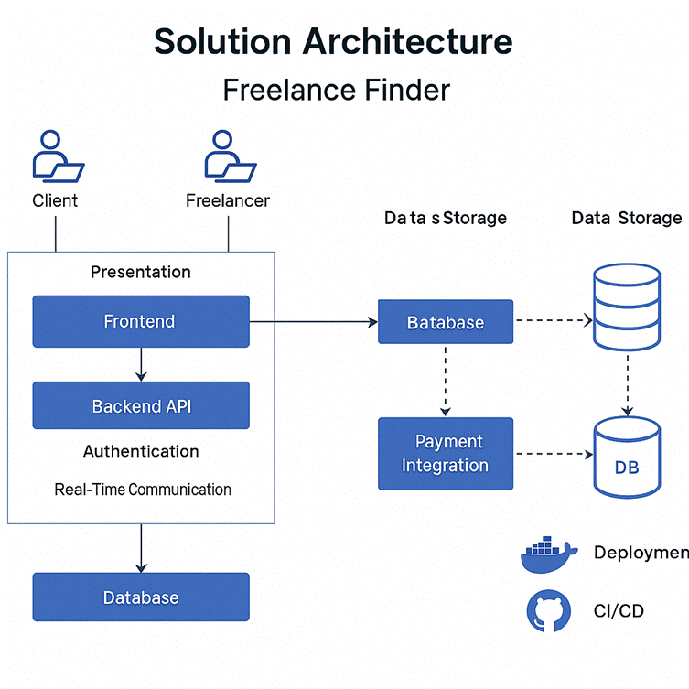

**Project Planning Phase**

**Project Planning (Product Backlog, Sprint Planning, Stories, Story points)**

|  |  |
| --- | --- |
| Date | 13-07-2025 |
| Team ID | SWUID20250174963 |
| Project Name | Freelancing Application MERN |
| Maximum Marks | 5 Marks |

## 

## Product Backlog & Sprint Schedule

|  |  |  |  |  |  |  |
| --- | --- | --- | --- | --- | --- | --- |
| **Sprint** | **Functional Requirement (Epic)** | **User Story Number** | **User Story / Task** | **Story Points** | **Priority** | **Team Members** |
| **Sprint-1** | User Authentication & Profiles | USN-1 | As a user, I can sign up and log in securely | 3 | High | Afiya |
|  |  | USN-2 | As a user, I can reset my password | 2 | Medium | Afiya |
|  |  | USN-3 | As a user, I can create and edit my profile (client/freelancer) | 3 | High | Afiya |
|  |  | USN-4 | As a freelancer, I can add my skills and description | 2 | Medium | Afiya |
| **Sprint-2** | Project Posting & Bidding | USN-5 | As a client, I can post a freelance job with skills, budget, and deadline | 3 | High | Harika |
|  |  | USN-6 | As a freelancer, I can view all posted jobs | 2 | High | Harika |
|  |  | USN-7 | As a freelancer, I can submit a bid and proposal for a project | 3 | High | Harika |
| **Sprint-3** | Project Assignment & Messaging | USN-8 | As a client, I can assign a freelancer to a project | 2 | High | Afiya |
|  |  | USN-9 | As a user, I can chat with the other party in real-time (client↔freelancer) | 3 | High | Afiya |
|  |  | USN-10 | As a freelancer, I can submit the completed project with link and details | 2 | High | Afiya |
| **Sprint-4** | Approval, Fund Transfer & Ratings | USN-11 | As a client, I can approve a project submission and release payment | 3 | High | Harika |
|  |  | USN-12 | As a freelancer, I can receive funds after project completion | 2 | High | Harika |
|  |  | USN-13 | As a user, I can rate and review the other party after job completion | 2 | Medium | Harika |
|  |  | USN-14 | As a user, I can change my account password | 1 | Low | Harika |

## Project Tracker, Velocity & Burndown Chart

|  |  |  |  |  |  |  |
| --- | --- | --- | --- | --- | --- | --- |
| **Sprint** | **Total Story Points** | **Duration** | **Sprint Start Date** | **Planned End Date** | **Story Points Completed** | **Actual Release Date** |
| **Sprint-1** | 10 | 6 Days | 14 June 2025 | 19 June 2025 | 10 | 19 June 2025 |
| **Sprint-2** | 8 | 6 Days | 20 June 2025 | 25 June 2025 | 8 | 25 June 2025 |
| **Sprint-3** | 7 | 6 Days | 26 June 2025 | 01 July 2025 | 7 | 01 Julu 2025 |
| **Sprint-4** | 8 | 6 Days | 02 July 2025 | 07 July 2025 | 8 | 07 July 2025 |

**Project Design Phase-II**

**Data Flow Diagram & User Stories**

|  |  |
| --- | --- |
| Date | 13-07-2025 |
| Team ID | SWUID20250174963 |
| Project Name | Freelancing Application MERN |
| Maximum Marks | 4 Marks |

**Data Flow Diagrams:**

A **Data Flow Diagram (DFD)** illustrates how data moves within the Freelancing Application MERN platform. It captures how users (freelancers and clients) interact with the system, how information flows between different components, and where the data is stored.

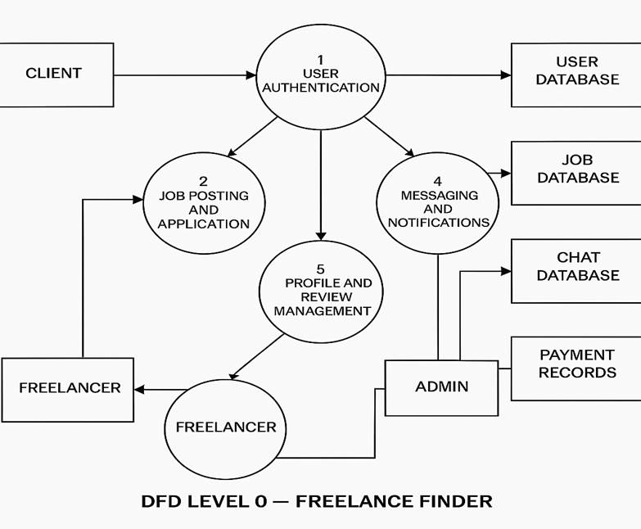

**User Stories**

**User Story Table – Freelancing Application MERN**

|  |  |  |  |  |  |
| --- | --- | --- | --- | --- | --- |
| **User Type** | **Functional Requirement (Epic)** | **User Story / Task** | **Acceptance Criteria** | **Priority** | **Release** |
| **Client** | Project  Posting   |  | | --- | |  |      |  | | --- | |  | | As a client, I can post a new freelance Project. | Project appears on homepage and my dashboard. | High | Sprint-1 |
|  | Project  Browsing   |  | | --- | |  |      |  | | --- | |  | | As a freelancer, I can browse and filter available  project | Filter returns relevant results. | Medium | Sprint-2 |
| **Freelancer** | Project Application | As a freelancer, I can apply to project proposal   |  | | --- | |  | | Application visible to client. | High | Sprint-1 |
| **User** | Messaging | As a user, I can chat with the other party in real-time. | Messages appear instantly. | Medium | Sprint-2 |
| **Freelancer** | Profile Management | As a freelancer, I can update my profile and portfolio. | Changes are saved successfully. | High | Sprint-2 |
| **Client** | Payment Processing | As a client, I can make secure payments after Project completion. | Payment recorded and shown in transaction history. | High | Sprint-2 |
| **user** | eEview System   |  | | --- | |  |      |  | | --- | |  | | As a user, I can leave a review after project cloure. | Review appears on profile. | Medium | Sprint-2 |
| **Admin** | User Moderation | As an admin, I can review reported users and take action. | Reports and actions logged. | High | Sprint-1 |

**Project Design Phase-II**

**Solution Requirements (Functional & Non-functional)**

|  |  |
| --- | --- |
| Date | 13-07-2025 |
| Team ID | SWUID20250174963 |
| Project Name | Freelancing Application MERN |
| Maximum Marks | 4 Marks |

**Functional Requirements:**

Following are the functional requirements of the proposed solution.

**Functional Requirements – Music Streaming App**

|  |  |  |
| --- | --- | --- |
| **FR No.** | **Functional Requirement (Epic)** | **Sub Requirement (Story / Sub-Task)** |
| **FR-1** | User Authentication | Sign up, Login, Password Reset   |  | | --- | |  | |
|  |  | |  | | --- | |  |      |  | | --- | | OAuth login using Google / GitHub | |
| **FR-2** | **Project Posting & Discovery** | |  | | --- | |  |      |  | | --- | | Post freelance project (clients) | |
|  |  | Browse and search project (freelancers) |
|  |  | Create and Manage Playlists |
| **FR-3** | |  | | --- | |  |      |  | | --- | | **Project Application & Management** | | Freelancers apply to project |
|  |  | Clients review and shortlist applications |
| **FR-4** | **Messaging** | Real-time chat between freelancers and clients |

**Non-functional Requirements:**

Following are the non-functional requirements of the proposed solution.

|  |  |  |
| --- | --- | --- |
| **NFR No.** | **Non-Functional Requirement** | **Description** |
| **NFR-1** | **Usability** | The platform should offer a clean, intuitive UI for users of all skill levels. |
| **NFR-2** | **Security** | All data transfers must be encrypted. Implement role-based access and token auth.   |  | | --- | |  |      |  | | --- | |  | |
| **NFR-3** | **Reliability** | Ensure project posting and work reliability |
| **NFR-4** | **Performance** | Pages should load within 2 seconds. Chat and project posting actions should be near-instant. |
| **NFR-5** | **Availability** | The system should maintain 99.9% uptime across all services   |  | | --- | |  | |
| **NFR-6** | **Scalability** | Should support high concurrency and rapid feature scaling through microservices   |  | | --- | |  | |

**Project Design Phase-II**

**Technology Stack (Architecture & Stack)**

|  |  |
| --- | --- |
| Date | 13-07-2025 |
| Team ID | SWUID20250174963 |
| Project Name | Freelancing Application MERN |
| Maximum Marks | 4 Marks |

**Technical Architecture:**

The Freelance Finder platform is designed with a scalable 3-tier architecture that includes the presentation layer (frontend), business logic (backend), and data storage layer. The solution ensures performance, security, and ease of integration with third-party APIs (e.g., Stripe for payments).

**Table-1 : Components & Technologies:**

|  |  |  |  |
| --- | --- | --- | --- |
| **S.No** | **Component** | **Description** | **Technology** |
|  | User Interface | Web-based interface for clients and freelancers | HTML, CSS, JavaScript / React Js etc. |
|  | Application Logic-1 | Project posting, application, dashboard, messaging | Node.js, Express.js |
|  | Application Logic-2 | |  | | --- | |  |      |  | | --- | | Admin panel, project tracking, notifications | | React js, Node js |
|  | Database | Stores user data, project, applications, messages | MongoDB |

**Table-2: Application Characteristics:**

|  |  |  |  |
| --- | --- | --- | --- |
| **S.No** | **Characteristics** | **Description** | **Technology** |
|  | Open-Source Frameworks | Frontend frameworks | React.js, Node.js, BootStrap, Tailwind CSS |
|  | Scalable Architecture | 3-tier architecture with RESTful APIs | SOA |

**References:**

[**React.js Documentation**](https://react.dev/)

[**Node js Best Practice**](https://nodejs.org/en/learn/getting-started/introduction-to-nodejs)

[**JSON Web Server Referance**](https://www.npmjs.com/package/json-server)

[**https://medium.com/the-internal-startup/how-to-draw-useful-technical-architecture-diagrams-2d20c9fda90d**](https://medium.com/the-internal-startup/how-to-draw-useful-technical-architecture-diagrams-2d20c9fda90d)