**Internship Tracker – Salesforce Project**

**Phase 2 : Org Setup & Configuration**

**Table of Contents**

1. Objective
2. Salesforce Edition
3. Company Profile Setup
4. Business Hours & Holidays
5. User Setup
6. Profiles & Permission Sets
7. Roles
8. Organisation-Wide Defaults (OWD) & Sharing Rules
9. Sandbox & Deployment Basics
10. Outcomes
11. Deliverables

**1. Objective**

The objective of Phase 2 is to set up and configure the Salesforce Developer Org for the Internship Tracker project. This ensures that all organization details, user roles, profiles, permissions, and sharing models are aligned with the university placement process.

**2. Salesforce Edition**

A Salesforce Developer Org was chosen for implementation.  
This environment provides:

* All core functionalities required for CRM customization
* Development, testing, and deployment capabilities
* Free lifetime access, suitable for academic/portfolio projects

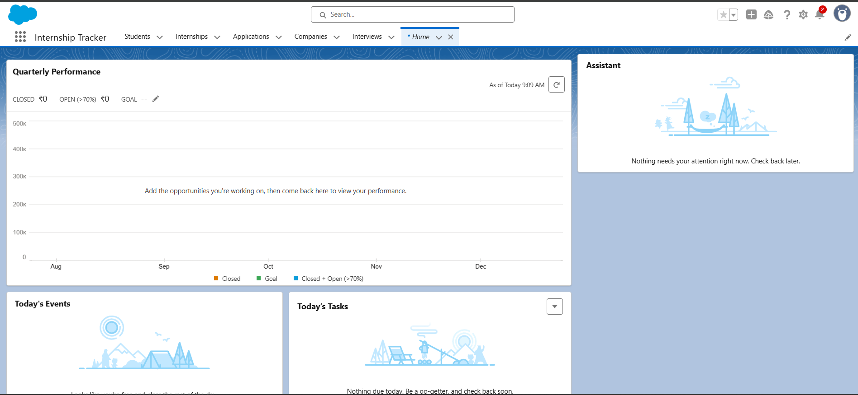

**3. Company Profile Setup**

Configured details in Company Information:

* Organization Name: University/Institute Name
* Default Time Zone: Local time zone
* Language: English (or chosen language)
* Currency: INR (or USD depending on use case)
* Fiscal Year: Configured as academic cycle-based

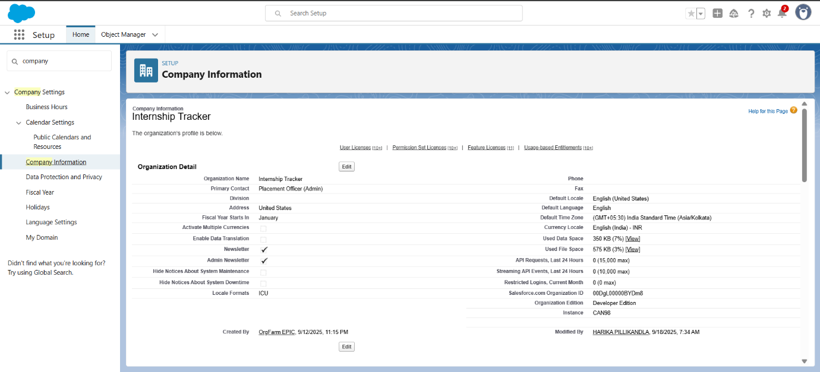

**4. Business Hours & Holidays**

* Defined Business Hours: Mon–Fri, 9 AM – 5 PM
* Added Holidays: University holidays, exam breaks, public holidays

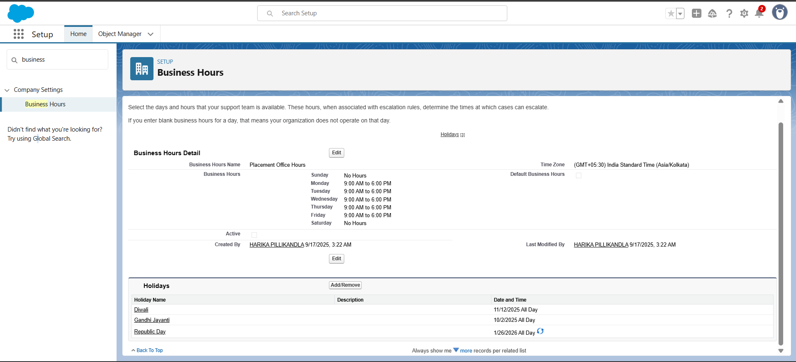

**5. User Setup**

Created users to represent stakeholders:

* **Placement Officer** – Admin privileges
* **Students** – Limited access, can apply & view own records
* **Recruiters** – External access for posting internships & reviewing applications

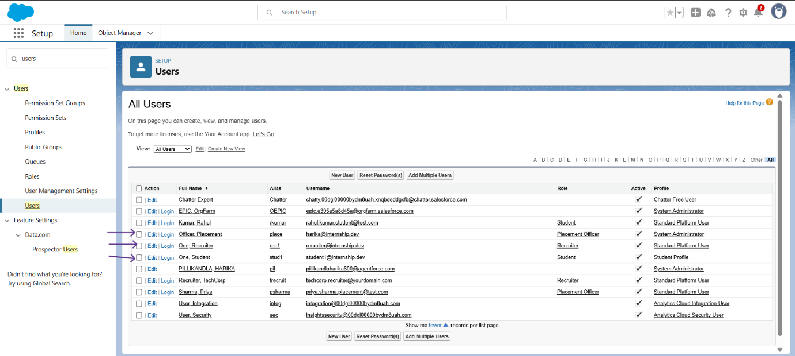

**6. Profiles & Permission Sets**

* **Profiles**: Defined baseline access for Students, Recruiters, Placement Officer
* **Permission Sets**: Used for special access (like Reports/Dashboards)

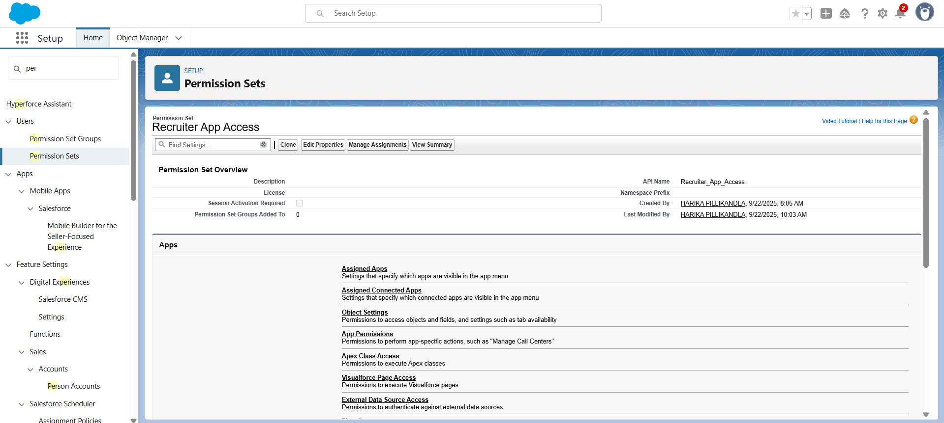

**7. Roles**

Created a Role Hierarchy:

* **Placement Officer** – Top level (full access)
* **Students** – Below officer (limited access)
* **Recruiters** – Parallel to students (independent access)

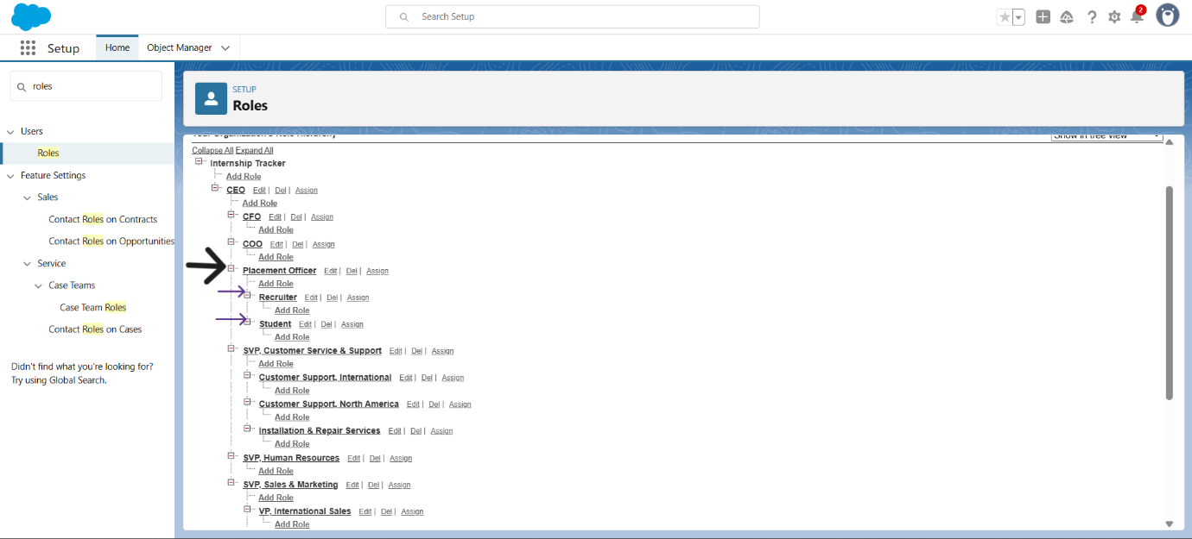

**8. Organization-Wide Defaults (OWD) & Sharing Rules**

* OWD set to:
  + **Students → Private** (can only see their own applications)
  + **Placement Officer → Full access via role hierarchy**
* Sharing rules allow Recruiters to view relevant Internship records
* 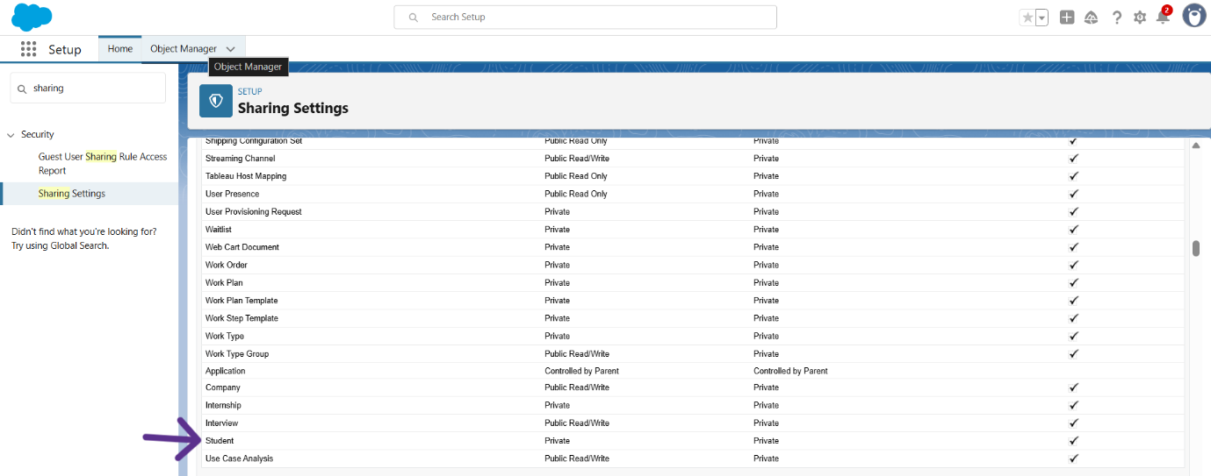

**9. Sandbox & Deployment Basics**

* Created a Sandbox for testing customizations safely
* Planned to use Change Sets to migrate from Sandbox to Production

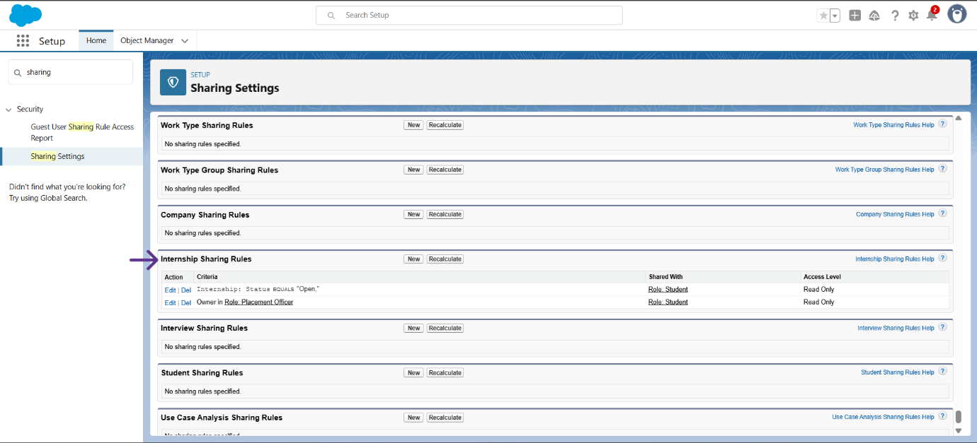

**10. Outcomes**

At the end of Phase 2:

* A secure Salesforce environment was established
* Clear role hierarchy between Placement Officer, Students, and Recruiters
* OWD and sharing ensured data privacy while supporting collaboration
* Foundation ready for Phase 3 (Data Modeling)

**11. Deliverables**

* Phase 2 Documentation (this file)
* Configured Salesforce Org with:
  + Users, Roles, and Profiles
  + OWD & Sharing Rules
  + Business Hours & Holidays
* Sandbox ready for development