**Internship Tracker – Salesforce Project**

**Phase 3 – Data Modeling & Relationships Requirements**

**1. Custom Objects**

You need to create and document the following objects:

* **Student –** stores student details (name, contact info, skills, etc.)
* **Company –** stores recruiter/company details
* **Internship –** stores internship details (role, stipend, skills required, status)
* **Application –** stores student applications to internships
* **Interview –** junction object linking Student and Company for interviews

**Requirement:** Each object must include all necessary fields relevant to the workflow.

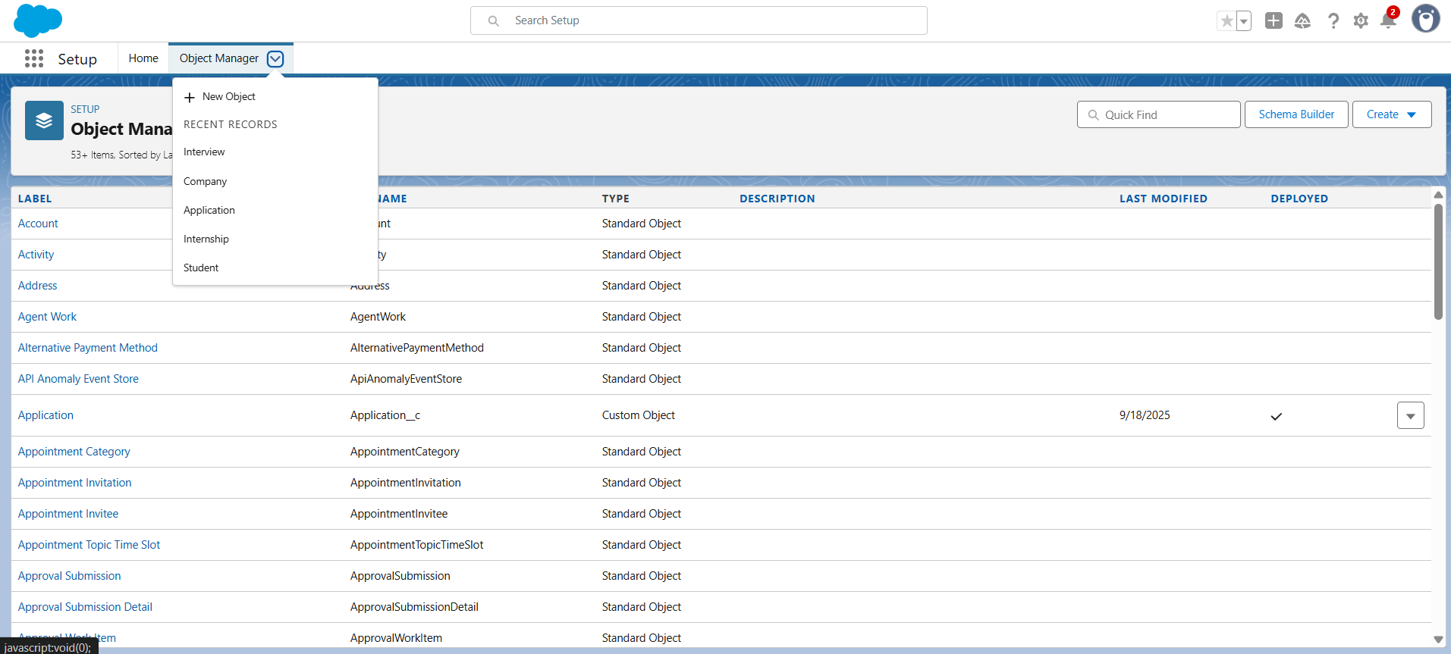

**2. Fields & Relationships**

For each object, you must define relevant fields. Examples:

| **Object** | **Key Fields** |
| --- | --- |
| **Student** | Name, Email, Contact, Skills, GPA, Application Lookup |
| **Company** | Name, Contact Person, Email, Industry |
| **Internship** | Role, Skills Required, Stipend, Status (Open/Closed), Record Type |
| **Application** | Student Lookup, Internship Lookup, Status, Applied Date |
| **Interview** | Student Lookup, Company Lookup, Interview Date, Feedback |

**Requirement:** Include field type, required/not required, and relationships.

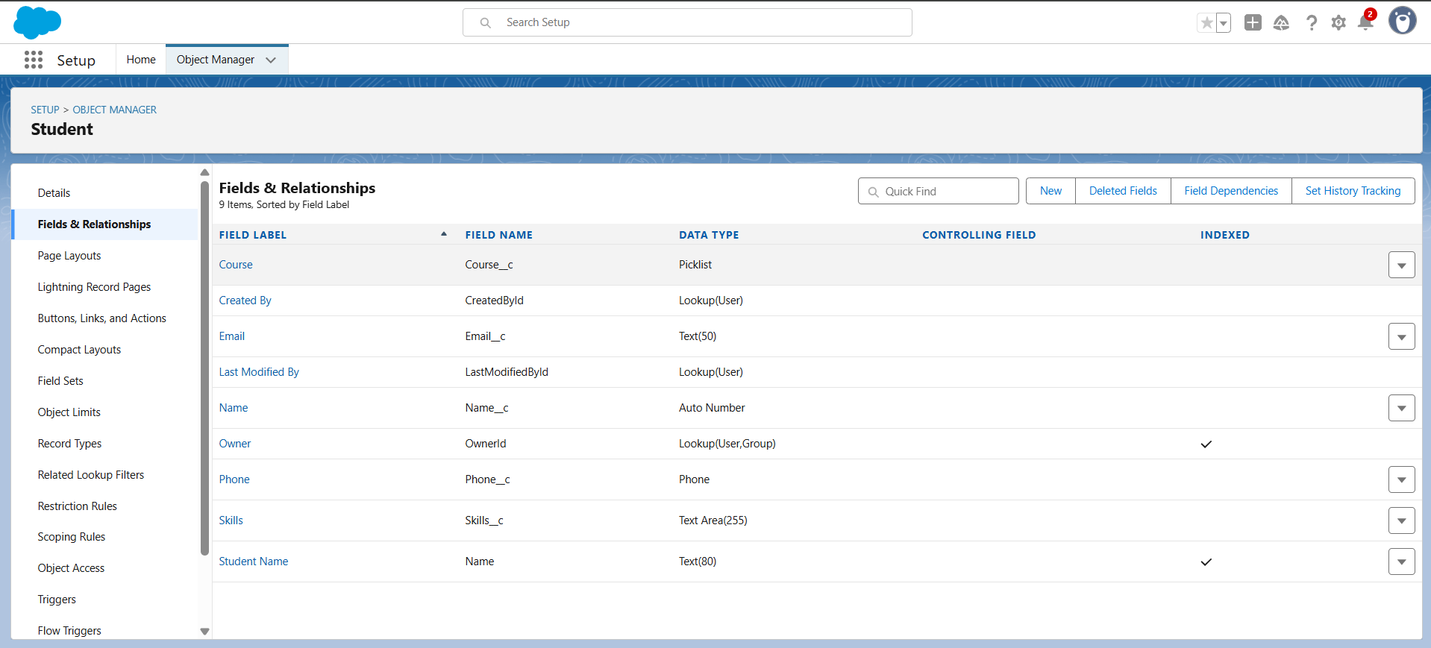

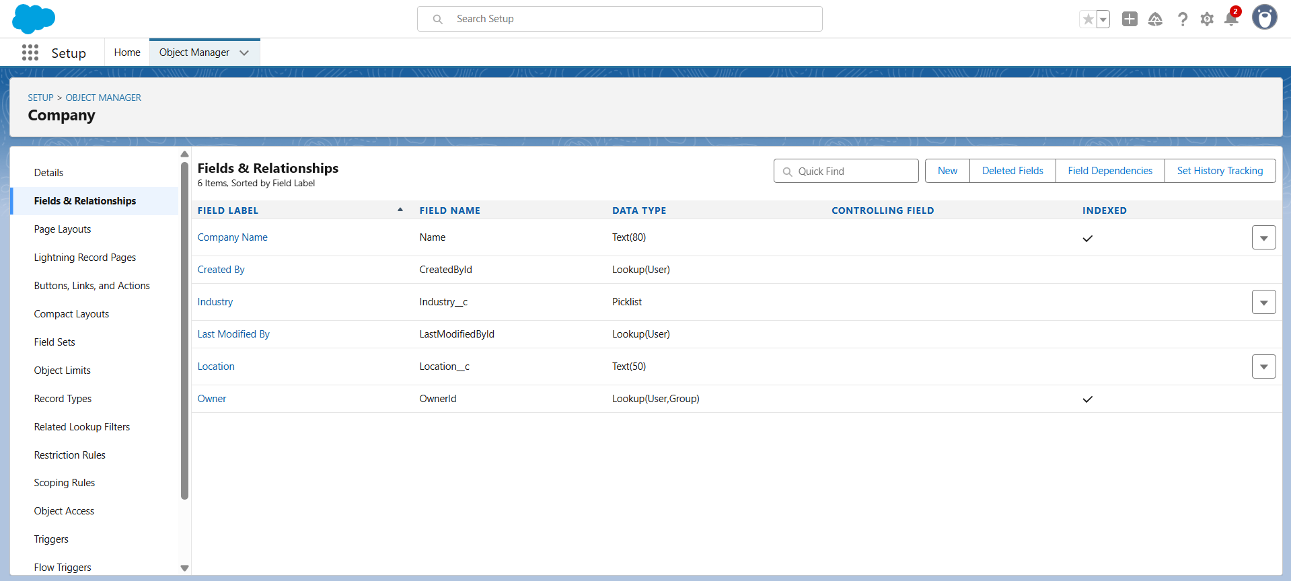

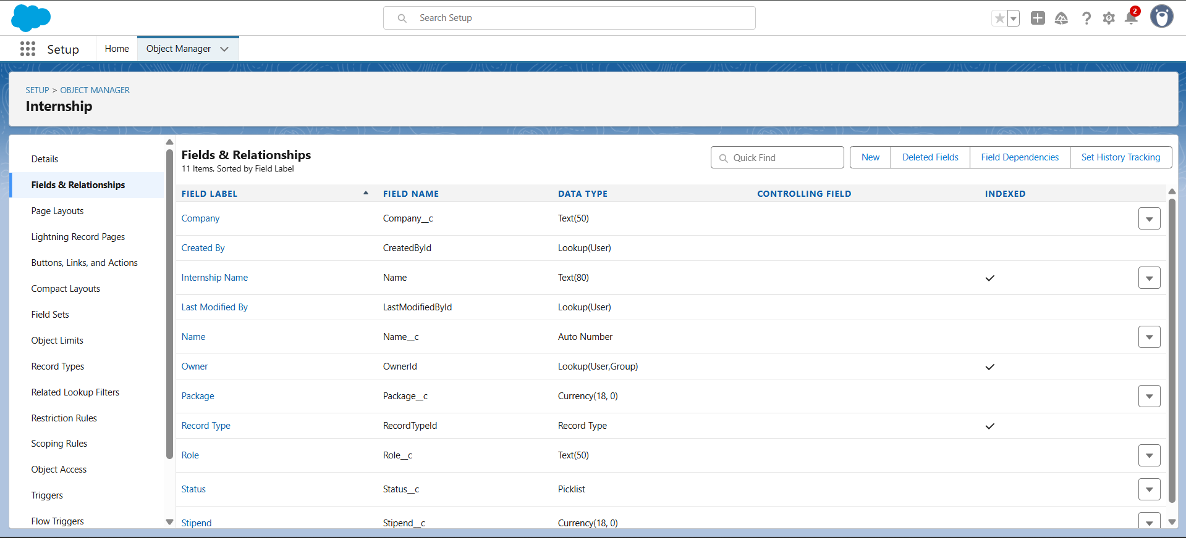

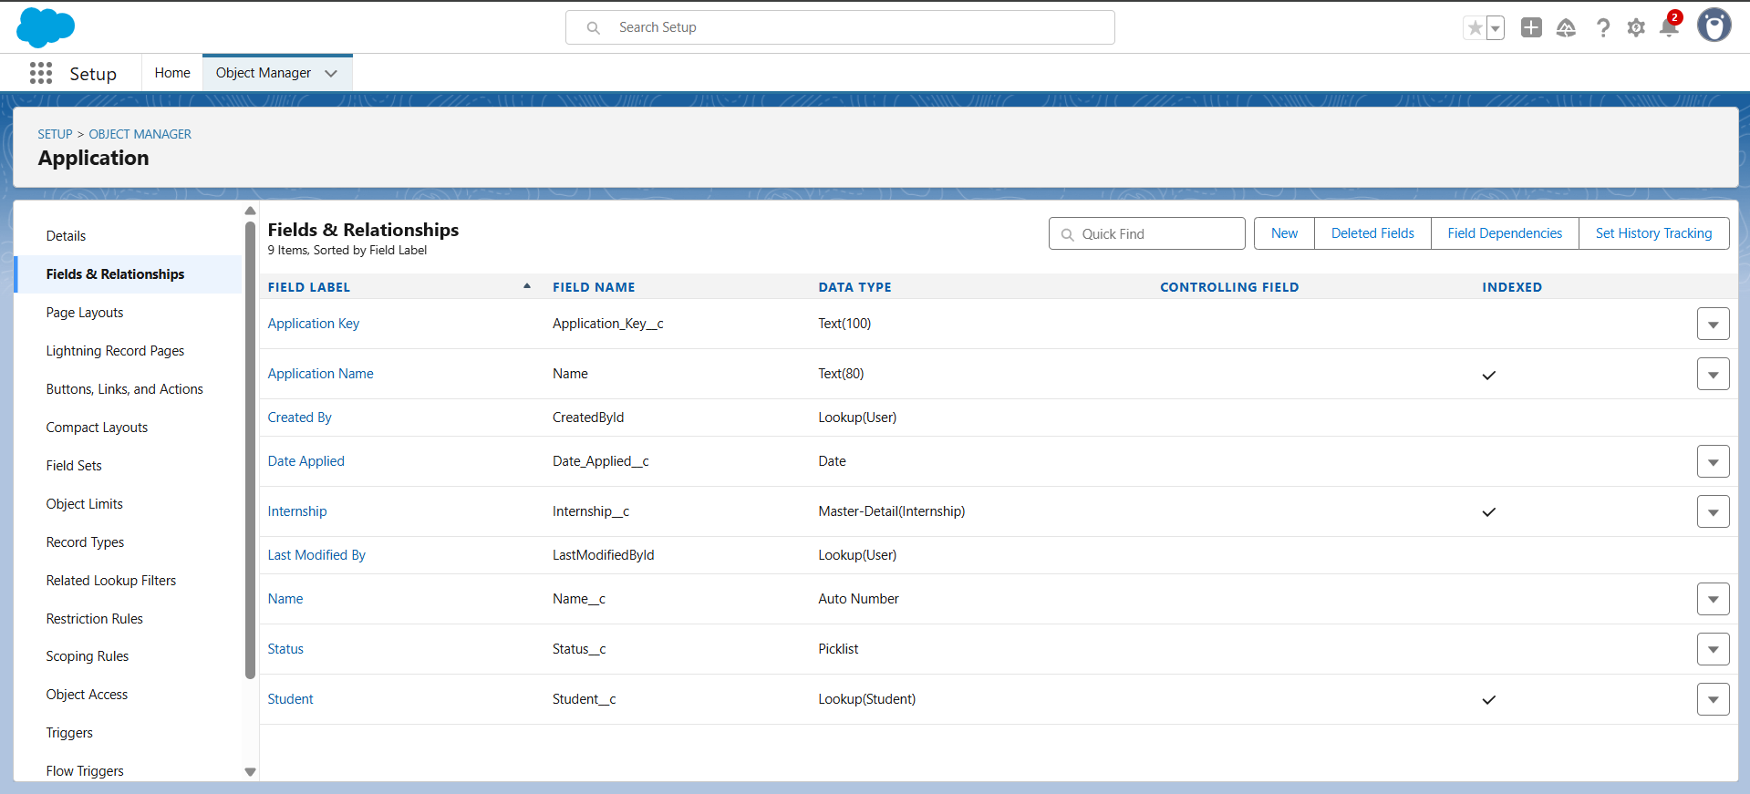

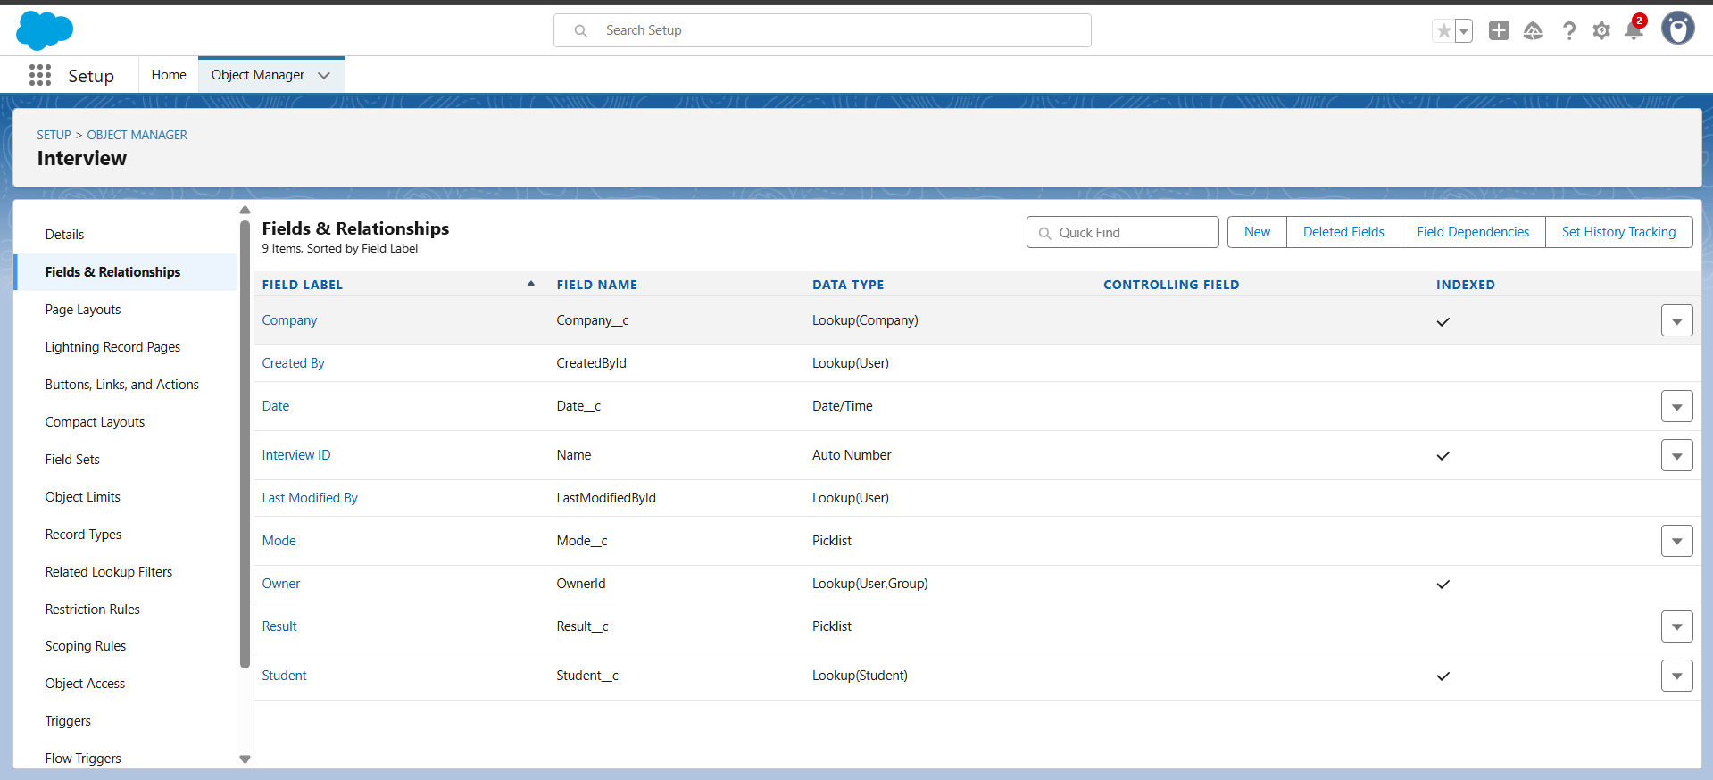

**3. Record Types**

* **Internship object must have record types**: Open, Closed, Shortlisted
* **Requirement:** Show record type setup for workflows and approval automation**.**

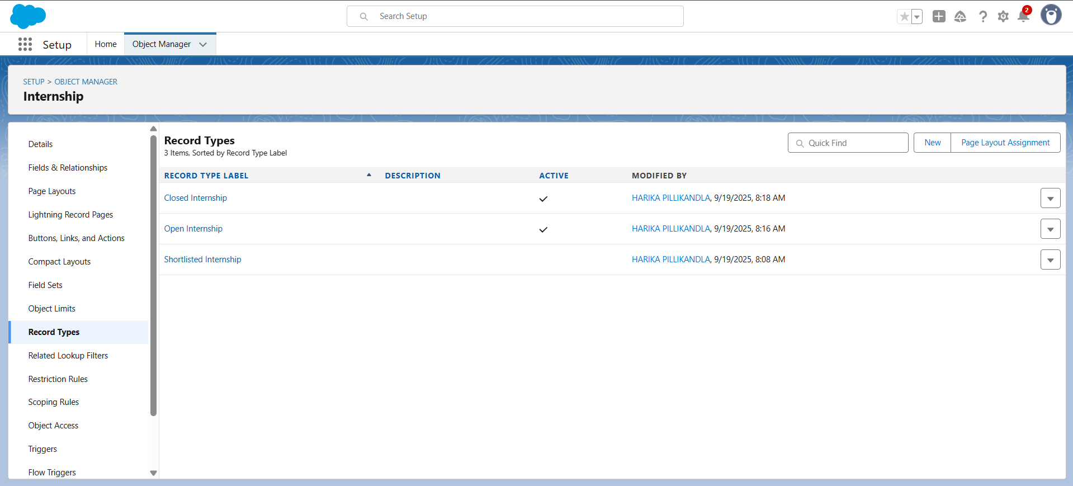

**4. Page Layouts**

* **Student Layout –** Fields for Placement Officers to view applications
* **Internship Layout –** Fields for Recruiters/Officers to view internship info
* **Requirement:** Include screenshots showing fields arrangement and sections.

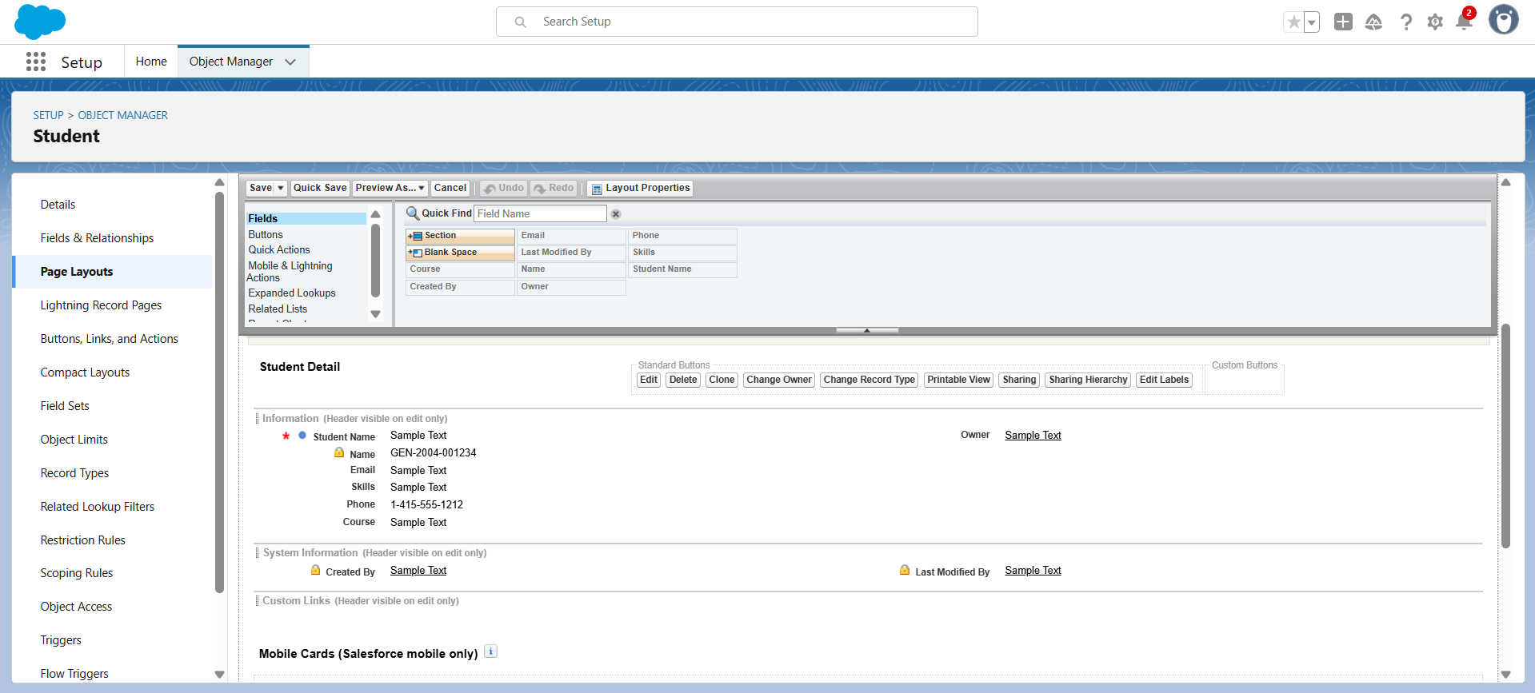

**5. Relationships**

Define object relationships:

* **Lookup Relationship:** Student → Application
* **Master-Detail Relationship:** Application → Internship
* **Junction Object:** Interview links Student and Company

**Requirement:** Show relationships in Schema Builder with all relevant objects.

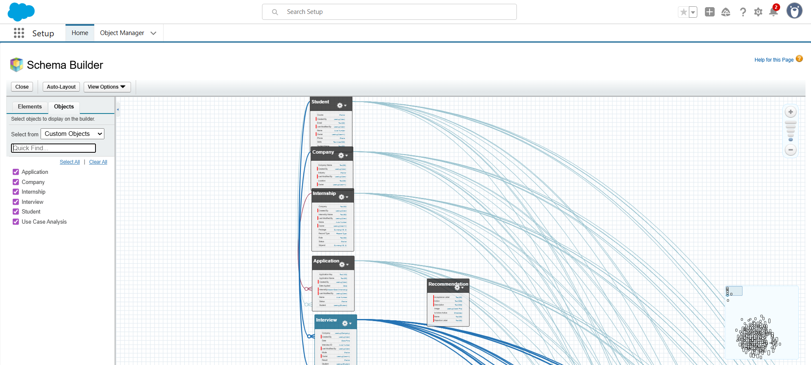

**6. Schema Builder**

* **Requirement:** Create a visual diagram showing all objects and their relationships.
* Include all fields and relationships, and show junction objects.

**7. Validation & Rules (Optional)**

* Include any unique fields, lookup validations related to the data model.
* **Example**: Prevent duplicate applications using unique Student–Internship combination.

**8. Deliverables**

1. **Custom Objects –** List of objects and their purpose
2. **Fields –** Key fields for each object
3. **Record Types –** Setup for Internship object
4. **Page Layouts** – Screenshots of Student & Internship layouts
5. **Relationships –** Schema Builder diagram
6. **Optional:** Notes on validation rules, field-level security