Results Analysis

In proposed method we used
- Soil prediction and crop recommendation
- Plant leaf disease detection and fertilizer recommendation
- Crop yield prediction

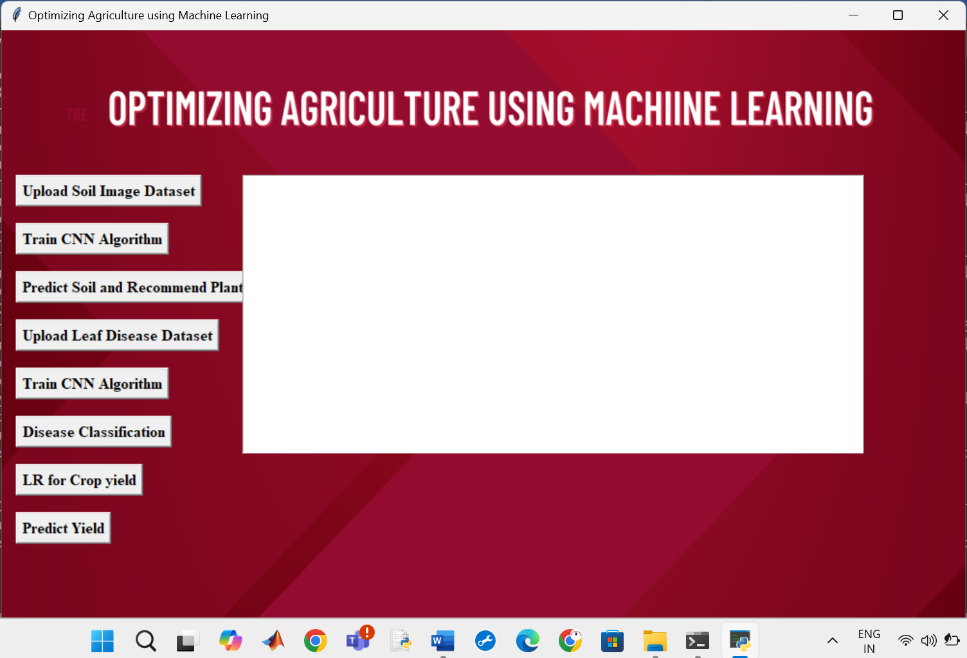

Fig. GUI for proposed Method

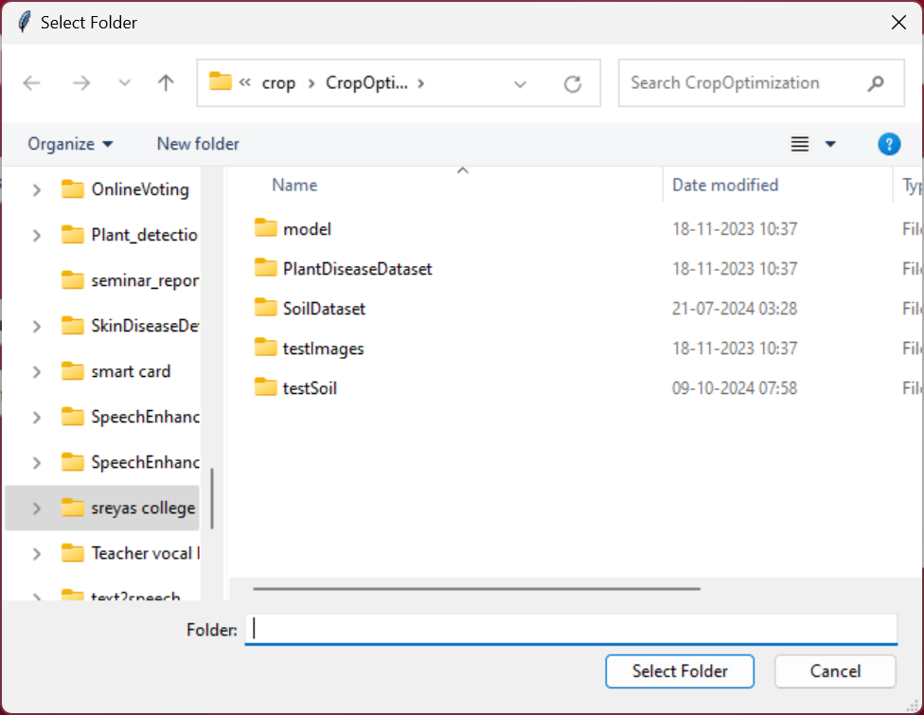
Fig. Upload the dataset related to soil
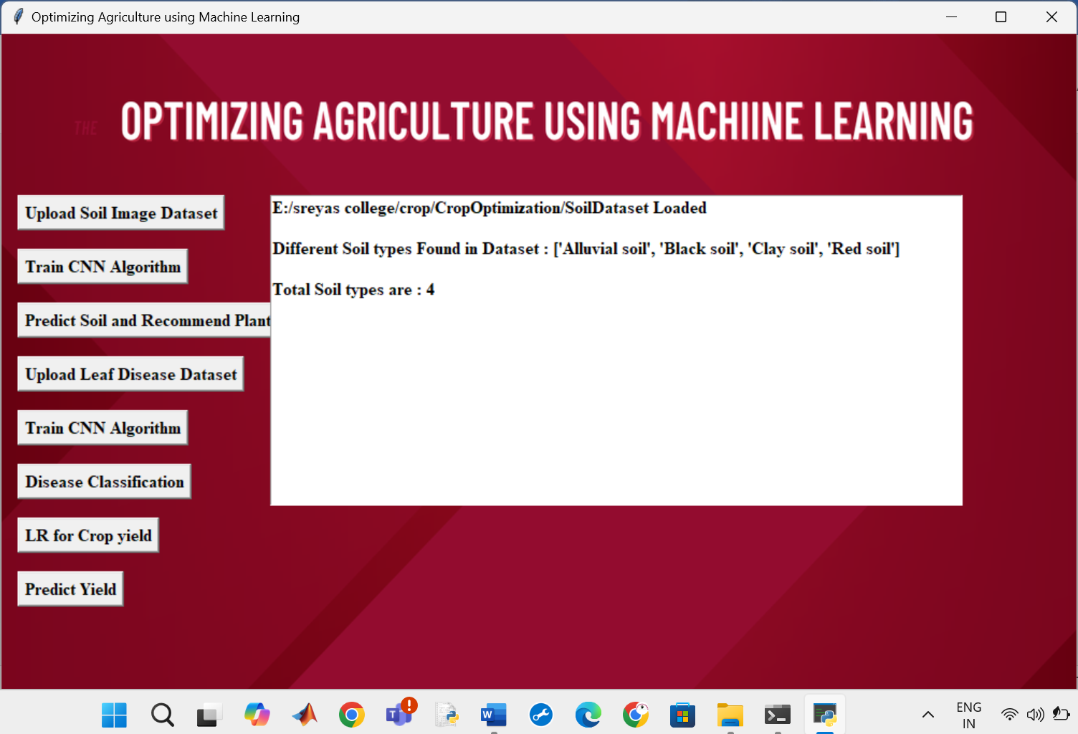
Fig. After uploading the soil dataset , details are shown
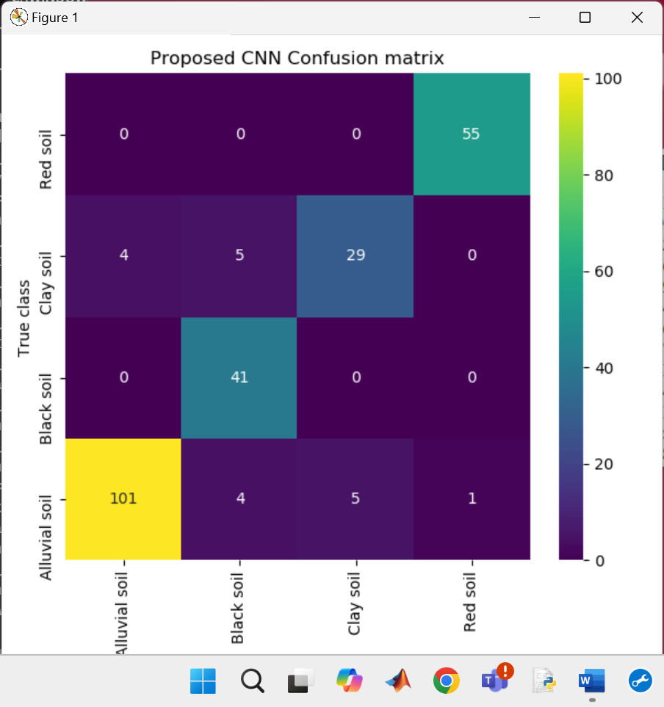
Fig. Confusion matrix for soil classification and plant recommendation

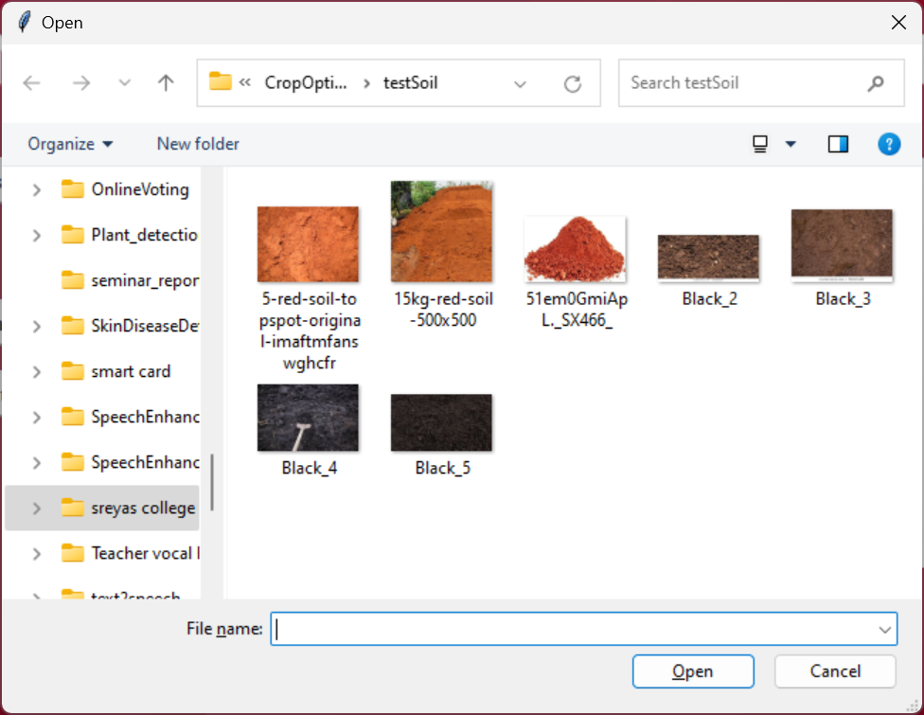
Fig. select soil image for testing

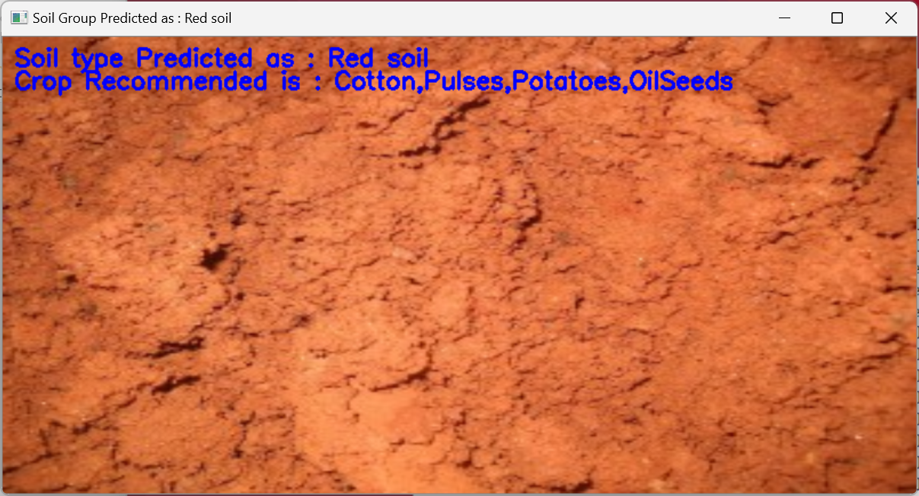
Fig. soil predicted and crop recommended


Fig. Uploading leaf disease dataset

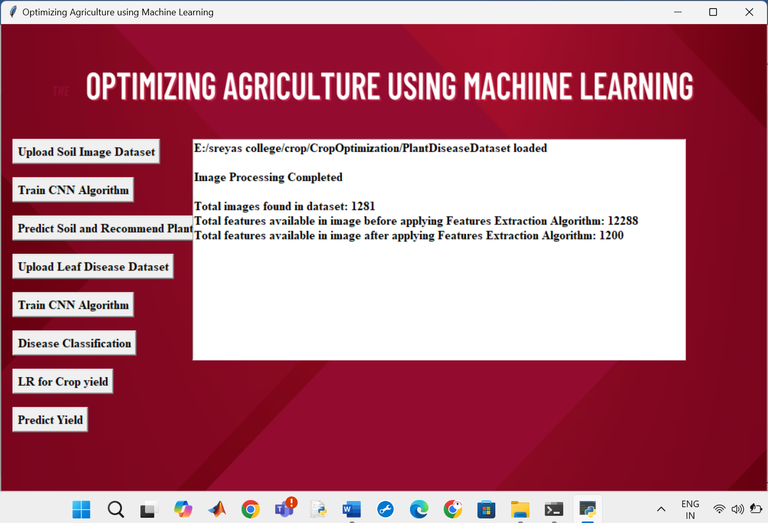
Fig. after uploading details are shown

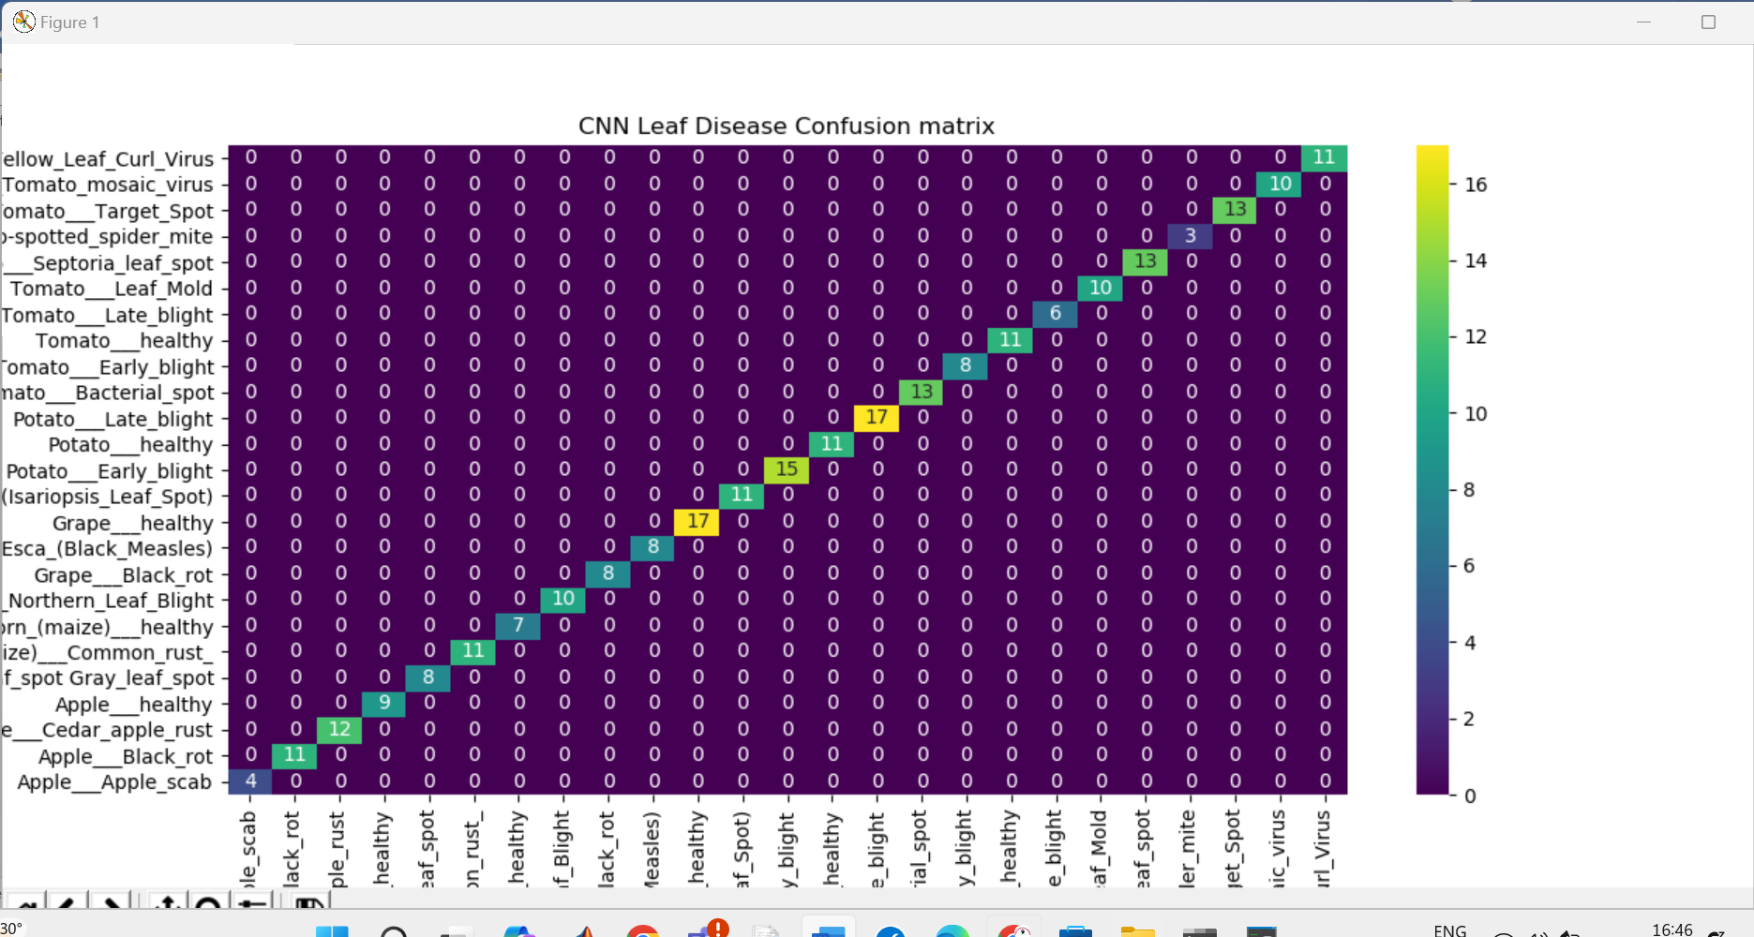
Fig. Confusion Matrix for plant disease detection and fertilizer recommendation

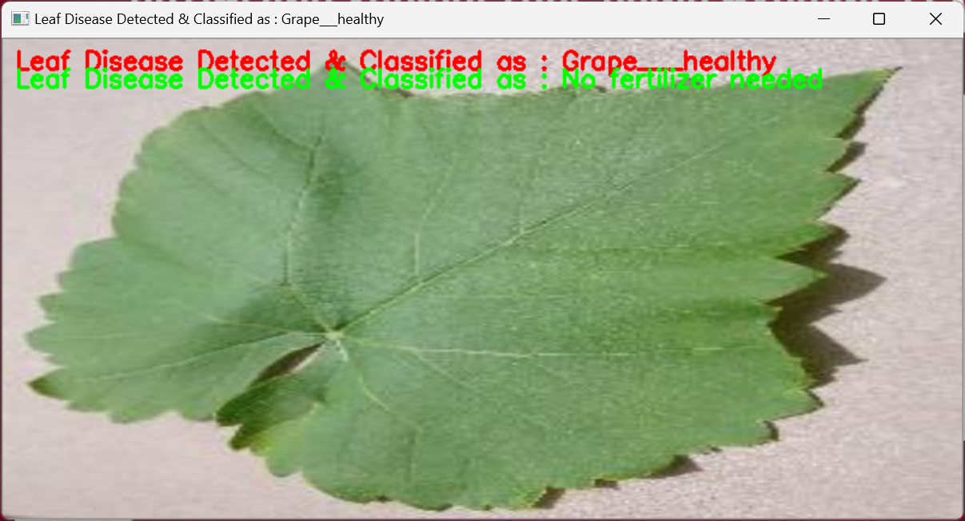
Normal leaf without disease

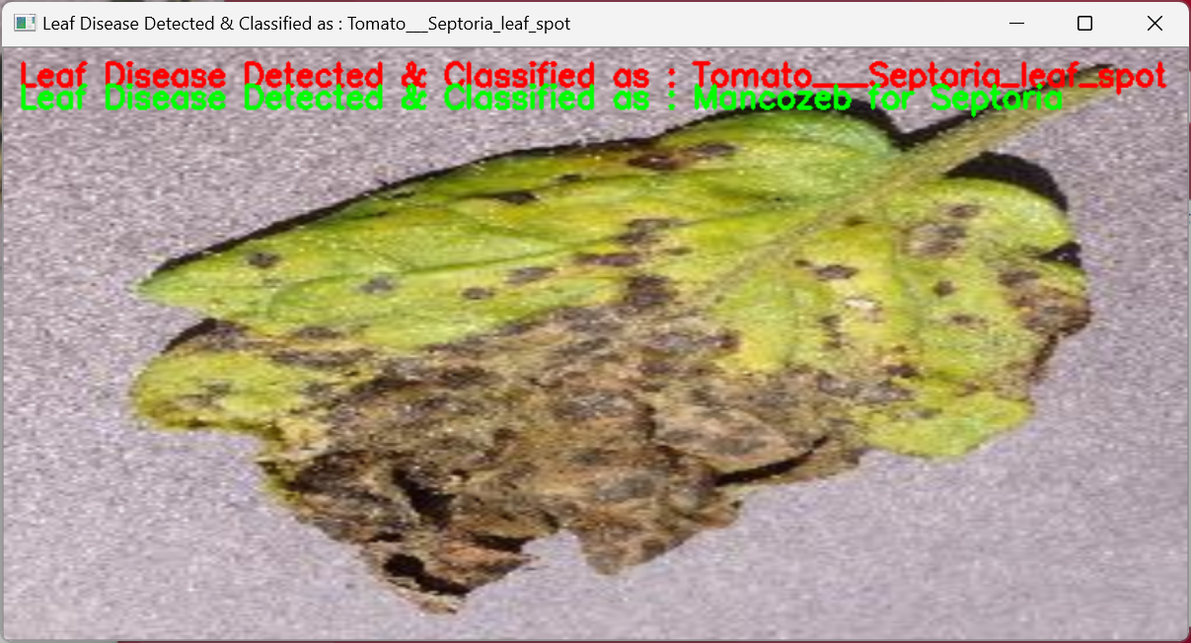
Fig. disease is predicted and fertilizer is recommended

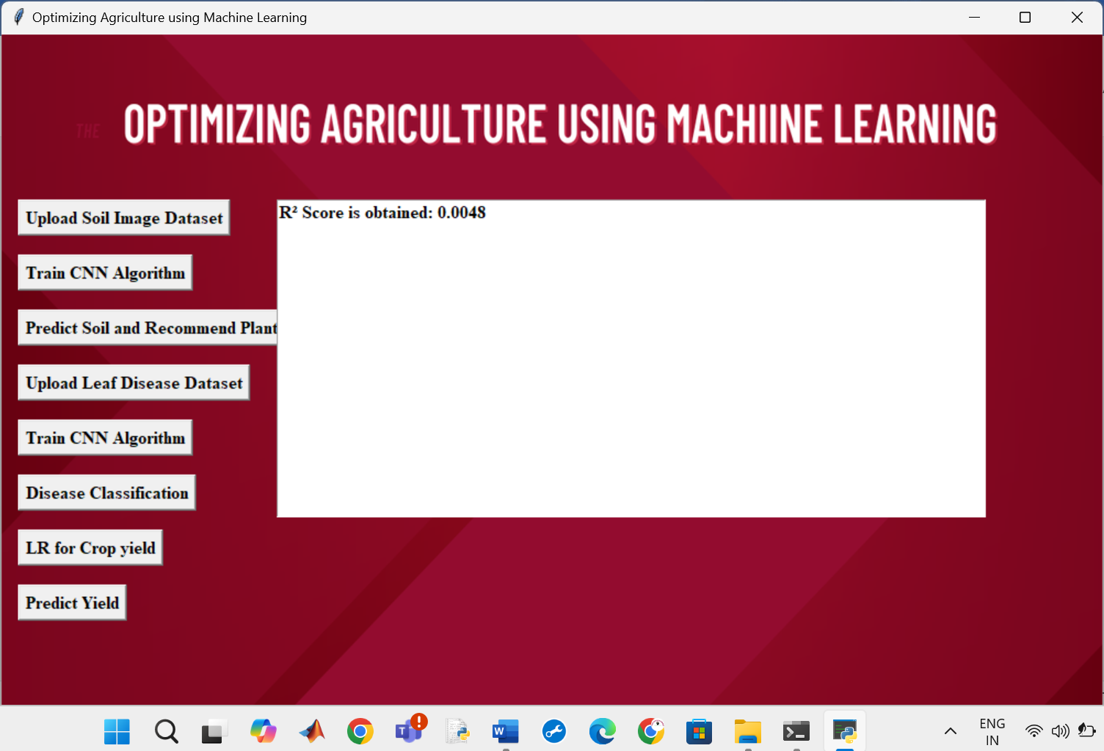
Fig. Linear regression R2 score is shown

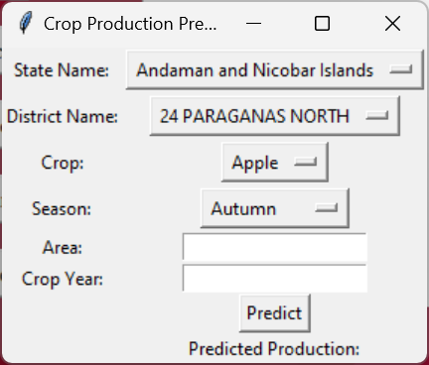
Fig. crop yield prediction interface

