**STRING COMPARISON**

**OBJECTIVE:**

To create a code for given string comparison.

**Language used:** Java

**Environment used:** Eclipse IDE

**Overview of the cod**e:

No: of strings

Less than 2 greater than 5 strings between

(at least 2 strings needed) (only compares up to 5 2 to 5

Strings)

Enter Strings

all characters numbers

(other than

characters)

vowels/consonants does not

have vowels

consonants

gives count, position

Based on this , the code was developed.

**Code Outputs:**

First, 3 strings are taken and the output is as follows:

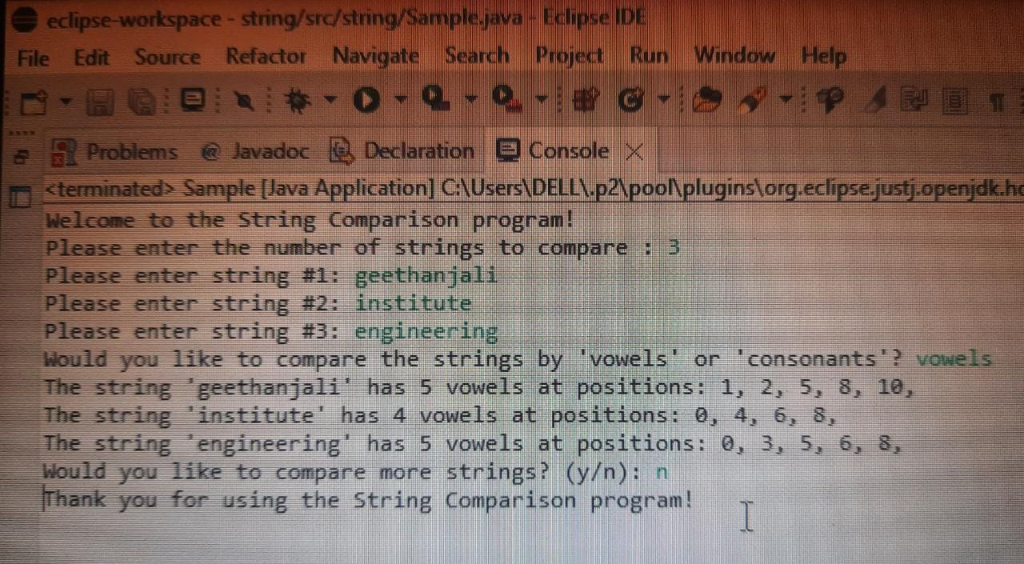

If less than 2 strings are taken, it prompts at least two strings needed.

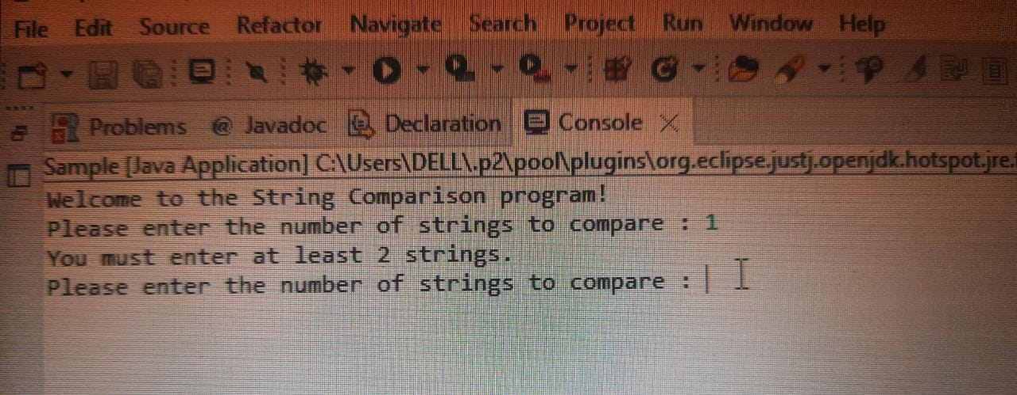

Likewise, if more than 5 strings are given ,it prompts “only compares up to 5 strings”

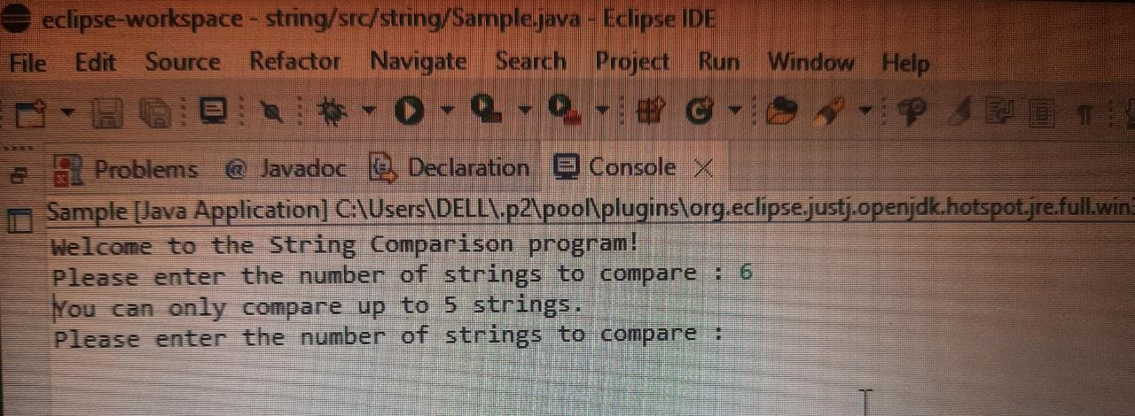

We can continue to compare more strings by typing “y”

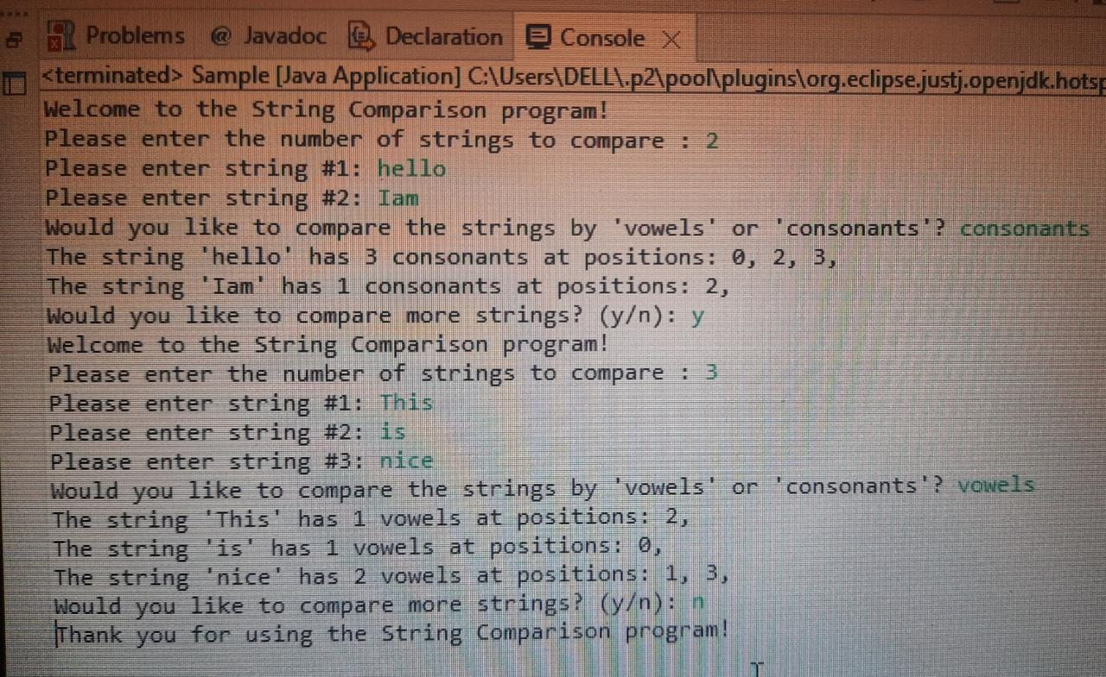

If we enter numbers (or) other than characters, it shows “does not have any vowels or consonants”

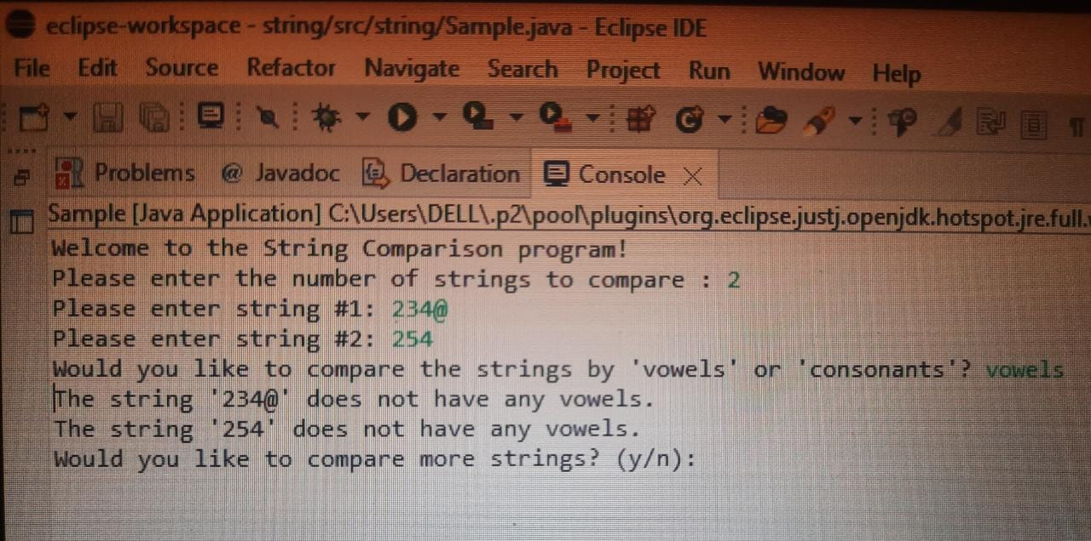

This is all about the outputs for the string comparison.