**EXERCISE -1 (Class diagrams)**

**1.VOTIONG**

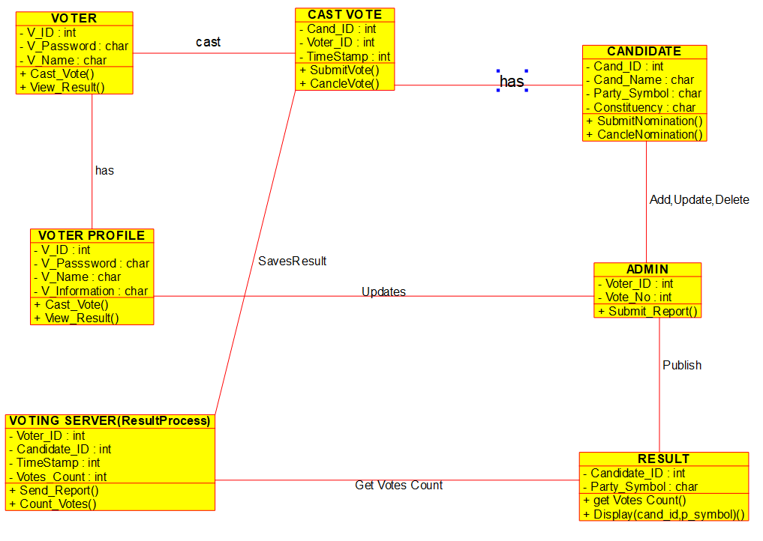

**2.LIBRARY MANAGEMENT**

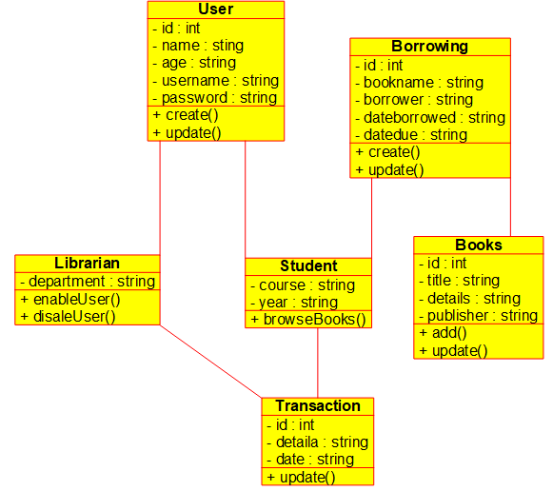

3.E-LIBRARY

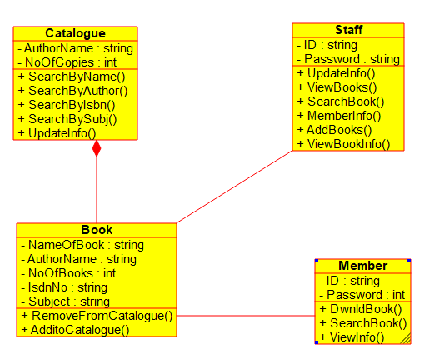

4.RESTAURANT

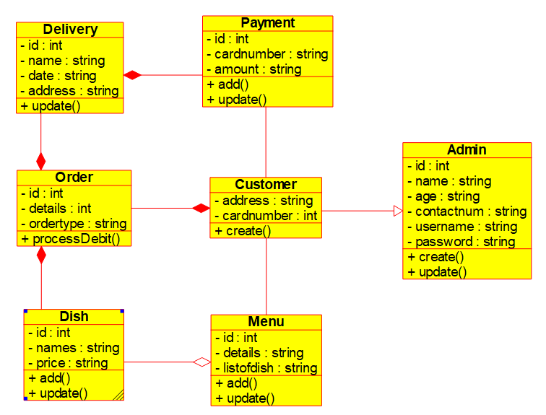

5.QUIZZES

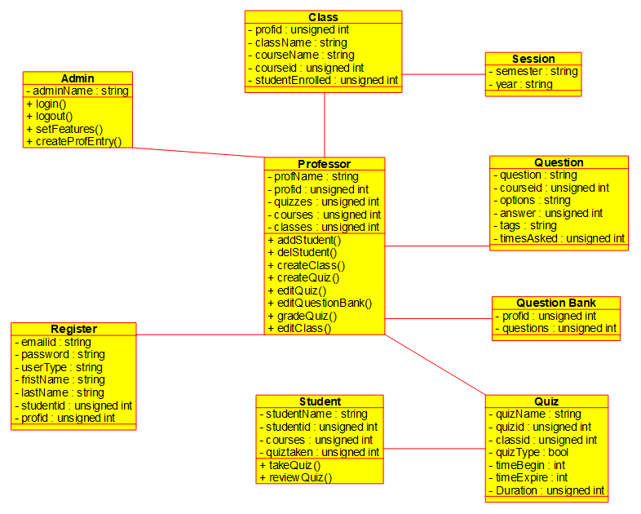

**EXERCISE-2 (Use-Case diagrams)**

**1.Online Voting System**

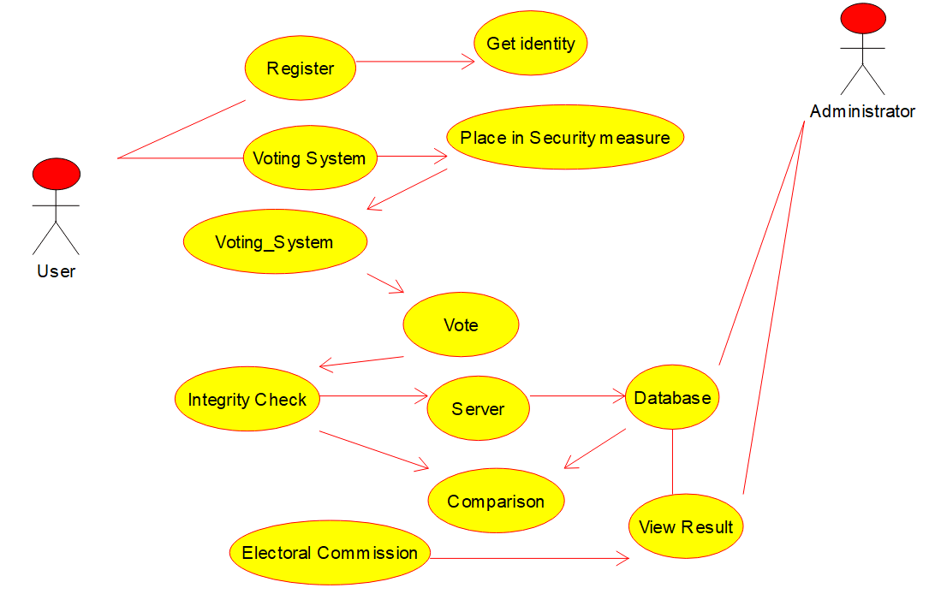

**2.Library Management System**

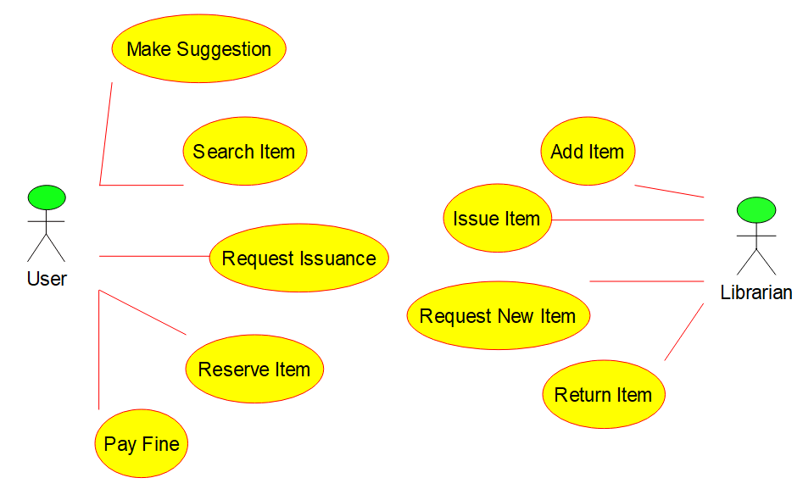

**3.Railway Reservation System**

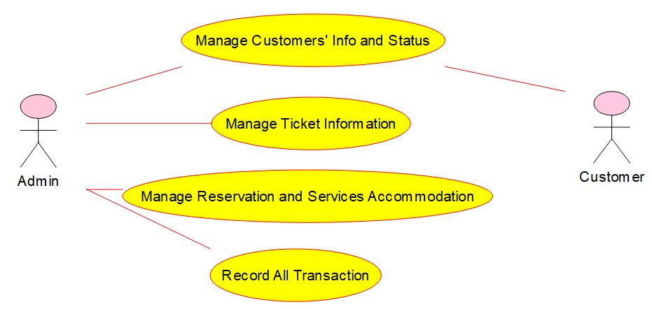

**4.Hospital Management System**

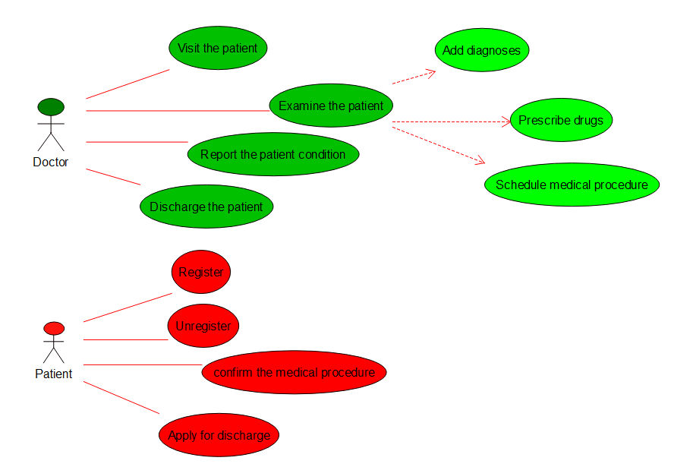

**5.ATM**

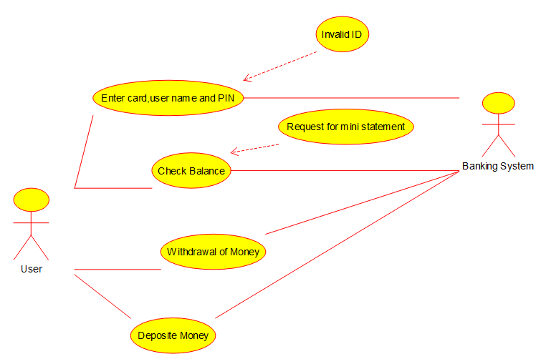

**6.Online College Management**

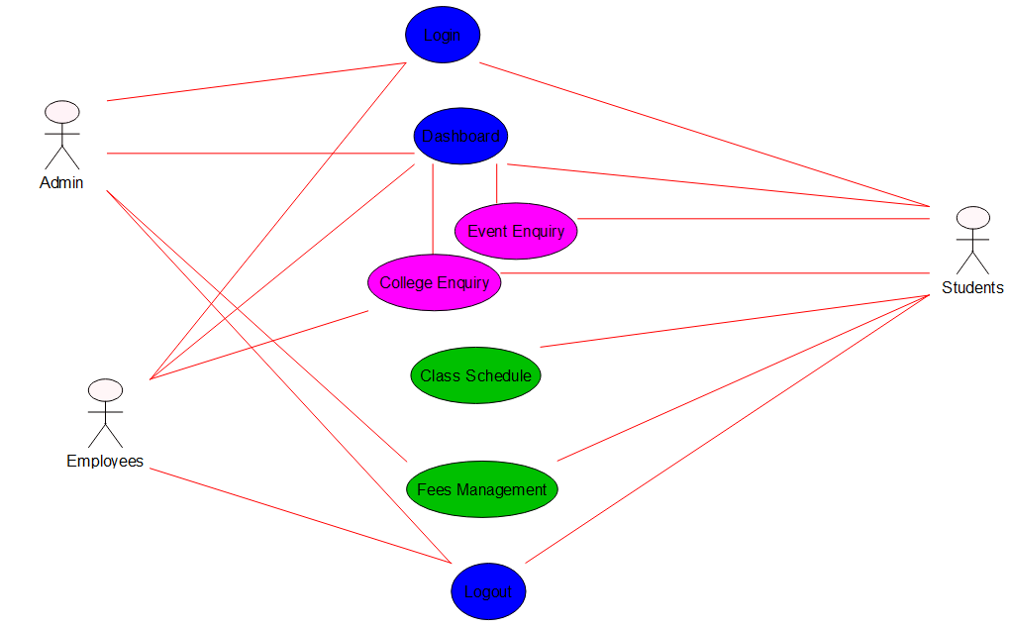

**7.Restaurant System**

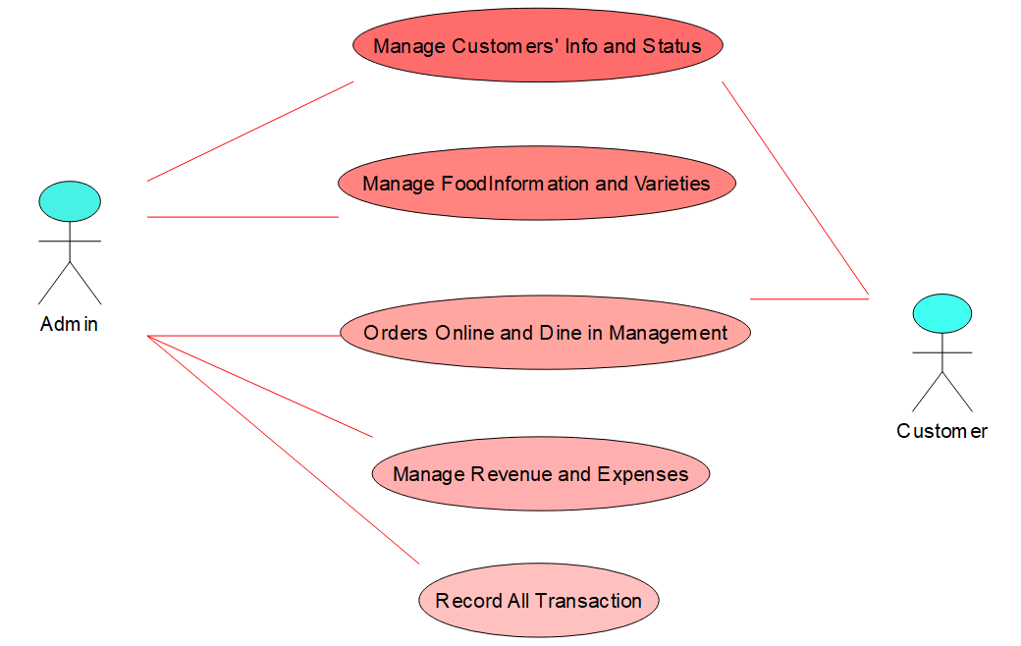

**8.QUIZZES**

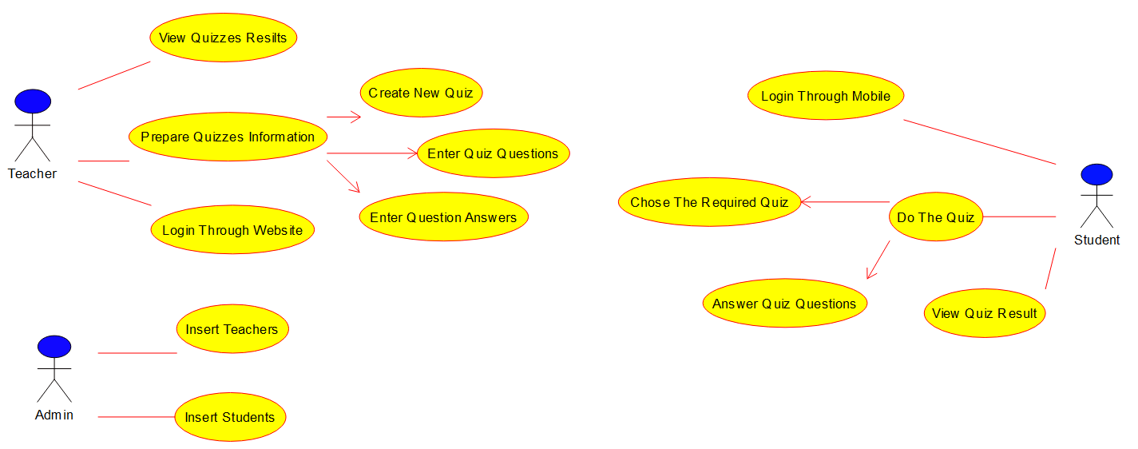

**9.Airline Reservation System**

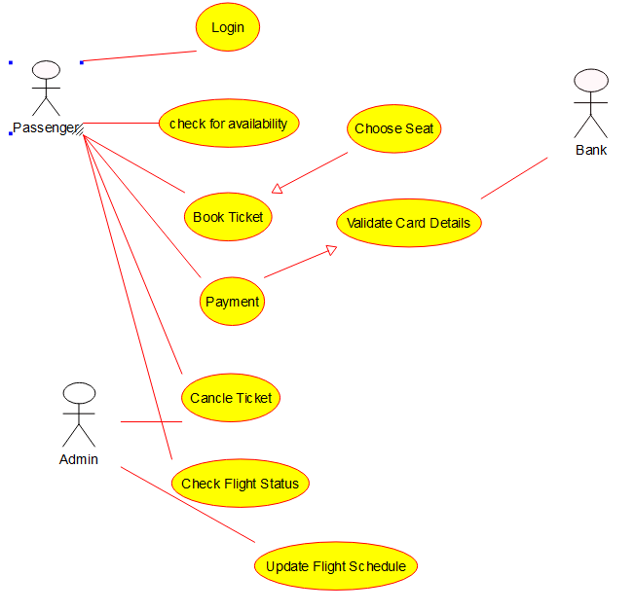

**EXERCISE-3 (Activity Diagram**

**1.Online Voting System**

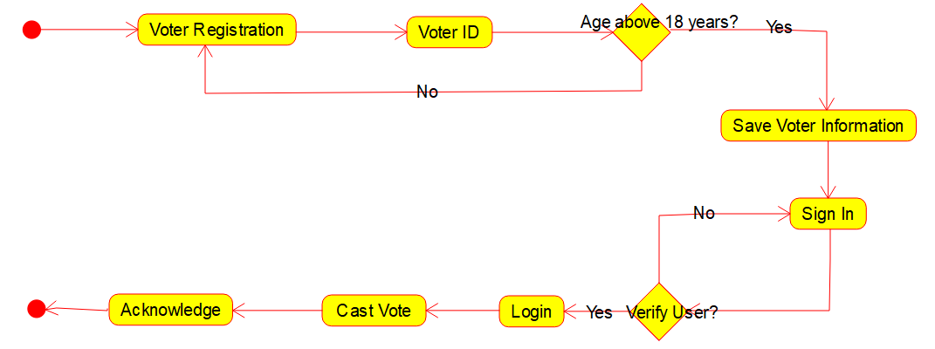

**2.Library Management System**

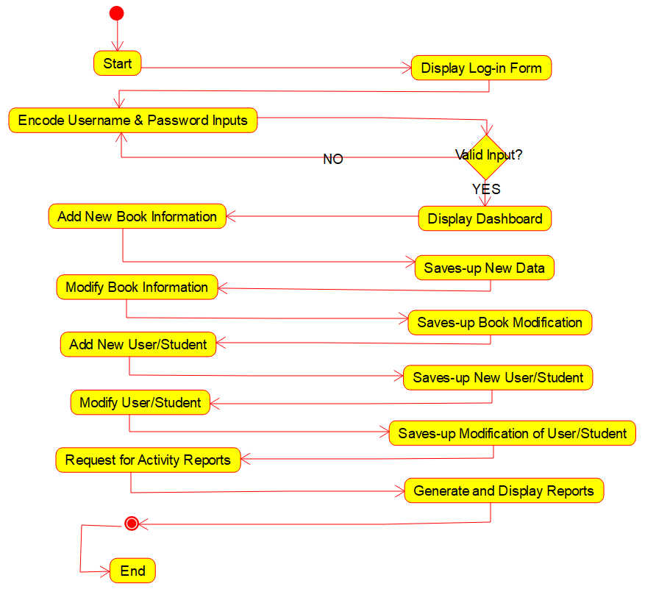

**3.Online Shopping System**

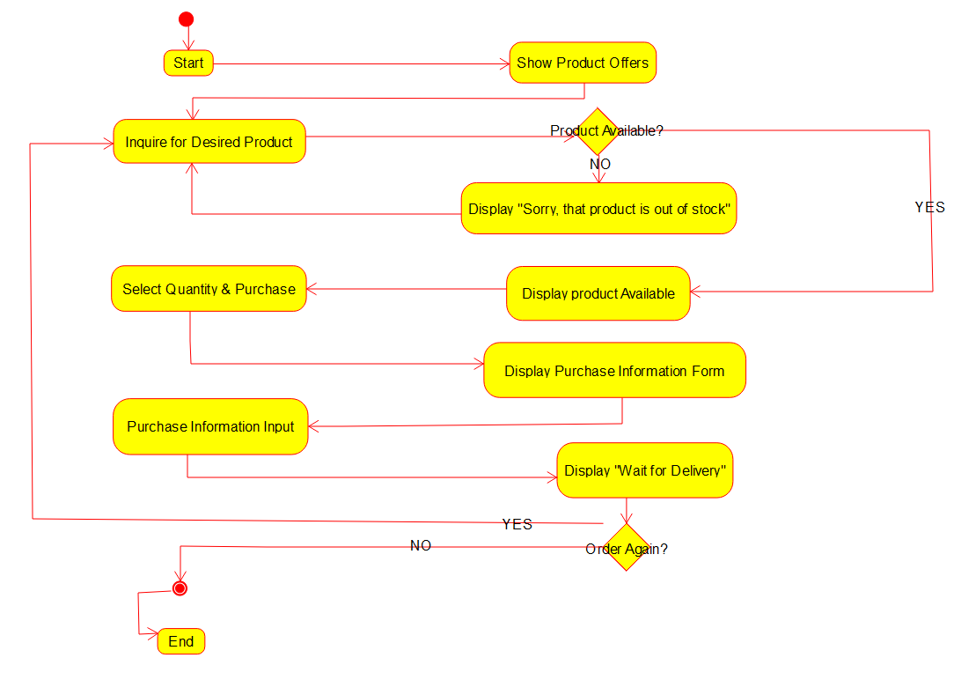

**4.Railway Reservation System**

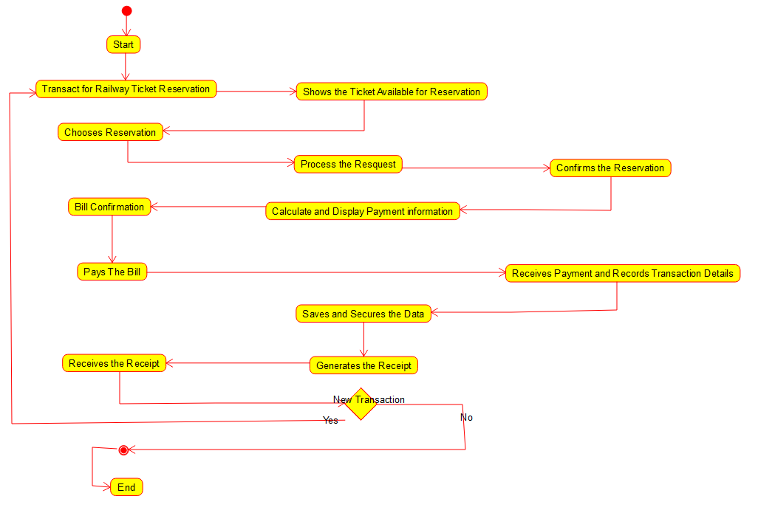

**5.Online Banking System**

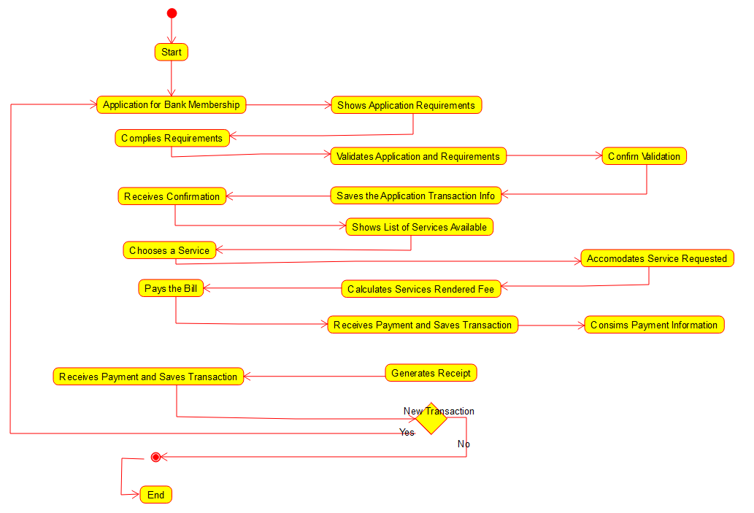

**6.E-Library**



**EXERCISE-4 (Raptor Problems)**

**1.Palindrome**

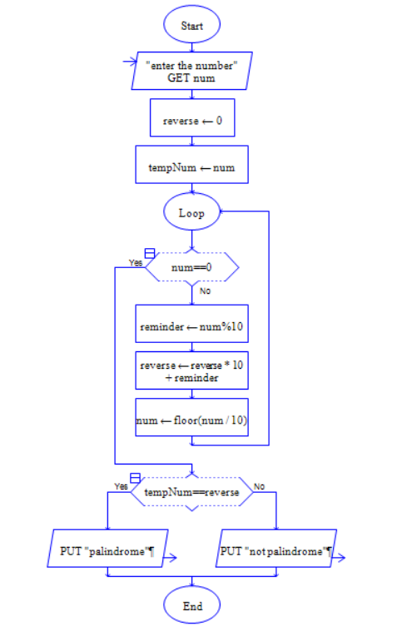

**2.Fibonacci Series**

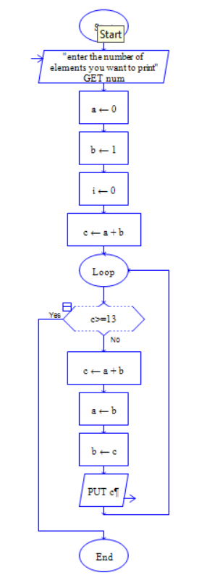

**3.Replacing Characters**

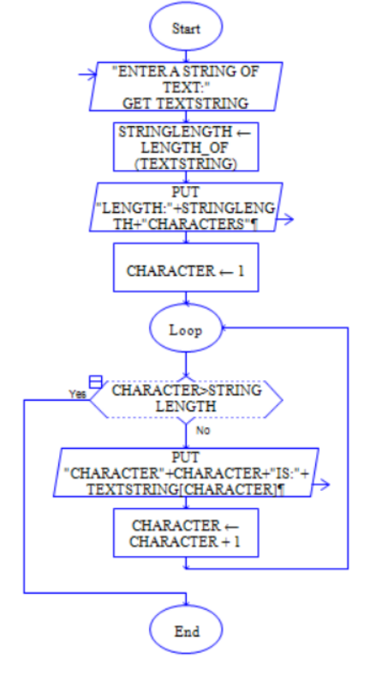

**4.Factorial of a Number**

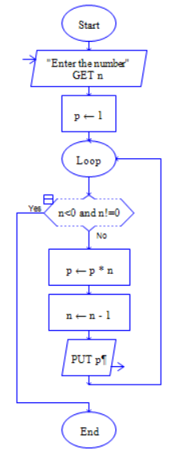

**5.Even Numbers**

