Exercise 1 – Inventory Management System

Scenario
You are developing an inventory management system for a warehouse. Efficient data storage and retrieval are crucial because warehouses store thousands of products. The system should allow users to add, update, delete, and display products efficiently.

1. Understanding the Problem
Data Structures and Algorithms (DSA) improve storage, retrieval, and manipulation of inventory data. Choosing the right data structure increases performance and scalability.
Data Structure | Advantages | Disadvantages
Array | Simple | Fixed size
ArrayList | Dynamic size | Search O(n)
HashMap | Fast lookup | More memory
Linked List | Easy insertion/deletion | Slow search
Chosen Data Structure: ArrayList because it supports dynamic storage and is easy to implement.

2. Setup
Project Name: InventoryManagementSystem
Classes: Product.java, InventoryManagement.java

3. Implementation
Product.java
class Product {
int productId;
String productName;
int quantity;
double price;
Product(int productId,String productName,int quantity,double price){
this.productId=productId;
this.productName=productName;
this.quantity=quantity;
this.price=price;
}
void display(){
System.out.println(productId+" "+productName+" "+quantity+" "+price);
}
}
InventoryManagement.java
import java.util.ArrayList;
public class InventoryManagement {
static ArrayList<Product> inventory=new ArrayList<>();
static void addProduct(Product p){ inventory.add(p); }
static void updateProduct(int id,int qty,double price){
for(Product p:inventory){
if(p.productId==id){
p.quantity=qty;
p.price=price;
return;
}
}
}
static void deleteProduct(int id){
inventory.removeIf(p->p.productId==id);
}
static void displayProducts(){
for(Product p:inventory) p.display();
}
public static void main(String[] args){
addProduct(new Product(101,"Laptop",10,65000));
addProduct(new Product(102,"Mouse",50,500));
addProduct(new Product(103,"Keyboard",25,1200));
updateProduct(102,60,550);
deleteProduct(103);
displayProducts();
}
}

4. Sample Output
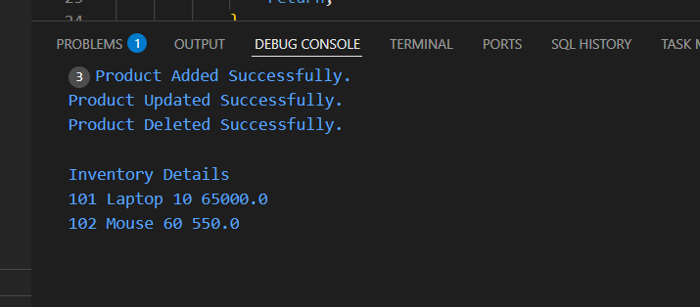

5. Algorithm
• Create a Product object.
• Add it to the ArrayList.
• Traverse the list to update or delete by productId.
• Traverse the list to display all products.

6. Time Complexity Analysis
Operation | Complexity
Add | O(1) amortized
Update | O(n)
Delete | O(n)
Display | O(n)

7. Optimization
For large inventories, HashMap<Integer, Product> provides O(1) average-time search, update, and delete operations.

8. Advantages
• Dynamic size
• Easy insertion
• Simple implementation
• Sequential traversal

9. Limitations
• Linear search
• Deletion shifts elements
• Performance decreases for large datasets

10. Conclusion
This exercise demonstrates how ArrayList can be used to build a simple inventory management system. It supports add, update, delete, and display operations efficiently for small and medium-sized inventories. For larger applications, HashMap is a better choice for faster access.

