Exercise 2 – E-commerce Platform Search Function

Scenario
You are working on the search functionality of an e-commerce platform. The search needs to be optimized for fast performance. The system should efficiently search products using both Linear Search and Binary Search algorithms.

1. Understanding Asymptotic Notation
Big O notation measures the efficiency of algorithms and helps compare their performance as input size grows.
Case | Description
Best Case | Element found immediately
Average Case | Element found in the middle
Worst Case | Element at the end or not found
Linear Search: Best O(1), Average O(n), Worst O(n)
Binary Search: Best O(1), Average O(log n), Worst O(log n)

2. Setup
Project Name: EcommerceSearchSystem
Classes: Product.java, SearchProduct.java

3. Implementation
Product.java
class Product{
int productId;
String productName;
String category;
Product(int productId,String productName,String category){
this.productId=productId;
this.productName=productName;
this.category=category;
}
void display(){
System.out.println(productId+" "+productName+" "+category);
}
}
SearchProduct.java
import java.util.*;
public class SearchProduct {
static Product linearSearch(Product[] products,String name){
for(Product p:products)
if(p.productName.equalsIgnoreCase(name))
return p;
return null;
}
static Product binarySearch(Product[] products,String name){
int low=0, high=products.length-1;
while(low<=high){
int mid=(low+high)/2;
int cmp=products[mid].productName.compareToIgnoreCase(name);
if(cmp==0) return products[mid];
else if(cmp<0) low=mid+1;
else high=mid-1;
}
return null;
}
public static void main(String[] args){
Product[] products={
new Product(101,"Laptop","Electronics"),
new Product(102,"Mouse","Electronics"),
new Product(103,"Keyboard","Electronics"),
new Product(104,"Monitor","Electronics"),
new Product(105,"Speaker","Electronics")
};
System.out.println("Linear Search");
Product p1=linearSearch(products,"Keyboard");
if(p1!=null) p1.display();
Arrays.sort(products, Comparator.comparing(p->p.productName));
System.out.println("\nBinary Search");
Product p2=binarySearch(products,"Keyboard");
if(p2!=null) p2.display();
}
}

4. Sample Output
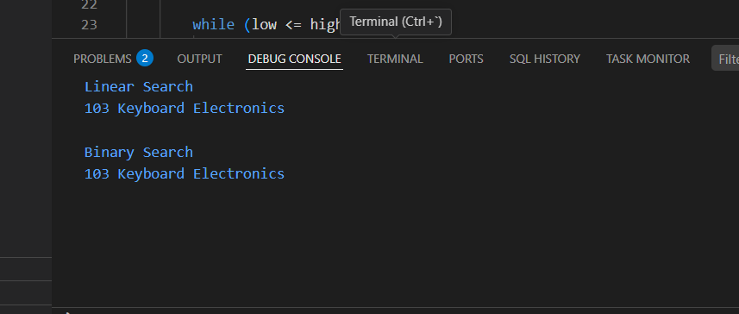

5. Algorithm
• Perform Linear Search by comparing each product name.
• Sort the array by product name.
• Perform Binary Search by repeatedly dividing the search space.
• Display the product if found; otherwise display 'Product Not Found'.

6. Time Complexity Analysis
Operation | Time Complexity
Linear Search | O(n)
Binary Search | O(log n)

7. Optimization
For large datasets, maintain sorted data and use Binary Search. A HashMap can provide O(1) average lookup by Product ID.

8. Advantages
• Simple implementation
• Fast searching using Binary Search
• Suitable for large sorted datasets

9. Limitations
• Linear Search is slow for large datasets
• Binary Search requires sorted data

10. Conclusion
This exercise demonstrates the implementation of Linear Search and Binary Search for an e-commerce platform. Binary Search is preferred for large, sorted datasets because it provides much faster search performance than Linear Search.

