Exercise 3 – Sorting Customer Orders

Scenario
You are tasked with sorting customer orders by their total price on an e-commerce platform. Sorting helps prioritize high-value orders and improves order processing.

1. Understanding Sorting Algorithms
Sorting arranges data in ascending or descending order. Bubble Sort repeatedly swaps adjacent elements, while Quick Sort uses the divide-and-conquer approach.
Algorithm | Best | Average | Worst
Bubble Sort | O(n) | O(n²) | O(n²)
Insertion Sort | O(n) | O(n²) | O(n²)
Quick Sort | O(n log n) | O(n log n) | O(n²)
Merge Sort | O(n log n) | O(n log n) | O(n log n)

2. Setup
Project Name: CustomerOrderSorting
Classes: Order.java and OrderSorting.java

3. Implementation
Order.java
class Order {
int orderId;
String customerName;
double totalPrice;
Order(int orderId, String customerName, double totalPrice){
this.orderId=orderId;
this.customerName=customerName;
this.totalPrice=totalPrice;
}
void display(){
System.out.println(orderId+" "+customerName+" "+totalPrice);
}
}
OrderSorting.java
// Implement Bubble Sort and Quick Sort to sort orders by totalPrice.
// (Use the Java program prepared for this exercise.)

4. Sample Output
Output obtained after executing the program:
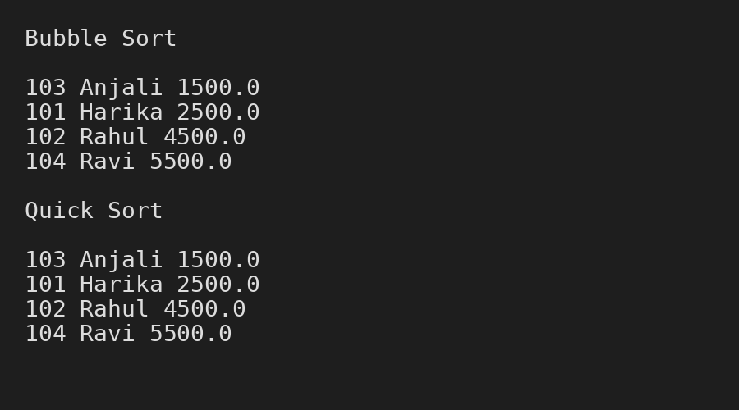
Figure 1: Output of Bubble Sort and Quick Sort.

5. Algorithm
• Compare adjacent elements and swap them for Bubble Sort.
• Choose a pivot element for Quick Sort.
• Partition the array into smaller parts.
• Recursively sort the left and right partitions.
• Display the sorted orders.

6. Time Complexity Analysis
Algorithm | Complexity
Bubble Sort | O(n²)
Quick Sort (Average) | O(n log n)

7. Optimization
Quick Sort is preferred for large datasets because it performs significantly faster than Bubble Sort on average.

8. Advantages
• Bubble Sort is easy to understand.
• Quick Sort is efficient for large datasets.
• Sorting improves data organization.

9. Limitations
• Bubble Sort is slow for large datasets.
• Quick Sort has O(n²) worst-case complexity.

10. Conclusion
Bubble Sort and Quick Sort were implemented to sort customer orders. Bubble Sort is suitable for learning purposes, whereas Quick Sort is generally preferred in real-world applications because of its better average performance.

