Exercise 4 – Employee Management System

Scenario
You are developing an employee management system for a company. Efficiently managing employee records is crucial.

1. Understanding Array Representation
Arrays store elements in contiguous memory locations. They provide fast indexed access but have a fixed size.
Advantages | Limitations
Fast access using index | Fixed size

2. Setup
Project Name: EmployeeManagementSystem
Classes: Employee.java and EmployeeManagement.java

3. Implementation
class Employee {
int employeeId;
String name;
String position;
double salary;
Employee(int employeeId,String name,String position,double salary){
this.employeeId=employeeId;
this.name=name;
this.position=position;
this.salary=salary;
}
void display(){
System.out.println(employeeId+" "+name+" "+position+" "+salary);
}
}
// EmployeeManagement.java
// Store Employee[] array and implement add(), search(), traverse(), delete(), and main().

4. Sample Output
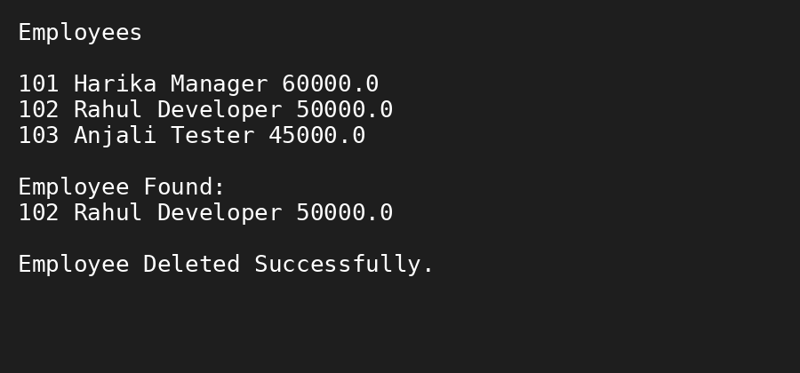

5. Algorithm
- Create an Employee array.
- Add employee records.
- Search employee using employeeId.
- Traverse the array to display records.
- Delete an employee by shifting elements.

6. Time Complexity Analysis
Operation | Complexity
Add | O(1)
Search | O(n)
Traverse | O(n)
Delete | O(n)

7. Optimization
Use ArrayList for dynamic storage or HashMap for faster searching.

8. Advantages
• Fast index access
• Simple implementation

9. Limitations
• Fixed size
• Costly insertion/deletion

10. Conclusion
This exercise demonstrates employee management using arrays with add, search, traverse and delete operations.

