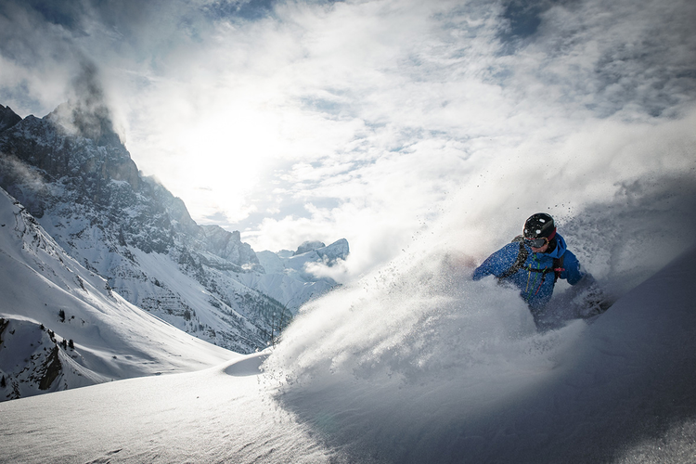

## San Diego Surf Spots

From the hippie beaches of Ocean Beach to the ritzy shores of La Jolla and everywhere in between. Discover the San Diego surf scene.

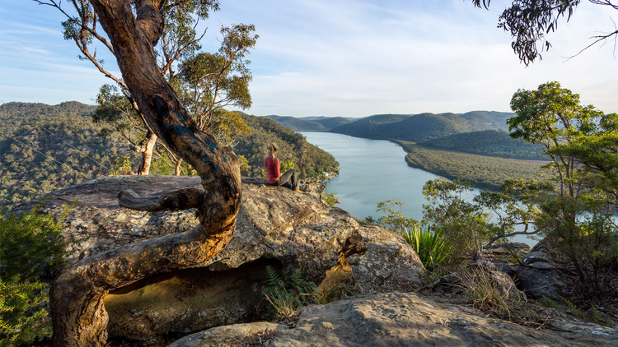

## San Diego Surf Spots

From the hippie beaches of Ocean Beach to the ritzy shores of La Jolla and everywhere in between. Discover the San Diego surf scene.

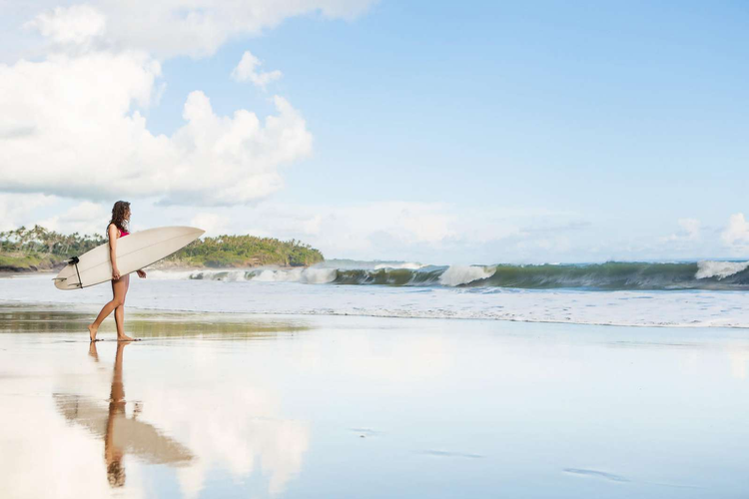

## San Diego Surf Spots

From the hippie beaches of Ocean Beach to the ritzy shores of La Jolla and everywhere in between. Discover the San Diego surf scene.

Featured Article

## Camping in Western Australia

The Australian West coast is a camper’s heaven. Endless miles of desert roads leading to secret beaches, vast canyons and crystal clear rivers, and the very few people you are likely to meet on your journey will be some of the most easy-going characters you’ll find anywhere in the world.

[Full Article](https://wknd.site/us/en/magazine/western-australia.html)

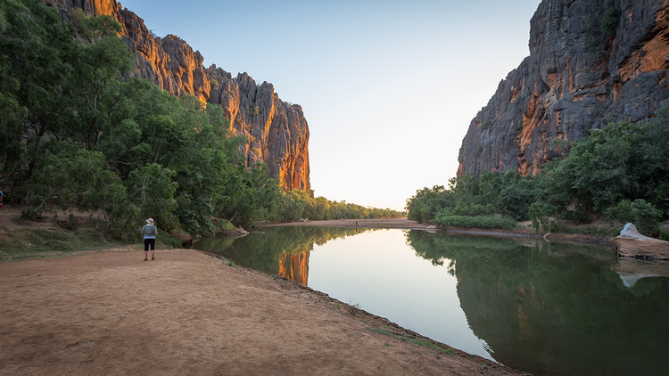

## Recent Articles



**Unmatched speed**

AEM is the fastest way to publish, create, and serve websites



**Content at scale**

AEM allows you to publish more content in shorter time with smaller teams



**Uncertainty eliminated**

Preview content at 100% fidelity, get predictable content velocity, and shorten project durations



**Widen the talent pool**

Authors on AEM use Microsoft Word, Excel or Google Docs and need no training

[All Articles](https://docs.google.com/document/u/0/d/18XT1_tQG1bvGunOommJpDTSjOH1x7wPVzey8Mg3YFp4/edit)

| Metadata | |
| --- | --- |
| Title | Home | AEM Boilerplate |
| Description | Use this template repository as the starting point for new AEM projects. |
| Image |  |