Overview on git commands: Rebase, Stash, Tagging, Reflog
Git Rebase: The git rebase is used to move or combine a sequence of commits from one branch onto another. It helps to maintain a linear and clean commit history, unlike git merge which can create extra merge commits.
During rebase, Git applies each commit from your current branch on top of the target branch one by one. If the same file is changed in both branches, conflicts may occur, which you'll need to resolve manually.
- I created a feature branch from master, made changes to file.txt, and committed them.
- I switched back to master, made a different update to the same file.txt, and committed it.
- Then I switched to the feature branch and ran git rebase master, which caused a merge conflict because both branches had edited the same line in the file.
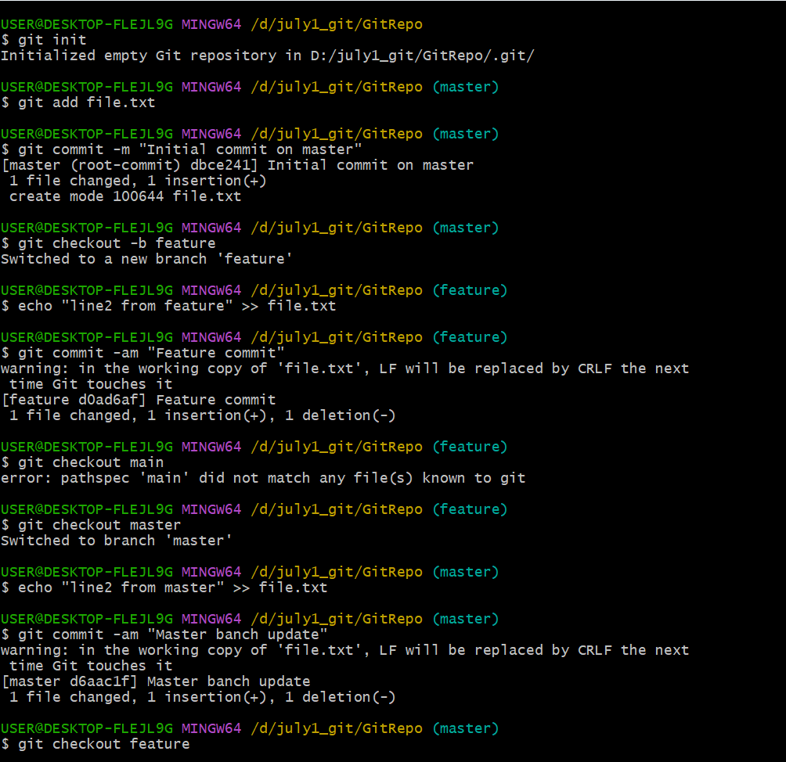

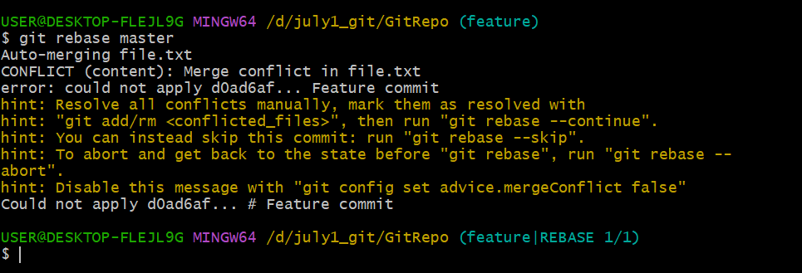

- Manually resolve the conflict in file.txt, then run git add file.txt followed by git rebase --continue to proceed with the rebase.

Git Stash: Git stash temporarily saves your uncommitted changes (modified and untracked files), so you can work on something else (like switching branches) and return later without losing progress.
- Added and modified files, then used git stash to temporarily save those changes. This cleaned your working directory without losing progress.
- Then ran git stash list to confirm the stash was saved. It showed one entry (stash@{0}) holding your current work.
- Used git stash pop to bring the stashed changes back. It restored all modified and untracked files, then automatically removed the stash from the list.
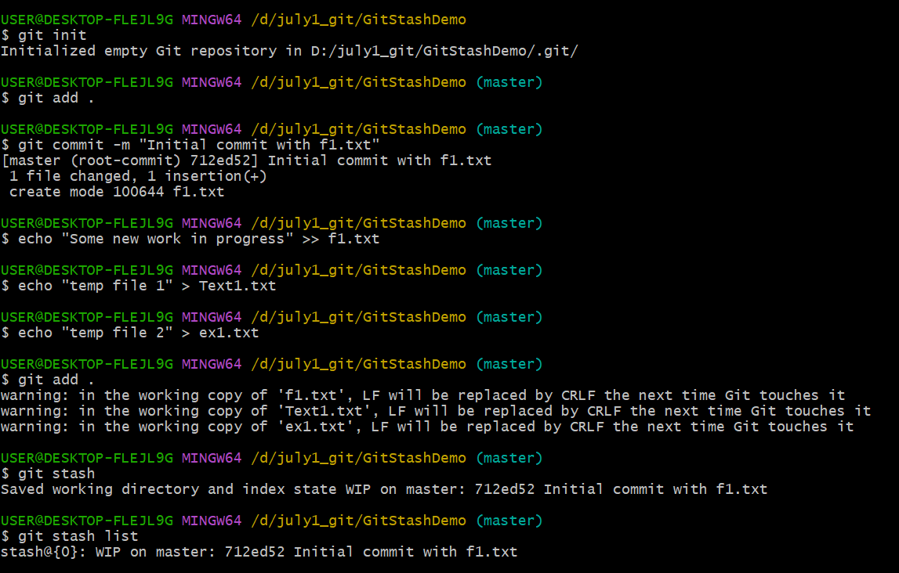

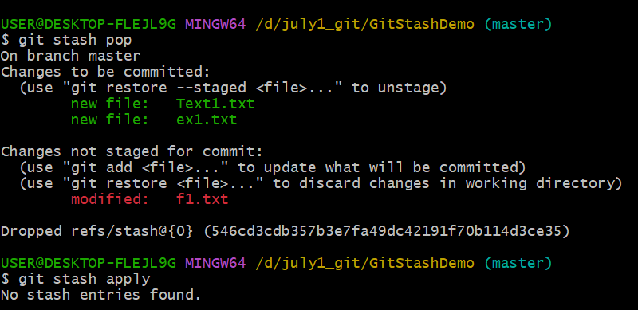

Git Tagging:
Tagging in Git is used to mark a specific point (commit) in a repository’s history as important typically for version releases like v1.0, v1.1, etc. Tags make it easy to refer to these points later.
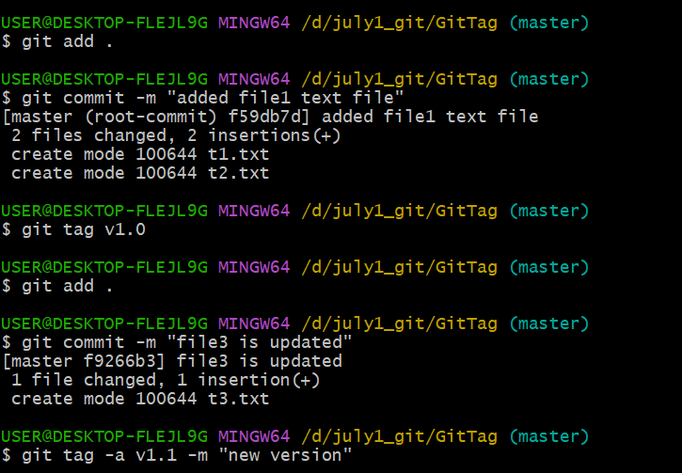

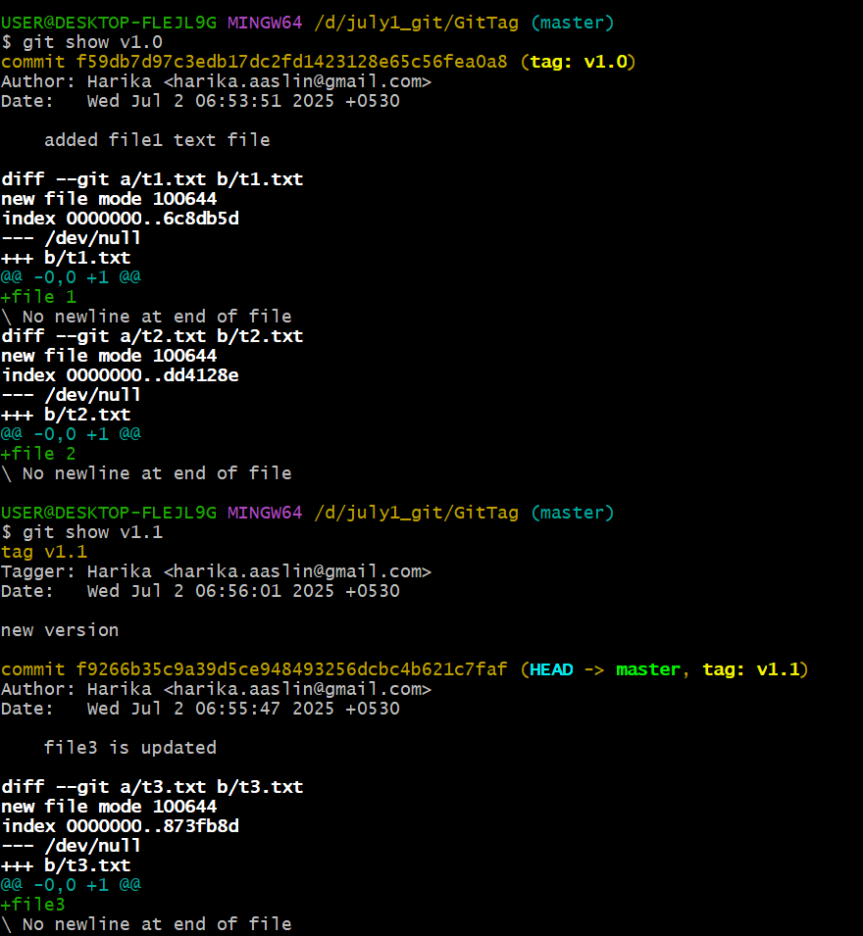

- Created a lightweight tag v1.0 after the first commit.
- Later, created an annotated tag v1.1 with a message "new version" after adding t3.txt.
- Used git show v1.0 and git show v1.1 to display the commit and file changes associated with each tag.

Git reflog: The git reflog is a command that shows a log of all recent changes to the branch tips (like HEAD) including commits, checkouts, rebases, resets, and more even if those changes are not visible in the normal git log.

