Assignment 1

Harika

2023-09-30

library(ISLR)

### The above syntax is used to call the library named "ISLR".

summary(Carseats)

## Sales CompPrice Income Advertising   
## Min. : 0.000 Min. : 77 Min. : 21.00 Min. : 0.000   
## 1st Qu.: 5.390 1st Qu.:115 1st Qu.: 42.75 1st Qu.: 0.000   
## Median : 7.490 Median :125 Median : 69.00 Median : 5.000   
## Mean : 7.496 Mean :125 Mean : 68.66 Mean : 6.635   
## 3rd Qu.: 9.320 3rd Qu.:135 3rd Qu.: 91.00 3rd Qu.:12.000   
## Max. :16.270 Max. :175 Max. :120.00 Max. :29.000   
## Population Price ShelveLoc Age Education   
## Min. : 10.0 Min. : 24.0 Bad : 96 Min. :25.00 Min. :10.0   
## 1st Qu.:139.0 1st Qu.:100.0 Good : 85 1st Qu.:39.75 1st Qu.:12.0   
## Median :272.0 Median :117.0 Medium:219 Median :54.50 Median :14.0   
## Mean :264.8 Mean :115.8 Mean :53.32 Mean :13.9   
## 3rd Qu.:398.5 3rd Qu.:131.0 3rd Qu.:66.00 3rd Qu.:16.0   
## Max. :509.0 Max. :191.0 Max. :80.00 Max. :18.0   
## Urban US   
## No :118 No :142   
## Yes:282 Yes:258   
##   
##   
##   
##

### The above values represent the summary for the 'Carseats' dataset.  
### This dataset contains a total of 400 observations.

max(Carseats$Advertising)

## [1] 29

### The above value represents the maximum value of the advertising attribute.

IQR(Carseats$Price)

## [1] 31

### The above value represents the Interquartile Range for Price attribute.

plot(Carseats$Sales,Carseats$Price, main = "Current Pricing Sales", xlab="sales" , ylab="price")

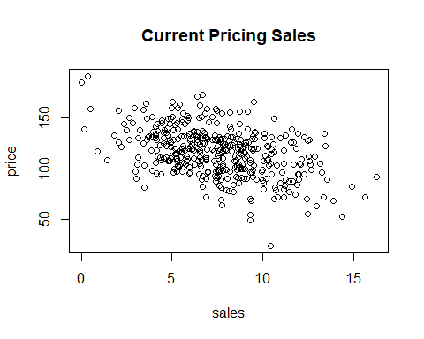

### The above is the representation of scatter plot for sales against price from the Carseats dataset.

correlation <- cor.test(Carseats$Sales,Carseats$Price,method = "pearson")  
correlation

##   
## Pearson's product-moment correlation  
##   
## data: Carseats$Sales and Carseats$Price  
## t = -9.912, df = 398, p-value < 2.2e-16  
## alternative hypothesis: true correlation is not equal to 0  
## 95 percent confidence interval:  
## -0.5203026 -0.3627240  
## sample estimates:  
## cor   
## -0.4449507

### The above value is the Pearson Correlation coefficient for the Sales and Price attributes, representing a negative correlation.