**A Project Report on**

**UIPATH STUDIO**

**Submitted by**

**BIGUVA HARIKA – R180503**

**Under the guidance of**

**M. MUNI BABU**

M.Tech, (Ph.D.), Assistant Professor

**Department of Computer Science and Engineering**





**Rajiv Gandhi University of Knowledge Technologies**

**RK Valley, Kadapa (Dist.), Andhra Pradesh, 516330**

**CERTIFICATE**

This is to certify that the project work titled **“UIPATH STUDIO”** is a bonified project work submitted by **BIGUVA HARIKA – R180503** in the Department of COMPUTER SCIENCE AND ENGINEERING in partial fulfilment of requirements for the award of the degree of Bachelor of Technology in **Computer Science and Engineering** for the academic year 2023- 2024 carried out the work under the supervision.

**GUIDE**

**Mr. M. MUNI BABU**

M. Tech, (Ph. D)

Assistant Professor

RGUKT RK VALLEY

**HEAD OF THE DEPARTMENT**

**Dr. P. RAVI KUMAR**

Assistant Professor, Ph. D, M.E

RGUKT RK VALLEY

**ACKNOWLEDGEMENT**

The satisfaction that accompanies the successful completion of any task would be incomplete without the mention of the people who made it possible and whose constant guidance and encouragement crown all the effort’s success.

I am extremely grateful to our respected Director, Prof. A V S S KUMARA SWAMI GUPTA for fostering an excellent academic climate in our institution.

I also, express my sincere gratitude to our respected Head of the Department Dr. PENUGONDA RAVI KUMAR for his encouragement, overall guidance in viewing this project a good asset and effort in bringing out this project.

I would like to convey thanks to our guide at college Mr. M. MUNI BABU for his guidance, encouragement, cooperation and kindness during the entire duration of the course and academics.

My sincere thanks to all the members who helped me directly and indirectly in the completion of the project work. I express my profound gratitude to all our friends and family members for their encouragement.

**Table of Contents**

|  |  |  |
| --- | --- | --- |
| **S.NO** | **INDEX** | **PAGE NO** |
|  | Abstract | i |
|  | List of Figures | ii |
| 1 | Introduction  1.1 Objective  1.2 Problem Statement  1.3 Motivation  1.4 Scope of the Project | 1 - 1  1 - 2  2 - 2  2 - 2 |
| 2 | Literature Review | 3 - 4 |
| 3 | System Architecture | 5 - 6 |
| 4 | Tasks  4.1 Task1  4.2 Task2  4.3 Task3 | 7 - 9  10 - 16  17 - 22 |
| 5 | Results and Discussion | 23 - 24 |
| 6 | Conclusion and Future Enhancement | 25 - 25 |
|  | References | 26 - 26 |

**ABSTRACT**

UiPath Studio would encapsulate its essence, focusing on its role as a leading Robotic Process Automation (RPA) tool. It would highlight its capabilities in automating repetitive tasks, its user-friendly interface for creating workflows through drag-and-drop functionality, its robust integration with various systems and applications, and its support for both attended and unattended automation scenarios. Additionally, it would mention UiPath's commitment to democratizing automation through its extensive community support and resources, making it accessible to users of all skill levels.

It would highlight UiPath's mission to empower organizations to automate repetitive tasks, streamline business processes, and drive digital transformation. The abstract might mention UiPath's comprehensive suite of RPA tools, including UiPath Studio for automation design, UiPath Orchestrator for centralized management, and UiPath Robots for executing automation workflows. Additionally, it could emphasize UiPath's commitment to innovation, scalability, and customer success, making it a preferred choice for enterprises seeking to harness the power of automation to optimize operations and enhance competitiveness.

i

**LIST OF FIGURES**

|  |  |  |
| --- | --- | --- |
| **Figure No.** | **Title** | **Page No** |
| Figure 3.1 | One-stop platform for all your process automation needs | 5 |
| Figure 5.1 | Output for Task1 | 23 |
| Figure 5.2 | Output for Task2 | 23 |
| Figure 5.3 | Output for Task3 | 24 |

ii

1. **INTRODUCTION**

UiPath Studio serves as the cornerstone of UiPath's Robotic Process Automation (RPA) platform, empowering users to design, automate, and manage business processes with ease. It provides a visual, drag-and-drop interface that allows users to create automation workflows without the need for extensive coding knowledge. With a focus on simplicity and efficiency, UiPath Studio enables organizations to streamline their operations by automating repetitive tasks across a wide range of applications and systems. Whether it's automating data entry, generating reports, or orchestrating complex business processes, UiPath Studio offers the flexibility and scalability needed to drive digital transformation and accelerate productivity.

**1.1 Objective:**

The objective of UiPath Studio is to provide organizations with a comprehensive and user-friendly platform for designing, developing, and deploying automation solutions. With a focus on simplicity, efficiency, and scalability, UiPath Studio aims to empower both technical and non-technical users to automate repetitive tasks, streamline business processes, and drive digital transformation initiatives. The ultimate goal of UiPath Studio is to accelerate the adoption of Robotic Process Automation (RPA) across industries, helping organizations achieve operational excellence, cost savings, and competitive advantage in today's rapidly evolving business landscape.

**1.2 Problem Statement:**

A problem statement regarding UiPath Studio could focus on challenges or pain points that users may encounter when utilizing the software. Here's an example, "Increasing demand for automation solutions has led to a surge in the adoption of UiPath Studio. However, despite its intuitive interface, users often face challenges in effectively leveraging its capabilities to automate complex business processes. These challenges include difficulty in integrating with legacy systems, limitations in handling unstructured data, and the need for advanced

**1**

programming knowledge to customize automation workflows. Addressing these issues is crucial to maximizing the potential of UiPath Studio and ensuring its seamless integration into organizational workflows."

**1.3 Motivation:**

The motivation behind UiPath Studio stems from the recognition of the growing need for organizations to automate repetitive tasks and streamline business processes in an increasingly digital world.

**1.4 Scope of the Project:**

The scope of UiPath Studio is expansive, encompassing a wide range of capabilities aimed at automating business processes and driving digital transformation within organizations. At its core, UiPath Studio provides a comprehensive platform for designing, developing, and deploying automation solutions across various industries and business functions.

**2**

1. **LITERATURE REVIEW**

Given below are the research papers used for our analysis while considering various approaches.

In Paper [1] Robotic Process Automation (RPA), often referred to as ‘robotics’ or ‘robots’, is

defined as the automation of rules-based processes with software that utilizes the user interface and which can run on any software, including web-based applications, ERP systems, and mainframe systems. Cognitive automation is the use of cognitive or artificial intelligence technologies such as natural-language processing and machine learning to enable more complex automation, typically based on the laws of probabilities. Digital workforce is used to describe the ‘robots’ – the automated solutions that are delivering processes within an organization. In most cases, the digital workforce will be either working in the background on virtual machines or accessed by consumers and co-workers through a command-based interface.

In Paper [2] This review focuses on web data extraction and integration techniques. It covers topics such as web scraping, web crawling, and data extraction from web forms, which are relevant to automating data capturing using web applications in RPA projects.

In Paper [3] One such advanced technology is Robotic Process Automation (RPA). However,

organisations do not always make the progress by using the RPA to increase the efficiency of their business processes. the scientific sources lack the synthesis of Process Management (PM) and RPA and insights into their interrelationship. This article aims to fill the gap in the systematic analysis of interrelations between PM and RPA from a managerial perspective by identifying less researched areas and formulating insights and recommendations for future research.

**3**

In Paper [4] The use of robots is not limited to the auto industry. According to a recent survey of more than 400 accounting and finance companies, 53 percent have already started using RPA, and this number is expected to increase by 72 percent over the next several years. Some of the major benefits of RPA and some of the common challenges and risk factors enterprises may face when implementing RPA should be highlighted. RPA enables enterprises to perform business processes in much simpler ways, without requiring much intuitive thinking. The phrase “divide and conquer” is applicable here with regard to such processes.

In Paper [5] This literature review specifically explores the application of RPA in the finance domain. It discusses how RPA can be utilized for data capturing from web applications, such as extracting financial data from banking portals or transactional systems.

In Paper [6] This literature review provides an overview of RPA and its applications in different industries. It highlights the importance of data capturing and extraction in RPA projects, emphasizing the role of web automation for capturing data from web applications.

In Paper [7] UiPath Studio encapsulates both simple and complex solutions for application integration and automating third-party applications, administrative IT tasks, and business IT processes. Studio is at the heart of automation with UiPath products. [Activities](https://docs.uipath.com/activities) form into comprehensive workflows in Studio, which are then executed by the [Robot](https://docs.uipath.com/robot) and published to [Orchestrator](https://docs.uipath.com/orchestrator).

**4**

1. **SYSTEM ARCHITECTURE**

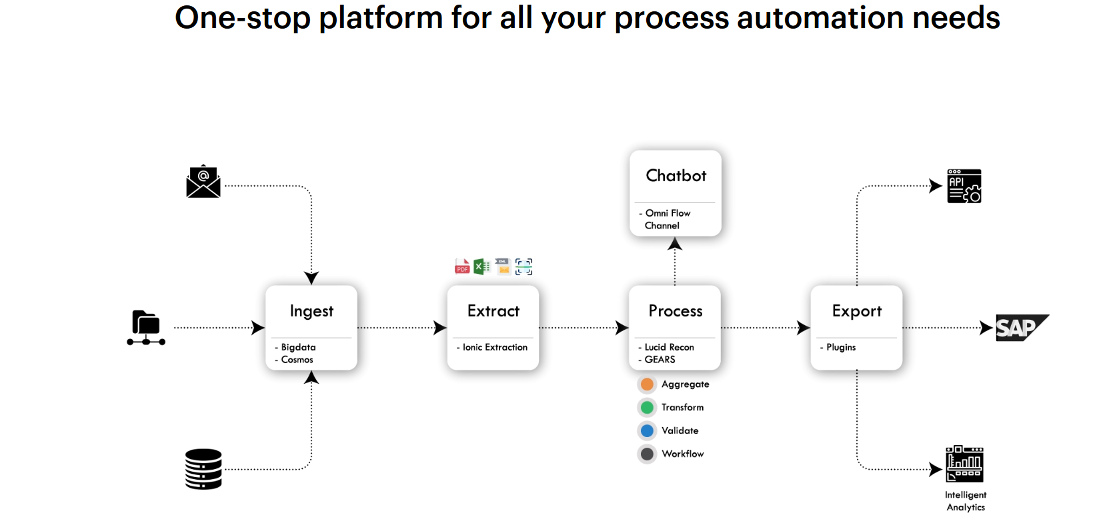

.

# 

# Figure 3.1 One-stop platform for all your process automation needs

**5**

**Ingest:**

Configure multiple data sources, document types, or both. Supports a wide range of data input channels such as Email, FTP server, Scanning stations, RDBMS, APIs, and RPA bots to fetch unstructured, semi-structured, and structured data into ACE.

**Extract:**

Capture key information from any document or data source. Ionic extraction leverages the world’s most advanced Machine learning and Computer vision algorithms to provide you with industry-leading accuracy on any document type.

**Process:**

Performs aggregation, transformation, validation, reconciliation, or anything else that you’d like to do with your data. Powerful modules such as Smart flows (BPMN 2.0), Business Rules Engine (DMN 1.3), Lucid Reconciliations available at the tap of a button to perform their magic. Day in, day out.

**Export:**

Send validated and structured data into any format. Connect ACE with any downstream transaction system such as SAP, Oracle, or custom system with out-of-the-box APIs or RPA bot connectors.

**6**

1. **TASKS**

**4.1 Task1**

 We have an Excel sheet with four columns Name, Id, Age, and Address. We have to add a status column to the sheet. Based on age we have to update the values in the status column.

**Condition:**

Age>=24 “success” otherwise “failed”.

**Input:**

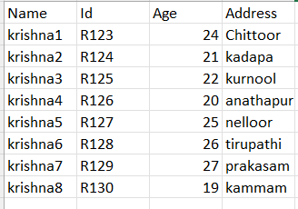

**Program:**

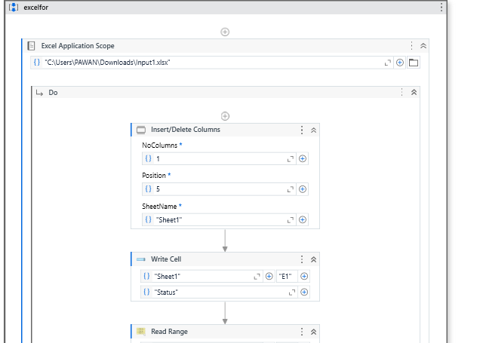

**7**

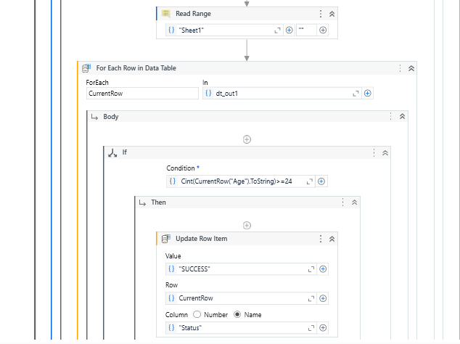

**8**

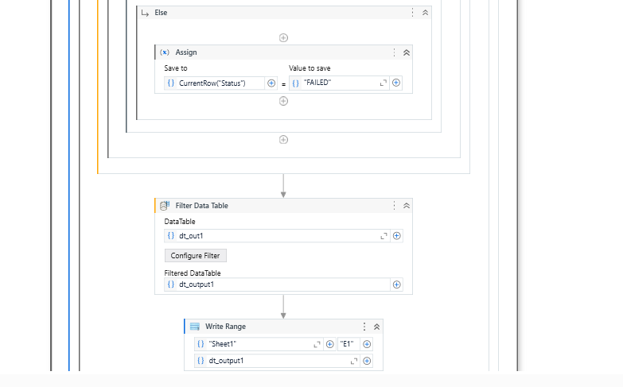

**9**

**4.2 Task2**

We Have an Excel sheet with four columns Name, Age, Paper1, Paper2. we have to add a total column and remarks column based on marks in Paper 1, and Paper 2. We have to print the output with six columns in another sheet.

**Conditions:**

If paper1 and paper2 both columns contain marks we should add a total of two paper marks and update in total column.

If paper1 is null or contains integers then we have to update in remarks invalid marks in paper1 and the total is paper2 marks.

If paper2 is null or containing non integers then we have to update in remarks invalid marks in paper2 and the total is paper1 marks.

**Input:**

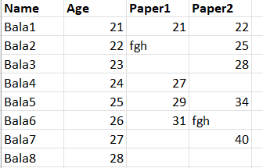

**10**

**Program:**

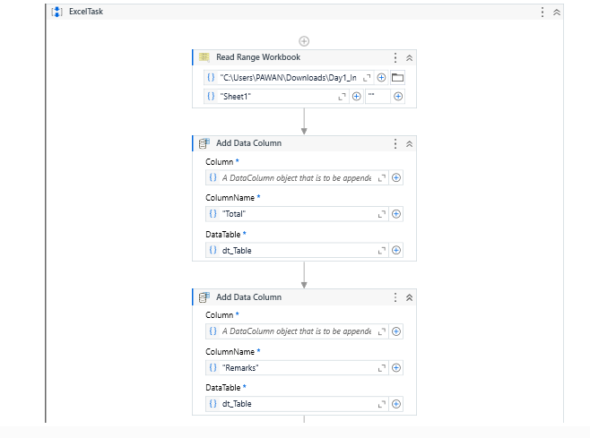

**11**

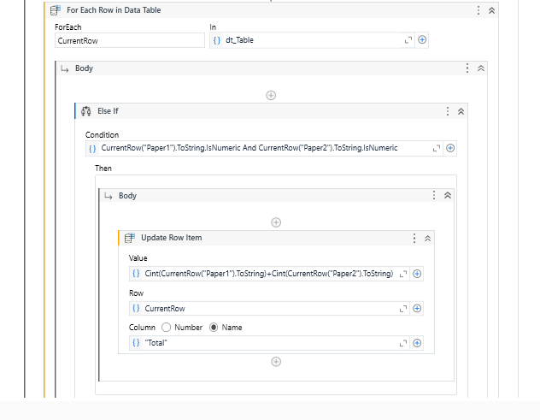

**12**

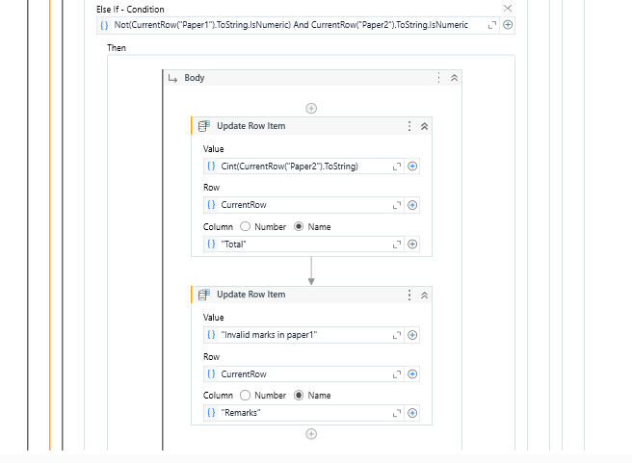

**13**

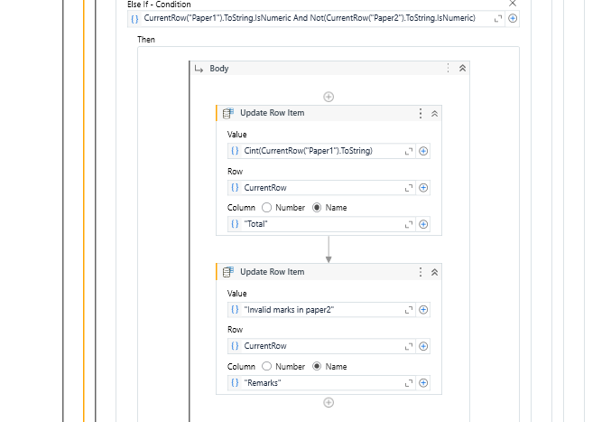

**14**

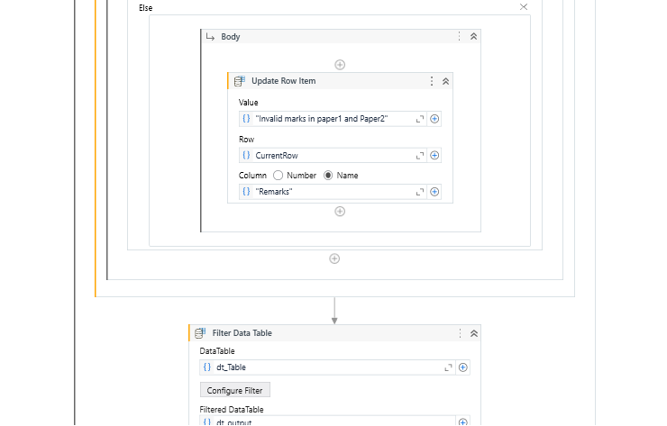

**15**

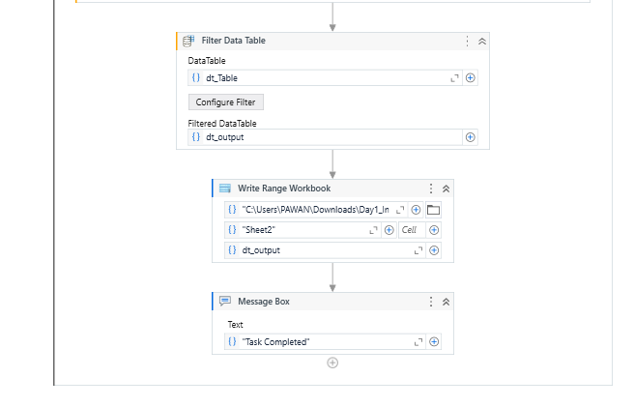

**16**

**4.3 Task3**

 Read the Excel sheet and store it in the data table.

Checking the existence of mandatory columns in sheet 1 and sheet 2 we have to add status and remark column in sheet1.

**Conditions:**

If columns exist, check the reference id’s in sheet1 & sheet 2 if the reference ID in sheet1 matches the reference ID in sheet2 then update the status column in sheet1 based on result column in sheet 2.

If Reference id’s are not match then update the Remarks column in sheet1 with the value Reference id is missing.

**Input:**

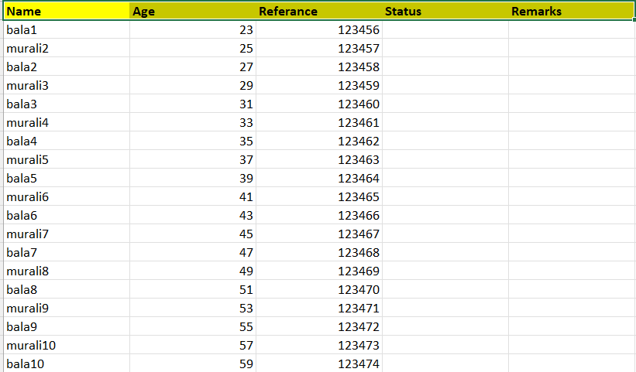

**17**

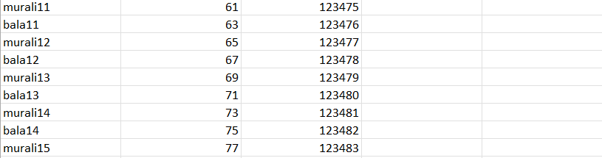

**Program:**

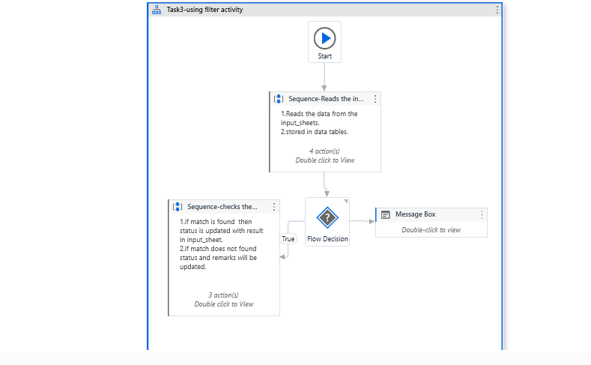

**18**

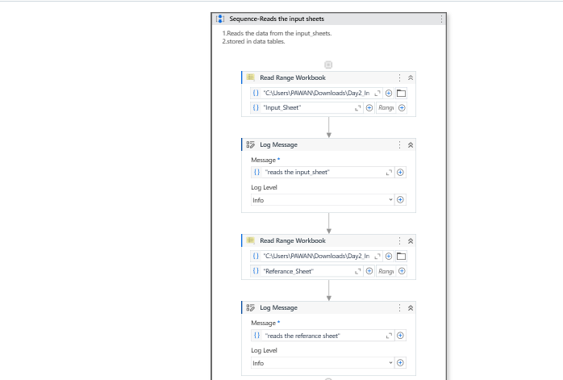

**19**

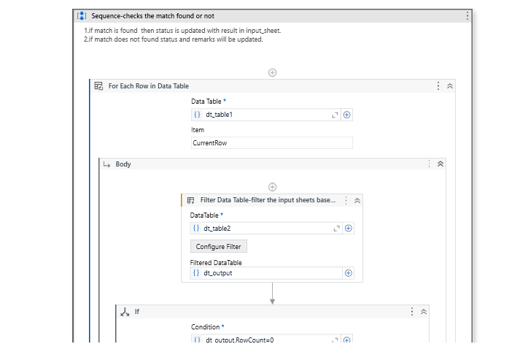

**20**

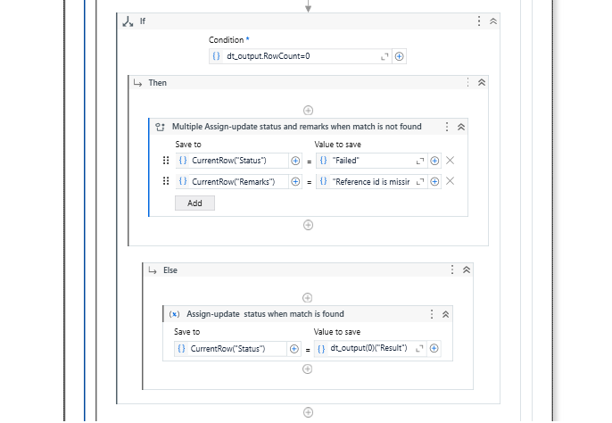

**21**

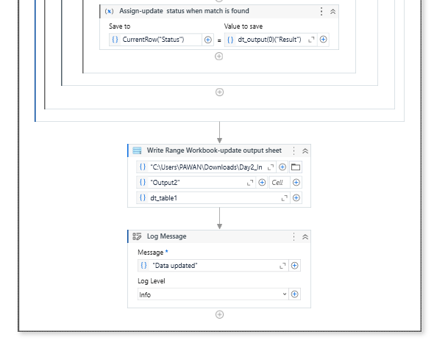

**22**

1. **RESULTS AND DISCUSSION**

**Output for Task1:**

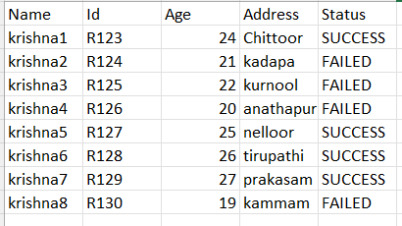

**Figure 5.1:** Based on the Condition I update the status column and the values.

**Output for Task2:**

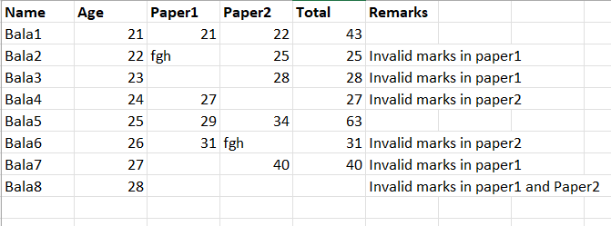

**Figure 5.2:** Based on the Conditions I update Total and Remarks column and the values.

**23**

**Output for Task3:**

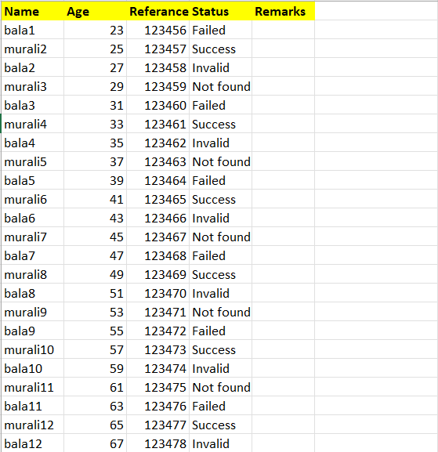

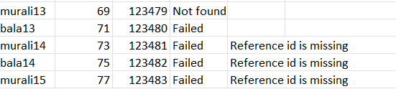

**Figure 5.3:** Based on Conditions I update the Status and Remarks Column.

**24**

**6. CONCLUSION AND FUTURE ENHANCEMENT**

**6.1 Conclusion:**

In conclusion, UiPath Studio stands as a powerful tool in the realm of Robotic Process Automation (RPA), revolutionizing the way organizations automate their business processes. Its user-friendly interface, scalability, and integration capabilities have enabled businesses to streamline operations, enhance efficiency, and drive digital transformation initiatives. Through its democratization of automation development, UiPath Studio empowers both technical and non-technical users to create sophisticated workflows tailored to their specific needs, fostering a culture of innovation and continuous improvement.

UiPath Studio represents more than just a software tool—it embodies a paradigm shift in how organizations harness automation to drive efficiency, innovation, and growth. As technology continues to evolve and organizations embrace automation at scale, UiPath Studio will undoubtedly play a central role in shaping the future of work and business operations.

**6.2 Future Enhancement:**

* **Enhanced AI and Machine Learning Integration**
* **Expanded Cloud Integration**
* **Enhanced Collaboration Features**
* **Low-Code/No-Code Enhancements**
* **Advanced Analytics and Reporting**
* **Robust Security and Compliance Features**
* **Cross-Platform Compatibility**
* **Augmented Reality (AR) and Virtual Reality (VR) Support**

**25**

**REFERENCES**

[1] Deloitte, "The robots are waiting: How UiPath is powering the automation-first era." Deloitte Insights, 2019.

[2] Marta Sabou et al, “A Literature Review on Web Data Extraction and Integration” International Journal of Research Publication and Reviews, issue no:6, vol. 4, 2019.

[3] Antony, Jiju, "Robotic Process Automation (RPA) in business process management (BPM) context: A conceptual framework." Business Process Management Journal, issue no. 2, vol. 26, 2020.

# [4] Angel R. Otero, Ph.D., CISA, CRISC, CPA, CITP, CICA and Ryan Paul Fink, CGBP, “Robotic Process Automation to Aid Accounting and Finance Departments” ISACA, 2020

[5] Ali A. Razzaq et al, “A State-of-the-Art Literature Review”, PMC (PubMed central), vol.12, 2021.

[6] Yashoda Bhagwat et al, “A Comprehensive Literature Review and Directions for Future Research”, International Journal of Research Publication and Reviews, issue no:6, vol.4, 2021.

[7] UiPath. "UiPath Studio Guide." [Official documentation] (<https://docs.uipath.com/studio/docs/introduction>).

**26**