**WEEK-3**

**Spring Core_Maven**

**Exercise 1: Configuring a Basic Spring Application**

**Scenario:** Your company is developing a web application for managing a library. You need to use the Spring Framework to handle the backend operations.

**File Name:pom.xml**

<dependencies>

<dependency>

<groupId>org.springframework</groupId>

<artifactId>spring-context</artifactId>

<version>5.3.30</version>

</dependency>

</dependencies>

**File Name:applicationContext.xml**

<bean id="bookRepository" class="BookRepository"/>

<bean id="bookService" class="BookService">

<property name="bookRepository" ref="bookRepository"/>

</bean>

**File Name:BookRepository.java**

package com.library.repository;

import java.util.ArrayList;

import java.util.List;

public class BookRepository {

private List<String> books = new ArrayList<>();

public void saveBook(String bookName) {

books.add(bookName);

System.out.println("Book saved: " + bookName);

}

public List<String> getAllBooks() {

System.out.println("BookRepository: Fetching book list from database...");

return books;

}

}

**File Name**:**BookService.java**

package com.library.service;

import com.library.repository.BookRepository;

import java.util.List;

public class BookService {

private BookRepository br;

public void setBookRepository(BookRepository br) {

this.br = br;

}

public void addBook(String bookName) {

br.saveBook(bookName);

}

public void showBooks() {

List<String> books = br.getAllBooks();

System.out.println("Library Collection:");

for (String book : books) {

System.out.println("-" + book);

}

}

}

**File Name:**MainApp.java

import org.springframework.context.ApplicationContext;

import org.springframework.context.support.ClassPathXmlApplicationContext;

import com.library.service.BookService;

public class MainApp {

public static void main(String[] args) {

ApplicationContext context = new ClassPathXmlApplicationContext("applicationContext.xml");

BookService bookService = (BookService) context.getBean("bookService");

bookService.addBook("Spirited Away");

bookService.addBook("Howl's Moving Castle");

bookService.addBook("My Neighbor Totoro");

bookService.showBooks();

}

}

**OUTPUT**:

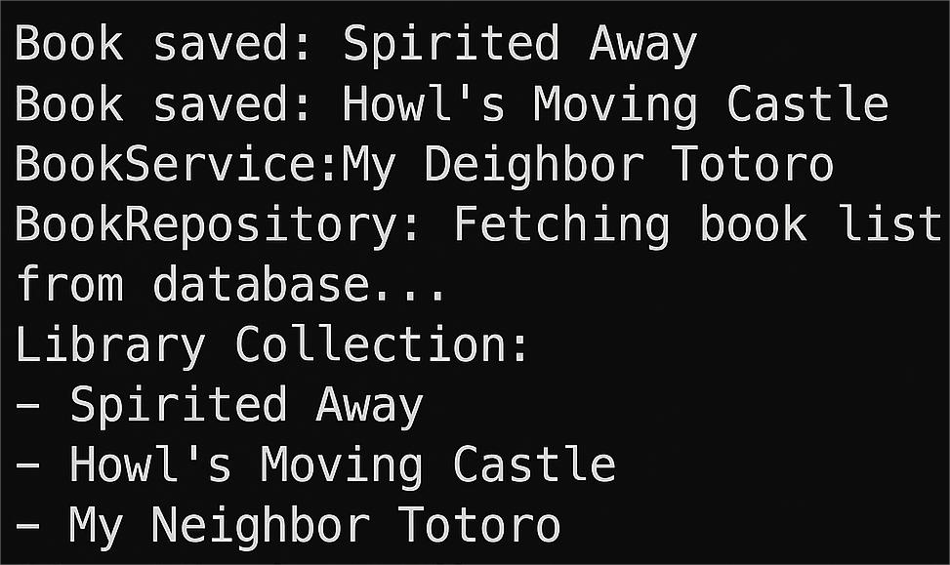

**Exercise 2: Implementing Dependency Injection**

**Scenario:** In the library management application, you need to manage the dependencies between the BookService and BookRepository classes using Spring's IoC and DI.

**File Name**:**applicationContext.xml**

<bean id="bookRepository" class="com.library.repository.BookRepository" />

<bean id="bookService" class="com.library.service.BookService">

<property name="bookRepository" ref="bookRepository"/>

</bean>

**File Name**:**BookService.java**

package com.library.service;

import com.library.repository.BookRepository;

public class BookService {

private BookRepository br;

public void setBookRepository(BookRepository br) {

this.br = br;

}

public void addBook(String bookName) {

System.out.println("BookService: Adding book - " + bookName);

br.save(bookName);

}

}

**File Name:LibraryManagementApplication.java**

package com.library;

import com.library.service.BookService;

import org.springframework.context.ApplicationContext;

import org.springframework.context.support.ClassPathXmlApplicationContext;

public class LibraryManagementApplication {

public static void main(String[] args) {

ApplicationContext context = new ClassPathXmlApplicationContext("applicationContext.xml");

BookService bookService = (BookService) context.getBean("bookService");

bookService.addBook("Seasons of Blossm");

}

}

**Output:**



**Exercise 4: Creating and Configuring a Maven Project**

**Scenario:** You need to set up a new Maven project for the library management application and add Spring dependencies.

**Project Name**: **LibraryMangement**

**File Name:pom.xml**

<dependencies>

<dependency>

<groupId>org.springframework</groupId>

<artifactId>spring-context</artifactId>

<version>5.3.30</version>

</dependency>

<dependency>

<groupId>org.springframework</groupId>

<artifactId>spring-aop</artifactId>

<version>5.3.30</version>

</dependency>

<dependency>

<groupId>org.springframework</groupId>

<artifactId>spring-webmvc</artifactId>

<version>5.3.30</version>

</dependency>

</dependencies>

<build>

<plugins>

<plugin>

<groupId>org.apache.maven.plugins</groupId>

<artifactId>maven-compiler-plugin</artifactId>

<version>3.8.1</version>

<configuration>

<source>1.8</source>

<target>1.8</target>

</configuration>

</plugin>

</plugins>

</build>